DBT ASSINGMENT-6

1) Write two different queries that would produce all orderss taken on October 3rd or 4th ,1990?
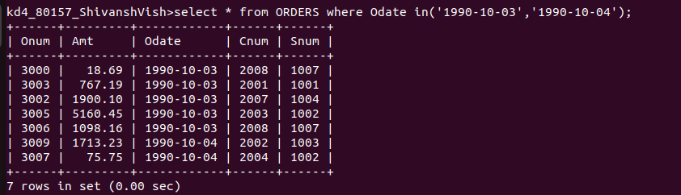
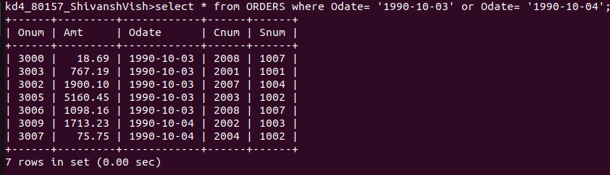
2) Write a query that selects all of the customers serviced by peel or motika?

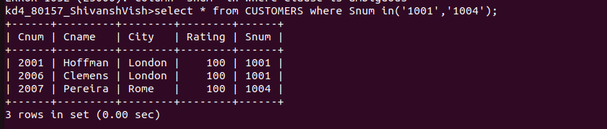
3) Write a query that will produce all the customers whose names begin with a letter from ’A’ to ‘G’?
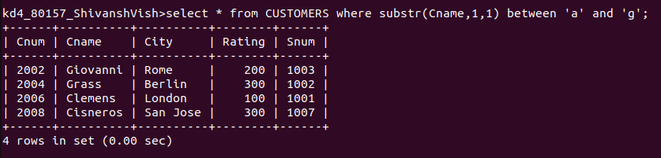

4) Write a query that selects all customers whose names begin with the letter ‘C’.

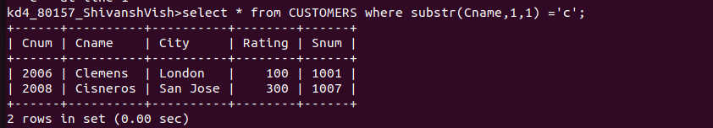
5) Write a query that selects all orders except those with zeros or nulls in the amt field?
