DBT ASSIGNMENT-7

1) Write a query that counts all orders for October 3rd?


2) Write a query that counts the number of different non-NULL city values in the customers table.


3) Write a query that selects each customer’s smallest order?

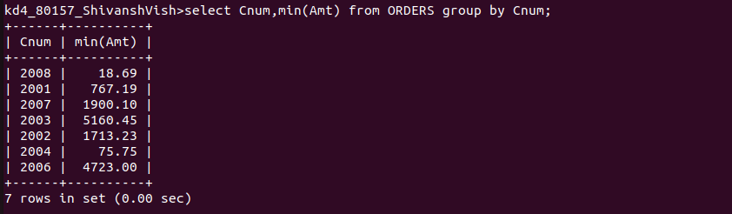
4) Write a query that selects the first customer in alphabetical order,whose name begins with G?



5) Write a query that selects the highest rating in each city?

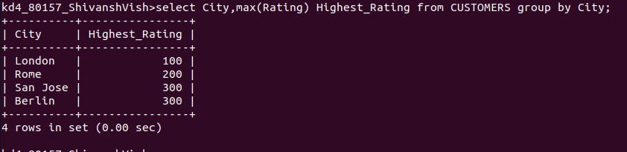

6) Write a query that counts the number of salespeople registering orders for each day.

