DBT ASSIGNMENT-8

1) Assume each salesperson has a 12% commission. Write a query on the orders table that will produce the order number , the salesperson number, and the amount of the salesperson’s commission for that order.

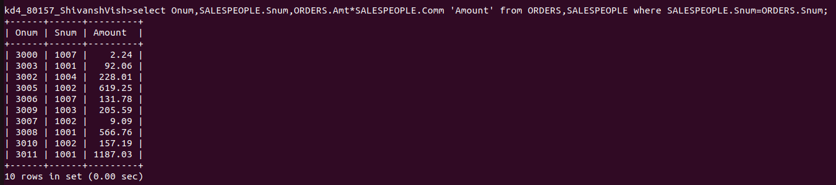
2) Write a query on the customers table that find the highest rating in each city. Put the output in this form.


3) Write a query that lists customers in descending order of rating. Output field first, followed by the customer’s name and number.

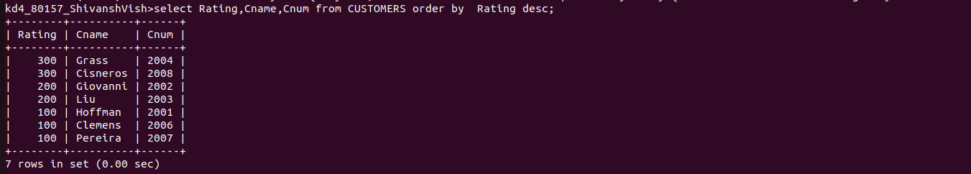

4) Write a query that totals the orders for each day and places the results in descending order.

