DBT ASSIGNMENT-15

1) Assume there is a table called Multicust, with all of the same column definitions as salespeople. Write a command that inserts all salespeople with more than one into this table.

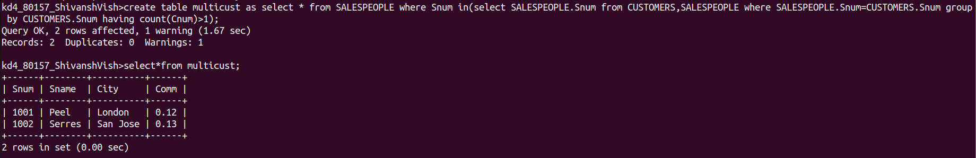

2) Write a command that deletes all customers with no current orders.

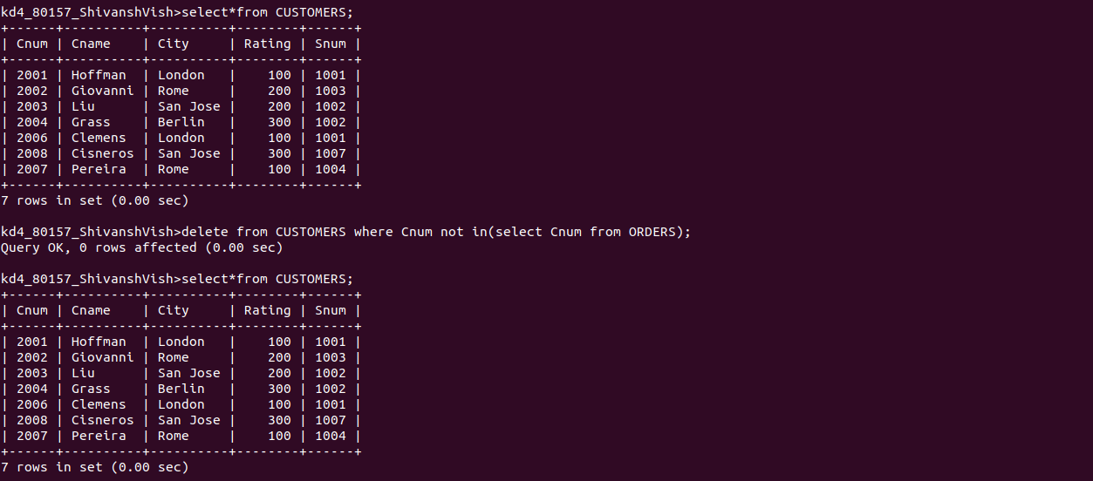

3) Write a command that inceases by twenty percent the commissions of all salespeople with total orders above Rs.3000.

