DBT ASSIGNMENT-14

1) Write a command that puts the following values, in their given order, into the salespeople table:
City - San Jose,Name-Blanco,Comm-Null, Cnum-1100.

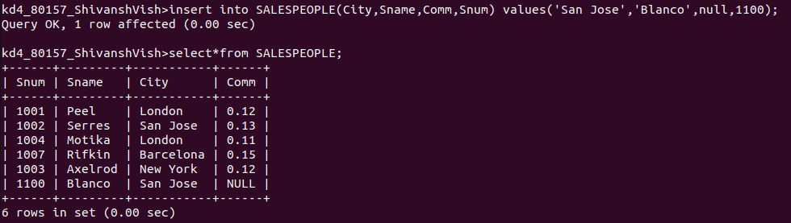

2) Write a command that removes all orders from customer Clemens from the order table.

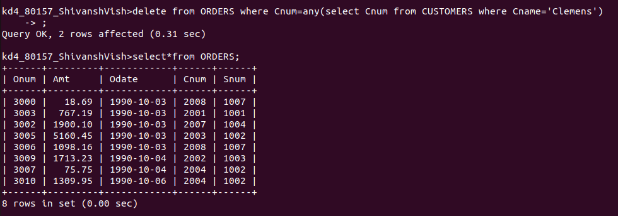

3) Write a command that increases the rating of all customers in Rome by 100.

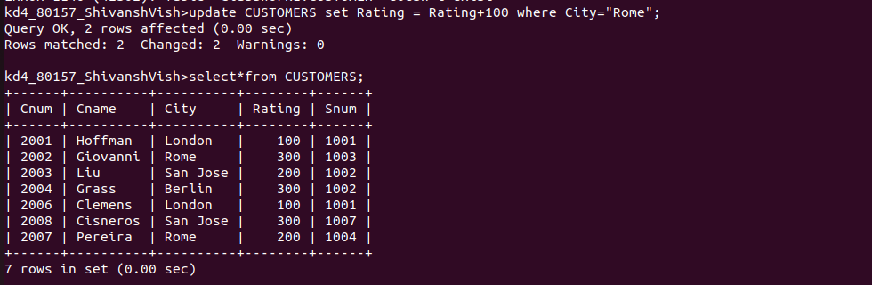

4) Salesperson serres has left the company. Assign her customers to Motika.

