  - "A review of Strategic Adaptation and Policy Synergies: Business Leadership at Japan's Economic Inflection Points"
  - By Reza Fayazi

Abstract

This is a study of Japan’s economy across the years 1945 to 2011, built around four moments where the trajectory of growth, prices, and employment bent into a genuinely new direction: the Nixon Shock of 1971, the asset bubble that peaked around 1989–1991, the Asian Financial Crisis of 1997–98, and the Global Financial Crisis of 2008. Rather than reading each of these as an external shock that simply happened to Japan, we look at how the country’s own institutional machinery, keiretsu cross-shareholding, main bank financing, and MITI administrative guidance, kept showing up across all four episodes, sometimes absorbing the impact and sometimes, as with the asset bubble, becoming the very channel through which the crisis grew. Two sets of indicators are tracked throughout: household-side measures such as the Unemployment rate and CPI inflation, and industrial measures such as the trade balance, deposit interest rates, and GDP growth, pulled from 1945 through 2011 wherever the underlying data allows it. Business leaders, among them Eiji Toyoda, Soichiro Honda, Hiroshi Okuda, and Akio Toyoda, are looked at individually rather than treated as interchangeable, since the institutions alone cannot explain why some of these turning points ended in resilience and others in a slow unwind that took over a decade to work through. What comes out of this is that Japan’s postwar growth, and the stagnation that followed it, were never simply handed down by policy or by markets abroad. They came out of the meeting point between what the institutions made available and what individual leaders chose to do with it. We close with a short note on where the available data thins out, particularly before 1971, and where this same framework could reasonably be carried forward into the years after 2011.

Keywords:
Japanese Economic Miracle, Post-War Inflection Points, Keiretsu Networks, Business Leaders/Entrepreneurs, MITI, METI, Corporate Adaptation, Strategic Decision-Making, Policy Synergies, Policy-Business Nexus, Economic Restructuring, Export-Led Growth, Bank of Japan.

Contents
Introduction 2
Literature Review 3
Inflection points 7
The Nixon Shock 8
Asset Bubble 9
The Asian Financial Crisis 11
The Global Financial Crisis 13
Conclusion 15
References 16

Introduction

Japan’s climb from wartime devastation to the world's second-largest economy by the late 1960s, followed by decades of stagnation that are still argued over today, tends to get told as a story of two extremes: the miracle, or the Lost Decades, rarely both in the same breath. That framing skips over most of what actually happened in between. Between 1945 and 2011 Japan moved through several sharp turns that, looked at quickly, resemble a string of external shocks that simply happened to Japan, an oil crisis here, a financial contagion there, but a closer look at the underlying data suggests something more layered was going on underneath each of them.
This paper is built around a fairly narrow question inside a fairly large subject: at Japan’s key economic inflection points, how much of the outcome came from the country’s own institutions, keiretsu networks, main bank financing, MITI and later METI guidance, the Bank of Japan’s rate policy, and how much came from the choices individual business leaders made with what those institutions handed them. We narrow the postwar period down to four inflection points that the data itself points to as genuine turning points rather than ordinary fluctuation: the Nixon Shock of 1971, the asset bubble of the late 1980s and its 1991 burst, the Asian Financial Crisis of 1997–98, and the Global Financial Crisis of 2008. Each of these is examined through the same pair of lenses, household indicators such as the Unemployment rate and CPI, and industrial indicators such as the trade balance, deposit interest rates, and GDP growth, so that the comparison across the four episodes rests on more than just narrative.
Running alongside the macro picture is a second, more human thread. Eiji Toyoda’s push into just-in-time production after the Nixon Shock, Soichiro Honda’s pivot toward fuel-efficient vehicles during the oil shock years, Hiroshi Okuda’s lean restructuring at Toyota through the Asian crisis, and Akio Toyoda’s return to core engineering discipline after 2008, these are four different people reaching for the same institutional toolkit and turning it toward four very different problems. Business leadership is treated here not as a footnote to policy but as one of the things that actually decided how each crisis played out on the ground.
The remainder of the paper is organized as follows. The Literature Review works through Addicott (2017), Grabowiecki (2006), and Takada (1999) on zaibatsu dissolution and the rise of keiretsu, alongside more recent work on the U.S.-Japan alliance and the international monetary system that Japan grew up inside of. The Inflection points section then lays out what we mean by an inflection point in this context and which indicators we lean on throughout. The four sections that follow, the Nixon Shock, the Asset Bubble, the Asian Financial Crisis, and the Global Financial Crisis, each work through the same structure: the data first, then the business leaders who responded to it, then the policy response that followed. The Conclusion draws these four cases back together and asks what, if anything, they add up to as one continuous story rather than four separate ones.

Literature Review

The postwar Japanese economic miracle (c. 1950–1973) exemplifies rapid industrialization driven by business adaptation, government policies, and institutional evolution. This review synthesizes three key works— Addicott, David A. C. (2017), Grabowiecki (2006), and Takada (1999)—focusing on business owners' actions at inflection points, supporting policies, and resulting economic outcomes. These papers collectively illuminate the transition from prewar zaibatsu conglomerates to postwar keiretsu networks, highlighting how relational governance and policy coordination fueled growth while revealing structural limitations.
Keiretsu was quite the start of the post-modern inter-firm networks that emerged after the postwar dissolution (and denazification) of a family-controlled conglomerates name Zaibatsu. They were clusters of independent companies linked by an economic institution which made them have a cross-shareholding policy Grabowiecki (2006). This kind of institution reshaped the competition in the business market of Japan and to some extent, it was a fine stepping stone for Japan’s Economy. The Keiretsu system fell into horizontal and vertical types. Business owners had high incentives to be a part of keiretsu due to stable capital, information flow, and coordinated investment.
Addicott, David A. C. (2017) provides a historical overview of the zaibatsu's rise and dissolution, emphasizing their role in Japan's modernization and the policy-driven shifts that reshaped business strategies. Zaibatsu—family-controlled conglomerates like Mitsui, Mitsubishi, Sumitomo, and Yasuda—emerged during the Meiji Restoration (1868 onward) as vehicles for state-led industrialization. Business owners leveraged political connections ("political merchants") to secure monopolistic advantages in banking, trading, mining, and manufacturing. By the interwar period, these groups dominated the economy, financing military expansion and wartime production.
SCAP occupation policies (1945–1952) marked a critical inflection point. Antitrust reforms mandated zaibatsu dissolution to democratize the economy and prevent militarism's recurrence. Holding companies were banned, family assets liquidated, and cross-holdings dismantled. Addicott details how these policies forced business leaders to adapt: former affiliates reorganized into looser, bank-centered keiretsu. This transition preserved core competencies in relational contracting while introducing greater competition. Policies such as land reform and labor democratization complemented these changes, creating a skilled workforce and broader domestic market.
Outcomes were largely positive in the short term. Freed from family control, professional managers pursued aggressive investment and technology adoption, supported by MITI (Ministry of International Trade and Industry, 1949–2001; later METI) guidance and Bank of Japan financing. Addicott argues this restructuring laid the foundation for export-led growth, with keiretsu enabling risk-sharing and long-term planning. However, incomplete dissolution allowed informal networks to persist, contributing to the "Japanese model" of coordinated capitalism. Criticisms in the literature (echoed by Addicott) note that reforms inadvertently concentrated power in banks, which we have seen the effects in asset bubbles. Business actions for diversification into heavy industries and quality-focused production, accomplished high growth but embedded rigidities, such as lifetime employment, that strained adaptability post-1970s.
Grabowiecki (2006) delves deeper into keiretsu as the postwar successor to zaibatsu, examining their organizational mechanics, governance, and macroeconomic impact. Horizontal keiretsu for instance Mitsui and Mitsubishi, featured diversified industries linked by president’s clubs, cross-shareholding, and main bank relationships. Vertical keiretsu, Toyota for example, organized tiered supplier networks around a core assembler, emphasizing just-in-time production and long-term contracting.
Business owners in these groups acted strategically at multiple inflection points. During high growth, they channeled U.S. aid, Korean War procurements, and domestic savings into capital-intensive sectors. Policies like the Income Doubling Plan (1960) provided indicative guidance, while financial repression (low interest rates, directed credit) supported keiretsu expansion. Grabowiecki highlights functions such as information sharing (via sogo shosha trading companies), risk distribution (mutual support during downturns), internal capital markets (reducing external financing costs), and strategic coordination (joint R&D and market entry). These mechanisms lowered transaction costs compared to arm's-length Western markets, enabling rapid scaling.
Empirical outcomes were impressive: keiretsu firms achieved superior productivity, technological upgrading, and export competitiveness, closing the gap with Western economies. Grabowiecki notes their role in "industrial dirigisme," where state-created capital flowed efficiently through group channels, mitigating coordination failures in large projects. Cross-shareholding insulated managers from short-term shareholder pressure, fostering patient capital and innovation diffusion. Labor unions further aligned worker and firm interests, boosting morale and firm-specific skills.
However, Grabowiecki cautions on long-term drawbacks. By the 1980s–1990s, keiretsu rigidity contributed to inefficiency amid globalization and financial deregulation. "Success as the source of failure" dynamics emerged, where cooperative norms discouraged radical innovation and exit from declining sectors. Comparative analysis with Polish and other transition economies suggests keiretsu-like groups require specific institutional preconditions (trust, main bank stability) not easily replicated. Business adaptation post-bubble involved unwinding cross-holdings and internationalizing, but with mixed results due to legacy commitments.
Takada (1999) complements the structural focus of the prior works by emphasizing multifaceted underlying factors and business strategies during the miracle. SCAP reforms (zaibatsu breakup, land reform, and labor democratization) created a level playing field that business leaders exploited. The Korean War (1950–1953) served as an exogenous boost, providing special procurements that injected foreign exchange and demand, enabling technology imports and capacity building.
Business owners prioritized heavy and chemical industries per MITI priorities, investing in imported machinery and process improvements Takada (1999). Strategies included aggressive exporting under undervalued yen (Bretton Woods fixed rate), quality enhancement (inspired by Deming), and supply chain integration within emerging keiretsu. High household savings, channeled through postal savings and banks, financed this without heavy foreign debt. Education expansion produced a disciplined, literate workforce, while cultural factors like group orientation supported cooperative competition.
On the international basis, and specifically the foundation of U.S alliance in favor of Japan’s growth, Beckley et al. (2018) emphasize the indispensable role of the United States in facilitating Japan’s economic resurgence, framing the U.S.-Japan alliance as a security and economic enabler rather than mere backdrop. Following defeat in World War II, Japan faced devastation, but U.S. occupation policies and subsequent Cold War strategy provided critical support. Business leaders benefited from reduced defense expenditures, allowing reallocation of resources toward industrial investment.
At key inflection points, such as the immediate postwar recovery and the 1950s–1960s export push, Japanese firms (reorganizing from dismantled zaibatsu into keiretsu structures) capitalized on American procurement during the Korean War and favorable trade terms. Policies like the Security Treaty (1951, revised 1960) insulated Japan from geopolitical risks, freeing capital for MITI-guided industrialization. Beckley et al. argue that without this alliance, Japan’s high savings, educational investments, and industrial policies would have yielded far slower results.
Business owners acted pragmatically: adopting American management techniques (e.g., quality control), investing in heavy industries, and pursuing scale via group coordination. Outcomes included rapid GDP expansion (averaging over 10% annually during the high-growth era), technological leapfrogging, and Japan’s emergence as a global exporter. However, the paper notes dependencies—over-reliance on U.S. markets exposed vulnerabilities during later shocks like the Nixon administration’s policy shifts. Beckley et al. (2018) thus portray the alliance as a double-edged sword: a catalyst for miracle-level growth that embedded structural reliance, influencing business strategies toward export orientation and relational governance well into the late 20th century.
Gooding (2026) situates Japan’s miracle within evolving international monetary and geopolitical frameworks, analyzing Bretton Woods, the Nixon Shock, and China’s rise as successive inflection points. The fixed exchange rate regime (¥360 per USD) under Bretton Woods provided undervaluation advantages, enabling export competitiveness and stable planning for business leaders. Combined with domestic policies, this fostered capital accumulation and industrial upgrading in sectors prioritized by government-business coordination.
Business actions during the miracle era involved heavy borrowing for technology imports and capacity expansion, supported by keiretsu internal markets and MITI direction. Gooding details how the system allowed firms to pursue aggressive market share strategies with predictable costs. The 1971 Nixon Shock—ending dollar-gold convertibility and pressuring yen appreciation—marked a turning point, forcing revaluation, inflation management, and structural adjustment. Japanese companies responded by enhancing productivity, relocating production overseas, and diversifying into high-value goods (e.g., electronics, automobiles). Subsequent China opening and WTO integration intensified competition, shifting global supply chains and pressuring Japan’s model.
Policy responses included floating the yen, fiscal stimulus, and later “Abenomics-style reforms,” but Gooding critiques delays in addressing keiretsu rigidities and demographic challenges. Economic outcomes were dual: the miracle delivered world-second-largest economy status by the late 1960s, with gains in living standards and infrastructure; yet post-1990s stagnation (“Lost Decades”) reflected adjustment frictions, asset bubbles, and relative decline. Gooding integrates institutional economics and developmental state theory, arguing that synergistic interactions of undervalued currency, and business relationships explain the rise, while global had limitations being forced through the economy.

Yoshioka and Kawasaki (2016) focus on Japan’s internal economic planning apparatus, detailing fiscal, monetary, and indicative planning tools that guided high-growth policies. Postwar policies from the economic institutions like keiretsu to the national income doubling plan served dual roles. Firstly, coordinating government actions to avoid inconsistencies, and secondly, signaling private sector expectations. Business owners used these as roadmaps for investment, aligning production with projected demand in targeted industries. They also examine policy instruments such as low-interest loans via the Japan Development Bank, tax incentives for exports, and MITI administrative guidance. These facilitated capital deepening and structural shifts from light to heavy industries. Coordination mechanisms ensured monetary, and fiscal stability. To which served as enabling sustained high investment rates without overheating the economy. At inflection points like trade liberalization (1960s), plans helped businesses adapt by forecasting opportunities and mitigating risks.
Each of these studies compiles a vital piece of the puzzle regarding the dynamics at Japan’s key economic inflection points and the external factors that shaped its postwar growth. Collectively, they reveal how Japan infused its economic institutions with mechanisms most suitable to its industrial context in the aftermath of World War II; ranging from U.S.-backed security and market access to indicative planning and adaptive keiretsu governance. The distinctiveness of Japan’s model, particularly when contrasted with liberal market economies elsewhere, renders it a compelling case for scholarly attention. Understanding what elevated Japan as a “house for titans” provides essential context for evaluating the miracle’s successes and limitations. These works thus not only document historical outcomes but also equip researchers with analytical tools to assess the interplay of agency and structure, offering transferable insights for other late-industrializing economies while highlighting the contingent nature of sustained competitiveness in a changing world order.

Inflection points

Before the study of the businesses reactions towards economic movements starts, we need first to realize what inflection point are, and which of those is the most definitive one to start with. Inflection points in mathematics refers to a point when the second derivative of a function shifts sign. Signaling the transition from a concave to convex curve or vice versa. In an easy word, the dynamics of the growth rate changes within an inflection point. On the other hand, in economic analysis, an inflection point refers to a critical juncture where the trajectory of key indexes (in an economy) goes through a markable change in direction. In studies of development and business cycles, inflection points denote periods of dramatic changes via exogenous shocks, policy interventions, or endogenous adaptations. Mainly characterized by high uncertainty, realignment of institutional frameworks, and changes in economic agent’s decision-making. In this study, we will be having a notice on the household economics by the unemployment rate, and CPI inflation rate (from now on, we will refer to this by CPI) . For the industrial section, we will be relying on the trade balance, deposit interest rates, GDP growth rates.
Although household economy is not amongst the concerns of the subject, but it is a vital economic factor to have in mind. Study of an economy is distinctly complex for its integrated nature. The model that we are trying to simplify Japan’s economy in, can’t have the households, the work force, out of the equation. By studying the patterns of unemployment rate and CPI, we can have insights about their actions via a filter that will be decent through this study. In an economy with a raising unemployment rate, we will be expecting the household expenditure, and savings to decrease. Furthermore, this proxy leads us to revenue expectations of businesses, and the wage expectations for the workforce. So, as sophisticated as it seems, we need also to pay attention to the household factors as well as the industry factors.
For the industrial section, we will rely primarily on core indicators such as trade balance, deposit interest rates, and GDP growth rates to capture a firm picture of business adaptation and policy effectiveness. These metrics serve as direct lenses into how firms navigated uncertainty, reallocating resources and leveraging institutional support at key stroke-points. A favorable trade balance, for instance, reflects successful export strategies and supply-chain coordination within keiretsu networks, often amplified by policies like undervalued currency regimes or MITI-directed investments in heavy industries. Deposit interest rates, shaped by financial repression and Bank of Japan (we will refer to as BoJ) interventions, influenced capital availability, enabling long-term planning and risk-sharing that distinguished Japanese business actions from short-term shareholder pressures in Western models. Meanwhile, fluctuations in GDP growth rates mark the aggregate outcomes of these efforts from the explosive double-digit expansions during the miracle era, driven by technology imports and capacity building, to the moderated trajectories post-Nixon Shock, where firms responded with productivity enhancements and overseas diversification. By examining these industrial variables alongside business leaders' strategic responses, such as just-in-time production and quality-focused innovation, we gain a clearer understanding of how policy synergies translated into tangible economic results, including sectoral upgrading and global competitiveness, while also revealing embedded rigidities that later constrained adaptability.
Japan’s post-war economic history shows several well-documented inflection points, identified through breaks in growth trends, policy regime changes, and structural transformations. However, only four to maximum of six, between years 1945 and 2011, are regarded as “inflection point” through the economic history of Japan. These are not arbitrary, but tied to observable discontinuities in data. Henceforth, our main concern will be on post Nixon Shock up to the global financial crisis at 2008.

The Nixon Shock

The Nixon Shock of 1971, which ended dollar-gold convertibility and led to yen’s appreciation under the Smithsonian Agreement (1971), marks a decisive inflection point that disrupted the stable, and undervalued exchange rate regime (¥360 per USD). Obviously, when the exchange rate is high in a country, their goods become cheaper for the globe. This leads to an export advantage for that country. Furthermore, Japan was capitalizing on the same matter during its miracle time. However, after the Nixon Shock the game changed. However, Japan’s growth stayed prosperous although the schematics of the export game was changed. To answer why didn’t this shock affect Japan, we need to focus on the global suppliers at that time. For a country like Japan at that time, the technology advancements, due to its high R&D expenditure, dampened the Shock’s force of impact. As you can see in the Trade balance chart (Figure 1), by having the Nixon Shock taken place, Japan’s economy didn’t take any damages. But for the years after, with the start of Yom Kippur war happening, the oil prices surged. With having Japan importing most of its energy, this leads to an increase in inflation. Look at the CPI chart (Figure 2). with CPI surging to 11.61% in 1973 and peaking at 23.22% in 1974. Exports of goods and services continued expanding from $22.03 billion in 1970 to $41.58 billion in 1973, while Imports of goods and services rose more dramatically due to energy costs, contributing to trade balance pressures. Deposit interest rates, influenced by BoJ tightening, reflected efforts to manage overheating.
Business leaders responded with pragmatic adaptation rather than retreat. A standout figure was Eiji Toyoda of Toyota Motor Corporation, who intensified the vertical keiretsu supplier networks emphasizing just-in-time (JIT) production to slash inventory costs and enhance efficiency for the rising input prices. Toyoda's leadership in process innovation and quality control, enabling Toyota to maintain competitiveness despite yen strengthening, positioning the firm for global dominance in automobiles. Similarly, Soichiro Honda at Honda Motor Company drove diversification into smaller, fuel-efficient vehicles and motorcycles, capitalizing on oil shock that has altered demand for gasoline; Honda's entrepreneurial push into international markets and R&D investment helped sustain revenue streams as domestic costs rose. At Sony, Akio Morita and Masaru Ibuka accelerated electronics innovation, focusing on high-value, compact products like the Walkman (developed later but rooted in this era's creativity), which reduced reliance on heavy industry vulnerabilities. All this could have been worse if the integrity of relational governance of keiretsu system wouldn’t work. Sharing the risks and coordinating investments, increased the external shock resistance through the capital markets for Japan.
On the other hand, Policy responses were equally critical. The government, via MITI (later METI), shifted from heavy industry prioritization toward energy conservation and technological upgrading, implementing administrative guidance for industrial restructuring. The BoJ managed monetary tightening, while fiscal measures supported export industries. Floating the yen post-1973 allowed market-driven adjustments. These policies aligned with business actions: firms relocated labor-intensive production overseas (early "hollowing out") while upgrading domestic operations. Despite GDP growth dipping to negative territory briefly in 1974, Japan avoided the deep recessions seen elsewhere, with Exports of goods and services advancing strongly by the late 1970s. Unemployment rate (Figure 2) stayed low (around 2.1–2.5% in the early 1970s per available data), preserving social stability.

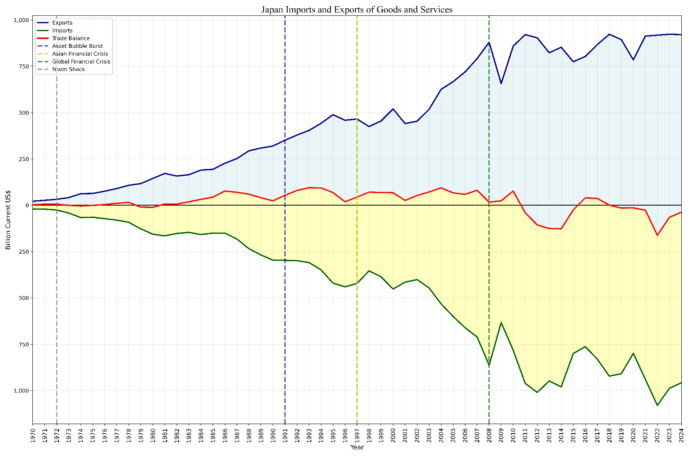
Asset Bubble
Source: World Bank DataCenter (Exports, Imports in current USD)
Figure 1) Japan Imports and Exports of Goods and Services

The asset bubble of the late 1980s, culminating in its peak around 1989–1991 and subsequent burst, represents a critical inflection point that transitioned Japan from the high-growth miracle era into the Lost Decades. This period was fueled by the 1985 Plaza Accord, which accelerated yen appreciation, prompting loose monetary policy from the BoJ to counteract export pressures. GDP growth remained solid at 6.79% in 1988 and 4.86% in 1989, but the speculative frenzy in stocks and real estate created unsustainable valuations. CPI stayed relatively moderate initially (around 0.68% in 1988 rising modestly), while Exports of goods and services surged from approximately $231 billion in 1985 toward $404 billion by 1990, reflecting continued global competitiveness even as domestic asset prices detached from fundamentals. However, Imports of goods and services also increased, and deposit interest rates (Figure 4) were kept artificially low by the BoJ, encouraging excessive borrowing and investment. In the global financial picture, Japan’s financial system, which is characterized by keiretsu main bank relationships, and regulatory insulation boosted domestic liquidity while integrating into international capital flows post-Plaza. This created a unique vulnerability: patient capital that once supported long-term industrial growth now fed speculative bubbles.
Business leaders though played pivotal roles, navigating the boom through aggressive expansion. A prominent figure was Yoshiaki Tsutsumi of the Seibu Group. Tsutsumi used keiretsu-style financing to gather vast property holdings, driving up urban land prices in Tokyo and contributing to the bubble’s inflation. His actions reflected broader business confidence in having the need to growth, fueled by low interest rates and export revenues. In manufacturing, Shoichiro Toyoda (succeeding Eiji) at Toyota expanded global production networks, using bubble-era capital surpluses for overseas plants to hedge yen strength, a strategic move that preserved competitiveness but diverted focus from domestic efficiencies. At Sony, Norio Ohga pushed aggressive diversification into entertainment (e.g., Columbia Pictures acquisition in 1989), betting on synergies between hardware and content. Ohga’s vision was to globalize Sony for that time, but exposed the firm to bubble-burst risks. Similarly, leaders in banking and trading houses, such as those at Sumitomo and Mitsubishi, channeled internal capital markets into property loans, reinforcing the keiretsu system’s risk-sharing but embedding moral hazard. These executives helped sustain short-term growth through massive investments, yet their optimism makes place for questioning their decision.
Policy responses initially accommodated the boom. The BoJ maintained loose policy to support exports after Plaza Accord yen appreciation, while the Ministry of Finance encouraged financial liberalization. However, tightening policies in 1989–1990 triggered the burst, with stock prices collapsing over 60% and land values plummeting. The government’s response included fiscal stimulus packages, but delayed bad loan recognition made the adjustment take more time than it was anticipated. In the global context, Japan’s financial faced scrutiny as interconnected keiretsu banks struggled with low-return loans, contrasting with more transparent international standards emerging in the 1990s.
Outcomes of such a point were considerable. GDP growth turned negative in 1993 (-0.52%) and remained subdued, while unemployment rate edged upward from low levels (approximately 2.5% in the early 1990s). Exports proved resilient, but the offsprings of what happened during the bubble inflected the slope of trade balance curve. Business adaptations after the burst started with gradual unwinding of the cross-holdings and start of an internationalization era. This inflection exposed how the same mechanisms (main bank financing, group coordination) that drove miracles could suffer from inefficiencies when they are not aligned with global shifts. Ultimately, the 1991 burst shifted Japan toward critical adjustment which were to balance the markets and the firms within it.

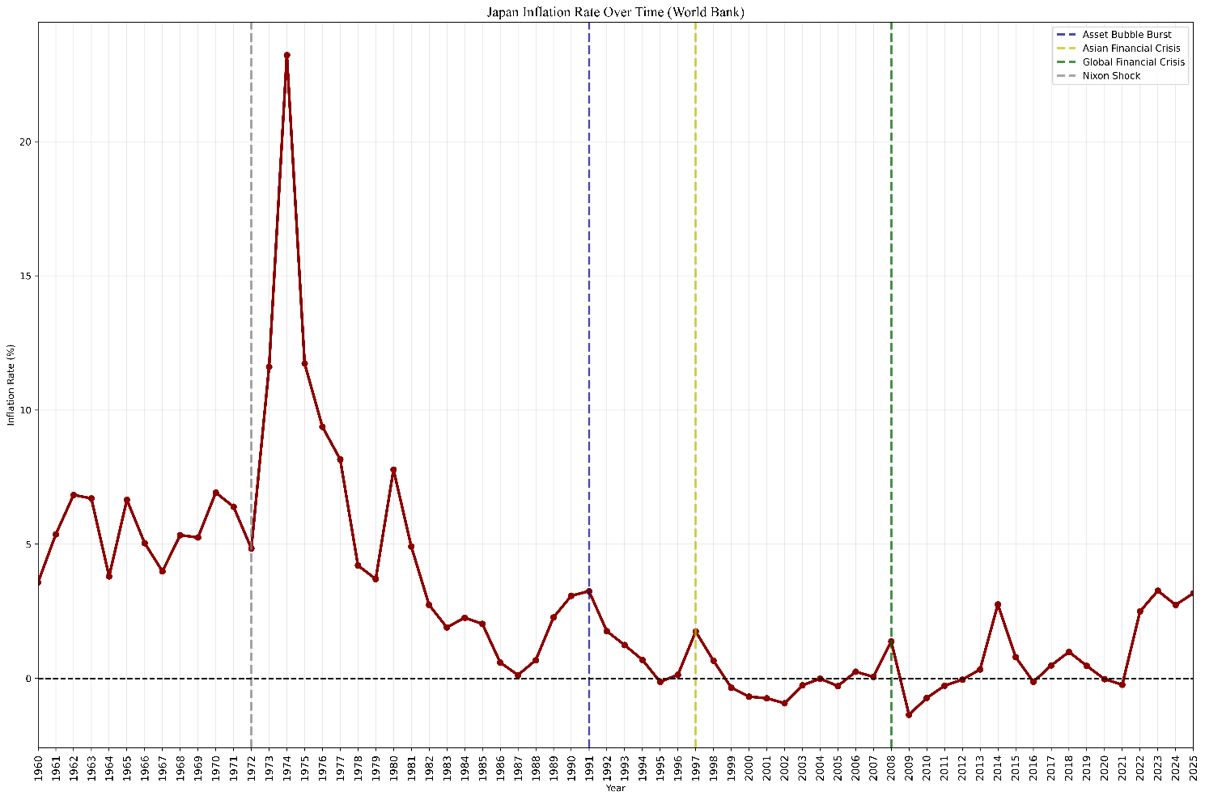
Figure 2) Japan’s Consumer Price Index (CPI)
Source: World Bank DataCenter (Inflation rate %)

The Asian Financial Crisis

Asian Financial Crisis of 1997–1998, which spread from Thailand to other regional economies including Japan, marked another significant inflection point that tested Japan’s financial system and business models in a more interconnected global landscape. Triggered by currency devaluations, capital flight, and speculative attacks amid high foreign debt in Southeast Asia, the crisis exposed vulnerabilities in Japan’s already fragile post-bubble banking sector. In the global picture of Japan’s financial system, the keiretsu main bank relationships, once pillars of stability, now amplified risks as non-performing loans from the 1990s bubble lingered. GDP growth turned negative at -1.77% in 1998, while CPI hovered near deflationary levels (0.66% in 1998). Despite all this, Exports never showed weakness, however the regional demand was diminished leading to a short collapse for that year. On the other hand, imports were getting adjusted due to yen fluctuations and energy prices. From February 1997 to Nov 1998, oil prices plummeted from 20.30$/barrel to 11.37 $/barrel. Knowing that Japan imports most of its energy, it would be evident that the CPI must fall as well. Unemployment rate (Figure 3) rose modestly but signaled broader workforce pressures in a system accustomed to lifetime employment norms.
Business leaders responded with pragmatic caution rather than panic, focusing on cost control and selective internationalization. A key figure was Hiroshi Okuda at Toyota, who as chairman emphasized lean management and global supply chain diversification to buffer against regional turmoil; Okuda’s push for operational efficiency and overseas production helped maintain export momentum despite Asian market contraction, reinforcing Toyota’s position through vertical keiretsu coordination. At Sony, Norio Ohga and successor Nobuyuki Idei accelerated digital and entertainment strategies, leveraging the crisis to acquire assets at discounted prices and reduce reliance on hardware financial tightening. In banking sector, leaders like those at Mitsubishi and Sumitomo worked on mergers and bad loan cleanup, though slowly due to relational commitments. These executives helped by prioritizing core competencies, risk-sharing within groups, and gradual unwinding of inefficient holdings, reducing the shock’s domestic impact through internal capital markets that provided patient support unavailable in more volatile Western systems.
On the policy side, the Japanese government and BoJ implemented measures including fiscal stimulus packages and zero-interest-rate policies to stabilize the economy. MITI/METI continued administrative guidance toward restructuring, while efforts were made to address non-performing loans, though with delays that prolonged adjustment. These policies aligned with business actions by supporting export industries and encouraging technological upgrading. Despite the regional contagion, Japan avoided the deepest crises seen in Thailand or Indonesia, thanks to its stronger reserves and diversified trade. Exports eventually recovered, but the crisis showed limitations, and inefficiencies in the financial system. But, since the interest rates (Figure 4) were held low, big financiers from all over the world were dragged to Japan. It was a simple arbitrage of interest rates from Japan to the rest of the world. Imagine the deposit interest rates in your country would be around 6%. You hear the news that BoJ has announced an interest rate below 0.5%. For the simplicity, we will assume that the costs of traveling to Japan is 0; in this case, a rational economic agent will get a loan at Japan only to exchange the money and deposit it in your country’s bank. Adding up to 5.5% margin for doing nothing. However, this is not the case for most of people. We are talking about big financiers who are sniffing the financial markets for 0.5% margin on their portfolio. We are talking about huge amounts of money being transferred from Japan, all the way to New York, London etc. Basically, BoJ decided to give everyone almost interest-free loans.
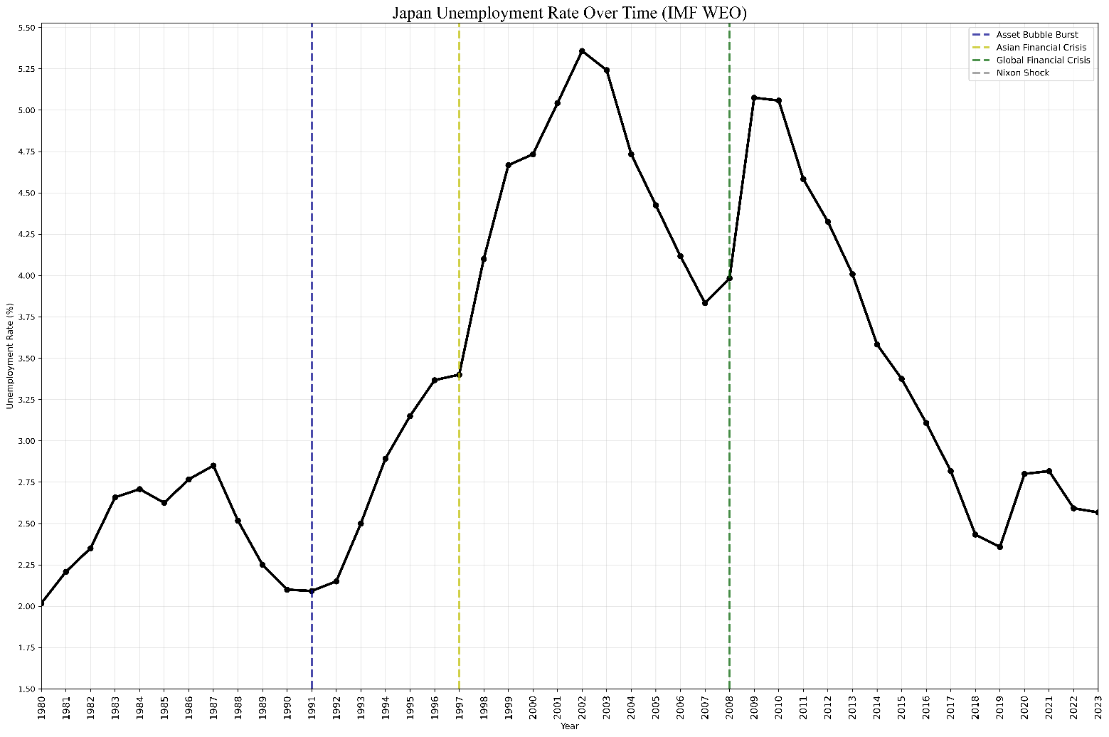
On the flip side, the free loan was not a bad idea at all. Having Japan’s Yen travelled to the countries with advanced financial markets was a guarantee that the buyers of Japan’s goods will show up at the doors. Moreover, BoJ learned that by changing JPY/USD, it could simply control the flows of Yen within its markets. A brilliant move from a brilliant player. We will witness the aftermath of this power during the 2008 financial crisis in the next section.
Source: International Monetary Fund (IMF WEO. Unemployment rate)
Figure 3) Unemployment rate (%)

The Global Financial Crisis

The 2008 Global Financial Crisis (GFC), originating from the U.S. subprime mortgage collapse and Lehman Brothers' bankruptcy, represented a point in which Japan faced effects of external crisis within itself. As interesting as it is, Japan was amongst the very first countries that saw signs of this crisis. According to GDP growth (Figure 5), during each of the previous inflection points, there was a significant lag between the start of the event and the reaction GDP Growth had towards the event. However, Japan faced the Global Financial crisis as soon as the last quarter of 2007, just about the mean times with U.S. Japan experienced a sharp contraction of -5.94% in 2009, the deepest among major economies at the time, following already subdued growth in prior years. Exports of goods and services (Figure 1) plummeted from peaks around $800 billion in 2008 to $657 billion in 2009. reflecting collapsed global demand for automobiles, electronics, and machinery. Imports of goods and services also declined but less dramatically due to the oil price fall from 127$ in June 2008 to 41.73$ in January 2009 leading to a temporary trade balance surplus for the time. Inflation, consumer prices (Figure 2) turned deeply deflationary (-1.35% in 2009), while Unemployment rate rose from around 4% to over 5% in 2009–2010. In total, the whole economy was having a meltdown which is expected during a global crisis. But the part to which we need to focus on, is that the speed of impact specially for the GDP growth, and the unemployment rate was as soon as the markets collapsed in U.S.
Having the Global Crisis taken place at the last quarter of 2007, the USD/JPY fell from 110 to 90.8, roughly 18% fall in a one-year basis. And here is the start of the problem. We were having financiers taking big loans for the close to zero deposit interest rate policy. Well now the game has changed. Over a few months you would get less than 91$ for what you exchanged for 110$. Everyone who had a loan to pay by the end of the year would have panicked, liquidating all the belongings to pay the loan. On the other side, the market is already collapsing into nothing for the “CDOs” that were flooding all over the place for less than 60 cents on a dollar in the first month. Almost every economic agent during that time had driven himself in a frenzy of rage. Back to Japan, from the Asian crisis, the zombie firms and loose credit system amongst firms, caused considerable uncertainty affecting the GDP growth (Figure 5), and the unemployment rate (Figure 3). Witnessing the annual growth rate dwindling to a 2% channel, and unemployment rate sky-rocketing to the highs of 5% before 2008, we could say the economy was already in bad shape.
Business leaders reacted with a mix of defensive restructuring and strategic repositioning, highlighting the centrality of adaptive agency. At Toyota, Akio Toyoda (who assumed presidency in 2009) confronted the crisis by implementing aggressive cost-cutting, temporary plant shutdowns, and accelerated hybrid vehicle development. His emphasis on lean manufacturing and supply-chain resilience, rooted in vertical keiretsu coordination, helped mitigate the export collapse, though sales dropped sharply in the U.S. and Europe. Toyoda publicly criticized over-reliance on financial engineering, advocating a return to core engineering excellence. At Honda, Takeo Fukui and successors focused on fuel-efficient models and North American production localization to buffer currency volatility. Sony's Howard Stringer accelerated digital transformation and entertainment diversification to offset hardware revenue losses from yen appreciation. In finance, leaders at Mizuho and other megabanks managed liquidity strains from carry trade reversals, with government-backed capital injections aiding stability.

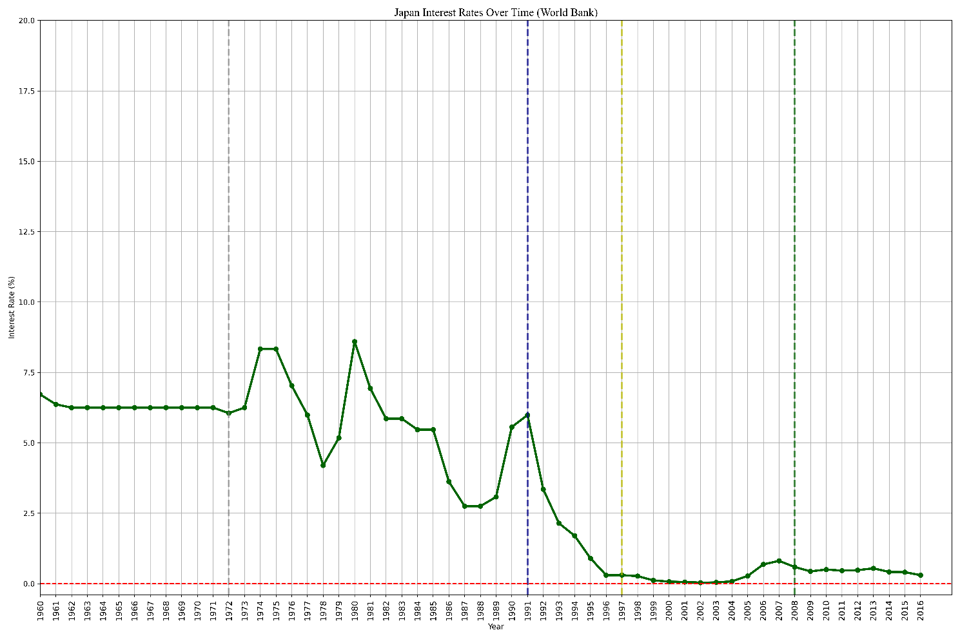
Figure 4) Japan’s Deposit interest rates
Source: World Bank DataCenter (Deposit interest rates)

Policy responses were multifaceted but constrained by prior debt burdens. BoJ expanded quantitative easing (QE), flooding markets with liquidity to counter deflation and support lending. The government launched fiscal stimulus packages focused on infrastructure, consumer rebates, and export support. Internationally, Japan participated in G20 coordination. However, the low-interest-rate regime persisted, perpetuating carry trade incentives until global normalization. These measures cushioned the blow but underscored the financial system's limitations. relational governance delayed bankruptcies (zombie firms), while export dependence amplified external shocks.
The crisis accelerated deleveraging and corporate governance reforms, with increased foreign investor pressure on keiretsu structures. Exports of goods and services recovered post-2009 on global stimulus, but Japan's relative global position weakened. Unemployment stabilized without mass layoffs due to lifetime employment norms, preserving skills but limiting flexibility. The yen carry trade unwind demonstrated how low rates, while supporting domestic borrowers, exposed the economy to volatile capital flows and JPY/USD movements. Business titans like Akio Toyoda narrated a culture of operational discipline and survival at all costs, using crisis liquidity for long-term positioning.

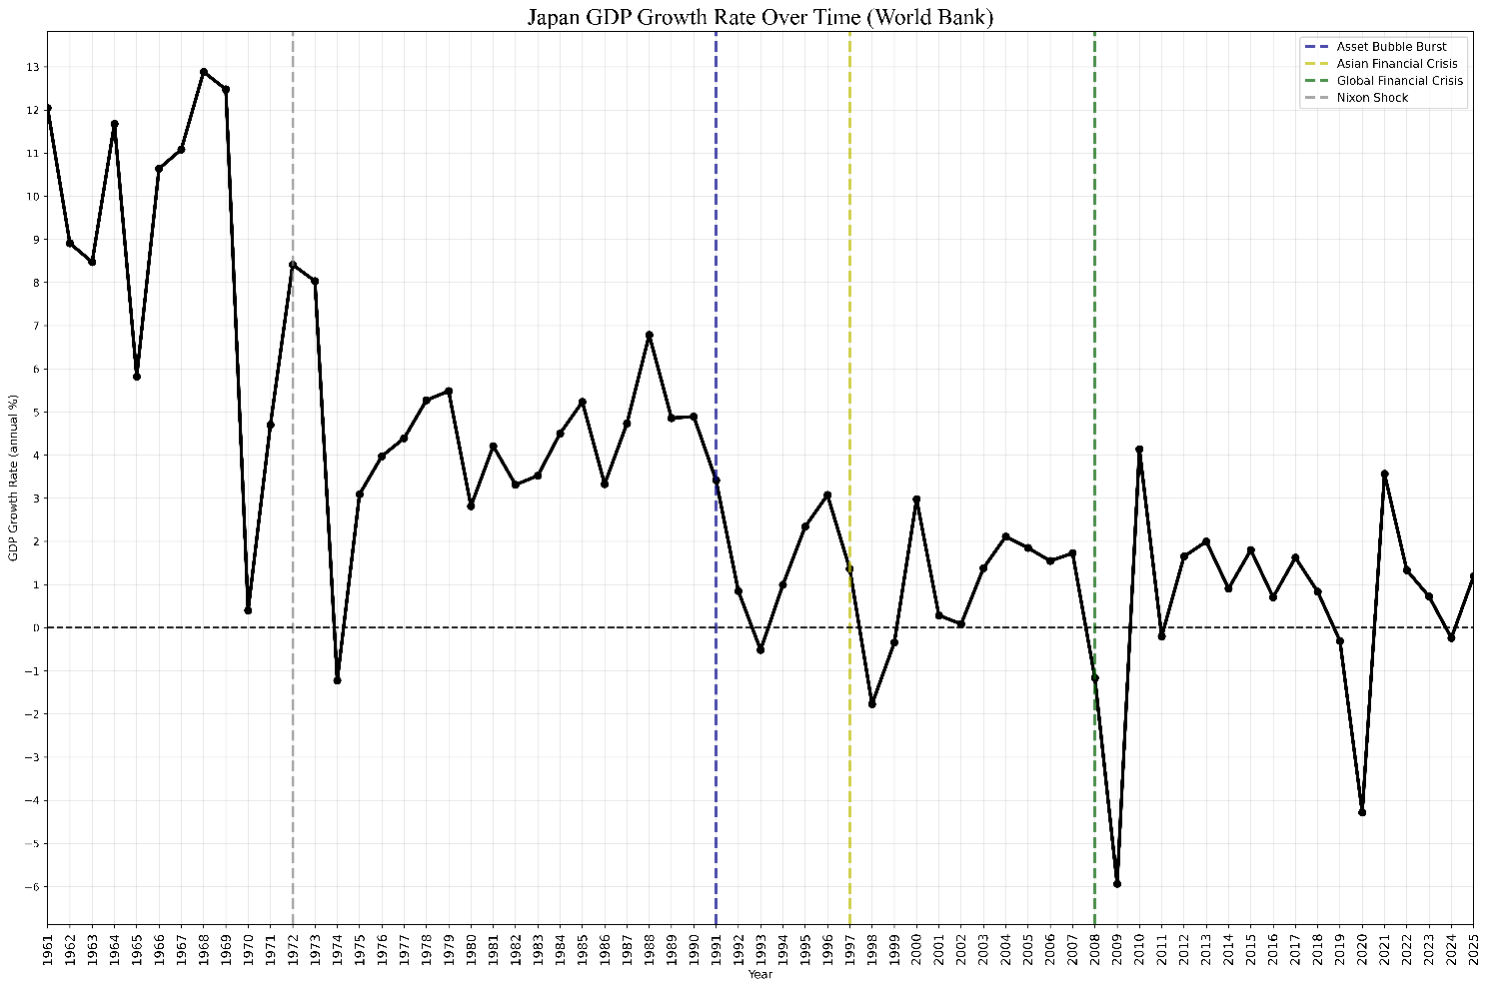
Figure 5) Japan’s GDP Growth Rate over time
Source: World Bank DataCenter (Growth Rate %)

Conclusion

Bringing together the four inflection points studied here, from the Nixon Shock in 1971 to the Global Financial Crisis of 2008, what stands out most is that Japan’s postwar economy was never a simple story of miracle followed by decline. It was a chain of adaptations, some of which solved the problem in front of them while quietly building the next one. The same institutional machinery, keiretsu cross-shareholding, main bank financing, and MITI guidance, that Grabowiecki and Takada credit for the high-growth era, shows up again and again across these four case studies, but never plays quite the same role twice. Facing the Nixon Shock, this machinery absorbed the impact well. Two decades later, that same patient capital, once the source of Japan’s strength, is what pushed Tokyo land and stock prices past any reasonable fundamental. Grabowiecki calls this "success as the source of failure," and the data gathered here supports that reading well.
Business leaders were far from passive throughout all this. Eiji Toyoda’s just-in-time system, Soichiro Honda’s pivot into fuel-efficient vehicles, Hiroshi Okuda’s lean restructuring during the Asian crisis, and Akio Toyoda’s return to core engineering discipline after 2008, these were not the same response repeated four times, but four different business titans reaching for the same institutional toolkit, keiretsu coordination, BoJ liquidity, MITI direction, and turning it toward whatever crisis stood in front of them. What this tells us is that Japan’s institutions alone do not explain the outcome. They handed business leaders a set of resources, and whether growth or crisis followed depended largely on how well those leaders used what they were given.

The household and industrial indicators tracked in this study tell the same story from two different angles. Unemployment stayed remarkably low across all four inflection points, a sign of how strongly lifetime employment norms held even under strain, while CPI and the trade balance moved far more sharply, absorbing the actual shock instead. The Global Financial Crisis stands apart among the four, being the only point where Japan felt the impact almost as fast as the United States itself did, rather than with the lag seen after the Nixon Shock or during the Asian crisis, a sign of how tied Japan’s financial system had become to the rest of the world by 2008.
This study is limited by how little usable data exists before 1971, and future research should try to close that gap, as well as extend this framework past 2011 into the Abenomics years. What can be said with confidence, though, is that none of Japan’s inflection points were purely external shocks. Each one was a meeting point of structure and agency, of keiretsu, government policy, and the individual choices of business leaders, and it was that meeting point, not the shock alone, that decided whether Japan came out the other side stronger, or merely still standing.

References

Addicott, D. A. C. (n.d.). The Rise and Fall of the Zaibatsu: Japan’s Industrial and Economic Modernization (Vol. 11). Retrieved https://digitalcommons.pepperdine.edu/globaltides/vol11/iss1/5
Beckley, M., Horiuchi, Y., & Miller, J. M. (2018). AMERICA’S ROLE IN THE MAKING OF JAPAN’S ECONOMIC MIRACLE. Journal of East Asian Studies, 18(1), 1–21. https://doi.org/10.1017/jea.2017.24
Gooding, N. (2026). Japan’s Economic Miracle, Bretton Woods, Nixon, China’s Rise, WTO Entry, and the Transformation of Global Industrial Power. SSRN. https://doi.org/10.2139/ssrn.5888862
Grabowiecki, & Jerzy. (2006). Keiretsu Groups: Their Role in the Japanese Economy and a Reference Point (or Paradigm) for Other Countries. 20–76.
Takada, M. (1999). Japan’s Economic Miracle: Underlying Factors and Strategies for the Growth.
Yoshioka, S., & Kawasaki, H. (2016). Japan’s High-Growth Postwar Period: The Role of Economic Plans. https://form.cao.go.jp/esri/en_opinion-0002.html

