Московский авиационный институт
(Национальный Исследовательский Институт)

Институт №8 информационных технологий и прикладной математики
Кафедра вычислительной математики и программирования

Лабораторная работа №3
по курсу «Численные методы»

Студент: Суханов Е.А
Группа: М8О-406Б-19
Оценка:
Преподаватель: Ревизников Д.Л.
Подпись:

Задание 3.1
Используя таблицу значений __ функции __, вычисленных в точках __ построить интерполяционные многочлены Лагранжа и Ньютона, проходящие через точки ___. Вычислить значение погрешности интерполяции в точке __.
Вариант:

0.1,-2.30259
0.5,-0.69315
0.9,-0.10536
1.3,0.26236

Листинг
main.go:
package main

import (
"encoding/csv"
"fmt"
"math"
"os"

"gonum.org/v1/plot"
"gonum.org/v1/plot/plotter"
"gonum.org/v1/plot/plotutil"
)

type Point struct {
x, y float64
}

type ftype func(float64) float64

func MakeLangrangeInterpolation(points []Point) func(float64) float64 {
n := len(points)
l := make([]float64, n)
for i := 0; i < n; i++ {
var w float64 = 1
for j := 0; j < n; j++ {
if j == i {
continue
}
w *= points[i].x - points[j].x
}

l[i] = points[i].y / w
}

return func(x float64) float64 {
var res float64
for i := 0; i < n; i++ {
var xx float64 = 1
for j := 0; j < n; j++ {
if j == i {
continue
}
xx *= x - points[j].x
}
res += l[i] * xx
}
return res
}
}

func MakeNewtonInterpolation(points []Point) func(float64) float64 {
n := len(points)
mat := make([][]float64, n)
mat[0] = make([]float64, n)
for i := 0; i < n; i++ {
mat[0][i] = points[i].y
}

for i := 1; i < n; i++ {
mat[i] = make([]float64, n-i)
for j := i; j < n; j++ {
mat[i][j-i] = (mat[i-1][j-i] - mat[i-1][j-i+1]) / (points[j-i].x - points[j].x)
}
}

return func(x float64) float64 {
ans := float64(0)
pow := float64(1)
for i := 0; i < n; i++ {
ans += pow * mat[i][0]
pow *= x - points[i].x
}
return ans
}
}

func f(x float64) float64 {
return math.Log(x)
}

func readFromFile(filePath string) []Point {
f, err := os.Open(filePath)
if err != nil {
panic("Unable to read input file " + filePath + " " + err.Error())
}
defer f.Close()

csvReader := csv.NewReader(f)
records, err := csvReader.ReadAll()
if err != nil {
panic("Unable to parse file as CSV for " + filePath + " " + err.Error())
}

points := make([]Point, len(records))
for i := 0; i < len(records); i++ {
_, err := fmt.Sscanf(records[i][0], "%f", &points[i].x)
if err != nil {
panic(err.Error())
}
_, err = fmt.Sscanf(records[i][1], "%f", &points[i].y)
if err != nil {
panic(err.Error())
}
}
return points
}

func genPlot(path string, lf ftype, nf ftype, f ftype, a float64, b float64, h float64) {
p := plot.New()

p.Title.Text = "Interpolation"
p.X.Label.Text = "X"
p.Y.Label.Text = "Y"

steps := int((b - a) / h)
o_p := make(plotter.XYs, steps)
l_p := make(plotter.XYs, steps)
n_p := make(plotter.XYs, steps)
x := a
for step := 0; step < steps; step++ {
o_p[step].X = x
o_p[step].Y = f(x)
l_p[step].X = x
l_p[step].Y = lf(x)
n_p[step].X = x
n_p[step].Y = nf(x)

x += h
}

err := plotutil.AddLinePoints(p,
"Original", o_p,
"Langrange", l_p,
"Newton", n_p)
if err != nil {
panic(err)
}

// Save the plot to a PNG file.
if err := p.Save(2000, 2000, path); err != nil {
panic(err)
}
}

func main() {
if len(os.Args) < 2 {
panic("Аргументов должно быть два")
}
inputFile := os.Args[1]
outputFile := os.Args[2]

points := readFromFile(inputFile)
lf, nf := MakeLangrangeInterpolation(points), MakeNewtonInterpolation(points)
eps := math.Abs(f(0.8) - lf(0.8))

fmt.Println("Значение интерполяционного многочлена: ", lf(0.8), "Значение погрешности: ", eps)
fmt.Println("Значение интерполяционного многочлена: ", nf(0.8), "Значение погрешности: ", eps)

genPlot(outputFile, lf, nf, f, points[0].x, points[len(points)-1].x, 0.01)
}

Вывод программы
Значение интерполяционного многочлена: -0.20036421874999993 Значение погрешности: 0.022779332564209775
Значение интерполяционного многочлена: -0.20036421875000013 Значение погрешности: 0.022779332564209775

Задание 3.2
Построить кубический сплайн для функции, заданной в узлах интерполяции. Вычислить значение функции в точке 1.5.
Вариант:
X = 1.5
0,0
1,1.8415
2,2.9093
3,3.1411
4,3.2432

Листинг
main.go:
package main

import (
"encoding/csv"
"fmt"
"os"

"github.com/Reterer/number_methods/internal/run_through"
"github.com/Reterer/number_methods/internal/utils"
"github.com/Reterer/number_methods/pkg/matrix"
"gonum.org/v1/plot"
"gonum.org/v1/plot/plotter"
"gonum.org/v1/plot/plotutil"
)

type Point struct {
x, y float64
}

type ftype func(float64) float64

func MakeSplainInterpolation(points []Point) func(float64) float64 {
n := len(points) - 1

c := make([]float64, n)
{
mat := matrix.MakeRealMatrix(n-1, n-1)
b := matrix.MakeRealMatrix(n-1, 1)
for i := 0; i < n-1; i++ {
hc := points[i+2].x - points[i+1].x
hp := points[i+1].x - points[i].x

if i > 0 {
mat.SetEl(i, i-1, hp)
}

mat.SetEl(i, i, 2*(hp+hc))

if i < n-2 {
mat.SetEl(i, i+1, hp)
}

fc := points[i+2].y - points[i+1].y
fp := points[i+1].y - points[i].y
b.SetEl(i, 0, 3*(fc/hc-fp/hp))

}

utils.PrintMatrix(mat)
utils.PrintMatrix(b)
c_2n := run_through.Do(mat, b)
utils.PrintMatrix(c_2n)

for i := 0; i < n-1; i++ {
c[i+1] = c_2n.GetEl(i, 0)
}
}

a := make([]float64, n)
for i := 0; i < n; i++ {
a[i] = points[i].y
}

b := make([]float64, n)
for i := 0; i < n-1; i++ {
fcurr := points[i+1].y - points[i].y
hcurr := points[i+1].x - points[i].x
b[i] = fcurr/hcurr - 1./3.*hcurr*(c[i+1]+2*c[i])
}
b[n-1] = (points[n].y-points[n-1].y)/(points[n].x-points[n-1].x) - 2./3.*(points[n].x-points[n-1].x)*c[n-1]

d := make([]float64, n)
for i := 0; i < n-1; i++ {
hcurr := points[i+1].x - points[i].x
d[i] = (c[i+1] - c[i]) / (3 * hcurr)
}
d[n-1] = -c[n-1] / (3 * (points[n].x - points[n-1].x))

fmt.Println("A: ", a)
fmt.Println("B: ", b)
fmt.Println("C: ", c)
fmt.Println("D: ", d)

return func(x float64) float64 {
// find interval
i := 0
for ; points[i+1].x < x; i++ {
}
dx := x - points[i].x
return a[i] + b[i]*dx + c[i]*dx*dx + d[i]*dx*dx*dx
}
}

func readFromFile(filePath string) []Point {
f, err := os.Open(filePath)
if err != nil {
panic("Unable to read input file " + filePath + " " + err.Error())
}
defer f.Close()

csvReader := csv.NewReader(f)
records, err := csvReader.ReadAll()
if err != nil {
panic("Unable to parse file as CSV for " + filePath + " " + err.Error())
}

points := make([]Point, len(records))
for i := 0; i < len(records); i++ {
_, err := fmt.Sscanf(records[i][0], "%f", &points[i].x)
if err != nil {
panic(err.Error())
}
_, err = fmt.Sscanf(records[i][1], "%f", &points[i].y)
if err != nil {
panic(err.Error())
}
}
return points
}

func genPlot(path string, sf ftype, points []Point, a float64, b float64, h float64) {
p := plot.New()

p.Title.Text = "Interpolation"
p.X.Label.Text = "X"
p.Y.Label.Text = "Y"

steps := int((b - a) / h)
s_p := make(plotter.XYs, steps)
x := a
for step := 0; step < steps; step++ {
s_p[step].X = x
s_p[step].Y = sf(x)

x += h
}
err := plotutil.AddLinePoints(p,
"Splain", s_p)
if err != nil {
panic(err)
}

// Scatter
scatter_data := make(plotter.XYs, len(points))
for i := 0; i < len(points); i++ {
scatter_data[i].X = points[i].x
scatter_data[i].Y = points[i].y
}
s, err := plotter.NewScatter(scatter_data)
if err != nil {
panic(err)
}
s.GlyphStyle.Radius = 10
p.Add(s)
p.Legend.Add("Points", s)
// Save the plot to a PNG file.
if err := p.Save(2000, 2000, path); err != nil {
panic(err)
}
}

func main() {
if len(os.Args) < 2 {
panic("Аргументов должно быть два")
}
inputFile := os.Args[1]
outputFile := os.Args[2]

points := readFromFile(inputFile)

sf := MakeSplainInterpolation(points)
// eps := math.Abs(f(0.8) - lf(0.8))
fmt.Println("Значение интерполяционного многочлена: ", sf(1.5))
genPlot(outputFile, sf, points, points[0].x, points[len(points)-1].x, 0.1)

}

Вывод программы
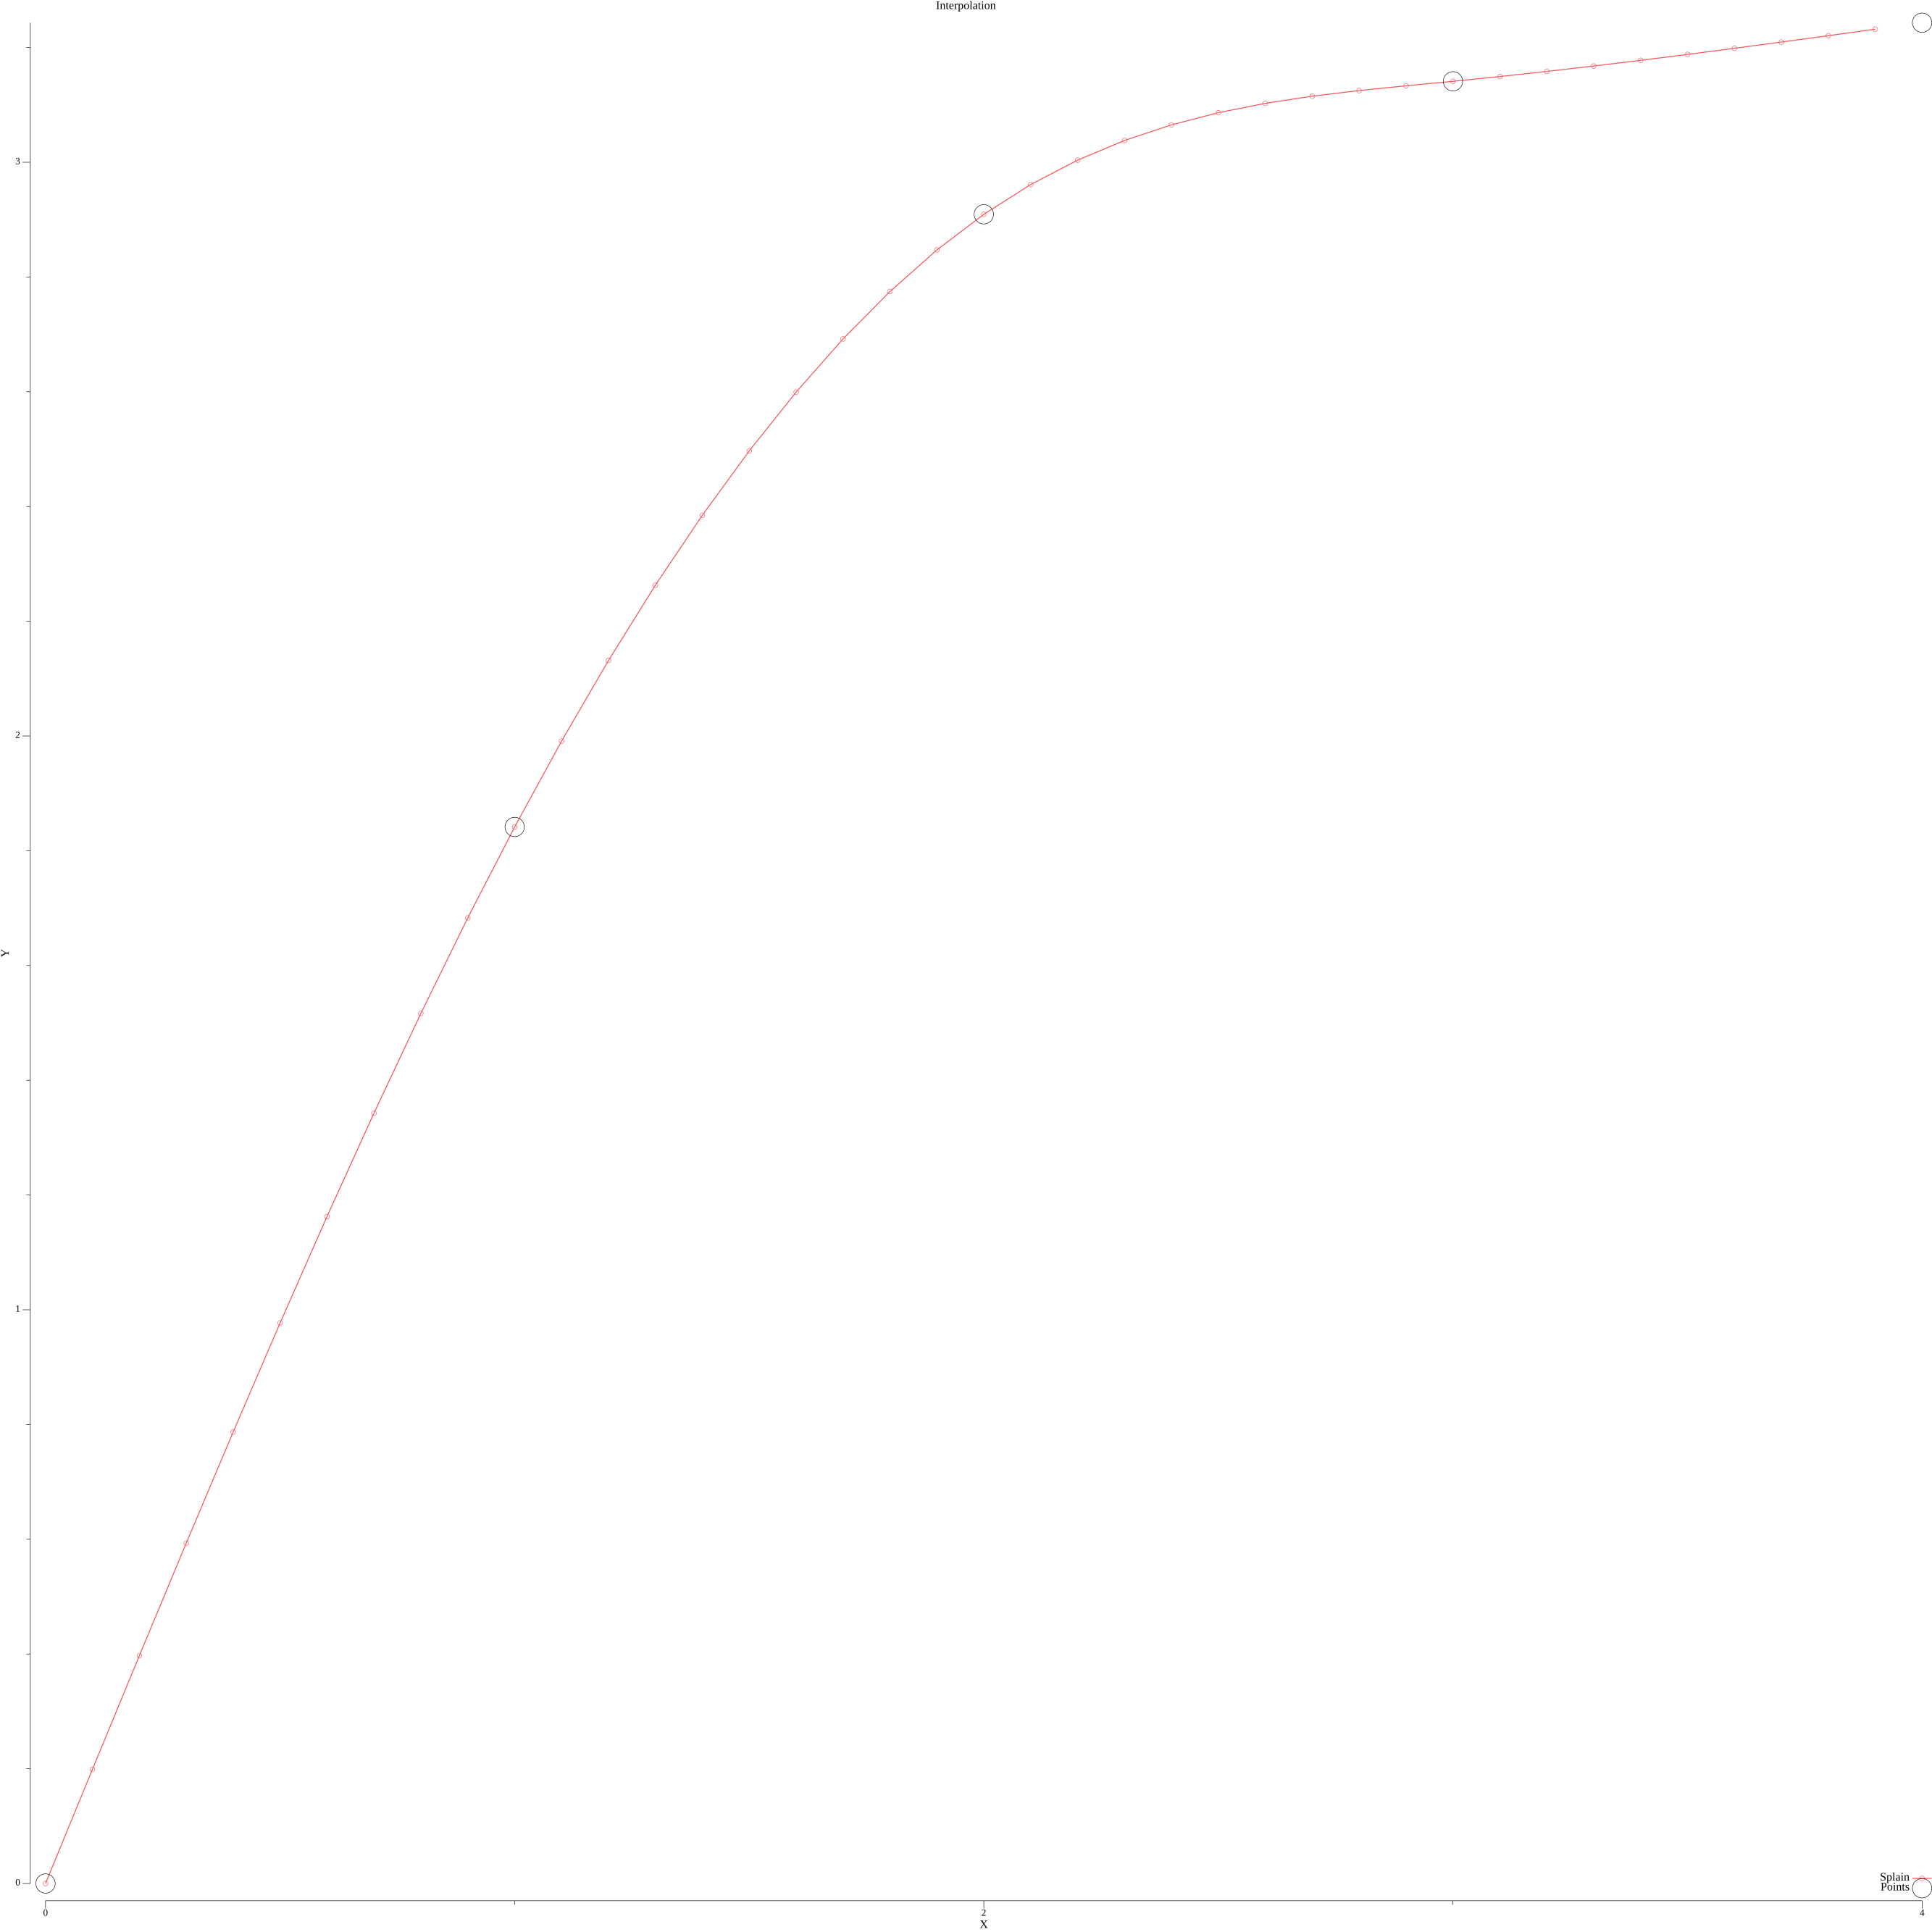
A: [0 1.8415 2.9093 3.1411]
B: [1.991342857142857 1.5418142857142856 0.5692999999999999 0.07978571428571415]
C: [0 -0.4495285714285712 -0.5229857142857146 0.03347142857142889]
D: [-0.14984285714285708 -0.02448571428571446 0.1854857142857145 -0.011157142857142963]
Значение интерполяционного многочлена: 2.4969642857142857

Задание 3.3
Для таблично заданной функции путем решения нормальной системы МНК найти приближающие многочлены a) 1-ой и б) 2-ой степени. Для каждого из приближающих многочленов вычислить сумму квадратов ошибок. Построить графики приближаемой функции и приближающих многочленов.
Вариант:
0,0
1.7,1.3038
3.4,1.8439
5.1,2.2583
6.8,2.6077
8.5,2.9155

Листинг
main.go:
package main

import (
"encoding/csv"
"fmt"
"math"
"os"

"github.com/Reterer/number_methods/internal/lu_decompose"
"github.com/Reterer/number_methods/pkg/matrix"
"gonum.org/v1/plot"
"gonum.org/v1/plot/plotter"
"gonum.org/v1/plot/plotutil"
)

type Point struct {
x, y float64
}
type ftype func(float64) float64

func squareError(points []Point, f func(float64) float64) float64 {
var err float64

for i := 0; i < len(points); i++ {
err += math.Pow(f(points[i].x)-points[i].y, 2)
}

return err
}

func lsm(points []Point, n int) func(float64) float64 {
N := len(points)
n1 := n + 1
a := make([]float64, n1)

{
// Делаем систему
A := matrix.MakeRealMatrix(n1, n1)
b := matrix.MakeRealMatrix(n1, 1)

for k := 0; k < n1; k++ {
for i := 0; i < n1; i++ {
var sumA, sumB float64
for j := 0; j < N; j++ {
sumA += math.Pow(points[j].x, float64(k+i))
sumB += math.Pow(points[j].x, float64(k)) * points[j].y
}
A.SetEl(k, i, sumA)
b.SetEl(k, 0, sumB)
}
}
// Решаем систему
LU := lu_decompose.MakeLU(lu_decompose.PermMin, A)
LU.Decompose()
aMat := LU.Solve(b)
for i := 0; i < n1; i++ {
a[i] = aMat.GetEl(i, 0)
}
}
return func(x float64) float64 {
var ans float64
var xk float64 = 1

for i := 0; i < n1; i++ {
ans += xk * a[i]
xk *= x
}

return ans
}
}

func readFromFile(filePath string) []Point {
f, err := os.Open(filePath)
if err != nil {
panic("Unable to read input file " + filePath + " " + err.Error())
}
defer f.Close()

csvReader := csv.NewReader(f)
records, err := csvReader.ReadAll()
if err != nil {
panic("Unable to parse file as CSV for " + filePath + " " + err.Error())
}

points := make([]Point, len(records))
for i := 0; i < len(records); i++ {
_, err := fmt.Sscanf(records[i][0], "%f", &points[i].x)
if err != nil {
panic(err.Error())
}
_, err = fmt.Sscanf(records[i][1], "%f", &points[i].y)
if err != nil {
panic(err.Error())
}
}
return points
}

func genPlot(path string, f_1 ftype, f_2 ftype, points []Point, a float64, b float64, h float64) {
p := plot.New()

p.Title.Text = "Interpolation"
p.X.Label.Text = "X"
p.Y.Label.Text = "Y"

steps := int((b - a) / h)
f1_p := make(plotter.XYs, steps)
f2_p := make(plotter.XYs, steps)
x := a
for step := 0; step < steps; step++ {
f1_p[step].X = x
f1_p[step].Y = f_1(x)
f2_p[step].X = x
f2_p[step].Y = f_2(x)

x += h
}
err := plotutil.AddLinePoints(p,
"lsm-1", f1_p,
"lsm-2", f2_p,
)
if err != nil {
panic(err)
}

// Scatter
scatter_data := make(plotter.XYs, len(points))
for i := 0; i < len(points); i++ {
scatter_data[i].X = points[i].x
scatter_data[i].Y = points[i].y
}
s, err := plotter.NewScatter(scatter_data)
if err != nil {
panic(err)
}
s.GlyphStyle.Radius = 10
p.Add(s)
p.Legend.Add("Points", s)
// Save the plot to a PNG file.
if err := p.Save(2000, 2000, path); err != nil {
panic(err)
}
}

func main() {
if len(os.Args) < 2 {
panic("Аргументов должно быть два")
}
inputFile := os.Args[1]
outputFile := os.Args[2]
points := readFromFile(inputFile)

f_1 := lsm(points, 1)
fmt.Println("a + bx: ", f_1(5.1), " serr: ", squareError(points, f_1))

f_2 := lsm(points, 2)
fmt.Println("a + bx + cx^2: ", f_2(5.1), " serr: ", squareError(points, f_2))

genPlot(outputFile, f_1, f_2, points, points[0].x, points[len(points)-1].x, 0.1)

}

Вывод программы
a + bx: 2.0915847619047616 serr: 0.48717378819047635
a + bx + cx^2: 2.3650514285714332 serr: 0.09455769485714287
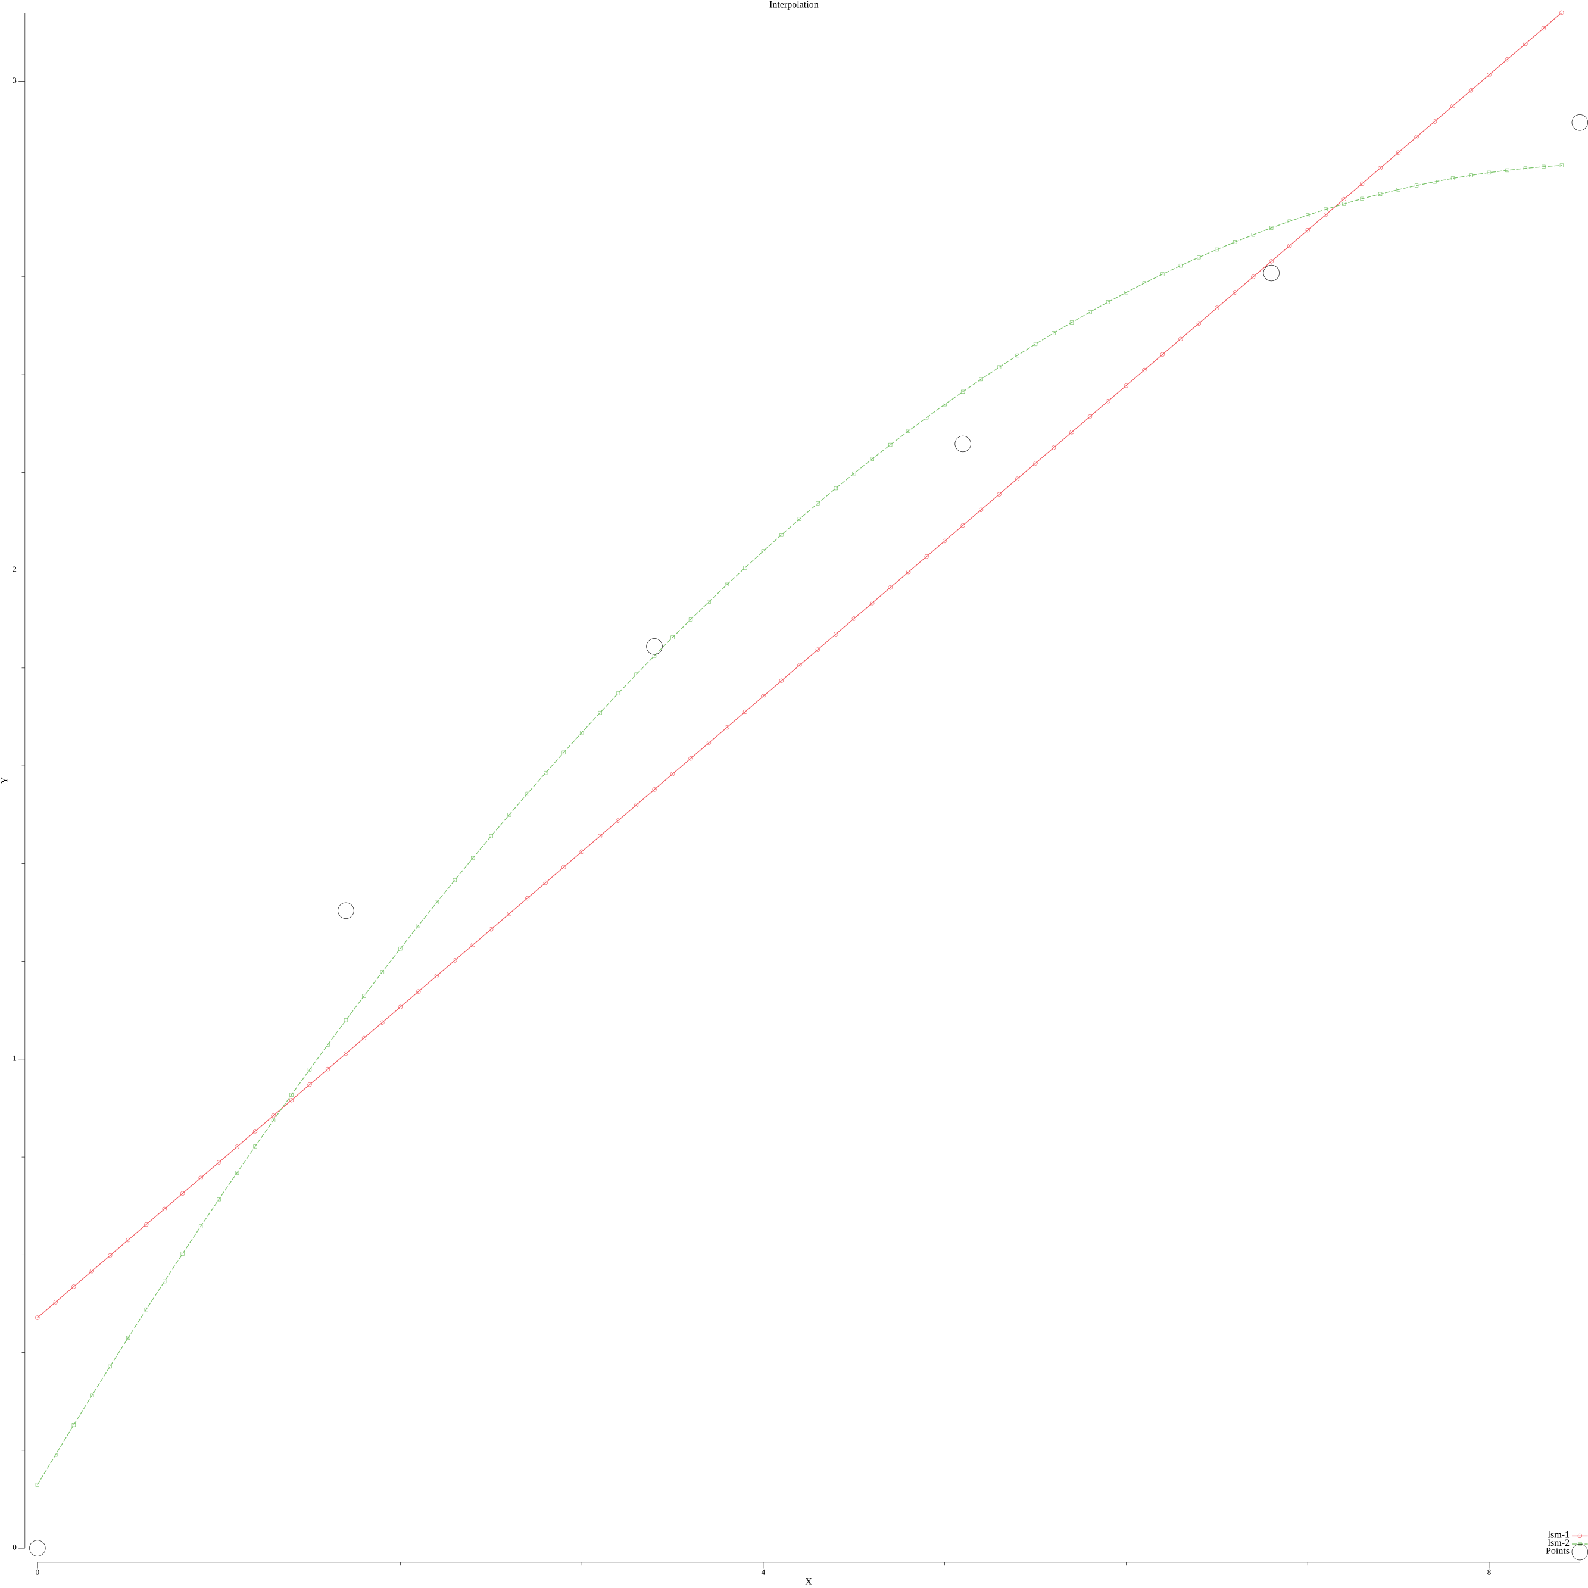

Задание 3.4
Вычислить первую и вторую производную от таблично заданной функции в точке 0.2.
Вариант:
0,1
0.1,1.1052
0.2,1.2214
0.3,1.3499
0.4,1.3499

Листинг
main.go:
package main

import (
"encoding/csv"
"fmt"
"os"

"gonum.org/v1/plot"
"gonum.org/v1/plot/plotter"
"gonum.org/v1/plot/plotutil"
)

type Point struct {
x, y float64
}
type ftype func(float64) float64

func firstDerivative(points []Point) func(float64) float64 {
n := len(points) - 2
a := make([]float64, n)
b := make([]float64, n)

for i := 0; i < n; i++ {
dy1 := points[i+1].y - points[i].y
dy2 := points[i+2].y - points[i+1].y
dx1 := points[i+1].x - points[i].x
dx2 := points[i+2].x - points[i+1].x
dxm := points[i+2].x - points[i].x

a[i] = dy1 / dx1
b[i] = (dy2/dx2 - dy1/dx1) / dxm
}
return func(x float64) float64 {
i := 0
for ; points[i+1].x < x; i++ {
}
return a[i] + b[i]*(2*x-points[i].x-points[i+1].x)
}
}

func secondDerivative(points []Point) func(float64) float64 {
n := len(points) - 2
a := make([]float64, n)

for i := 0; i < n; i++ {
dy1 := points[i+1].y - points[i].y
dy2 := points[i+2].y - points[i+1].y
dx1 := points[i+1].x - points[i].x
dx2 := points[i+2].x - points[i+1].x
dxm := points[i+2].x - points[i].x

a[i] = 2 * (dy2/dx2 - dy1/dx1) / dxm
}

return func(x float64) float64 {
i := 0
for ; points[i+1].x < x; i++ {
}
return a[i]
}
}

func readFromFile(filePath string) []Point {
f, err := os.Open(filePath)
if err != nil {
panic("Unable to read input file " + filePath + " " + err.Error())
}
defer f.Close()

csvReader := csv.NewReader(f)
records, err := csvReader.ReadAll()
if err != nil {
panic("Unable to parse file as CSV for " + filePath + " " + err.Error())
}

points := make([]Point, len(records))
for i := 0; i < len(records); i++ {
_, err := fmt.Sscanf(records[i][0], "%f", &points[i].x)
if err != nil {
panic(err.Error())
}
_, err = fmt.Sscanf(records[i][1], "%f", &points[i].y)
if err != nil {
panic(err.Error())
}
}
return points
}

func genPlot(path string, f ftype, ff ftype, points []Point, a float64, b float64, h float64) {
p := plot.New()

p.Title.Text = "Interpolation"
p.X.Label.Text = "X"
p.Y.Label.Text = "Y"

steps := int((b - a) / h)
f_p := make(plotter.XYs, steps)
s_p := make(plotter.XYs, steps)
x := a
for step := 0; step < steps; step++ {
f_p[step].X = x
f_p[step].Y = f(x)
s_p[step].X = x
s_p[step].Y = ff(x)

x += h
}
err := plotutil.AddLinePoints(p,
"first derivative", f_p,
"second derivative", s_p,
)
if err != nil {
panic(err)
}

// Scatter
scatter_data := make(plotter.XYs, len(points))
for i := 0; i < len(points); i++ {
scatter_data[i].X = points[i].x
scatter_data[i].Y = points[i].y
}
s, err := plotter.NewScatter(scatter_data)
if err != nil {
panic(err)
}
s.GlyphStyle.Radius = 10
p.Add(s)
p.Legend.Add("Points", s)
// Save the plot to a PNG file.
if err := p.Save(2000, 2000, path); err != nil {
panic(err)
}
}

func main() {
if len(os.Args) < 2 {
panic("Аргументов должно быть два")
}
inputFile := os.Args[1]
outputFile := os.Args[2]

points := readFromFile(inputFile)
fmt.Println(points)
f := firstDerivative(points)
fmt.Println("f'", f(0.2))

ff := secondDerivative(points)
fmt.Println("f\"", f(0.2))

genPlot(outputFile, f, ff, points, points[0].x, points[len(points)-3].x, 0.01)
}

Вывод программы
f' 1.223500000000001
f" 1.223500000000001

Задание 3.5
Вычислить определенный интеграл, методами прямоугольников, Трапеций, Симпсона с шагами 0.5 и 0.25. Оценить погрешность вычислений, используя Метод Рунге-Ромберга.
Вариант:

Листинг
main.go:
package main

import (
"fmt"
"math"
)

type fn func(x float64) float64

func rectangleMethod(xs, xe, h float64, f fn) float64 {
var res float64
for x := xs + h; x <= xe; x += h {
res += h * f(x-h/2)
}
return res
}

func trapezeMethod(xs, xe, h float64, f fn) float64 {
var res float64
for x := xs + h; x <= xe; x += h {
res += h * (f(x) + f(x-h))
}
return res / 2
}

func simpsonMethod(xs, xe, h float64, f fn) float64 {
var res float64
h *= 2
for x := xs + h; x <= xe; x += h {
res += h * (f(x) + 4*f(x-h/2) + f(x-h))
}
return res / 6
}

func rungeRombergMethod(fh1, fh2, h1, h2 float64) float64 {
k := h1 / h2
return fh2 + (fh2-fh1)/(math.Pow(k, 2)-1)
}

func main() {
var x0 float64 = -1
var xk float64 = 1
h1 := 0.5
h2 := 0.25
f := func(x float64) float64 {
return x / math.Pow(3*x+4, 2)
}

{
f1 := rectangleMethod(x0, xk, h1, f)
f2 := rectangleMethod(x0, xk, h2, f)
fmt.Println("Метод прямоугольников:", "h1: ", f1, "h2 ", f2)
fmt.Println("Рунге-Ромберг-Ричардсон: ", rungeRombergMethod(f1, f2, h1, h2))

}
{
f1 := trapezeMethod(x0, xk, h1, f)
f2 := trapezeMethod(x0, xk, h2, f)
fmt.Println("Метод трапеций:", "h1: ", f1, "h2 ", f2)
fmt.Println("Рунге-Ромберг-Ричардсон: ", rungeRombergMethod(f1, f2, h1, h2))
}
{
f1 := simpsonMethod(x0, xk, h1, f)
f2 := simpsonMethod(x0, xk, h2, f)
fmt.Println("Метод Симпсона:", "h1: ", f1, "h2 ", f2)
fmt.Println("Рунге-Ромберг-Ричардсон: ", rungeRombergMethod(f1, f2, h1, h2))
}
}

Вывод программы
Метод прямоугольников: h1: -0.1191431329134778 h2 -0.14931195938119501
Рунге-Ромберг-Ричардсон: -0.15936823487043408
Метод трапеций: h1: -0.27663349637375617 h2 -0.19788831464361697
Рунге-Ромберг-Ричардсон: -0.17163992073357057
Метод Симпсона: h1: -0.20557935570922584 h2 -0.1716399207335706
Рунге-Ромберг-Ричардсон: -0.16032677574168552

