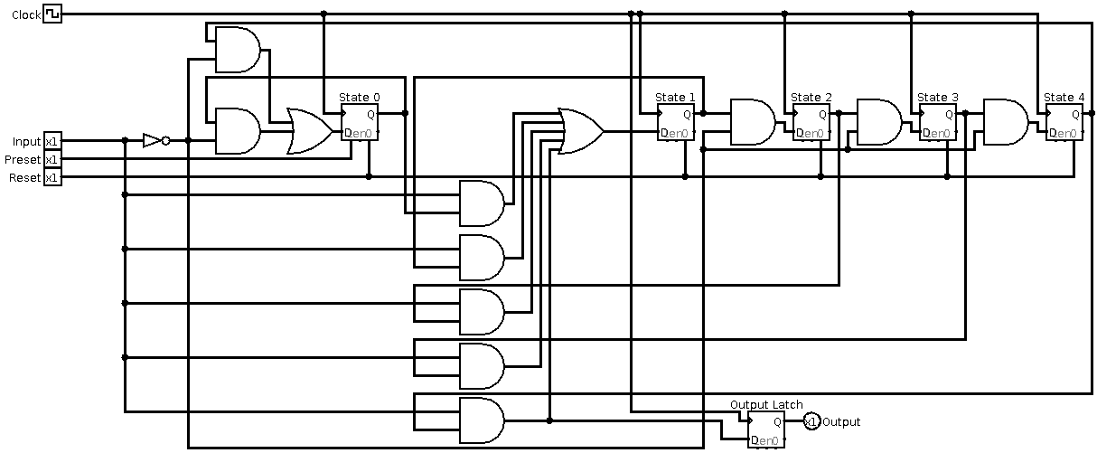
1.
How did you represent the current state?
A binary number, a line per state, or something else?

A D-Latch holding the state whose immediate output would be 1.

2.
How did you label the lines that represent the current state?
They are just the ouputs of the respective labeled D-latches.
3.
How did you label the input?
“Input”
4.
How did you label the clock?
“Clock”
5.
How did you label the reset line?
“Reset”
6.
How did you label the output?
“Output”, but it has its own latch so that the input does not immediately affect it (which is labeled “Output Latch”)

