Digital Forensic Investigation Report
Unauthorized System Access and Modification
Case identifier | DFIR-PROJ-2024-1108-G03-001
Project source reviewed | Digital Forensics.pptx, 16 slides, last modified 2026-06-02
Investigators | Rethick, Sreenivas, Rahgu, Bhargav
Report date from PPT | 08-11-2024, interpreted as 2024-11-08
Acquisition date from PPT | 25-10-2024, interpreted as 2024-10-25
Subject system | Windows 8.1 Enterprise, computer name SENSEI
Scenario | IT staff found an unexpected message file on the system and reported it for forensic review.
Revision status | PPT findings integrated into professional academic project report
Prepared date | 2026-06-02
Source-data update
The PowerPoint contains project details missing from the earlier DOCX report, including image verification checksums, investigator names, the original case prompt, and additional executable-comparison evidence. Unavailable legacy items remain recorded as limitations rather than invented facts.

1. Executive Summary
The PowerPoint confirms this was an academic digital-forensics project involving a Windows 8.1 Enterprise image and an unexpected message file discovered by IT staff. The added slide data materially strengthens the report because it supplies verified image hashes and additional evidence supporting the hypothesis that Magnify.exe was replaced with cmd.exe.
The evidence supports these findings: the forensic image verification passed for MD5 and SHA1, the system was named SENSEI, the Administrator account was suspicious based on login/user activity, Notepad activity occurred at 2015-12-12 03:24:08, Magnify.exe appeared in the relevant execution timeline, and the suspicious Magnify.exe matched cmd.exe by size/icon evidence and VirusTotal identification. The initial access method and full chain of custody remain unresolved.

2. New Findings from PowerPoint Review
Finding | PPT Evidence | Report Impact | Confidence
Image integrity data exists | Slide 3 records MD5 9a737b6a21ecbe979126c5661ca7b8db and SHA1 ebef2bdc6329563ccf85769c3e5b8ceca852992b as verified. | The previous report limitation about no image hash should be narrowed: MD5/SHA1 are available, while SHA-256 image hash and chain-of-custody remain unavailable. | High
Original scenario is confirmed | Slide 2 states IT staff found an unexpected message in a file and reported it. | The report can frame the incident as an investigation into a discovered message file, not only a generic unauthorized-access claim. | High
README path is corroborated | Slide 5 states README.txt path as root/tools/README.txt and timestamp 2015-12-12 03:24:39. | This corrects the earlier uncertainty about the README path. | High
Administrator attribution is stronger | Slides 7-9 identify Administrator as suspicious and state Administrator NTUSER.DAT showed Notepad access at 2015-12-12 03:24:08. | The report can attribute the Notepad artifact to Administrator as source-deck evidence, while still noting that independent SID/hive mapping should be retained. | Medium-High
ShimCache supports Magnify.exe relevance | Slide 10 states Magnify.exe was the only executable used close to the attack time. | This strengthens the Magnify.exe finding beyond simple file presence. | Medium-High
Executable replacement evidence is stronger | Slides 12-15 show the suspicious Magnify.exe differed from legitimate Magnify.exe and matched cmd.exe in size/icon. | The report can state the evidence is consistent with Magnify.exe being replaced by cmd.exe. | High
SHA-256 transcription corrected | Slide 14 gives SHA256 0B9BC863E2807B6886760480083E51BA8A66118659F4FF274E7B73944D2219F5. | The earlier 65-character hash transcription is invalid and is corrected to the PPT value. | High

3. Evidence Integrity and Acquisition Data
The PPT supplies the following image acquisition and verification data. This is enough to document MD5/SHA1 verification for the project image, but it still does not replace a complete chain-of-custody record.
Item | Value from PPT | Assessment
Acquisition started | Fri Dec 11 09:35:03 2015 | Recorded in slide 3; likely original image acquisition timeline.
Acquisition finished | Fri Dec 11 09:47:19 2015 | Recorded in slide 3.
Verification started | Fri Oct 25 09:47:19 2024 | Recorded in slide 3.
Verification finished | Fri Oct 25 09:52:48 2024 | Recorded in slide 3.
MD5 checksum | 9a737b6a21ecbe979126c5661ca7b8db : verified | Usable project integrity value.
SHA1 checksum | ebef2bdc6329563ccf85769c3e5b8ceca852992b : verified | Usable project integrity value.
Still unavailable | Source media identifier, storage location, chain-of-custody log, image SHA-256, exported artifact hashes except suspicious executable SHA-256 | Keep as limitations.

4. Consolidated Timeline
Timestamp | Artifact / Event | Source | Finding
2015-12-11 09:35:03 | Image acquisition started | PPT slide 3 | Project image acquisition began.
2015-12-11 09:47:19 | Image acquisition finished | PPT slide 3 | Project image acquisition completed.
2015-12-11 19:18:54 | Magnify.exe modified / AppCompatCache entry | PPT slides 10-11; screenshots | Suspicious executable activity close to attack window.
2015-12-12 03:24:08 | NOTEPAD.EXE accessed by Administrator | PPT slide 8; UserAssist screenshot | Supports interactive text-file access by Administrator.
2015-12-12 03:24:39 | README.txt in root/tools/README.txt | PPT slide 5; FTK screenshot | Message file of interest located.
2015-12-12 03:25:14 | Administrator last logon shown in SAM | SAM screenshot | Supports Administrator activity near event period.
2024-10-25 09:47:19-09:52:48 | Image verification performed | PPT slide 3 | MD5 and SHA1 verified during project verification.

5. Detailed Analysis

5.1 Message File and Incident Prompt
The project prompt states that IT staff discovered a suspicious message written in a file on the system. The file of interest is README.txt at root/tools/README.txt, with a displayed timestamp of 2015-12-12 03:24:39. The visible message says: Hello master, Catch me if you can! Best regards, Your Admin ;).
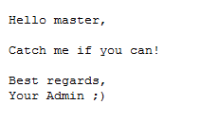
Exhibit 1. Suspicious README message text shown in the PowerPoint source.
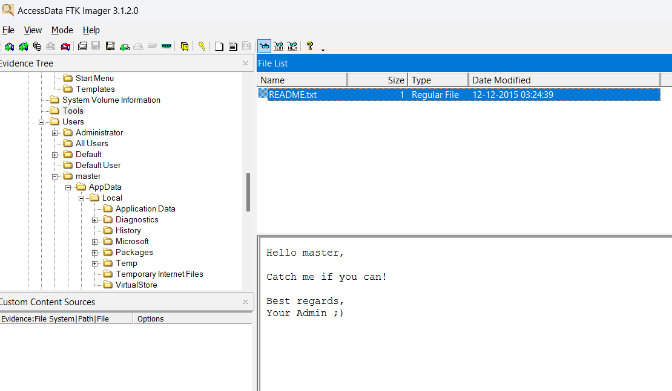
Exhibit 2. FTK Imager screenshot showing README.txt and message content.

5.2 Registry and User Activity
The PPT identifies extracted registry hives as SAM, SOFTWARE, SECURITY, SYSTEM, DEFAULT, NTUSER.DAT, and USERCLASS.DAT. SAM analysis identified the Administrator account as suspicious because of login activity. NTUSER.DAT/UserAssist evidence showed NOTEPAD.EXE access at 2015-12-12 03:24:08, attributed in the deck to the Administrator account.
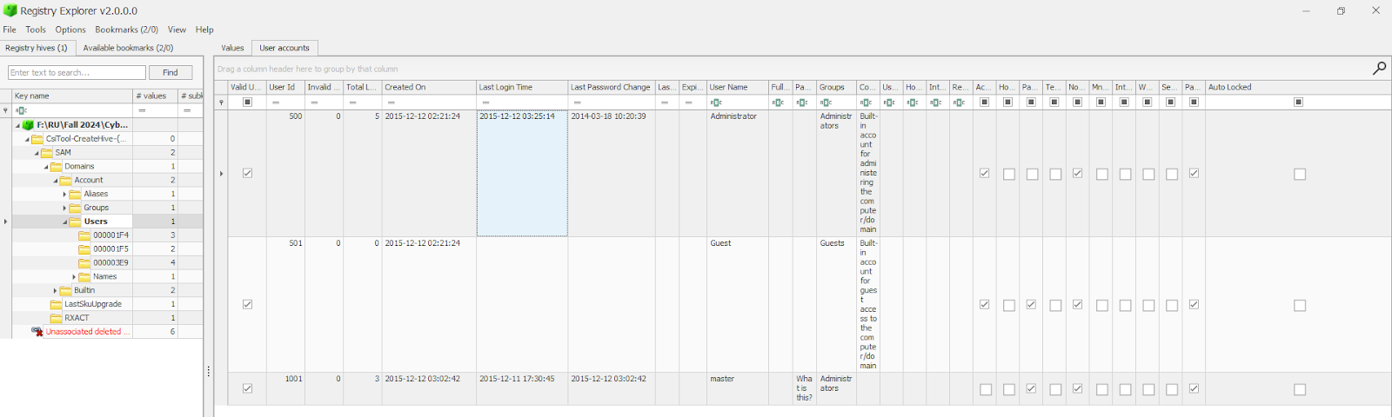
Exhibit 3. SAM account view showing user-account information.
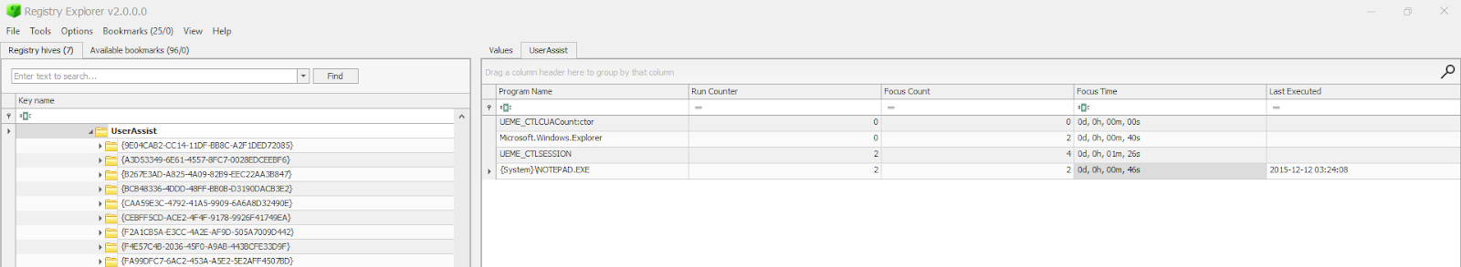
Exhibit 4. UserAssist evidence showing NOTEPAD.EXE activity.
SYSTEM analysis identified the computer name as SENSEI and the operating system as Windows 8.1 Enterprise. The PPT lists the timezone as PST (Pakistan Standard Time); the abbreviation should be verified because PST is commonly ambiguous and the earlier DOCX described it differently.

5.3 ShimCache and Suspicious Executable
The PPT states that ShimCache/AppCompatCache was reviewed at SYSTEM\CurrentControlSet\Control\Session Manager\AppCompatCache and that Magnify.exe was the only executable used close to the attack time. This is a key supporting artifact because it ties the suspicious executable to the relevant activity window.
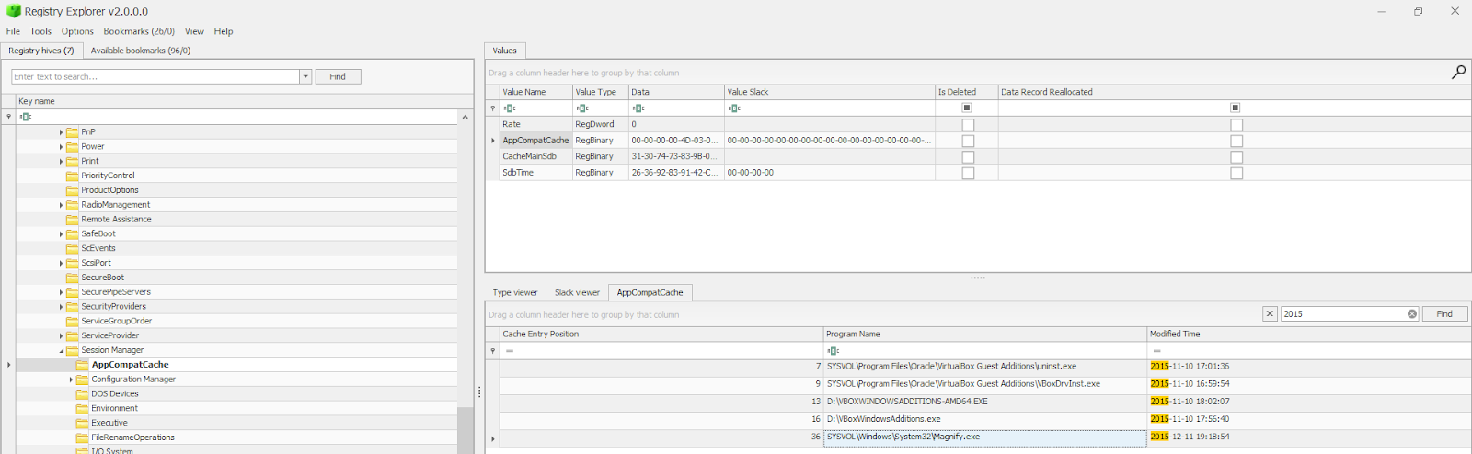
Exhibit 5. AppCompatCache/ShimCache view showing Magnify.exe near the event timeline.
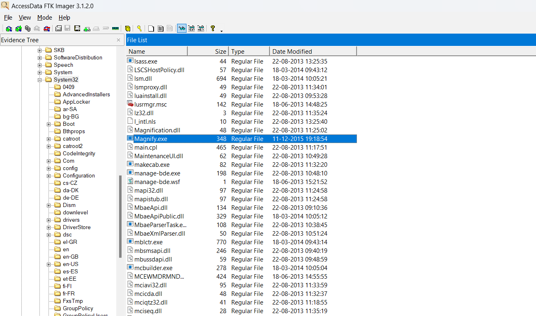
Exhibit 6. FTK Imager screenshot showing Magnify.exe in Windows System32.
The suspicious Magnify.exe was extracted into a sandbox environment. The PPT shows that the extracted file was approximately 348 KB and dated 2015-12-11 13:18/19:18 depending on tool display, while a legitimate Windows Magnify.exe in a reference System32 folder was 732 KB. A separate comparison shows cmd.exe and the suspicious Magnify.exe were both 348 KB, supporting the conclusion that the suspicious Magnify.exe was actually cmd.exe or a cmd.exe replacement.
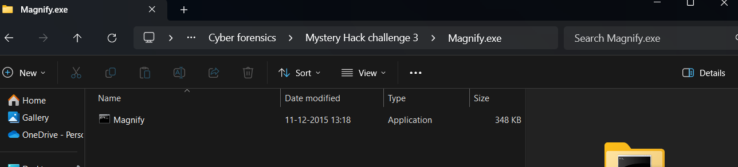
Exhibit 7. Extracted suspicious Magnify.exe in the sandbox/project folder.
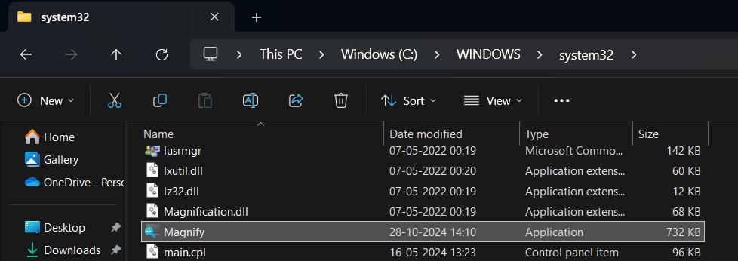
Exhibit 8. Reference System32 Magnify.exe shown as 732 KB, different from suspicious file.
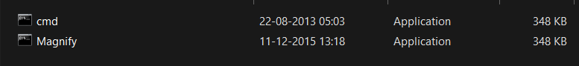
Exhibit 9. cmd.exe and suspicious Magnify.exe shown with matching 348 KB size.

5.4 Hash and VirusTotal Verification
The PPT gives the suspicious executable SHA-256 as 0B9BC863E2807B6886760480083E51BA8A66118659F4FF274E7B73944D2219F5. This corrects the earlier report transcription, which contained 65 hexadecimal characters and was therefore invalid as a SHA-256 value.
VirusTotal identified the submitted file as Cmd.Exe. The screenshot also indicates 0/67 detections and Microsoft distribution context, so the significance is not malware detection; the significance is file substitution/renaming of a trusted command interpreter.
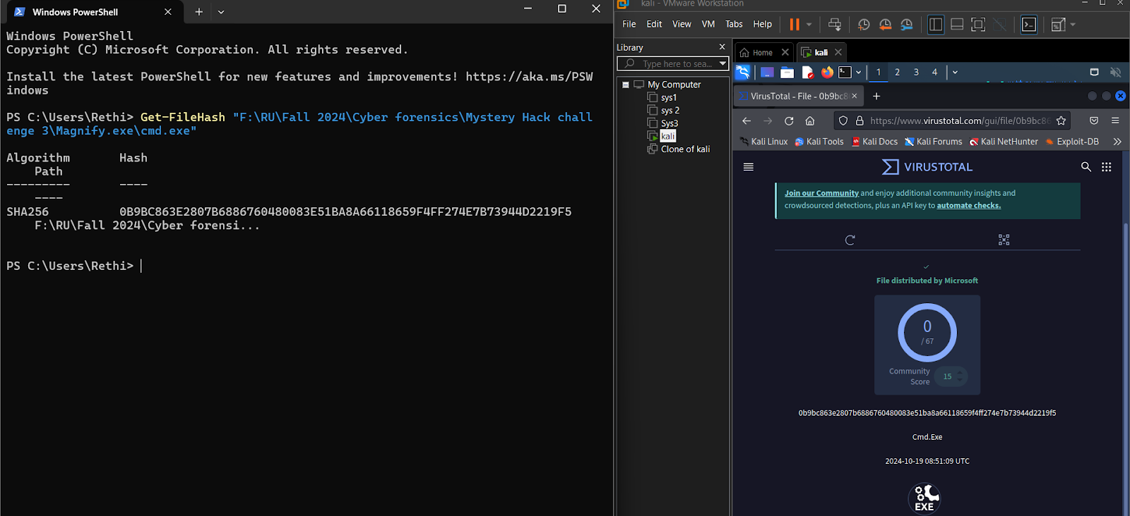
Exhibit 10. PowerShell hash and VirusTotal evidence identifying the submitted file as Cmd.Exe.

6. Findings and Professional Assessment
Assessment Area | Finding | Residual Risk / Caveat
Primary finding | Evidence is consistent with a privileged user or actor replacing Magnify.exe with cmd.exe, likely to obtain command-shell access through a trusted accessibility binary name. | Initial access method is still not proven.
Account activity | Administrator activity is supported by SAM and UserAssist artifacts in the PPT. | Independent SID-to-hive mapping should be retained in future versions.
File activity | README.txt in root/tools/README.txt is the message file of interest and is temporally close to Notepad activity. | The exact creation path and export hash of README.txt were not retained.
Executable evidence | Suspicious Magnify.exe differs from legitimate Magnify.exe and matches cmd.exe by size/icon evidence, with SHA-256 linked to Cmd.Exe in VirusTotal. | No original clean hash comparison table from the affected image is available.
Integrity evidence | MD5 and SHA1 image verification are available and verified in the PPT. | No source media identifier, chain-of-custody log, or image SHA-256 was retained.
Timezone/date consistency | PPT report date is 08-11-2024 and timezone says PST (Pakistan Standard Time). | Earlier DOCX had 04-11-2024 and Pacific Standard Time wording; PPT should be treated as stronger source but timezone should be verified.

7. Remaining Gaps and Inconsistencies
- Report date conflict: source DOCX used 04-11-2024, while PPT slide 1 uses 08-11-2024. This integrated report uses the PPT date because it contains the fuller project record.
- Timezone conflict: PPT says PST (Pakistan Standard Time), while the earlier report used Pacific Standard Time. Treat all local timestamps as source-tool displayed values until timezone is verified.
- Magnify.exe size notation varies between 346 KB and 348 KB. The screenshots support approximately 348 KB; small differences may be caused by KB/KiB display or rounding.
- The PPT references a hashes/password text file, but the password file contents are not included in the retained materials.
- Chain of custody, storage location, source media identifier, and exported artifact hashes are still unavailable.
- The investigation still lacks event-log, Prefetch, Amcache, SRUM, network, and full shellbag correlation.

8. Conclusion
After reviewing the PowerPoint project data, the strongest supported conclusion is that the Windows 8.1 Enterprise system named SENSEI showed suspicious Administrator-associated activity and a likely replacement or renaming of Magnify.exe with cmd.exe. The README message, Notepad/UserAssist activity, SAM login evidence, ShimCache Magnify.exe entry, executable size/icon comparison, and VirusTotal identification collectively support this assessment.
The PowerPoint adds confirmed image MD5/SHA1 verification and improves the report materially. It does not prove the initial access vector, attacker identity, remote access path, exfiltration, or complete custody of the evidence. Those remain professional limitations.

9. Recommendations
- Use the PPT-provided MD5 and SHA1 values in the final report, and do not claim unavailable SHA-256 image verification unless it is recovered.
- Keep the generated case ID DFIR-PROJ-2024-1108-G03-001 for this academic project report.
- Correct the suspicious executable SHA-256 to 0B9BC863E2807B6886760480083E51BA8A66118659F4FF274E7B73944D2219F5.
- State the Magnify.exe finding as file substitution evidence, not malware detection, because VirusTotal indicates Cmd.Exe with no detections.
- Preserve future project evidence with acquisition logs, chain-of-custody entries, exported artifact hashes, exact paths, and timezone-normalized timelines.
- For a production environment, monitor accessibility binaries such as Magnify.exe, sethc.exe, utilman.exe, and osk.exe for unexpected hash, size, or path changes.

