KONE AI Sales Visualisation Platform
Deployment & Maintenance Guide
Hosting, domain/SSL, secure credentials handoff, backups, redeployment, and known limitations
Client handover | Version 1.0 | 19 September 2026
Purpose: This guide describes how to host, operate, update and maintain the current KONE implementation. It does not contain passwords, private keys, access tokens or other credentials.

1. Deployment summary
KONE is a multi-service application. The React frontend is built into static files, the Node/Express API manages authentication and workflow orchestration, MongoDB stores application state, and a GPU-enabled Python service performs image and video processing. FireRed and ComfyUI are optional private services used by the AI workflow.
Area | Current implementation | Production recommendation
Frontend | Vite/React application; development launcher uses port 3000. | Build with npm run build and serve dist/ through Nginx/CDN.
Application API | Node/Express API on port 4000. | Run with NODE_ENV=production behind a reverse proxy and process manager/container runtime.
AI services | FastAPI 8001, FireRed 8010, optional ComfyUI 8188. | Use a private GPU worker or private network; expose none of these directly to the internet.
Database | MongoDB on port 27017. | Use managed MongoDB or a secured private MongoDB host with encrypted backups.
Media | Local output/storage/uploads paths, optional Azure Blob sync. | Use durable object storage for production media and define retention rules.
Secrets | Environment variables read by the API/startup scripts. | Inject from a secrets manager/vault at runtime; do not place production values in Git or Word documents.

2. Recommended hosting topology
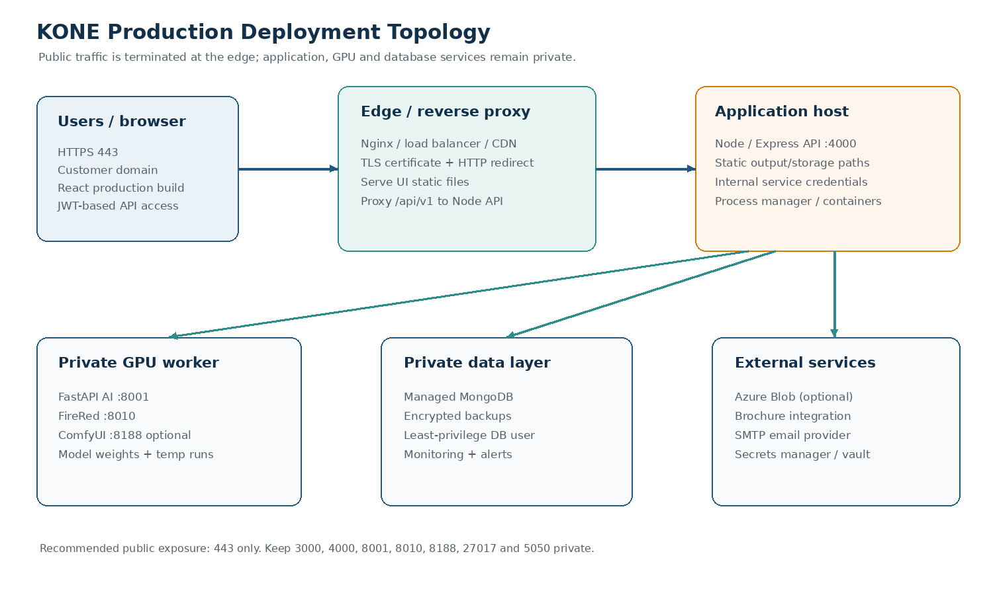
Only the HTTPS edge should be public. The API may proxy or call the private AI worker, while MongoDB, FireRed, ComfyUI and the Azure payload service remain on loopback or a private security group/network.

3. Hosting, server, domain and SSL handoff

3.1 Server requirements
Component | Requirement / guidance | Owner to confirm
Application host | Linux server; Node.js 20+; npm; reverse proxy; process manager. | Hostname, OS image, CPU/RAM and disk allocation.
GPU worker | Linux host with NVIDIA GPU, compatible CUDA/PyTorch stack, Python 3.11–3.13 and FFmpeg. | GPU model, VRAM, driver/CUDA versions and storage for weights.
Database | Managed MongoDB preferred, or private MongoDB with authentication and encrypted storage. | Provider/cluster, database name, network allowlist and backup policy.
Object storage | Azure Blob is supported optionally; local media directories exist in the current code. | Storage account/container, lifecycle and retention policy.
Monitoring | Central logs, uptime checks, disk/GPU alerts and error alerting. | Monitoring provider, alert recipients and on-call owner.

The current local launcher assumes /root/Kone and starts development servers. For production, use deployment-specific paths and service definitions rather than copying its hardcoded paths or local JWT value.

3.2 Domain and DNS plan
DNS record | Recommended target | Notes
app.<domain> | Edge proxy / load balancer | Serves the React frontend over HTTPS.
api.<domain> | Same edge or private API ingress | Use this only if the frontend is configured with an absolute VITE_API_BASE_URL.
internal GPU hostname | Private IP / service discovery | Not published in public DNS; used by Node API for LOGIC_URL.
MongoDB hostname | Managed/private database endpoint | Not publicly exposed; restrict inbound access to the API/worker network.

The simpler deployment is one public application domain with /api/v1 proxied to the Node API. This matches the local Vite proxy pattern and avoids cross-origin configuration complexity. If separate app and API domains are used, set VITE_API_BASE_URL to the HTTPS API URL and configure CORS explicitly.

3.3 SSL/TLS checklist
- Issue the certificate at the reverse proxy, managed load balancer or CDN. The Node and Python services should normally listen on private HTTP ports only.
- Redirect HTTP to HTTPS and verify that API, upload, download and video URLs remain HTTPS to prevent browser mixed-content failures.
- Automate certificate renewal and test renewal before the first expiry window.
- Use secure security headers at the edge and retain the application helmet middleware. Enable HSTS only after confirming every required subdomain is HTTPS-ready.
- Document the certificate provider, renewal owner, DNS validation method and emergency contact in the internal operations record—not in this Word document.

4. Credentials handoff through a secure vault
No credentials should be handed over through email, chat, source control, screenshots or this document. Create a vault entry for each secret, grant named users/groups least-privilege access, and share only the vault path or item name with the client.

4.1 Secret inventory
Secret / configuration | Used by | Vault handoff rule
JWT_SECRET | Node API token signing | Generate a new long random production value; never reuse the local development value.
MONGODB_URL | Node API | Store the full connection string in the vault; use a dedicated application DB user.
AZURE_STORAGE_CONNECTION_STRING | Node API/Azure service | Store as a secret; restrict storage account permissions and rotate on staff changes.
BROCHURE_INTEGRATION_API_KEY | Node API | Store separately from the integration URL; grant only the API runtime access.
SMTP_USERNAME / SMTP_PASSWORD | Node API email service | Use a dedicated SMTP credential or provider token, not a personal mailbox password.
HF_TOKEN | Setup/maintenance only when restricted model downloads need it | Do not persist in application logs; revoke after model provisioning if no longer needed.
SSH / cloud / DNS / certificate access | Infrastructure administration | Use named accounts, MFA and role-based access; do not share a common root password.

4.2 Vault handoff procedure
- Create a production vault/project with separate folders for infrastructure, application, database, storage and third-party integrations.
- Add secrets using names matching the environment-variable names, plus a short description, owner, rotation interval and last-rotated date.
- Grant access to named client administrators and the application deployment identity. Avoid shared personal credentials.
- Inject secrets at deployment time through the process manager, container secret store or CI/CD secret variables.
- Run a smoke test, confirm logs do not print secret values, then record the handoff date and revoke temporary setup credentials.
Example vault reference (placeholder only):
vault://kone/production/api/JWT_SECRET
vault://kone/production/database/MONGODB_URL
vault://kone/production/integrations/AZURE_STORAGE_CONNECTION_STRING

5. Initial production deployment

5.1 Prepare the host
- Provision the application and GPU hosts, private network rules, DNS records and managed database.
- Install Node.js 20+, npm, Python 3.11–3.13, FFmpeg, Git, curl and the required NVIDIA driver/CUDA stack on the GPU host.
- Create a non-root service account and deployment directory. Give the API/worker only the filesystem permissions they require.
- Provision the vault entries and inject the environment variables without writing secrets into Git.
- Install model weights and third-party runtime files using Kone_Setup_Python3.12_3.13.sh setup. Record model versions and checksums in the release record.

5.2 Build the frontend
cd /path/to/Kone/Frontend/kone-ui-master
npm ci
# Set VITE_API_BASE_URL to the production HTTPS API before building
npm run build
# Serve the generated dist/ directory from the reverse proxy or CDN
Vite values are compiled into the frontend at build time. If VITE_API_BASE_URL or another VITE_* value changes, rebuild the frontend; restarting the static server alone is not enough.

5.3 Install and run the API
cd /path/to/Kone/Frontend/kone-api-master
npm ci --omit=dev
NODE_ENV=production PORT=4000 node src/index.js
Use systemd, PM2, a container service or an equivalent process manager for automatic restart and log collection. The package includes a PM2-oriented start script, but the current repository snapshot does not provide a verified production process definition; validate the chosen process-manager configuration during deployment.

5.4 Run the AI services
cd /path/to/Kone/elevator_mod_pipeline
/path/to/.venv/bin/python -m uvicorn server:app --app-dir src --host 127.0.0.1 --port 8001
# FireRed, when enabled
/path/to/firered_venv/bin/python -m uvicorn firered_service:app --host 127.0.0.1 --port 8010 --workers 1
Use private addresses for internal services. If a separate GPU host is used, set LOGIC_URL to its private HTTPS or private HTTP service endpoint and allow only the API host/network to connect.

5.5 Reverse proxy routing
Public route | Upstream | Required behavior
/ | Frontend dist/ | Serve SPA entry point and static assets; route unknown browser paths to index.html if needed.
/api/v1/ | Node API :4000 | Proxy authorization headers, JSON, multipart uploads and long-running request timeouts.
/output/ and media routes | Node API/static object storage | Prefer private/signed object URLs in production; avoid exposing broad filesystem paths.

Increase proxy/read timeouts for image and video operations according to the expected workflow duration. Keep upload-size limits aligned across the edge proxy, Express JSON/multipart handling and object storage.

6. Update and redeploy procedure

6.1 Standard release checklist
- Confirm the release commit/tag and review the change list, especially model, schema, upload, authentication and media-path changes.
- Check backup freshness and take a pre-deployment MongoDB/media backup.
- Put the application into a maintenance window if the release changes workflow behavior or restarts GPU services.
- Pull the release into a new versioned directory or deployment slot; do not overwrite the previous working release in place.
- Install locked dependencies with npm ci and recreate/refresh the Python environment only when the release requires it.
- Build the frontend with production VITE_* values and publish the new dist/ directory.
- Restart services in order: AI worker dependencies, FastAPI, Node API, then edge/static frontend. Confirm each process is healthy before continuing.
- Run the smoke tests below, monitor logs and GPU/database health, then close the maintenance window.

6.2 Smoke tests after deployment
Check | Expected result
Open public domain over HTTPS | Certificate valid; frontend loads without mixed-content or console API errors.
Sign in / token refresh | User can authenticate and refresh a session.
Create project and offering | MongoDB write succeeds; records appear in the UI.
Upload and precheck a small test image | Upload completes and pipeline returns a valid precheck result.
Generate preview | Offering status moves through processing to preview_ready or a documented failure.
Optional video test | Video generation completes or returns a clear status/error; GPU/ComfyUI logs are healthy.
Download/export test | Generated media is reachable only through intended authenticated/signed paths.
Review logs | No secret values, unexpected 5xx spikes or unbounded queue/process growth.

6.3 Rollback
- Stop or drain the new release and route traffic to the previous release directory/container.
- Restore the previous frontend dist/ and restart the API/worker processes using the previous dependency/model set.
- Restore MongoDB only if a schema/data change requires it and the rollback plan explicitly includes that restore. Take a new backup before restoring.
- Repeat the smoke tests and record the failed release, logs, backup identifiers and rollback decision.
The repository does not show a dedicated database migration framework. Treat model/schema changes as release-sensitive, test them against a copy of production data, and create a manual migration/rollback script when a change is not backward-compatible.

7. Backup and restore strategy
Back up three categories separately: database records, generated/source media, and deployment configuration/model assets. A backup is not complete until restoration has been tested on a separate environment.

7.1 Recommended policy
Asset | Minimum recommendation | Restore test
MongoDB | Automated daily logical backup plus provider snapshots/point-in-time recovery where available. Encrypt at rest and in transit. | Restore into an isolated database and verify users, projects, offerings and token indexes.
Source/generated media | Store production media in durable object storage with lifecycle/versioning; retain local disks only as a cache. | Restore a sample project and verify image/video URLs and download behavior.
Environment configuration | Back up deployment manifests and non-secret config in Git; keep secret values only in the vault. | Provision a clean staging host from the documented vault references.
AI models/weights | Record model versions/checksums and retain an immutable copy or reproducible download location. | Start a worker from the recorded bundle and run a precheck/preview test.
Logs/audit | Forward logs to centralized retention; do not rely only on local logs under /root/Kone/logs. | Search a restored/retained period for an incident ID or request timestamp.

7.2 Example MongoDB commands
# Run from a protected backup host; replace placeholders and keep the URI in the vault
mongodump --uri="$MONGODB_URL" --archive=/secure/backups/kone-$(date +%F).archive --gzip
# Restore only into an isolated target after approval
mongorestore --uri="$RESTORE_MONGODB_URL" --archive=/secure/backups/kone-YYYY-MM-DD.archive --gzip --drop
Use a secure backup location with restricted permissions, encryption and an off-host/off-region copy. Define retention, RPO and RTO with the client; suggested starting points are daily backups, a 30-day retention window, and a quarterly restore rehearsal.

8. Routine maintenance
Frequency | Tasks
Every deployment | Check service status, HTTPS, API authentication, one preview workflow, logs, disk space and GPU availability.
Daily | Review failed pipeline/video jobs, MongoDB/backup status, disk growth in uploads/output/storage/runs, and error alerts.
Weekly | Review dependency/security alerts, certificate expiry, vault access audit, backup success and model worker resource usage.
Monthly | Apply OS/security updates in a maintenance window, rotate temporary credentials, test restore of a backup sample, and review storage lifecycle costs.
Quarterly | Perform a full disaster-recovery exercise, review access/users, test certificate renewal, document capacity/performance and update this guide.

Useful local diagnostics
# Service ports
lsof -iTCP:3000 -sTCP:LISTEN
lsof -iTCP:4000 -sTCP:LISTEN
lsof -iTCP:8001 -sTCP:LISTEN
lsof -iTCP:8010 -sTCP:LISTEN
lsof -iTCP:8188 -sTCP:LISTEN
# FireRed readiness
curl -fsS http://127.0.0.1:8010/health
# Repository checks
cd Frontend/kone-ui-master && npm run type-check && npm run lint && npm run test
cd ../kone-api-master && npm test && npm run lint
The current kill_ports.sh can stop listeners on the local KONE ports, but it uses force-kill behavior after a short grace period. Use it only on a dedicated development host or after confirming the listed ports are not shared with another application.

9. Known issues and limitations
Issue / limitation | Impact | Recommended handling
Local launcher is development-oriented | start_kone.sh uses absolute /root/Kone paths, NODE_ENV=development, a local JWT value and Vite dev servers. | Use a production process manager, injected secrets, production build and reverse proxy.
No verified production deployment manifest in this snapshot | PM2/Docker scripts are referenced by package.json, but the matching production definition should be validated before use. | Create and test systemd/PM2/container definitions as part of infrastructure setup.
Swagger is development-only | The /api/v1/docs route is not intended as a public production endpoint. | Protect or disable it in production; share an approved API specification separately.
GPU/model dependencies are environment-sensitive | CUDA, PyTorch, model weights and VRAM affect startup time and output reliability. | Pin versions, record checksums, keep model bundles, and test on the target GPU.
ComfyUI/Wan video is optional and resource-heavy | Video generation may be slow, fail if models are absent, or require a separate GPU/process. | Keep it private, monitor queue/resource use, and provide OpenCV fallback where appropriate.
Guest routes are separate from bearer-token auth | Guest endpoints need deployment-level abuse controls and retention policies. | Rate-limit at the edge, restrict payload size, monitor sessions and clean up abandoned media.
Local media paths can grow without retention | output/, storage/, uploads/, tmp_uploads/ and pipeline run directories can consume disk. | Use object storage/lifecycle policies and scheduled cleanup with an approved retention period.
No dedicated migration/backup scripts are included | Schema/data changes and disaster recovery require operator-owned procedures. | Add versioned migration and restore automation before long-term production operation.
Broad default CORS/static behavior should be reviewed | The current API enables CORS and serves several local media directories. | Set explicit allowed origins and use signed/private media delivery in production.

10. Incident response quick reference
- Confirm the public symptom and record time, affected user/project/offering, release version and request IDs if available.
- Check edge/proxy, API, FastAPI, FireRed, ComfyUI and MongoDB health separately; do not assume an API error is a model error.
- Check disk space, GPU memory/processes, MongoDB connectivity, vault secret freshness and third-party integration status.
- If data integrity is at risk, stop destructive retries, preserve logs and take a backup/snapshot before changes.
- Use the rollback procedure for release-related regressions. Escalate to the infrastructure/model owner for GPU, CUDA or external-provider failures.
- After recovery, document root cause, affected assets, backup/restore actions and a prevention task.
Area | First places to check
Frontend/API connection | Browser console, HTTPS certificate, reverse-proxy access/error log, VITE_API_BASE_URL.
Authentication | API log, MongoDB connection, JWT_SECRET consistency across API instances, user status.
Image processing | logic-firered log, FastAPI status.json/run directory, GPU memory, model paths and CUDA/PyTorch versions.
FireRed | curl http://127.0.0.1:8010/health and FireRed service log.
Video | ComfyUI log, COMFY_URL/COMFY_ROOT/runner paths, model availability and GPU capacity.
Downloads/media | Node output/storage/uploads paths, Azure sync status, object-storage permissions and retention policy.

11. Handover checklist
- Production domain, DNS owner and certificate renewal owner confirmed.
- Application host, GPU worker and database host details recorded in the client infrastructure register.
- Vault project created; named users/groups have least-privilege access; no secrets shared in plaintext.
- Frontend production build and API environment values tested against the production domain.
- Private network rules verified for API → AI worker, API → MongoDB and optional storage/integration services.
- Backup jobs enabled, retention agreed and a restore test completed.
- Process manager, logs, alerts, disk/GPU monitoring and escalation contacts confirmed.
- Rollback release and release checklist stored with the deployment record.
This guide intentionally leaves provider-specific hostnames, IP addresses, certificate identifiers and vault paths as deployment-owned information. Fill those values in the client infrastructure register or secure vault—not in a public handover document.

