KONE AI Sales Visualisation Platform
Technical & Architecture Documentation
System architecture, database schema, API catalogue, integrations, folder structure, and key-module walkthrough
Prepared for client handover | Version 1.0 | 19 September 2026

Purpose: This document describes the current implementation in the KONE repository. It is intended for technical handover, onboarding, deployment planning, and future maintenance.

1. System overview
KONE is a web application for creating AI-assisted elevator visualisations and client-ready sales materials. A user uploads an image, selects elevator components, places those components into the scene, generates image or video previews, and exports the final result. The solution is split into a browser frontend, a Node.js API, a Python AI pipeline, and supporting data/media services.
Layer | Technology | Responsibility
Web application | React 18, TypeScript, Vite, Tailwind CSS, Radix UI, Zustand | Authentication screens, project/offering workflow, image canvas, video options, downloads and brochure content.
Application API | Node.js, Express, Mongoose, JWT, Passport | Authentication, authorization, persistence, upload handling, workflow orchestration, integrations and API responses.
AI service | Python, FastAPI, PyTorch, OpenCV, PIL | Precheck, object/component detection, segmentation, geometry, inpainting, placement, repin and video orchestration.
Persistence/media | MongoDB; optional Azure Blob Storage; local run directories | Stores users, projects, offerings, tokens and activity logs; stores or synchronizes image/video assets.

2. Architecture diagram
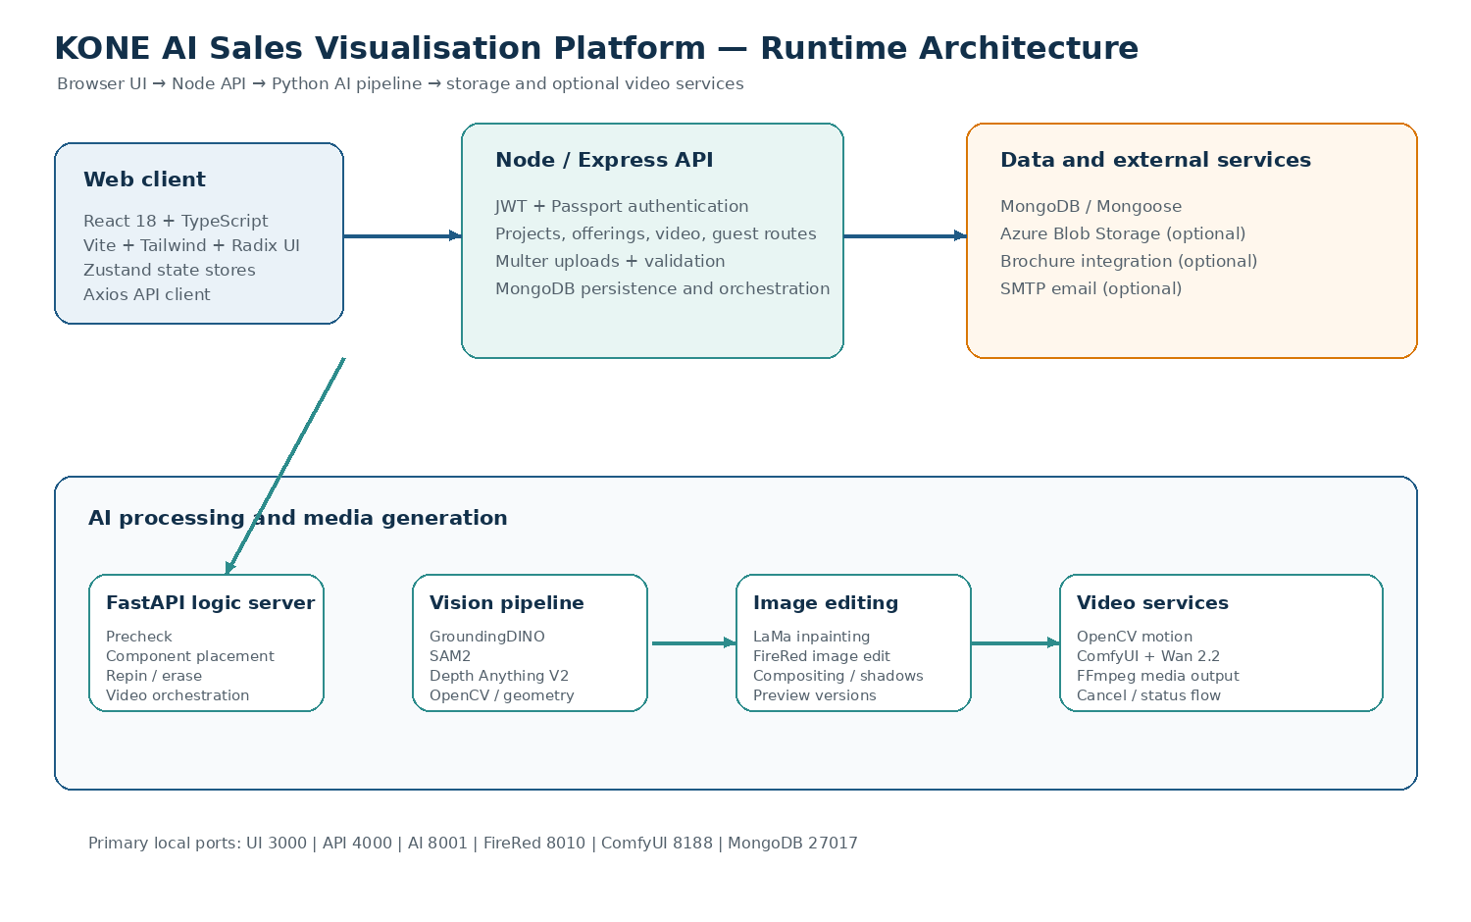
The Node API is the main application boundary. It authenticates the caller, validates requests, persists workflow state in MongoDB, and delegates computationally expensive work to the FastAPI logic server. FireRed and ComfyUI are separate local services used when their respective features are enabled.

3. Main runtime flows

3.1 Authenticated visualisation flow
- The user signs in through the React application. The Node API validates credentials and returns access/refresh tokens.
- The user creates or opens a project and an offering. Project and offering state is stored in MongoDB.
- The browser uploads the source image through the Node API. Multer handles multipart input and the API records the local/blob paths.
- The API calls the FastAPI precheck endpoint to validate image quality and detect a usable elevator scene.
- The API sends selected environments, components, assets and placement options to the AI backend. The AI pipeline detects, segments, removes and inserts components.
- The result is stored as a preview version. The user may repin or erase areas and repeat the preview operation.
- The user selects a motion style and submits video generation. The API delegates to OpenCV or optional ComfyUI/Wan 2.2 processing.
- The final image/video paths and pipeline status are stored on the offering. The frontend exposes the result for download or brochure handoff.

3.2 AI image-processing flow
The Python service receives a project payload containing the session/project identifiers, source paths, selected components, component instances/assets, environment selections and optional transforms. The pipeline validates and preprocesses the input, runs detection and segmentation, estimates geometry/depth where needed, creates removal masks, performs inpainting, places the selected component with perspective-aware warping, applies compositing/refinement, and returns a preview path plus metadata. The exact model stages are controlled by elevator_mod_pipeline/config.yaml.

3.3 Guest flow
The guest route family provides a session-based workflow without the normal authenticated user route. A guest session is created, the image is uploaded, the same precheck/components/repin/video stages are executed using a guest session identifier, and the guest can finalize or download the result. Guest endpoints do not use the standard auth middleware; they should therefore be protected by the deployment boundary and appropriate rate limits before production exposure.

4. Database schema
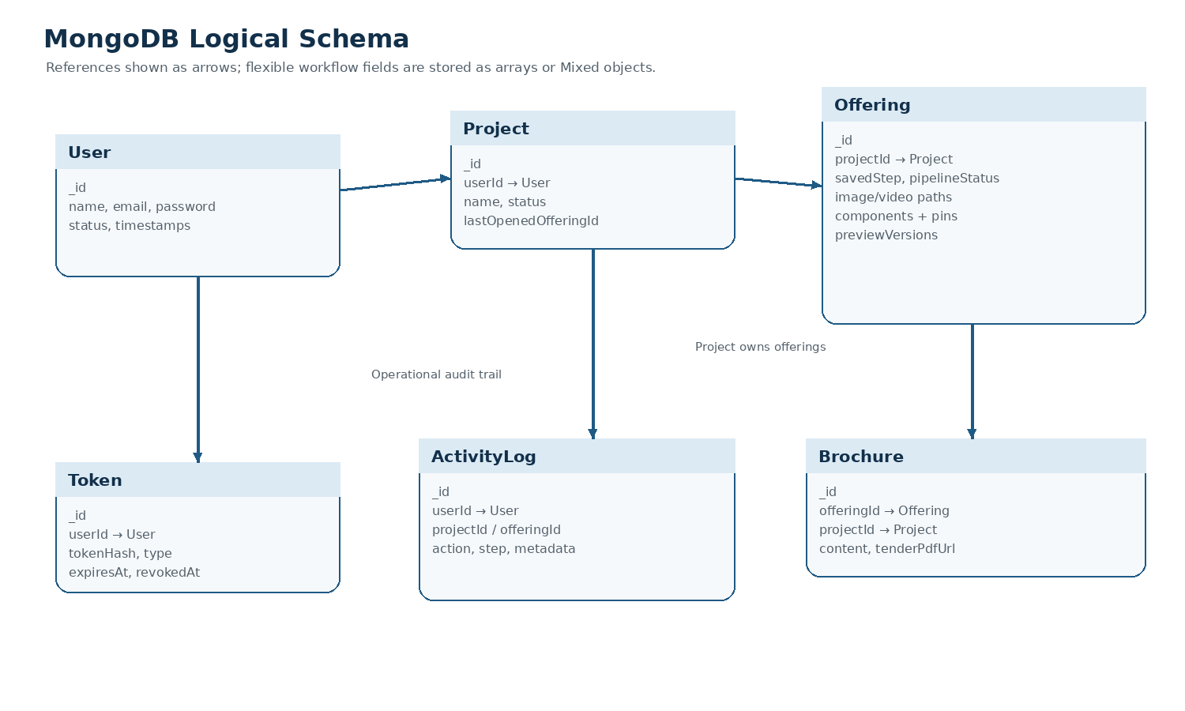
MongoDB is accessed through Mongoose models. ObjectId references connect the user, project, offering and brochure records. Workflow-specific structures such as selected components, component instances, pins, transforms and preview versions are intentionally flexible and are stored as arrays or Mixed fields.

4.1 Collections and important fields
Collection | Key fields | Role
users | name, email, password, status, createdAt, updatedAt | Application users. Password is private and hashed before save. Email is unique and normalized.
projects | userId, name, status, lastOpenedOfferingId, timestamps | Top-level customer/project container owned by a user.
offerings | projectId, savedStep, pipelineStatus, paths, components, pins, previewVersions, video options | Main workflow record for one visualisation and its generated assets.
brochures | offeringId, projectId, content, tenderPdfUrl, sectionsComplete | Optional brochure/sales-content record associated with an offering.
tokens | userId, tokenHash, type, expiresAt, revokedAt | Refresh, password-reset and email-verification token records.
activity_logs | userId, projectId, offeringId, action, step, metadata, ipAddress, userAgent | Operational audit trail for user/workflow actions.

4.2 Offering workflow state
Field | Values / shape | Meaning
status | draft | active | complete | Business status of the offering.
savedStep | 1–6 | Last saved frontend workflow step.
pipelineStatus | idle | uploaded | processing | preview_ready | video_ready | ready_for_download | failed | Technical processing state used by UI and API.
selectedComponents | String[] | Component keys selected by the user.
componentPins | Subdocuments: componentKey, x/y, bbox, dimensions, URLs | Manual/AI placement information for each component.
previewVersions | Versioned subdocuments with URLs, transforms and feedback | History of generated previews and repin iterations.
outputImageUrl / outputVideoUrl | String or null | Final media references returned to the client.

5. API documentation
The application API is mounted below /api/v1. In development, Swagger UI is available at http://localhost:4000/api/v1/docs. The route is registered only when NODE_ENV=development. The authoritative request validation is implemented in the API validation modules and controllers; use the running Swagger page for request/response schemas when available.
Service | Base URL / port | Notes
Node API | http://localhost:4000/api/v1 | Public application API used by the frontend.
Swagger UI | http://localhost:4000/api/v1/docs | Development-only API explorer.
Python AI | http://localhost:8001 | Internal FastAPI service; normally called by Node API.
FireRed | http://127.0.0.1:8010 | Internal image-edit service used by repin/edit workflows.
ComfyUI | http://localhost:8188 | Optional video-generation runtime.

5.1 Authentication and user endpoints
Method | Endpoint | Auth | Purpose
POST | /auth/register | None | Currently disabled; route returns 403.
POST | /auth/login | None | Authenticate a user and issue tokens.
POST | /auth/guest-login | None | Currently disabled; route returns 403.
POST | /auth/logout | Bearer | Revoke/logout using the submitted refresh token.
POST | /auth/refresh-tokens | Refresh token | Issue a new access/refresh token pair.
POST | /auth/forgot-password | None | Start password reset flow.
POST | /auth/reset-password | Reset token | Set a new password.
POST | /auth/send-verification-email | Bearer | Send account verification email.
POST | /auth/verify-email | Verification token | Verify an email address.
POST | /users | Admin | Create a managed user.
GET | /users | Admin | List users with filters/pagination.
GET | /users/:userId | User/Admin | Get a user.
PATCH | /users/:userId | Admin | Update a user.
DELETE | /users/:userId | Admin | Delete a user.

5.2 Project and offering endpoints
Method | Endpoint | Auth | Purpose
GET | /projects | Bearer | List the current user’s projects.
POST | /projects | Bearer | Create a project.
PATCH | /projects/:projectId | Bearer | Update project details/state.
DELETE | /projects/:projectId | Bearer | Delete a project.
GET | /projects/:projectId/offerings | Bearer | List offerings within a project.
POST | /projects/:projectId/offerings | Bearer | Create an offering.
PATCH | /projects/:projectId/visualizations/:visualizationId | Bearer | Update a visualization/offering record.
DELETE | /projects/:projectId/visualizations/:visualizationId | Bearer | Delete a visualization/offering record.
GET | /offerings/:offeringId | Bearer | Get offering workflow state and asset references.
PATCH | /offerings/:offeringId | Bearer | Save offering fields and workflow progress.
POST | /offerings/:offeringId/ai-placement | Bearer | Request AI placement through the offering workflow.
POST | /offerings/:offeringId/render | Bearer | Render/generate an offering preview.
POST | /offerings/:offeringId/complete | Bearer | Mark the offering workflow complete.
POST | /offerings/:offeringId/brochure-redirect | Bearer | Create/return brochure integration redirect.
GET | /offerings/:offeringId/brochure | Bearer | Get brochure content.
POST | /offerings/:offeringId/brochure | Bearer | Create brochure content.
PATCH | /offerings/:offeringId/brochure | Bearer | Update brochure content.

5.3 Authenticated media and video endpoints
Method | Endpoint | Auth | Purpose
POST | /video/upload-image | Bearer | Upload source image; multipart field is image.
POST | /video/precheck | Bearer | Validate image and precheck elevator scene.
POST | /video/select-environment | Bearer | Save selected environment.
POST | /video/select-components | Bearer | Save selected components/assets.
POST | /video/repin | Bearer | Generate a repin preview with transforms.
POST | /video/repin/erase | Bearer | Erase/repair a selected area in repin workflow.
POST | /video/generate | Bearer | Generate video from the prepared image.
POST | /video/cancel | Bearer | Cancel an active video request.

5.4 Guest endpoints
Method | Endpoint | Auth | Purpose
POST | /guest/session | Guest session | Create a guest workflow session.
POST | /guest/upload | Guest session | Upload a guest source image.
POST | /guest/precheck | Guest session | Run image/elevator precheck.
POST | /guest/components | Guest session | Run component placement.
POST | /guest/repin | Guest session | Run repin preview.
POST | /guest/repin/erase | Guest session | Run repin eraser.
GET | /guest/status | Guest session | Read guest processing status.
POST | /guest/video | Guest session | Generate guest video.
POST | /guest/finalize | Guest session | Finalize guest result.
GET | /guest/download | Guest session | Download guest result.

5.5 Internal Python AI endpoints
Method | Endpoint | Called by | Purpose
POST | http://localhost:8001/precheck | Node API | Validate source image and detect usable scene.
POST | http://localhost:8001/run-components | Node API | Run component detection, removal, placement and preview generation.
POST | http://localhost:8001/repin-components | Node API | Generate a transformed/repinned preview.
POST | http://localhost:8001/repin-erase | Node API | Erase or repair a repin region.
POST | http://localhost:8001/generate-video | Node API | Create video using OpenCV or ComfyUI/Wan configuration.

6. Third-party integrations and model services
Integration | Use in the platform | Configuration / operational note
MongoDB + Mongoose | Primary application database and model layer. | MONGODB_URL; use a secured managed/server instance in production.
Azure Blob Storage | Optional upload/synchronization of source images, selected images and final videos. | AZURE_UPLOAD_ENABLED, AZURE_STORAGE_CONNECTION_STRING and AZURE_STORAGE_CONTAINER_NAME.
Brochure integration | Sends brochure/offer content to an external sales/brochure service. | BROCHURE_INTEGRATION_URL and BROCHURE_INTEGRATION_API_KEY; keep the key server-side.
SMTP provider | Password reset, verification and notification emails. | SMTP_HOST, SMTP_PORT, SMTP_USERNAME, SMTP_PASSWORD and EMAIL_FROM.
GroundingDINO | Text-guided object/component detection. | Model weights are downloaded/configured by the setup script.
SAM2 | Segmentation masks for detected objects and scene regions. | Requires compatible local weights and PyTorch/CUDA environment.
Depth Anything V2 | Depth/geometry cues for perspective-aware placement. | Configured in elevator_mod_pipeline/config.yaml.
LaMa / OpenCV | Removal masks, inpainting, cleanup and image compositing. | Local Python dependencies; FFmpeg is required for media operations.
FireRed Image Edit | Dedicated image-edit/repin service, normally on port 8010. | Started by start_logic_with_firered.sh; uses a separate Python environment.
ComfyUI + Wan 2.2 | Optional higher-quality image-to-video workflow. | ComfyUI on port 8188; model files/workflows under vdotest.
Hugging Face | Source for restricted/open model files during setup. | HF_TOKEN may be required; do not commit tokens.

7. Repository folder structure
Kone/
├── Frontend/
│ ├── kone-ui-master/ React/Vite frontend
│ │ └── src/
│ │ ├── api/ Axios client and guest workflow calls
│ │ ├── components/ Shared canvases, upload and progress UI
│ │ ├── mocks/ Optional mock API for frontend-only demo
│ │ ├── pages/ Landing, auth, projects and offering steps
│ │ ├── router/ Route definitions and guards
│ │ └── store/ Zustand auth/project/offering state
│ └── kone-api-master/ Node/Express API
│ └── src/
│ ├── config/ Environment and service configuration
│ ├── controllers/ Request orchestration and responses
│ ├── docs/ Swagger/OpenAPI setup
│ ├── middlewares/ Auth, validation, upload, rate limiting
│ ├── models/ Mongoose schemas
│ ├── routes/v1/ Versioned API routes
│ ├── services/ Azure, brochure, email and ComfyUI services
│ ├── utils/ Shared helpers and startup utilities
│ └── validations/ Joi request schemas
├── elevator_mod_pipeline/
│ ├── src/server.py FastAPI internal AI service
│ ├── src/pipeline.py End-to-end image pipeline
│ ├── src/detect.py Detection and model adapters
│ ├── src/inpaint.py Removal/inpainting
│ ├── src/insert_mod.py Component insertion/compositing
│ ├── src/geometry.py Depth and geometric calculations
│ ├── src/video*.py OpenCV and ComfyUI/Wan video paths
│ └── config.yaml Pipeline configuration
├── models/ Local AI model files
├── weights/ Detection/segmentation weights
├── vdotest/ ComfyUI runtime and workflows
├── start_kone.sh Full local launcher
└── Kone_Setup_Python3.12_3.13.sh Environment/model setup

8. Key-module code walkthrough

8.1 Frontend
Module | What it does | Why it matters
src/router/index.tsx | Defines public/protected routes and redirects. | Central navigation boundary and auth-aware user journey.
src/api/client.ts | Creates the Axios client, base URL, timeout and token handling. | Single integration point for frontend-to-API communication.
src/store/authStore.ts | Stores authentication state and user/session actions. | Keeps login state available across pages.
src/store/projectStore.ts | Loads, creates and updates project records. | Synchronizes project list/detail screens with the API.
src/store/offeringStore.ts | Tracks offering data, selected components, steps and generated assets. | Coordinates the multi-step visualisation workflow.
src/pages/offering/* | Implements upload, component selection, placement, repin, video and download steps. | Each screen maps to a business stage and API call.
ImageCanvas / RepinTransformCanvas | Renders image, masks, pins and transforms in the browser. | Provides the interactive editing surface for placement and repin.

8.2 Node API
Module | What it does | Why it matters
src/index.js | Loads environment configuration, connects Mongoose and starts Express. | Application process entry point.
src/app.js | Registers security middleware, body parsing, CORS, static output paths, Passport and API routes. | Defines the HTTP runtime and cross-cutting protections.
routes/v1/*.route.js | Maps HTTP methods/paths to middleware and controllers. | The public contract of the API.
controllers/*.controller.js | Validates workflow state, calls models/services and shapes responses. | Application orchestration layer.
models/*.model.js | Defines MongoDB schema, indexes, timestamps and serialization. | Persistence contract and data integrity.
services/azureBlob.service.js | Uploads selected local files to Azure when enabled. | Keeps external media storage behind a service boundary.
services/brochureIntegration.service.js | Posts brochure data to the external brochure system. | Isolates a client-facing integration from controllers.
utils/comfyStartup.js | Checks ComfyUI health and optionally starts it. | Supports local video generation without manual startup.

8.3 Python AI service
Module | What it does | Why it matters
src/server.py | FastAPI entry point and five internal processing endpoints. | Stable service boundary for the Node API.
src/pipeline.py | Coordinates validation, detection, segmentation, inpainting, insertion and output writing. | Main image-generation workflow.
src/detect.py | Runs GroundingDINO and related detection/geometry validation. | Finds relevant elevator components and scene regions.
src/inpaint.py | Builds removal masks and runs LaMa/OpenCV cleanup. | Creates a clean background before insertion.
src/insert_mod.py | Warps and composites selected component assets with shadows/harmonization. | Produces the client-visible visualisation.
src/video.py / video_comfy.py | Creates OpenCV motion videos or dispatches ComfyUI/Wan workflows. | Converts final still imagery into deliverable video.
config.yaml | Controls model paths, pipeline stages, quality and video modes. | Allows deployment-specific tuning without changing core code.

9. Configuration and deployment notes

9.1 Environment variables
Variable | Example / default | Used by
NODE_ENV | development | Node API; enables development Swagger route.
PORT | 4000 | Node API listening port.
MONGODB_URL | mongodb://localhost:27017/kone | Node API database connection.
JWT_SECRET | long random secret | Token signing; use a strong secret outside source control.
LOGIC_URL | http://localhost:8001 | Node API → Python AI service.
VITE_API_BASE_URL | http://localhost:4000/api/v1 | Frontend → Node API base URL.
VITE_ENABLE_MOCK_API | false | Frontend-only demo mode when true.
AZURE_UPLOAD_ENABLED | false | Enables Azure media synchronization.
BROCHURE_INTEGRATION_URL / API_KEY | deployment-specific | External brochure integration.
SMTP_* / EMAIL_FROM | deployment-specific | Email workflows.
COMFY_AUTOSTART / COMFY_URL / COMFY_ROOT / COMFY_* | deployment-specific | Optional ComfyUI video runtime.

9.2 Startup order
- Start MongoDB on port 27017.
- Start FireRed on port 8010 when image editing/repin requires it.
- Start the FastAPI logic service on port 8001.
- Start the Node API on port 4000.
- Start the React/Vite frontend on port 3000.
- Start ComfyUI on port 8188 only when Wan video generation is enabled.
The repository includes start_kone.sh and related startup scripts that automate this order for local Linux development. Production deployments should use a process manager/container orchestration, private network access for internal AI services, TLS at the edge, managed MongoDB, and a secrets manager.

9.3 Security and operational considerations
- Never commit real JWT, Azure, SMTP, brochure or Hugging Face credentials. Use deployment secrets and keep .env files local.
- Keep FastAPI, FireRed and ComfyUI off the public internet; allow only the Node API or internal worker network to call them.
- Guest endpoints are intentionally separate from bearer-token routes. Add an edge proxy, rate limiting and abuse monitoring before public production exposure.
- Uploaded files and generated media should use controlled storage paths and retention rules in production.
- The API already uses security middleware, request validation, CORS configuration, upload handling and rate limiting in the Node layer; review allowed origins and limits for each deployment.
- The current Swagger server definition in src/docs/swaggerDef.js uses a /v1 server suffix while the Express route is mounted at /api/v1. Use the working UI URL above and align the OpenAPI server value before distributing the spec externally.

10. Useful development commands
# Full local stack
cd /root/Kone
bash start_kone.sh
# API documentation (development)
http://localhost:4000/api/v1/docs
# Frontend checks
cd Frontend/kone-ui-master
npm run type-check
npm run lint
npm run test
# API checks
cd ../kone-api-master
npm test
npm run lint
# Backend setup checks
cd ../../
bash Kone_Setup_Python3.12_3.13.sh checks
For installation prerequisites, environment setup and the complete local run guide, refer to the companion README / Setup Guide. This document intentionally focuses on architecture and technical handover.

11. Handover summary
The platform is a modular, service-oriented application: React owns the interactive workflow, Node/Express owns authentication and business orchestration, MongoDB stores workflow state, and FastAPI owns GPU-intensive image/video processing. Optional Azure, brochure, SMTP, FireRed and ComfyUI integrations are isolated behind configuration and service boundaries. The main maintenance points are the route/controller/validation layer, the Offering model and workflow state, the Python pipeline configuration, and the startup scripts that connect the local services.

