**Project Name: OnlineMedico**

**Version 1.2**

**June 11, 2020**

**Team Members:**

Akhitha Tumula

Satish Kumar Mandapalli

Rohan Bhandari

Sravani Jaidi

Kavya Reddy Mylapurapu

Rethima Reddy Polam

Submitted in partial fulfillment

Of the requirements of

CSIS 44-691 Graduate Directed Project 1

# Revision History

|  |  |  |  |
| --- | --- | --- | --- |
| **Date** | **Description** | **Author** | **Comments** |
| <date> | <Version 1> | <Your Name> | <First Revision> |
|  |  |  |  |

**Document Approval**

The following Software Requirements Specification has been accepted and approved by the following:

|  |  |  |  |
| --- | --- | --- | --- |
| **Signature** | **Printed Name** | **Title** | **Date** |
|  |  |  |  |
|  |  |  |  |

**Table of Contents**

**Table of Contents                                                                                      Page Number**

1. Introduction ……………………………………………………5
   1. Purpose ………………………………………………….....5
   2. Scope ………………………………………………….......5
   3. Definitions, Acronyms, and Abbreviations ……………….5
   4. References ………………………………………………...5
   5. Overview ………………………………………………….5
2. General Description

2.1 Product Perspective …………..............................................6

2.2 Product Functions ………..................................................6

2.3 User Characteristics …………………………………….…6

2.4 General Constraints ………………………………………..6

2.5 Assumptions and Dependencies …………………………...6

1. Specific Requirements

3.1. External Interface Requirements …………………............8

3.1.1. User Interfaces ……………………………………8

3.1.2. Hardware Interfaces ……………………………....8

3.1.3. Software Interfaces ……………………………….8

3.1.4. Communications Interface ……………………..…8

3.2. Functional Requirements ………………………………….8

3.3. Use Cases …………………………………………………10

3.4. Class/Objects

3.5. Non-Functional Requirements ……………………………10

3.5.1. Performance ……………………………………..10

3.5.2. Reliability …………………………………….….10

3.5.3. Availability ………………………………………10

3.5.4. Security …………………………………………..10

3.5.5. Portability ………………………………………..10

3.6.      Inverse Requirements

3.7.      Design Constraints

3.8.      Logical Database Requirements

3.9.      Other Requirements

3.10.   Prototypes (for complete project)

3.11.   Use Case Diagrams

1. Design ……………………………………………………11

4.1. ER diagram …………………………………………11

4.2. GUI…………………………………………………..12

1. Analysis Models

5.1. Data Flow Diagram

5.2. Sequence Diagram

## 

## Chapter 1: Introduction

**1.1 Purpose:**

To buy medicines in any business area, we usually go there in person. In our everyday life, we often come across such issues. So, our main aim of this project is to buy medicines online based on the location and available drug stores of those business areas, especially by the senior citizens. The website has both perspectives like the user can place orders for required medicine and the service provider can accept or reject the requested medicines based on their availability and validity of the prescription. To begin with, we are working on a website that can buy medicines online in the drug stores nearby, and further this can be extended more to book appointments at any business area like hospitals for doctor consultation.

**1.2 Scope:**

New users have to register themselves with their details to use the Website. After registering, the user needs to give permission to location access. If the user is already registered, they need to log in using their credentials. Based on the location, for all users i.e. existing and new users the website displays nearby drug stores where medicines can be ordered online by selecting a particular drug store.

The website displays the drug stores which were nearby to your location. Users can go through their profile in settings where they can edit their credentials including their mobile number. If an individual wants to change password, they get a confirmation message to their registered mail or mobile number, and then after confirming the password is updated.

Service providers (here drug store owners) start with registering their details and exact location and they need to give permission to location access.

Once it is registered, the drug store is visible to the nearest users to place orders for medicines available. They can edit medico profile and drug store details and their availability of medicines and delivery facility So that the user can select the available medicines by placing a request which was not available when they were searching (gets after updating).

Users can pay online after the medicines are added to the cart. One has the option to save their card details during payment for future use. The application can be used within ten miles of radius around the globe for users. It displays drug stores to the user based on the radius. It can be used within a city with many numbers of users.

**1.4 References:**

* <https://www.lucidchart.com/pages/>

**1.5 Overview:**

Instead of going to drug stores to buy medicines, you can directly buy them with registered drug stores online by uploading prescriptions using this website. Can find drug stores within 10 miles radius. Payments can be done online. Drug stores can accept the request made by the users for particular medicines when they are available and notify the users. It can reach a selected drug store using maps for pickup also.

**Chapter 2: General Description**

**2.1 Product Perspective**

Our website OnlineMedico, will help people find their medication and buy them easily. This website makes the user find the available store to buy their medications. In our application, there are two main users. They are

* **Pharmacy owner**

They will provide the list of drugs that are available in their store and can track the online orders they got to deliver them.

* **General Users**

They can view the list of nearby pharmacies and can view the list of drugs that are available in their store to purchase. If the purchase of any medicine needs a prescription then they can upload it and add them to cart. Once they found all the needed drugs they can order through home delivery or through self-carry out.

**2.2 Product Functions**

The website functions in two different ways based on the person logged in. If a drug provider is logged in, their functionalities will be enabled like adding medical drugs into their store, to view the list of online orders, view order history, view complaints (if any) and to view the requests for new drugs. And if the person logged in is a general user, their functionalities like finding nearby pharmacies and searching for required drugs. Then to add them to cart and order online.

**2.3 User Characteristics**

Here are a few user characteristics for our project.

* Every pharmacy owners has login credentials, store Id, contact details, address, list of drugs available
* Every Customer has login credentials, name, contact details, address and access to payment gateway.

**2.4 General Constraints**

There are constraints a user must contain to use our application. They are

* User must be in a position to access computer or any other device to browse the website
* User must be able to connected to internet
* Users must be educated enough to search for the medicine they need.

**2.5 Assumptions and Dependencies**

While creating our project we made some assumptions. They are as follows:

* The pharmacy owners are willing to share their drug details in our application
* The pharmacy owners are willing to accept online orders and payments.
* The users are well educated and are able to understand the description of each medicine provided in our application.
* The users are willing to pay online for the drugs.

Below are the dependencies we have in our project.

* Our project is mainly dependent on pharmacy owners and their trust in our application.

**Chapter 3: Specific Requirements**

**3.1. External Interface Requirements**

External interface requirements specify hardware, software, or database elements with which a system or component must interface...." This section provides information to ensure that the system will communicate properly with external components.

**3.1.2. Hardware Interfaces**

* Processor: Minimum 1 GHz; Recommended 2GHz or more
* Ethernet connection (LAN) OR a wireless adapter (Wi-Fi)
* Hard Drive: Minimum 32 GB; Recommended 64 GB or more
* Memory (RAM): Minimum 1 GB; Recommended 4 GB or above

**3.1.3. Software Interfaces**

* Vscode
* Node js
* React js
* Windows: 7 or newer
* Mac: OS X v10.7 or higher
* Linux: Ubuntu

**3.2 Functional Requirements**

OnlineMedico is a website where the users can buy medicines online from the registered drug stores. Here, Drug stores are the clients and websites are the link to buy the medicines for users. Presently there is no existing platform to buy the medicines online and to make a request for required medicines to buy later. So, the main purpose of the website is to make the client’s business easy.

Responsive design for varying screen size, Version compatibility for devices, more touch flexibility and less keyboard usage in the application are the features of the website. The other main feature of the website is data security. Payments are also available on the website users can pay after adding medicines to their cart or can pay with cash if it is picked up.

**Requirements**

* **Signup Page:**

The store owner and customer has to first register into the application.

* **Customer login:**

After successful registration, customers log in using this activity in order to view or place orders.To use the website, one must login with appropriate details. If a user forgot a password, then they can reset it with a phone number or email.

* **Owner login:**

Owner upon successful registration login using email and password to view the requests from customers and to process them. To use the website, owner must login with appropriate details. If they forgot a password, then can reset it with a phone number or email.

* **Medical Stores Display:**

It will list out all the stores that are registered with the application.

* **Add to Cart:**

In this activity customers can add their desired medicines into the cart before placing orders.

* **Checkout:**

This is the page where users can pay the amount using different types of payment methods that are available.

* **Update/Modify user info:**

Customers can update their details given during registration.

* **Request Medicine:**

Customers can request the medicine from a particular store if it is not found in that store.

* **Contact to Store:**

If customers want to clear their doubts they can contact the store owner using this function.

* **Search:**

The user is able to find the nearby drug stores with the help of a search functionality available after the user logged in.

* **Add/View/Modify/Delete Store details by Owner:**

Drug store owners who have logins must update the medicines availability and also can view the requested medicine from the user.

* **Confirmation of order:**

Drug stores must accept the request after verifying the prescription of the user with required medicines.

**3.3 Use Cases:**

* 1. **Non-Functional Requirements:**
* Devices must have active Internet services.
* This Website should be user-friendly
* This Website should have less response time
* All the sensitive information will be encrypted.
* The user can access only a few drug stores that are registered with this website.
* Users can even pay manually at the drug store if they have opted for a medicine pickup option.
* We should have a database to store all the data such as user information and all their medicine request details.
* This website should find all nearby drug stores registered with the website.

**3.4.1. Performance:**

* Less battery consumption while using the website.
* Managing memory by keeping track of each memory allocation by Dalvik Virtual Machine.

**3.4.2. Reliability:**

* 10000 requests can be handled per second.
* Website takes less than 100ms API response time.

**3.4.3. Availability:**

* It displays the drugstores within 10 miles radius from the current location.
* It also displays the updated availability of medicines in any drug store from time to time.

**3.4.4. Security:**

● Strong security that balances great encryption and good performance.

● Restricting access to sensitive permissions makes websites less vulnerable for attackers.

**3.4.5. Portability:**

● Website can be used on mobile devices, tablets, laptops and computers.

**Chapter 4: Design**

**4.1. ER diagram**

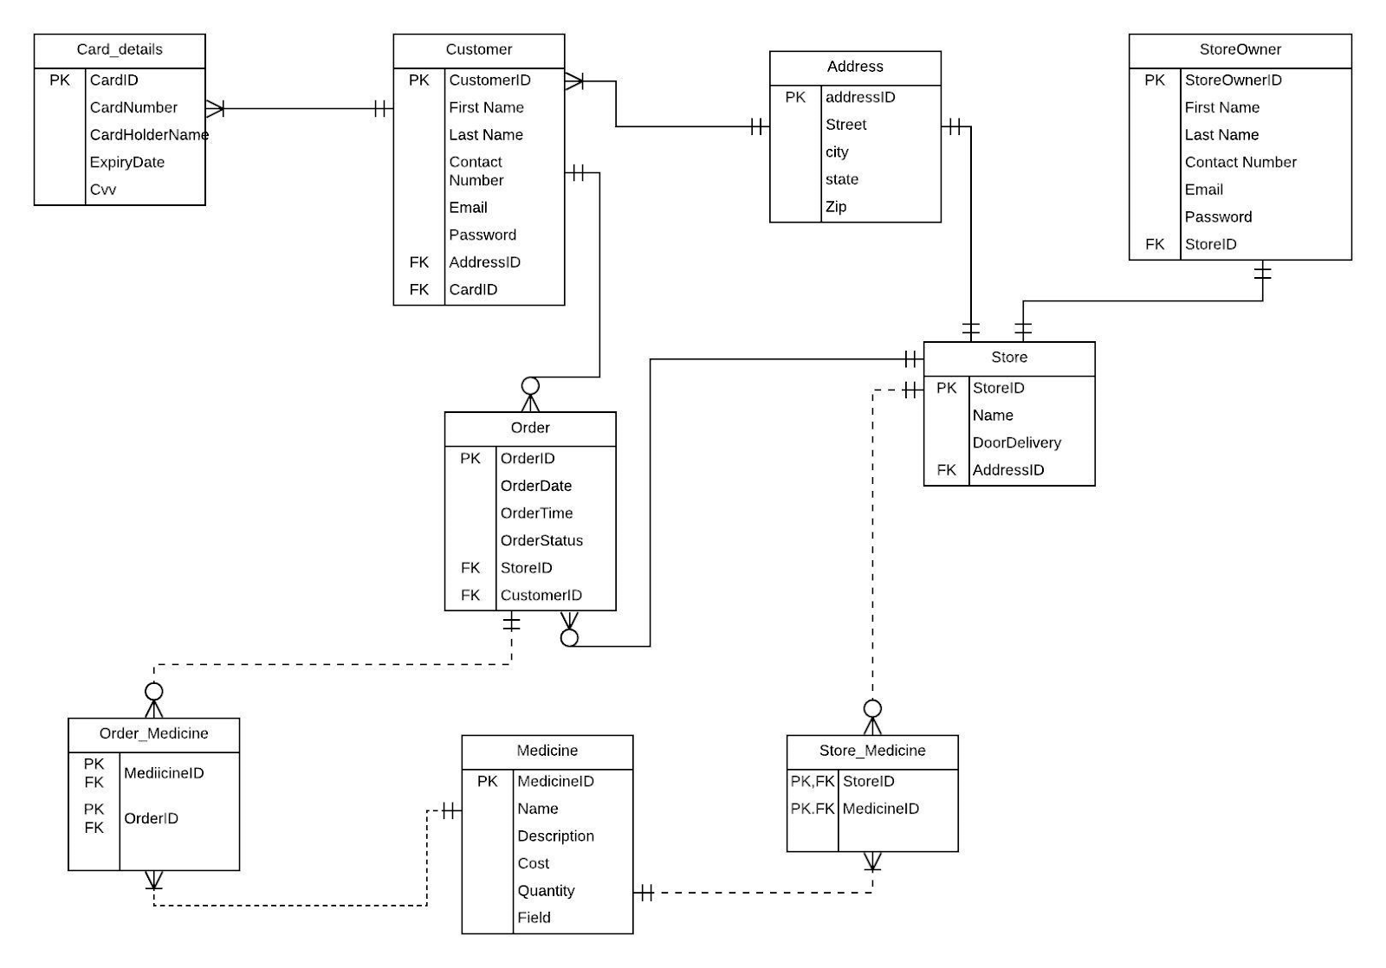

**E-R Diagram:**

Every customer has at least one card details and each card has exactly one customer. Every customer has exactly one address and at each address there will be at least one customer. Each customer may or may not place an order or multiple orders and each order will have a mandatory customer. Each Store has exactly one owner and each owner has exactly one store. Each store has exactly one address and at each address there will be exactly one store. Each store may or may not have one or many orders and each order belongs to exactly one store. Each store will have one or many medicines and each medicine may or may not be in one or many stores. This a M: M relationship so we are using an associative entity Store_medicine. Each order has at least one medicine and each medicine may or may not be in one or many orders. This a M: M relationship so we are using an associative entity Order_Medicine.

**4.2. GUI**

**Home Page:**

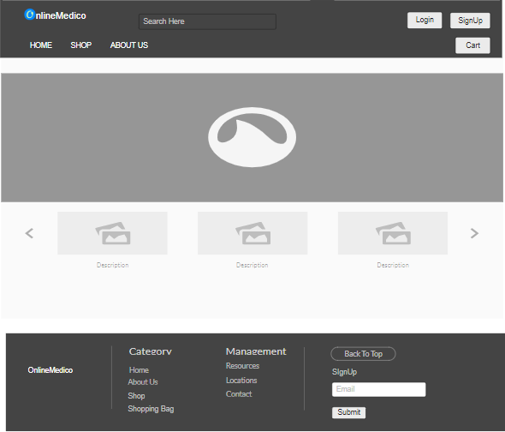

**Registration Page:**

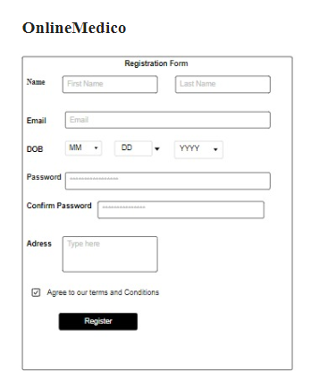

**Login Page:**

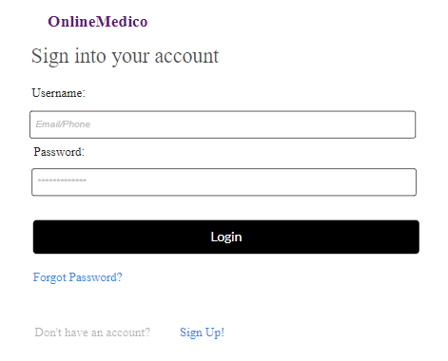

**Product Page:**

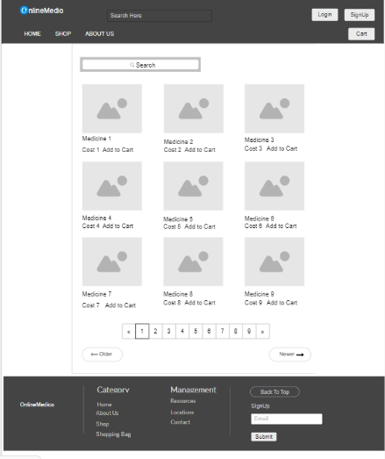

**Add To Cart Page:**

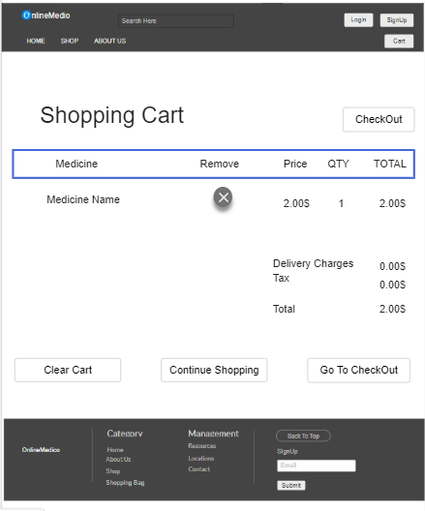

**CheckOut Page:**

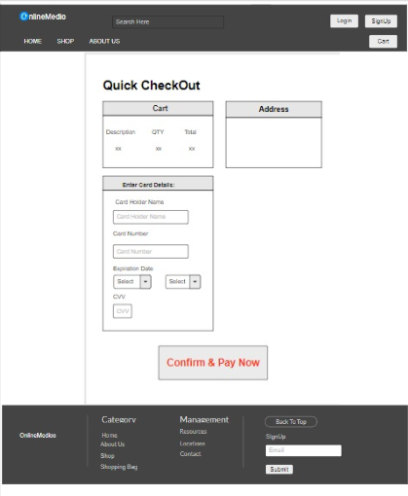

**Customer Profile Update page:**

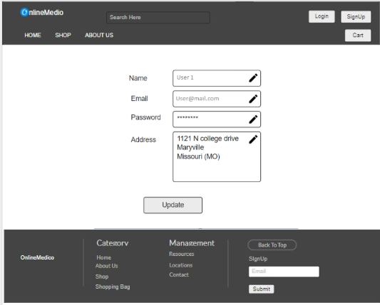

**Previous Orders Page:**

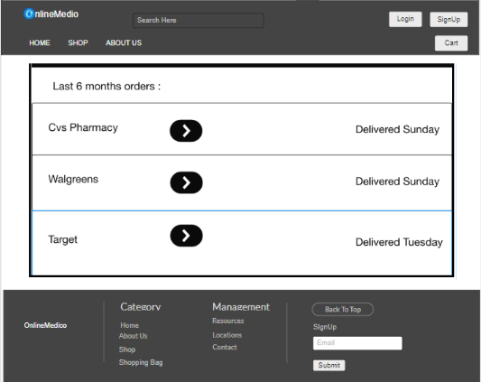

**Previous Orders info Page:**

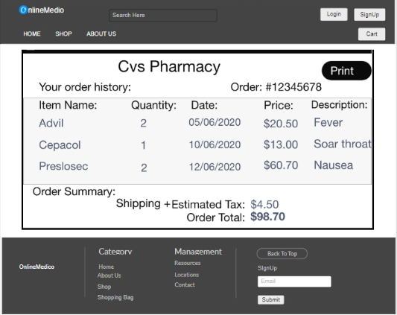

**Store Owner Home Page:**

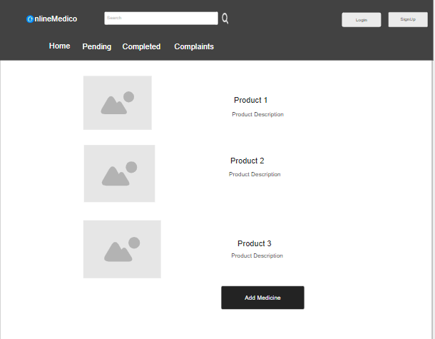

**Update Customer Information:**



**Update Owner Information:**

