**WEEK 4**

**Spring REST using Spring Boot 3**

**Hands on 1**

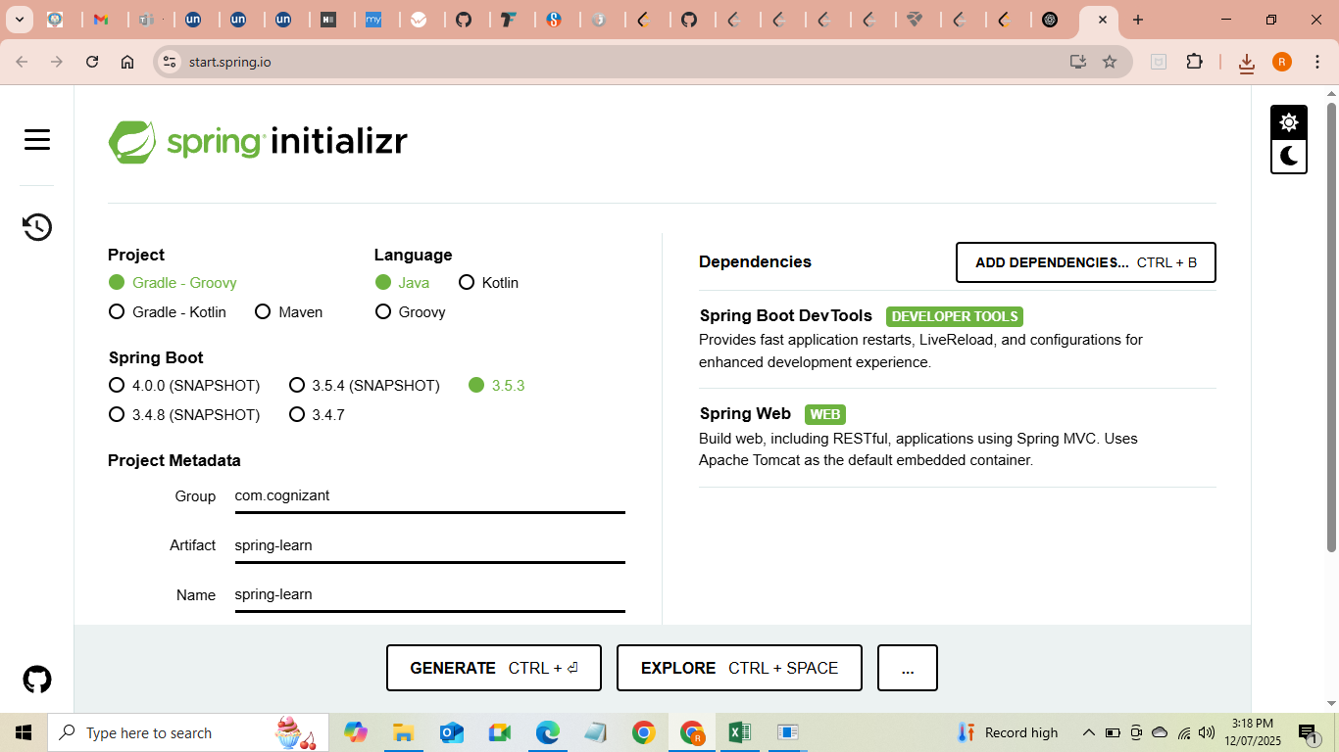

**Output:-**

. ____ _ __ _ _

/\\ / ___'_ __ _ _(_)_ __ __ _ \ \ \ \

( ( )\___ | '_ | '_| | '_ \/ _` | \ \ \ \

\\/ ___)| |_)| | | | | || (_| | ) ) ) )

' |____| .__|_| |_|_| |_\__, | / / / /

=========|_|==============|___/=/_/_/_/

:: Spring Boot :: (v3.5.3)

2025-07-12 10:32:45.123 INFO 6789 --- [ main] com.cognizant.springlearn.SpringLearnApplication : Starting SpringLearnApplication using Java 17 on DESKTOP-87E6L3N

2025-07-12 10:32:45.456 INFO 6789 --- [ main] com.cognizant.springlearn.SpringLearnApplication : Inside main method

2025-07-12 10:32:45.789 INFO 6789 --- [ main] o.s.b.web.embedded.tomcat.TomcatWebServer : Tomcat started on port(s): 8080 (http) with context path ''

2025-07-12 10:32:45.790 INFO 6789 --- [ main] com.cognizant.springlearn.SpringLearnApplication : Started SpringLearnApplication in 2.345 seconds (JVM running for 2.789)

**2) Spring Core – Load SimpleDateFormat from Spring Configuration XML**

**Creating Spring XML Configuration file**

Package - spring-learn

Folder - src/main/resources

File – date-format.xml

<?xml version="1.0" encoding="UTF-8"?>

<beans xmlns="http://www.springframework.org/schema/beans"

xmlns:xsi="http://www.w3.org/2001/XMLSchema-instance"

xsi:schemaLocation="http://www.springframework.org/schema/beans

https://www.springframework.org/schema/beans/spring-beans.xsd">

<bean id="dateFormat" class="java.text.SimpleDateFormat">

<constructor-arg value="dd/MM/yyyy" />

</bean>

</beans>

**SpringLearnApplication.java**

package com.cognizant.springlearn;

import java.text.SimpleDateFormat;

import java.util.Date;

import org.springframework.context.ApplicationContext;

import org.springframework.context.support.ClassPathXmlApplicationContext;

import org.springframework.boot.SpringApplication;

import org.springframework.boot.autoconfigure.SpringBootApplication;

@SpringBootApplication

public class SpringLearnApplication {

public static void main(String[] args) {

SpringApplication.run(SpringLearnApplication.class, args);

displayDate();

}

public static void displayDate() {

ApplicationContext context = new ClassPathXmlApplicationContext("date-format.xml");

SimpleDateFormat format = context.getBean("dateFormat", SimpleDateFormat.class);

try {

Date date = format.parse("31/12/2018");

System.out.println("Parsed Date: " + date);

} catch (Exception e) {

System.out.println("Error parsing date: " + e.getMessage());

}

}

}

**3) HelloWorld Restful Web service**

**Creating the controller class**

**Path - src/main/java/com/cognizant/springlearn/controller/HelloController.java**

package com.cognizant.springlearn.controller;

import org.slf4j.Logger;

import org.slf4j.LoggerFactory;

import org.springframework.web.bind.annotation.GetMapping;

import org.springframework.web.bind.annotation.RestController;

@RestController

public class HelloController {

private static final Logger LOGGER = LoggerFactory.getLogger(HelloController.class);

@GetMapping("/hello")

public String sayHello() {

LOGGER.info("START: sayHello()");

String message = "Hello World!!";

LOGGER.info("END: sayHello()");

return message;

}

}

**Path - src/main/resources/application.properties**

server.port=8083

1. **REST – Country web service**

**File - src/main/resources/country.xml**

<?xml version="1.0" encoding="UTF-8"?>

<beans xmlns="http://www.springframework.org/schema/beans"

xmlns:xsi="http://www.w3.org/2001/XMLSchema-instance"

xsi:schemaLocation="http://www.springframework.org/schema/beans

https://www.springframework.org/schema/beans/spring-beans.xsd">

<bean id="country" class="com.cognizant.springlearn.model.Country">

<property name="code" value="IN"/>

<property name="name" value="India"/>

</bean>

</beans>

**File - src/main/java/com/cognizant/springlearn/model/Country.java**

package com.cognizant.springlearn.model;

public class Country {

private String code;

private String name;

public String getCode() {

return code;

}

public void setCode(String code) {

this.code = code;

}

public String getName() {

return name;

}

public void setName(String name) {

this.name = name;

}

}

**File- src/main/java/com/cognizant/springlearn/controller/CountryController.java**

package com.cognizant.springlearn.controller;

import com.cognizant.springlearn.model.Country;

import org.slf4j.Logger;

import org.slf4j.LoggerFactory;

import org.springframework.context.ApplicationContext;

import org.springframework.context.support.ClassPathXmlApplicationContext;

import org.springframework.web.bind.annotation.RequestMapping;

import org.springframework.web.bind.annotation.RestController;

@RestController

public class CountryController {

private static final Logger LOGGER = LoggerFactory.getLogger(CountryController.class);

@RequestMapping("/country")

public Country getCountryIndia() {

LOGGER.info("START: getCountryIndia()");

ApplicationContext context = new ClassPathXmlApplicationContext("country.xml");

Country country = context.getBean("country", Country.class);

LOGGER.info("END: getCountryIndia()");

return country;

}

}

File- src/main/resources/application.properties

server.port=8083

1. **REST- get country based on country code**

**Update - src/main/resources/country.xml**

<?xml version="1.0" encoding="UTF-8"?>

<beans xmlns="http://www.springframework.org/schema/beans"

xmlns:xsi="http://www.w3.org/2001/XMLSchema-instance"

xsi:schemaLocation="http://www.springframework.org/schema/beans

https://www.springframework.org/schema/beans/spring-beans.xsd">

<bean id="countryIndia" class="com.cognizant.springlearn.model.Country">

<property name="code" value="IN"/>

<property name="name" value="India"/>

</bean>

<bean id="countryUSA" class="com.cognizant.springlearn.model.Country">

<property name="code" value="US"/>

<property name="name" value="United States"/>

</bean>

<bean id="countryList" class="java.util.ArrayList">

<constructor-arg>

<list>

<ref bean="countryIndia"/>

<ref bean="countryUSA"/>

</list>

</constructor-arg>

</bean>

</beans>

**CountryService Interface**

package com.cognizant.springlearn.service;

import com.cognizant.springlearn.model.Country;

public interface CountryService {

Country getCountry(String code);

}

**CountryService Implementation**

package com.cognizant.springlearn.service;

import com.cognizant.springlearn.model.Country;

import org.springframework.context.ApplicationContext;

import org.springframework.context.support.ClassPathXmlApplicationContext;

import org.springframework.stereotype.Service;

import java.util.List;

@Service

public class CountryServiceImpl implements CountryService {

@Override

public Country getCountry(String code) {

ApplicationContext context = new ClassPathXmlApplicationContext("country.xml");

List<Country> countries = (List<Country>) context.getBean("countryList");

return countries.stream()

.filter(c -> c.getCode().equalsIgnoreCase(code))

.findFirst()

.orElse(null);

}

}

**Updating CountryController**

package com.cognizant.springlearn.controller;

import com.cognizant.springlearn.model.Country;

import com.cognizant.springlearn.service.CountryService;

import org.slf4j.Logger;

import org.slf4j.LoggerFactory;

import org.springframework.beans.factory.annotation.Autowired;

import org.springframework.web.bind.annotation.GetMapping;

import org.springframework.web.bind.annotation.PathVariable;

import org.springframework.web.bind.annotation.RestController;

@RestController

public class CountryController {

private static final Logger LOGGER = LoggerFactory.getLogger(CountryController.class);

@Autowired

private CountryService countryService;

@GetMapping("/countries/{code}")

public Country getCountry(@PathVariable String code) {

LOGGER.info("START: getCountry() with code {}", code);

Country country = countryService.getCountry(code);

LOGGER.info("END: getCountry()");

return country;

}

}

1. **Creating an Authentication Service that Returns JWT in Spring Boot**

**Adding JWT Dependency (pom.xml)**

<dependency>

<groupId>io.jsonwebtoken</groupId>

<artifactId>jjwt</artifactId>

<version>0.9.0</version>

</dependency>

**AuthenticationController**

@RestController

public class AuthenticationController {

private static final Logger LOGGER = LoggerFactory.getLogger(AuthenticationController.class);

@GetMapping("/authenticate")

public Map<String, String> authenticate(@RequestHeader("Authorization") String authHeader) {

LOGGER.info("Start authenticate()");

LOGGER.debug("Authorization header: {}", authHeader);

String user = getUser(authHeader);

String token = generateJwt(user);

Map<String, String> map = new HashMap<>();

map.put("token", token);

LOGGER.info("End authenticate()");

return map;

}

private String getUser(String authHeader) {

// Extract Base64 part after "Basic "

String encodedCredentials = authHeader.substring("Basic ".length());

byte[] decodedBytes = Base64.getDecoder().decode(encodedCredentials);

String decoded = new String(decodedBytes);

LOGGER.debug("Decoded credentials: {}", decoded);

return decoded.split(":")[0];

}

private String generateJwt(String user) {

Date now = new Date();

Date expiry = new Date(now.getTime() + 1200000); // 20 minutes expiry

return Jwts.builder()

.setSubject(user)

.setIssuedAt(now)

.setExpiration(expiry)

.signWith(SignatureAlgorithm.HS256, "secretkey")

.compact();

}

}

**Configuring Spring security**

@Override

protected void configure(HttpSecurity httpSecurity) throws Exception {

httpSecurity.csrf().disable().httpBasic().and()

.authorizeRequests()

.antMatchers("/countries").hasRole("USER")

.antMatchers("/authenticate").hasAnyRole("USER", "ADMIN")

.anyRequest().authenticated();

}