**WEEK 6- REACT HANDS ON EXERCISE**

**Downloading Node.js**

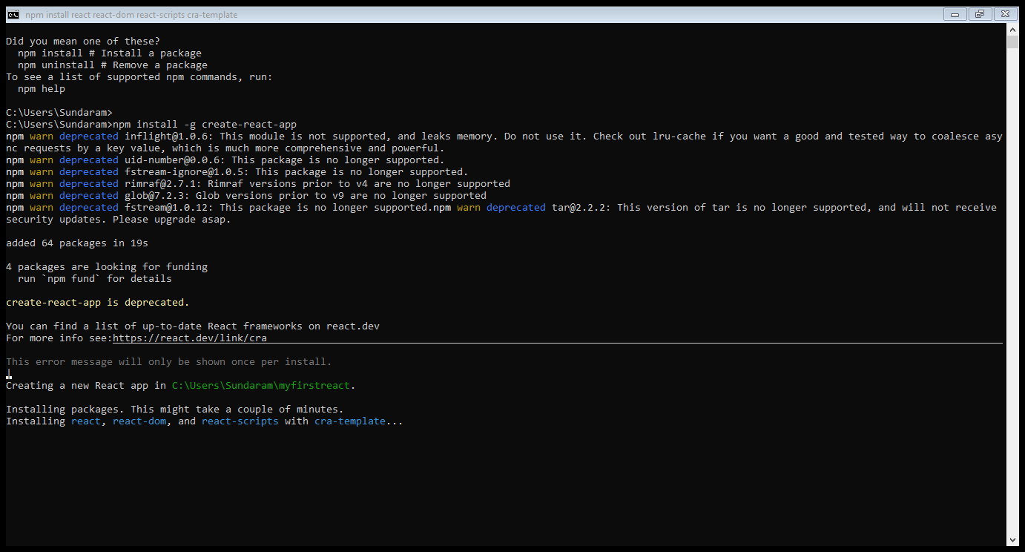

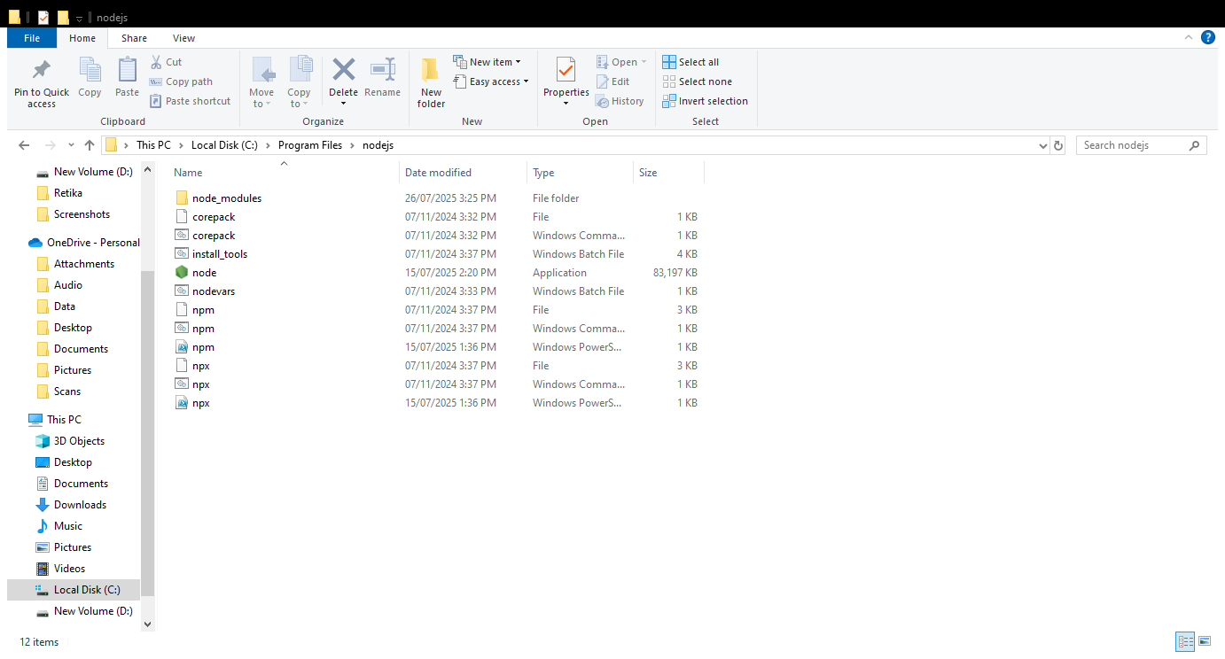

npm install –g create-react-app

npx create-react-app myfirstreact

cd myfirstreact

**App.js**

function App(){

return( <h1> Welcome to the first session of react </h1> );

}

npm start

**Exercise 2**

npx create-react-app StudentApp

**Home.js**

import React, {Component} from ‘react’;

import class Home extends Component{

render(){

<div>

<h3> Welcome to the home page of Student Mnagement Portal </h3>

</div>

}

}

About.js

import logo from ‘./logo.svg’;

import ‘./App.css’;

import {Home} from ‘./Components/Home’;

import {About} from ‘./Components/About’;

import {Conatct} from ‘./Components/Contact’;

function App(){

return(

<div className=”container”>

<Home/>

<About/>

<Contact/>

</div>

);

}

export default App;

npm start

**Exercise 3**

npx create-react-app scorecalculatorapp

**CalculateScore.js**

import ‘./Stylesheets/mystyle.css’

const percentToDecimal= (decimal) =>{

return (decimal.toFixed(2)+’%’)

}

const calcScore = (total,goal) =>{

return percentToDecimal(total/goal)

}

export const CalculateScore= {Nmae,School,total,goal})=>(

<div classNmae=”formatstyle”>

,h1><font color=”Brown”>Student Details:</font></h1>

<div className=”Name”>

<b><span>Name:</span></b>

<span>{Name}</span>

</div>

<div className=”School”>

<b><span>School: </span></b>

<span>{School}</span>

</div>

<div className=”Total”>

<b><span>Total:</span></b>

<span>{total}</span>

<span>Marks</span>

</div>

<div className=”Score”>

<b>Score:</b>

<span>

{calcScore(total,goal)}

</span>

</div>

</div>

**mystyle.css**

.Name{

font-weight:300;

color:blue;

}

.School{

color:crimson;

}

.Total{

color:darkmagenta;

}

.formatstyle{

text-align:center;

font-size:large;

}

.Score{

color:forestgreen;

}

**App.js**

import {CalculateScore} from ‘../src/components/CalculateScore’;

function App(){

return(

<div>

<CalculateScore Name={“Steeve”}

School={“DNV Public School”}

total={284}

goal={3}

/>

</div>

)

}

export default App;

npm start

**Exercise 4**

npx create-react-app blogapp

Modify Post.js and all the required components

npm start

**Exercise 5**

Download cohorttracker.zip provided.

Unzip the application.

Open the application

Create the CohortDetails.module.css file

Run the application