# Building future landscapes to assess impact of land use land cover change on provisioning of ecosystem services

Reto Schmucki1

1 CEH, Benson Lane, MacLean Building, Wallingford, OX10 8BB, UK

### Abstract

LULC change models (Schmucki *et al.* 2016) may become fundamental (Aquilué *et al.* 2017) tools to accurately inform policy makers and land managers committed to sustainable development, biodiversity conservation $\sqrt{27}$ and regional assessments of ecosystem services provisioning.

### Introduction

Land use are dynamics and change in configuration (Phillips *et al.* 2017) and history of land use have important impact on provisioning of $X_{i,j}^{2}$ ecosystem services.

a <- 2+4  
b <- 1/sqrt(4)  
c <- a/b

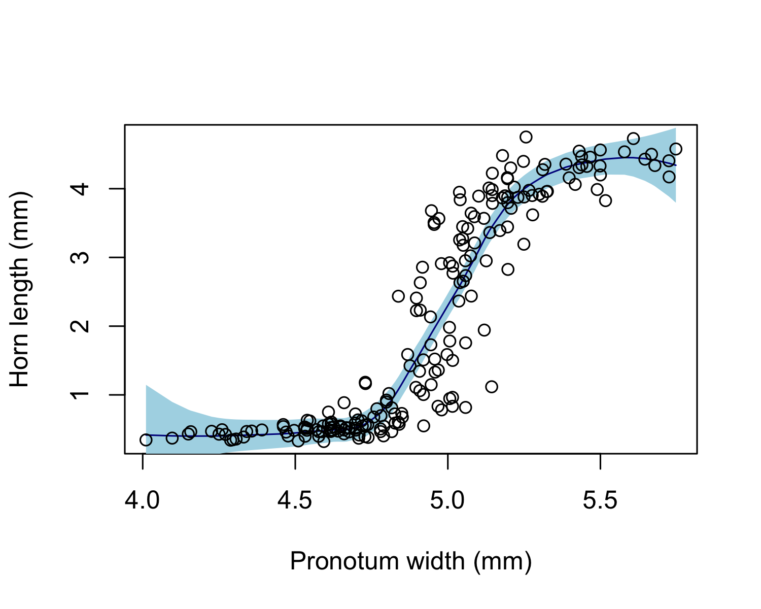

The super result table

|  |  |  |
| --- | --- | --- |
| Header 1 | Header 2 | Header 3 |
| 0.819 | 0.088 | 0.808 |
| 1.738 | -1.672 | 0.674 |
| 1.354 | -0.640 | -0.780 |
| 0.676 | 1.350 | -0.565 |
|  |  |  |

### References

Aquilué, N., De Cáceres, M., Fortin, M.-J., Fall, A. & Brotons, L. (2017) A spatial allocation procedure to model land-use/Land-cover changes: Accounting for occurrence and spread processes. *Ecological Modelling*, **344**, 73–86.

Phillips, S.J., Anderson, R.P., DudÍk, M., Schapire, R.E. & Blair, M.E. (2017) Opening the black box: An open-source release of Maxent. *Ecography*, n/a–n/a.

Schmucki, R., Pe’er, G., Roy, D.B., Stefanescu, C., Van Swaay, C.A., Oliver, T.H., Kuussaari, M., Van Strien, A.J., Ries, L., Settele, J., Musche, M., Carnicer, J., Schweiger, O., Brereton, T.M., Harpke, A., Heliölä, J., Kühn, E. & Julliard, R. (2016) A regionally informed abundance index for supporting integrative analyses across butterfly monitoring schemes. *Journal of Applied Ecology*, **53**, 501–510.