Building future landscapes to assess impact of land use land cover change on provisioning of ecosystem services

Reto Schmucki

# Abstract

LULC change models may become fundamental tools to accurately inform policy makers and land managers committed to sustainable development, biodiversity conservation and regional assessments of ecosystem services provisioning.

# Introduction

Land use are dynamics and change in configuration and history of land use have important ~~impact on provisioning of~~ ecosystem services.

a <- 2+4  
b <- 1/sqrt(4)  
c <- a/b

# Wessex study region

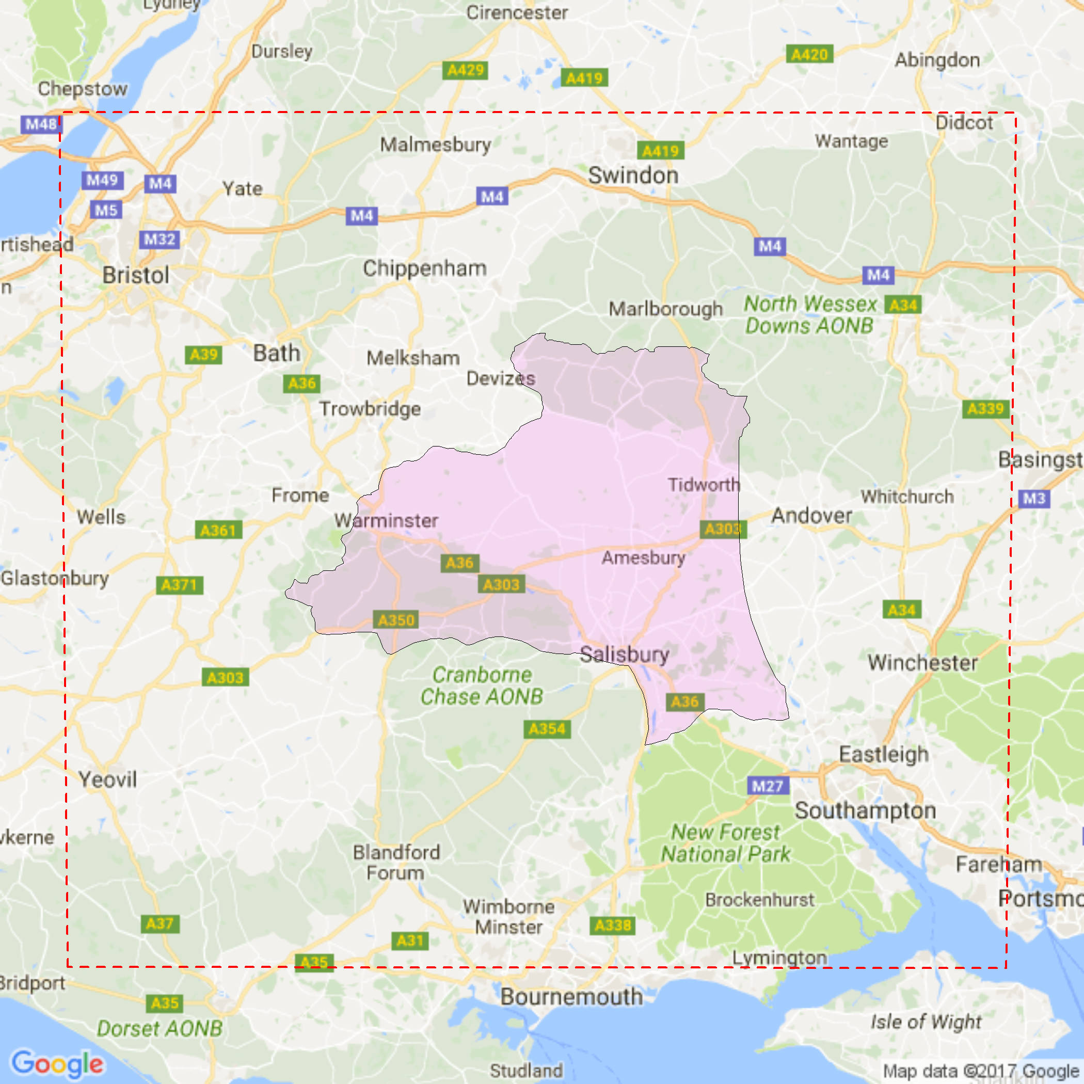

Wessex region