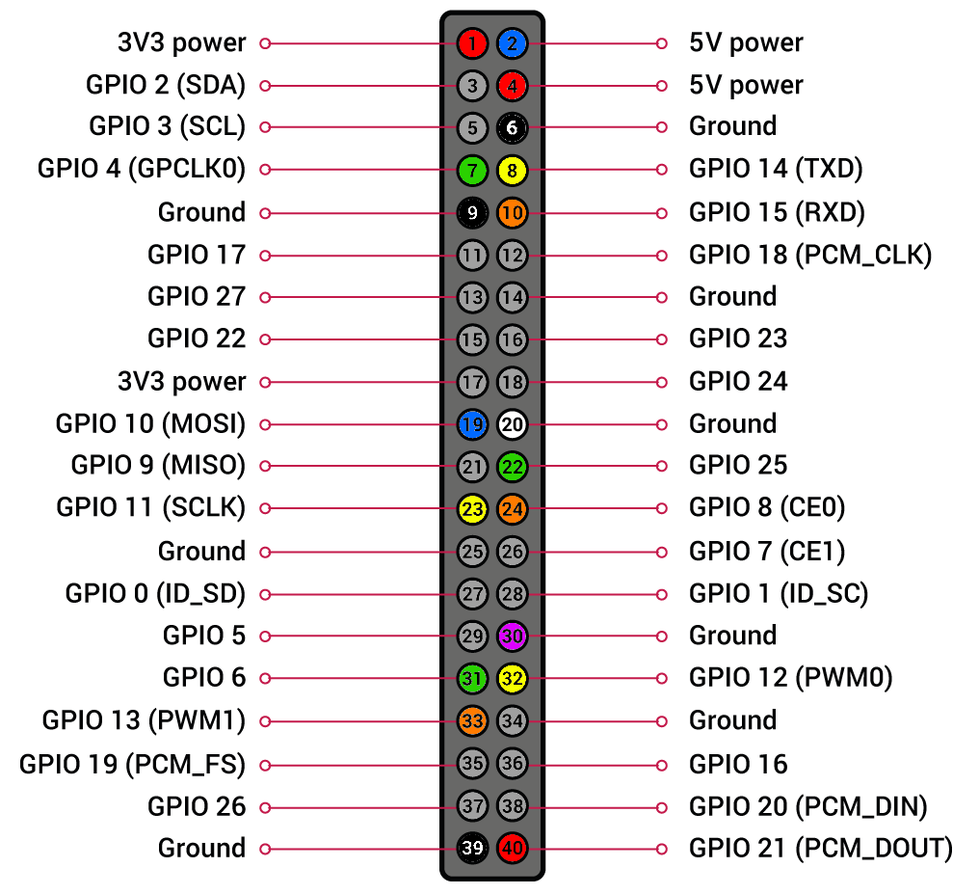**Pin-Belegung**

|  |  |  |
| --- | --- | --- |
| **PIN** | **Farbe** | **Bezeichnung** |
| 1 | **ROT** | 3,3V (Lüfter) |
| 2 | **BLAU** | 5V (Drehregler) |
| 4 | **ROT** | 5V (Touch-Dis) |
| 6 | **SCHWARZ** | GROUND (Touch-Display) |
| 7 | **GRÜN** | SW (Drehregler Bass UP) |
| 8 | **GELB** | DT (Drehregler Bass DOWN) |
| 9 | **SCHWARZ** | GROUND (Lüfter) |
| 10 | **ORANGE** | CLK (Drehregler Bass RESET) |
| 19 | **BLAU** | Daten (LED-Streifen) |
| 20 | **WEISS** | GROUND (LED-Streifen) |
| 22 | **GRÜN** | SW (Drehregler Höhe UP) |
| 23 | **GELB** | DT (Drehregler Höhe DOWN) |
| 24 | **ORANGE** | CLK (Drehregler Höhe RESET) |
| 30 | **LILA** | GROUND (Drehregler) |
| 31 | **GRÜN** | SW (Drehregler Vol. UP) |
| 32 | **GELB** | DT (Drehregler Vol. DOWN) |
| 33 | **ORANGE** | CLK (Drehregler Vol. An/Aus) |
| 39 | **SCHWARZ** | GROUND (Button Trinkspruch) |
| 40 | **ROT** | Daten (Button Trinkspruch) |