2025-11-08
Eric Petersen

LAB 08: SUB-LIST SORT ANALYSIS

Step 1: Modularization Metrics
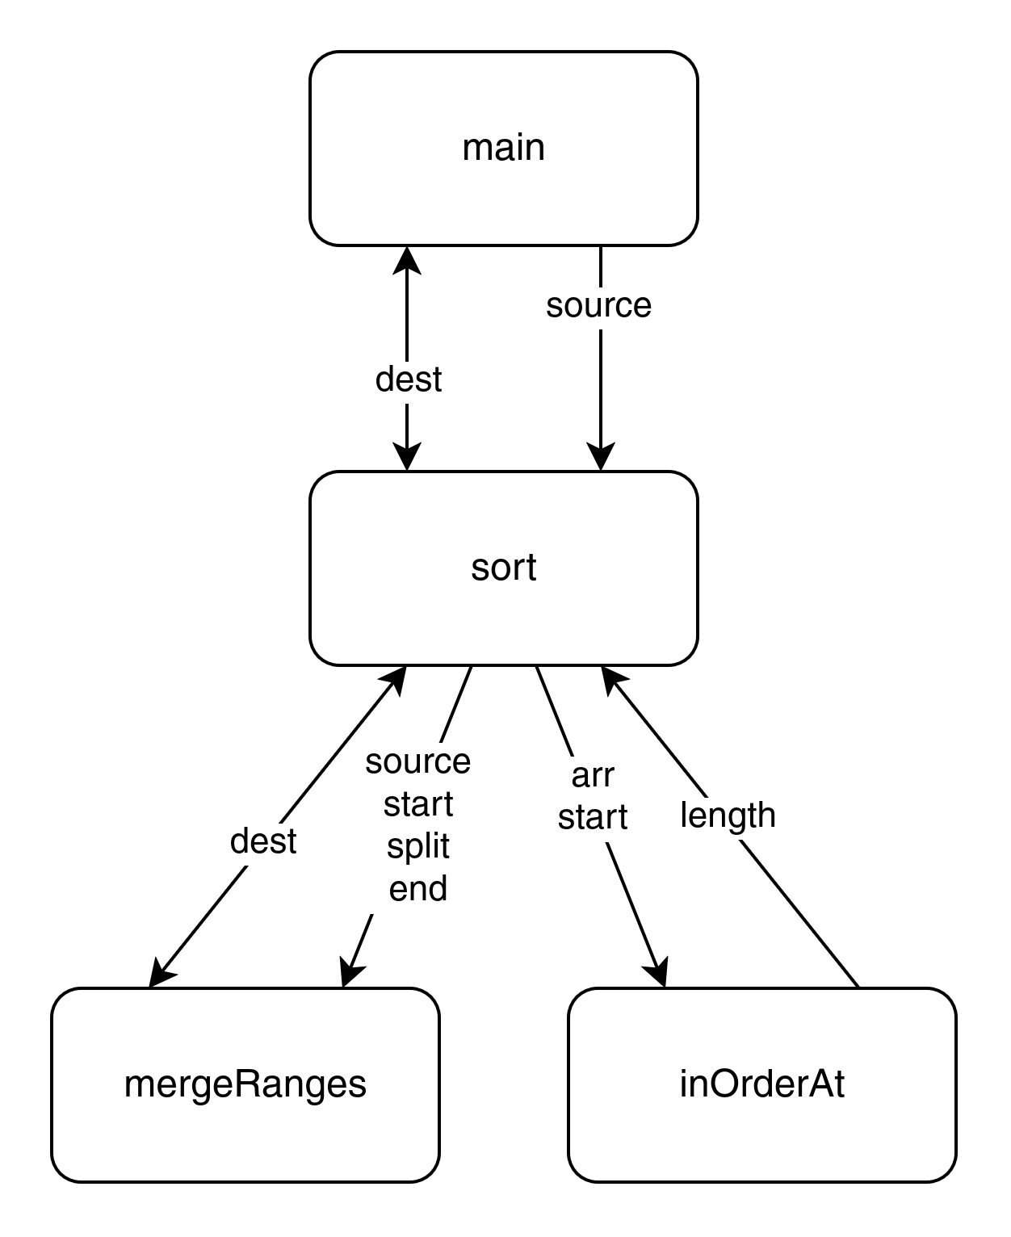
main - The main function has strong cohesion by definition, as it performs one task completely and only that task. The main function has trivial coupling as no values are passed to or from main.

sort - The sort function has strong cohesion, as it sorts the input source list into the dest list, and performs no other actions. The sort function has simple coupling as the source and dest parameters are easy to select and and interpret, with the only requirement keeping this from being encapsulated being the requirement of matching lengths between the two array parameters.

mergeRanges - The mergeRanges function has strong cohesion, as it merges the two ranges denoted by [start, split) and [split, end) from source into dest. The mergeRanges function has simple coupling as each parameter is easy to supply and interpret, although each parameter value must require validation.

inOrderAt - The inOrderAt function has strong cohesion, as it returns the length of the in-order sublist at a certain index, and only performs that task - nothing else. The inOrderAt function has simple coupling as each parameter is easy to select and interpret, yet the index parameter must be validated to be less than or equal to the length of the arr parameter.
Step 2: Algorithmic Metrics
PROCEDURE mergeRanges(source, dest, start, split, end) // The mergeRanges function is O(N)
// ASSERT 0 <= LENGTH(source) == LENGTH(dest)
// ASSERT start <= split <= end <= LENGTH(source)

IF split == start or split == end THEN // O(1)
dest[start:end] <- source[start:end] // O(1) * O(N)
RETURN // O(1)
ENDIF

left <- start // O(1)
right <- split // O(1)
index <- start // O(1)
// While loop runs at most O(N) times. This is because one of left or right is incremented
// each loop, and the loop terminates when left == split or right == end, which is at most
// end - start iterations, which is N.
WHILE left < split and right < end DO
IF source[left] <= source[right] THEN // O(N) * O(1)
dest[index] <- source[left] // O(N) * O(1)
left <- left + 1 // O(N) * O(1)
ELSE
dest[index] <- source[right] // O(N) * O(1)
right <- right + 1 // O(N) * O(1)
ENDIF
index <- index + 1 // O(N) * O(1)
ENDWHILE

WHILE right < end DO // O(N) as right is incremented until == end, which is <= N
dest[index] <- source[right] // O(N) * O(1)
index <- index + 1 // O(N) * O(1)
right <- right + 1 // O(N) * O(1)
ENDWHILE

WHILE left < split DO // O(N) as left is incremented until == split, which is <= N
dest[index] <- source[left] // O(N) * O(1)
index <- index + 1 // O(N) * O(1)
left <- left + 1 // O(N) * O(1)
ENDWHILE
ENDPROCEDURE

PROCEDURE inOrderAt(arr, start) // inOrderAt is O(N)
// ASSERT 0 <= start <= LENGTH(arr)

index <- start + 1 // O(1)
WHILE index < LENGTH(arr) DO // While loop is O(N) as index is repeatedly incremented until N
IF arr[index] < arr[index - 1] THEN // O(1)
RETURN index - start // O(N) * O(1)
ENDIF
index <- index + 1 // O(N) * O(1)
ENDWHILE
RETURN LENGTH(arr) - start // O(1)
ENDPROCEDURE

PROCEDURE sort(source, dest) // sort is O(N * LOG(N))
// ASSERT LENGTH(source) == LENGTH(dest)

WHILE TRUE DO // At most O(Log(N)) overall because each iteration cuts the problem in half
IF inOrderAt(source, 0) == LENGTH(source) THEN // O(N) because of inOrderAt
dest[:] <- source // O(Log(N)) * O(N)
RETURN // O(Log(N)) * O(1)
ENDIF

start <- 0 // O(Log(N)) * O(1)
// While loop is overall O(N) bcause O(A) * O(B) is O(N)
WHILE start < LENGTH(source) DO // O(Log(N)) * O(B) because start is set to end until N
split <- start + inOrderAt(source, start) // O(Log(N)) * O(B) * O(A) because inOrderAt
end <- split + inOrderAt(source, split) // O(Log(N)) * O(B) * O(A) because inOrderAt
mergeRanges(source, dest, start, split, end) // O(Log(N)) * O(B) * O(A)
start <- end // O(Log(N)) * O(B) * O(1)
ENDWHILE

source <- dest // O(Log(N)) * O(1)
ENDWHILE
ENDPROCEDURE
Step 3. Test
Testing Array:

Function | Test Type | Provided Input | Expected Output
mergeRanges | normal | ([1,2,3,4,5], [0,0,0,0,0], 0, 0, 3) | dest is now [1,2,3,0,0]
mergeRanges | normal | ([5,4,3,2,1], [0,0,0,0,0], 0, 1, 2) | dest is now [4,5,0,0,0]
mergeRanges | normal | ([3,4,5,1,2], [0,0,0,0,0], 0, 3, 5) | dest is now [1,2,3,4,5]
mergeRanges | error | ([1,2,3,4,5], [], 0, 0, 0) | assertion error
mergeRanges | error | ([1,2,3,4,5], [0,0,0,0,0], 0, 0, 100) | assertion error
mergeRanges | error | ([], [0,0,0,0,0], 0, 0, 0) | assertion error
mergeRanges | boundary | ([1,2,3,4,5], [0,0,0,0,0], 0, 0, 0) | dest is now [0,0,0,0,0]
mergeRanges | boundary | ([], [], 0, 0, 0) | dest is now []
mergeRanges | boundary | ([1], [0], 0, 0, 1) | dest is now [1]
inOrderAt | normal | ([1,2,3,4,5], 0) | 5
inOrderAt | normal | ([1,2,3,4,5], 3) | 2
inOrderAt | normal | ([1,2,5,0,0], 0) | 3
inOrderAt | error | ([1,2,3,4,5], -10) | assertion error
inOrderAt | error | ([1,2,3,4,5], 10) | assertion error
inOrderAt | boundary | ([1,2,3,4,5], 5) | 0
inOrderAt | boundary | ([], 0) | 0
sort | normal | ([1,2,3,4,5], [0,0,0,0,0]) | dest is [1,2,3,4,5]
sort | normal | ([5,4,3,2,1], [0,0,0,0,0]) | dest is [1,2,3,4,5]
sort | normal | ([5,1,4,3,2], [0,0,0,0,0]) | dest is [1,2,3,4,5]
sort | error | ([1,2,3,4,5], []) | assertion error
sort | error | ([], [0, 0, 0, 0, 0]) | assertion error
sort | boundary | ([], []) | dest is []
sort | boundary | ([0], [0]) | dest is [0]
sort | boundary | ([5,5,5,5,5], [0,0,0,0,0]) | dest is [5,5,5,5,5]

Automation Drivers:

def test_mergeRanges() -> None:
tests = [
([1,2,3,4,5], [0,0,0,0,0], 0, 0, 3, [1,2,3,0,0]),
([5,4,3,2,1], [0,0,0,0,0], 0, 1, 2, [4,5,0,0,0]),
([3,4,5,1,2], [0,0,0,0,0], 0, 3, 5, [1,2,3,4,5]),
([1,2,3,4,5], [], 0, 0, 0, "assertion error"),
([1,2,3,4,5], [0,0,0,0,0], 0, 0, 100, "assertion error"),
( [], [0,0,0,0,0], 0, 0, 0, "assertion error"),
([1,2,3,4,5], [0,0,0,0,0], 0, 0, 0, [0,0,0,0,0]),
( [], [], 0, 0, 0, []),
( [1], [0], 0, 0, 1, [1]),
]

for test in tests:
source, dest, start, split, end, expected = test
try:
mergeRanges(source, dest, start, split, end)
assert dest == expected
except AssertionError:
assert expected == "assertion error"

def test_inOrderAt() -> None:
tests = [
([1,2,3,4,5], 0, 5),
([1,2,3,4,5], 3, 2),
([1,2,5,0,0], 0, 3),
([1,2,3,4,5], -10, "assertion error"),
([1,2,3,4,5], 10, "assertion error"),
([1,2,3,4,5], 5, 0),
( [], 0, 0),
]

for test in tests:
arr, start, expected = test
try:
result = inOrderAt(arr, start)
assert result == expected
except AssertionError:
assert expected == "assertion error"

def test_sort() -> None:
tests = [
([1,2,3,4,5], [0,0,0,0,0], [1,2,3,4,5]),
([5,4,3,2,1], [0,0,0,0,0], [1,2,3,4,5]),
([5,1,4,3,2], [0,0,0,0,0], [1,2,3,4,5]),
([1,2,3,4,5], [], "assertion error"),
( [], [0,0,0,0,0], "assertion error"),
( [], [], []),
( [0], [0], [0]),
([5,5,5,5,5], [0,0,0,0,0], [5,5,5,5,5]),
]

for test in tests:
source, dest, expected = test
try:
sort(source, dest)
assert dest == expected
except AssertionError:
assert expected == "assertion error"

def runTests() -> None:
test_inOrderAt()
test_mergeRanges()
test_sort()

if __name__ == "__main__":
runTests()

