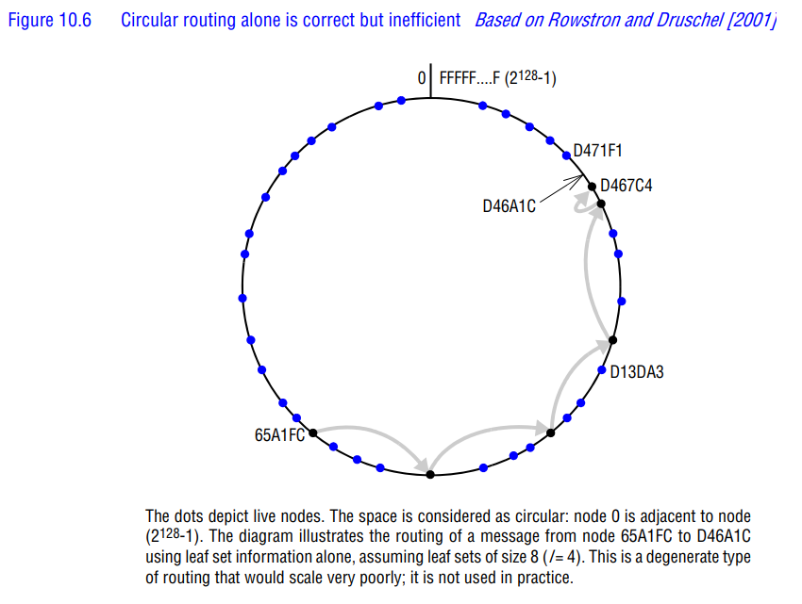

Example Breakdown
- Starting Point:
  - Source node: 65A1FC
  - Destination node: D46A1C
  - The nodes are arranged in a circular GUID space from 0 to 2^128-1

- Routing Path (shown by gray arrows):
  - Node 65A1FC → D13DA3 → D4213F → D46A1C

- How It Works:
  - First Hop: From 65A1FC to D13DA3
    - Matches first hex digit ‘D’ of destination
    - Uses routing table to find node starting with ‘D’
  - Second Hop: From D13DA3 to D4213F
    - Extends matching prefix to ‘D4’
    - Routes to node sharing more digits with destination
  - Final Hop: From D4213F to D46A1C
    - Reaches destination node D46A1C
    - Each hop brought message closer in GUID space

- Efficiency:
  - The routing takes ~log16(N) hops because:
    - Each hop matches at least one more hex digit
    - With 16 possible hex digits per position
    - In a network of N nodes, reaching destination takes logarithmic steps

- Key Features Demonstrated:
  - Prefix-based routing
  - Progressive convergence to destination
  - Logarithmic routing efficiency
  - Circular nature of GUID space
This example shows how Pastry efficiently routes messages using prefix matching and its routing table structure, achieving logarithmic performance in the number of network nodes.

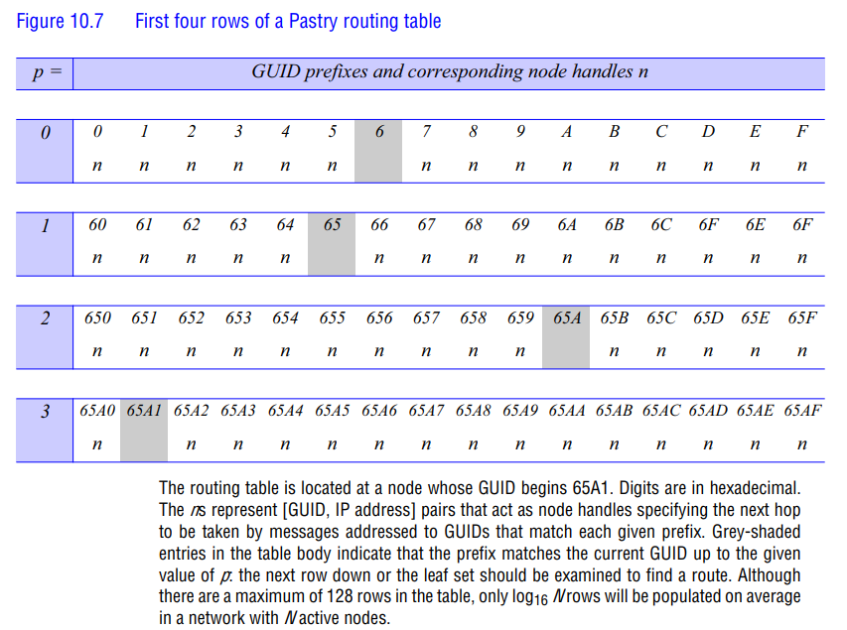

Structure and Key Elements
- Node Location
    - The routing table belongs to a node with GUID beginning with “65A1”
  - All digits are in hexadecimal (0-F)
- Table Organization
  - Rows §: Shows first 4 rows (p = 0 to 3) of possible 128 rows
  - Columns: 16 columns (0-F) representing all possible hex digits
  - Each cell contains ‘n’ representing a [GUID, IP address] pair
- Row-by-Row Breakdown
  - Row 0 (p=0):
    - Contains nodes with different first digits
    - Grey-shaded entry at ‘6’ (matches first digit of current node)
  - Row 1 (p=1):
    - All entries start with ‘6’
    - Different second digits (0-F)
    - Grey-shaded at ‘65’ (matches first two digits)
  - Row 2 (p=2):
    - All entries start with ‘65’
    - Grey-shaded at ‘65A’ (matches first three digits)
  - Row 3 (p=3):
    - All entries start with ‘65A’
    - Grey-shaded at ‘65A1’ (matches first four digits)
- Special Features
  - Grey-shaded entries: Indicate where prefix matches the current node’s GUID
  - Node handles (n): Each entry contains both GUID and IP address for routing
  - Population: Though table has 128 rows, only log₁₆(N) rows are typically populated
- Routing Logic
  - Each row progressively matches more digits with destination
  - Non-shaded entries provide next-hop options
  - When encountering a shaded entry, algorithm moves to next row or leaf set

Example Usage
For routing to destination “D46A1C” from node “65A1”:
- First look at row 0 to find entry starting with ‘D’
- Then row 1 to match ‘D4’
- Continue until reaching closest match or leaf set
This structure enables efficient O(log₁₆N) routing by matching one additional hex digit at each hop.

