**Colorspaces**



Linear – each vertical bar difference is constant



Gamma correction – difference between each bar is different (based on a curve)

You author in gamma, but you do calculations for rendering in linear (this improves accuracy).

You author in gamma because human vision is nonlinear.

When compared with a camera or digital screen human eyes are much more sensitive to changes in darker tones then similar changes in brighter tones. This is basically because the sun is so bright. If we were equally sensitive to bright vs dark tones going outside would be too overwhelming for our eyes.

Gamma correction takes a linear image and applies a curve to that so it matches how the eyes would see this image. This is always done in the expectation the image will be viewed on a computer scene.

So, when we work on digital content and texture authoring a gamma curve is always being applied. Working in sRGB color space means a gamma curve is applied. This is so it looks more accurate to your eye. This makes authoring easier, but rendering complicated.

To counter this when you import into a 3d engine the gamma curve is removed from the texture and reapplied by the shading model. If you are working this way you say you are working in a linear workflow. Linear workflows are the modern standard in real time graphics today.

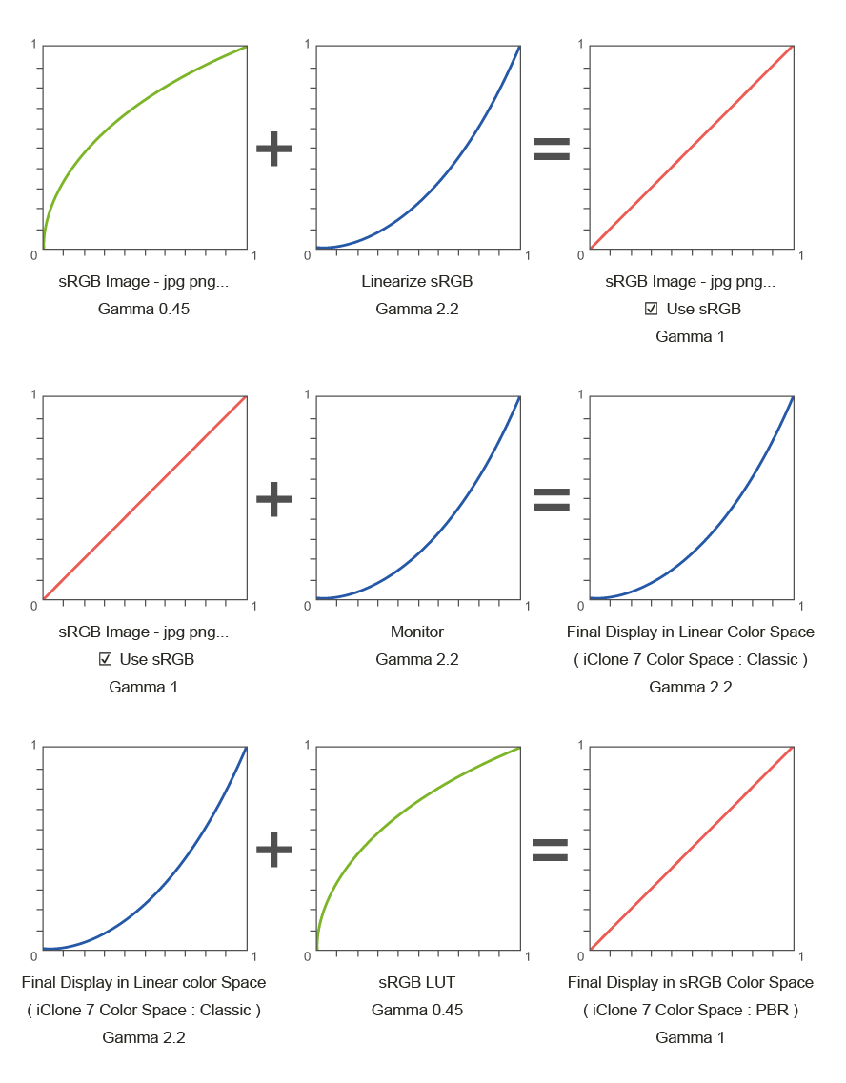

Gamma - unlit

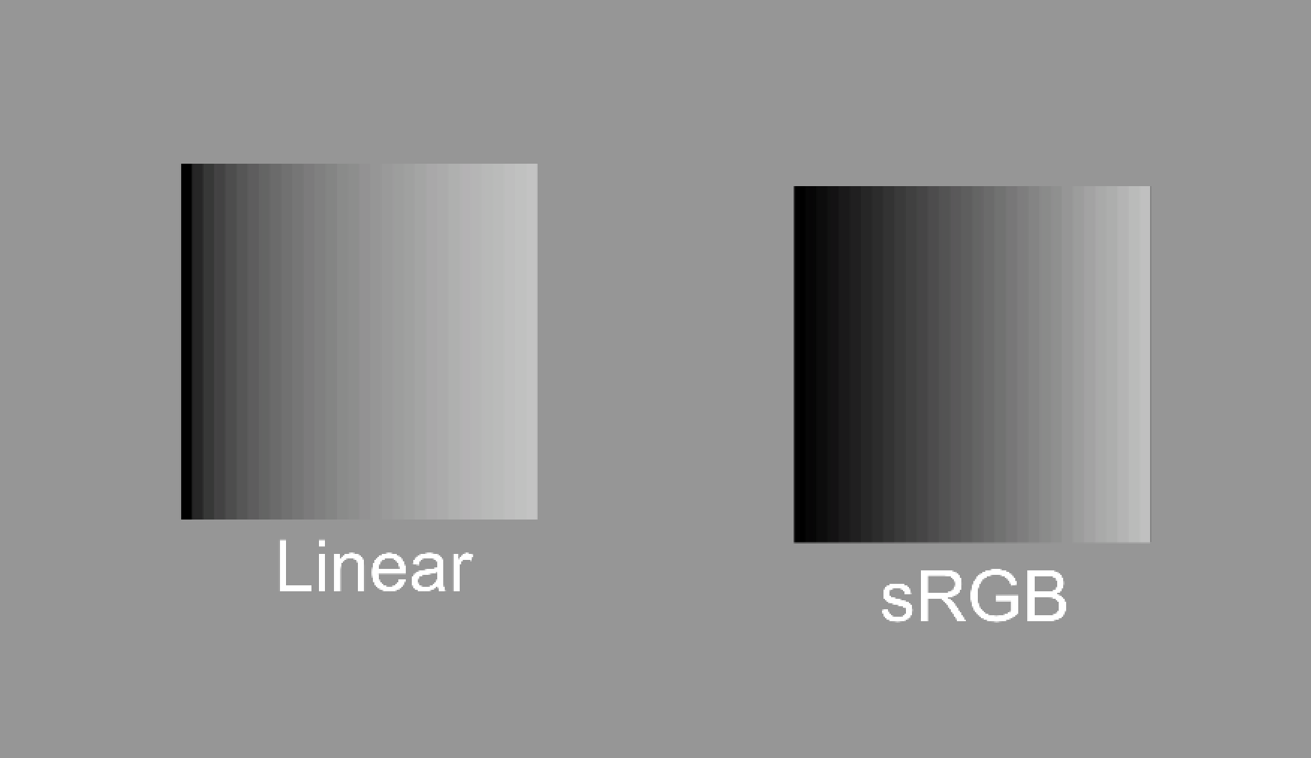

Gamma - lit

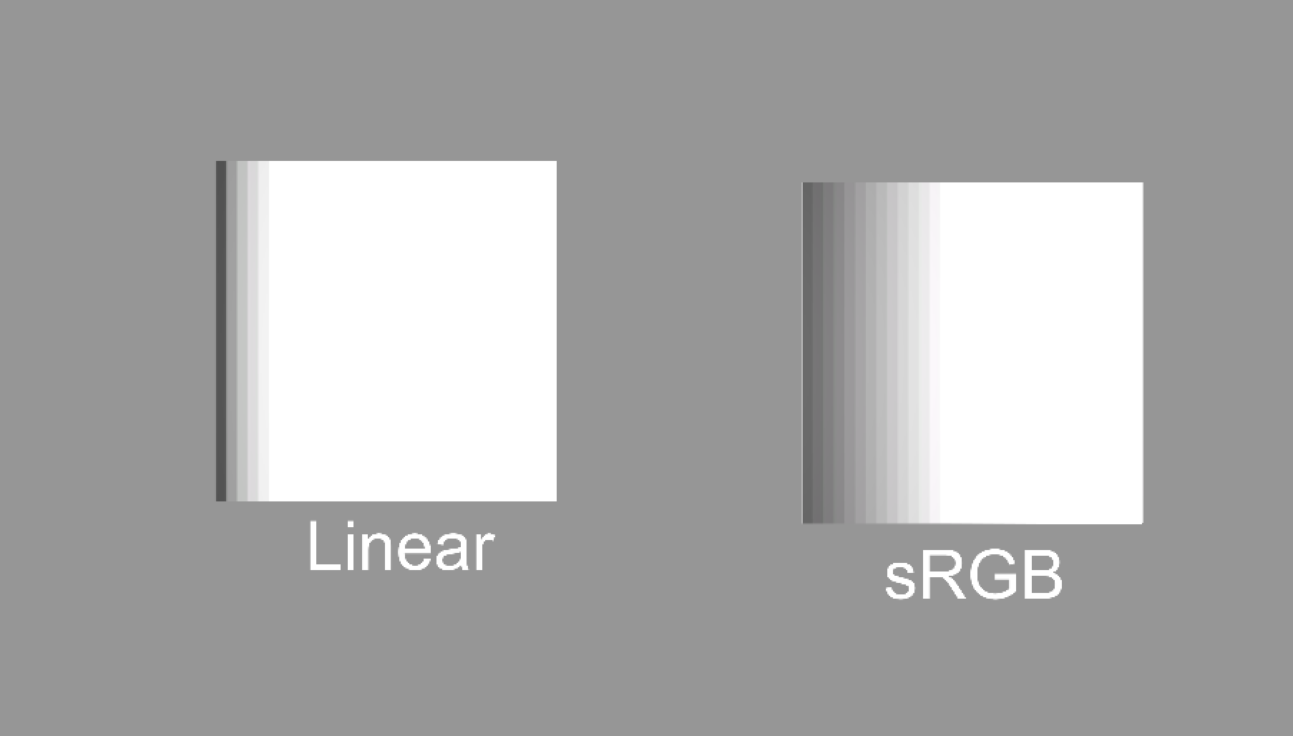

Gamma – lit + tonemapping

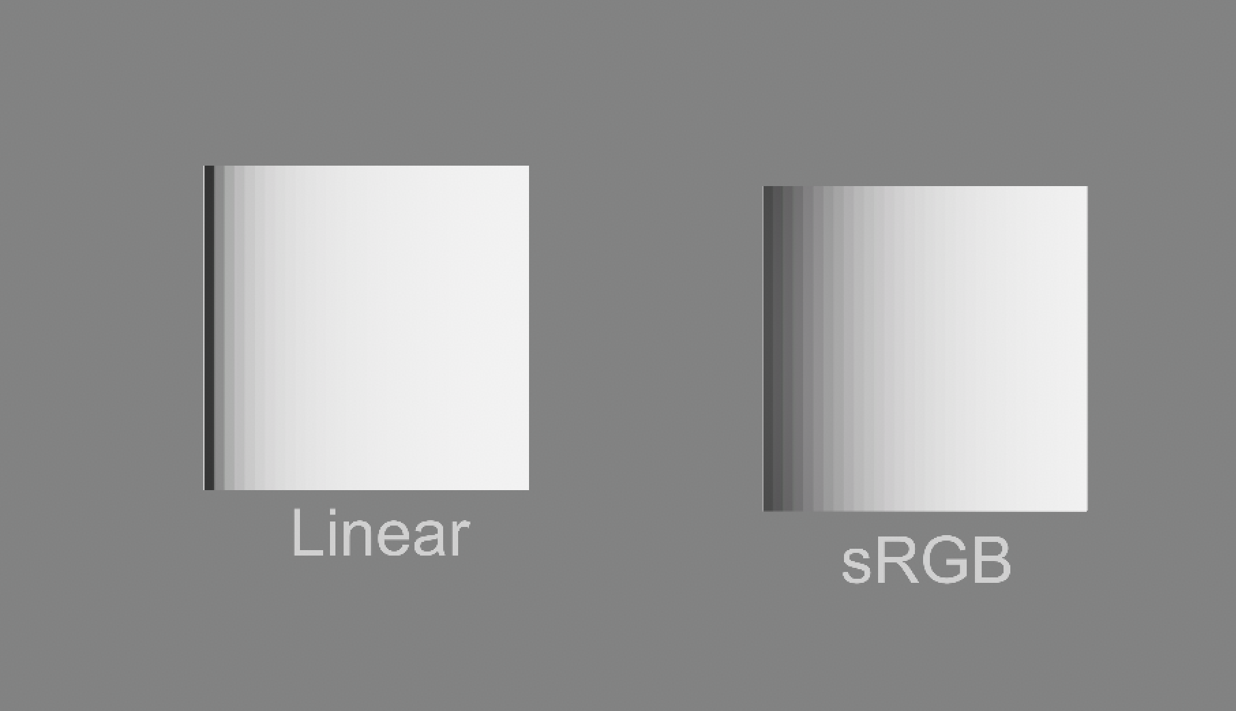

Linear – unlit

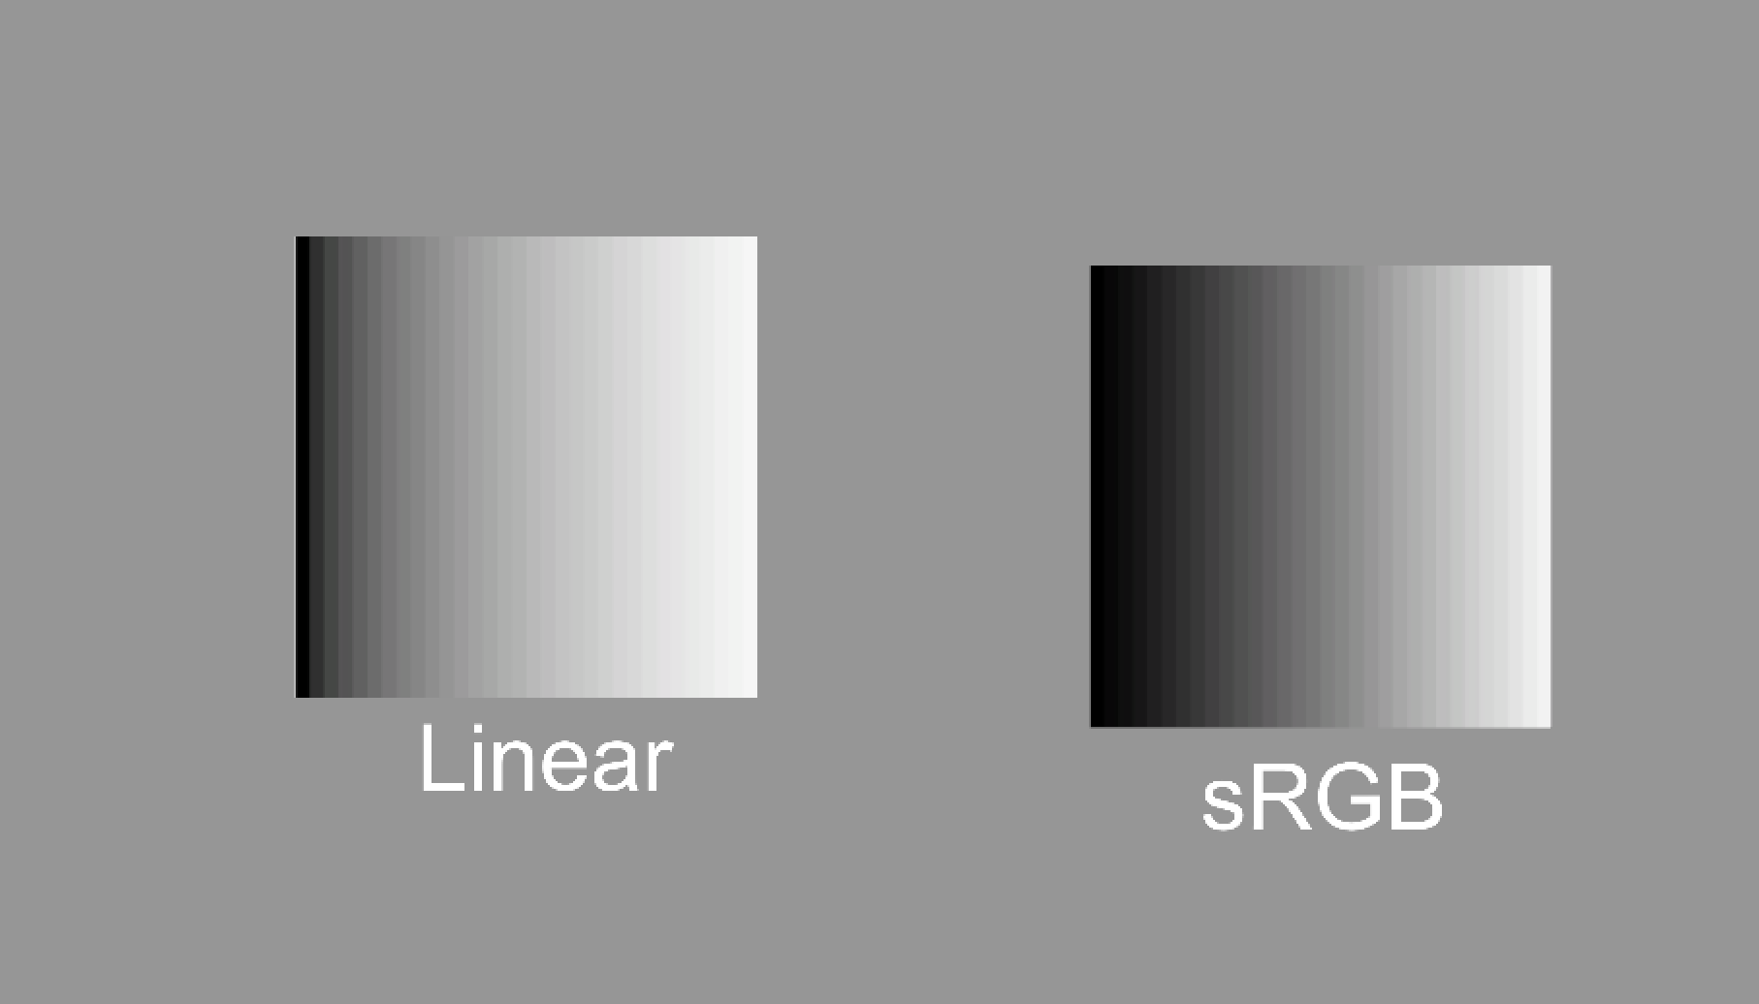

Linear – lit

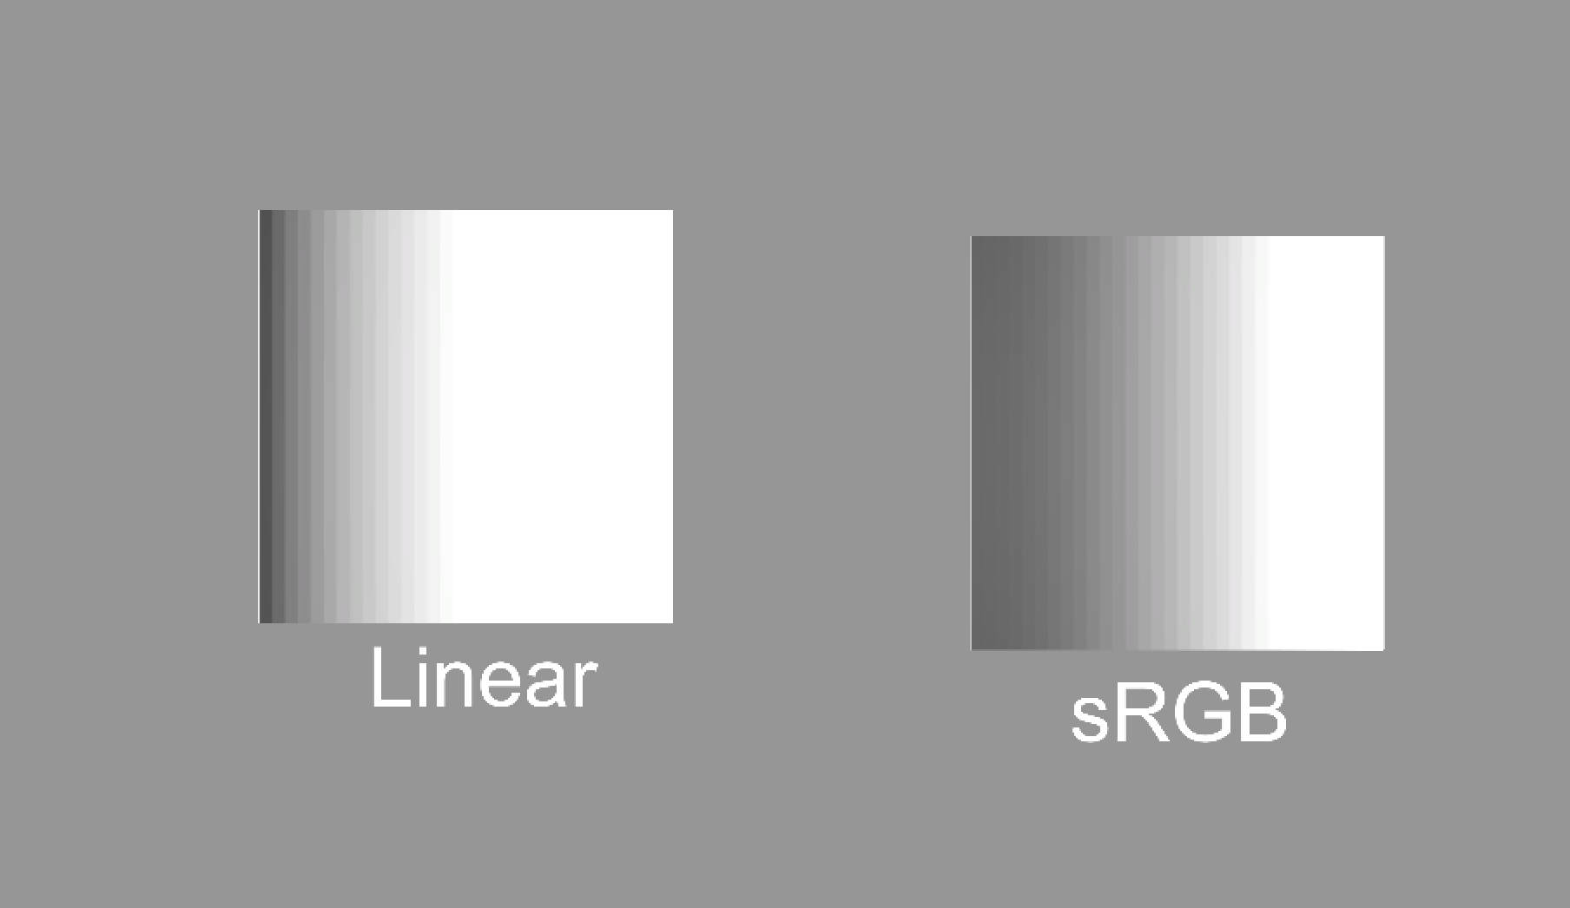

Linear – lit + tonemapping

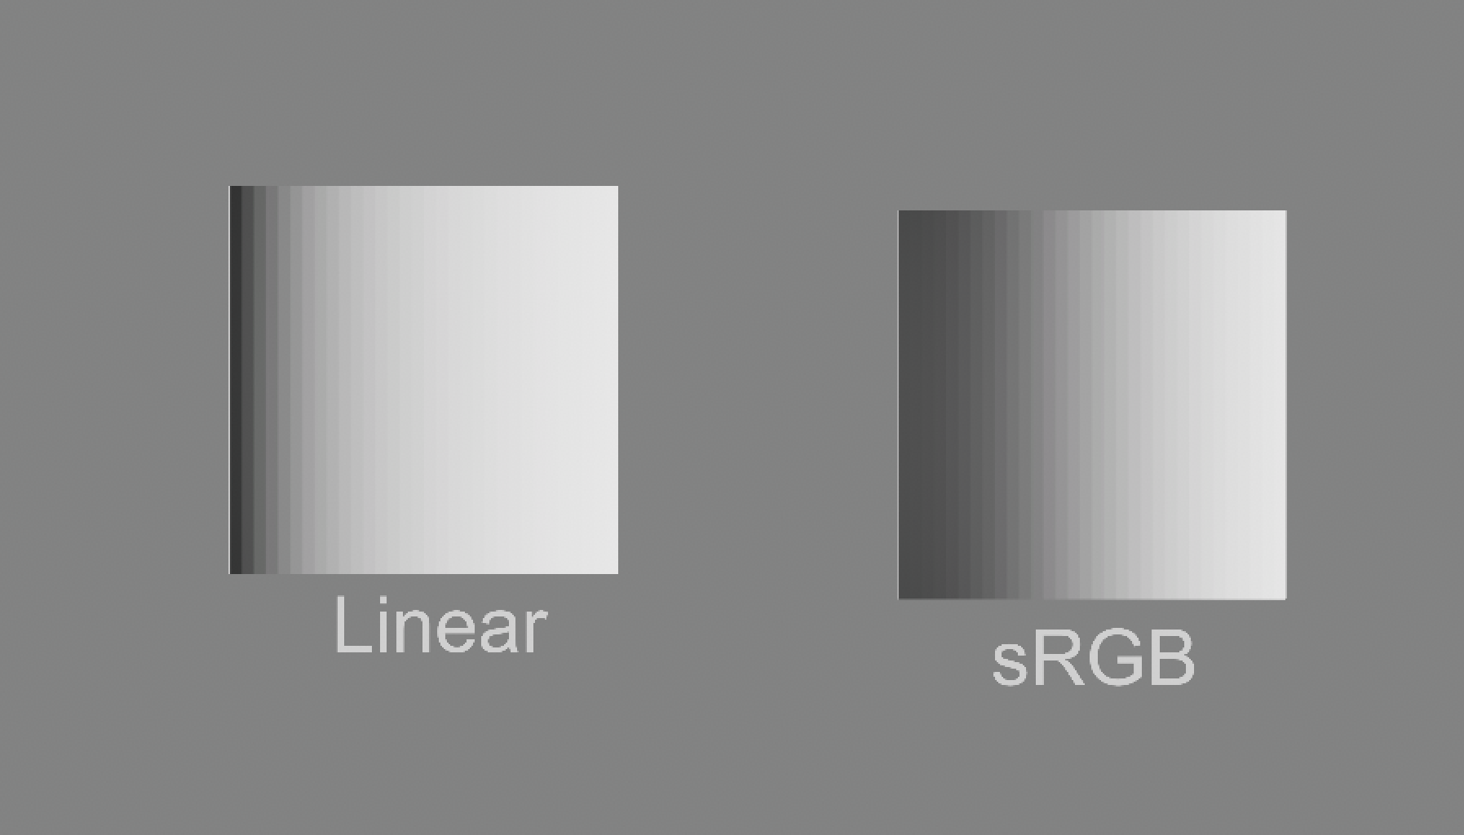

**Tone mapping**:

Notice how even in linear space bright colors quickly become blown out as light is adding.

*Special note: In a Physically based shading workflow (the modern standard) – values should never be true black or true white. These values do not render accurately.*

*The range here shows 50 – 243 and is in the expected sRGB authoring range for PBR.*

**

*So, in the images above our min and max values will never look quite right.*

Tone mapping takes one set of values and maps it to another.

You want to apply tone mapping as soon as you start lighting a digital scene.

The full range of light intensities the eye can preserve is much large then modern screens can render.

When you tone map a scene you are remapping the values to approximate the appearance of high dynamic range. This allows more variation to be perceivable in very bright areas.