By default, it’s set to 10 seconds since that’s my attention span lol you can ask me how to edit it if you can’t figure it out

You will need to upload your pics into the “pics” folder. By default, there will be some cool animal pictures I placed in there as a placeholder 😊 feel free to change them out!

To setup a task in task scheduler for this program you can follow along with the pictures and text at the bottom.

*********START BY CREATING A BASIC TASK***************

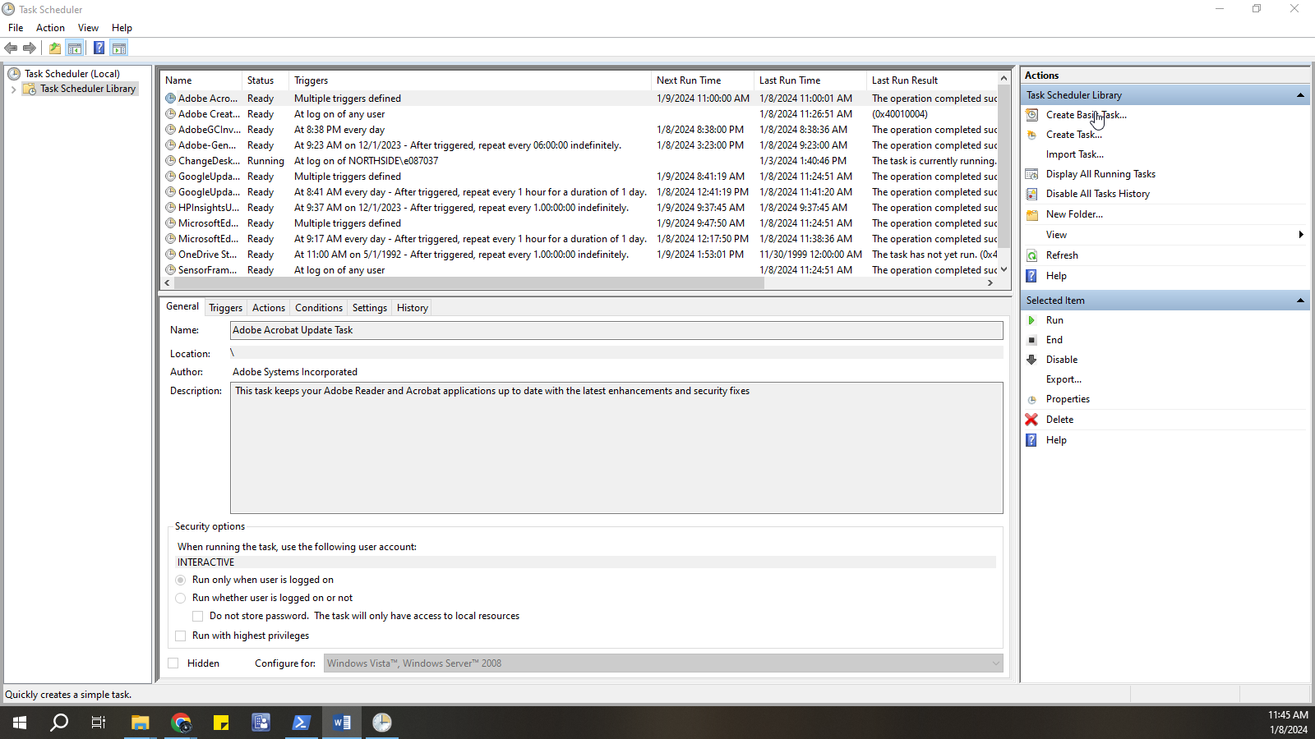

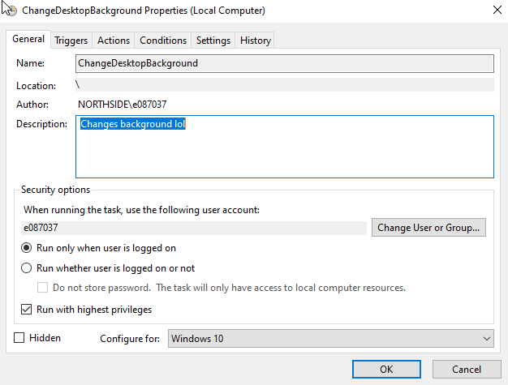

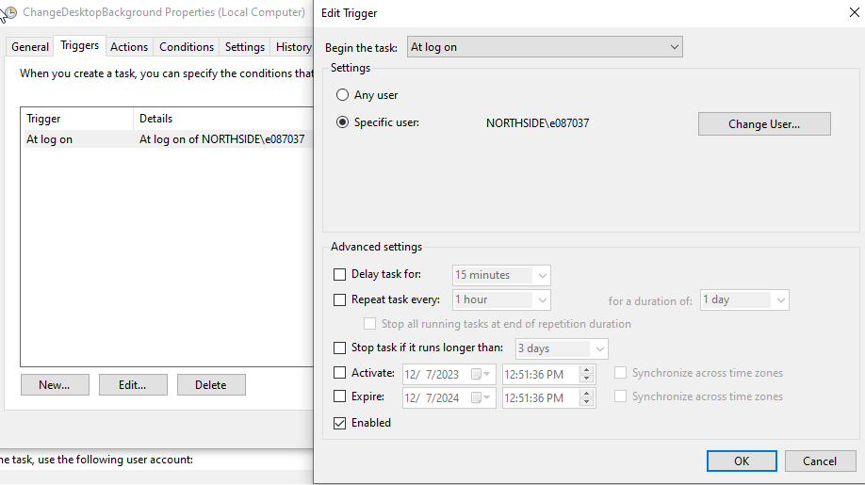

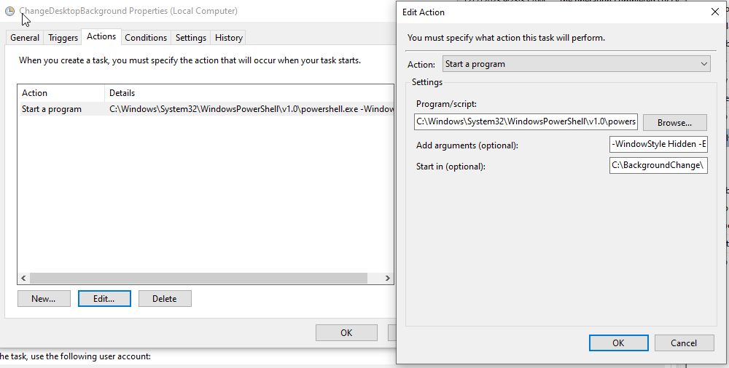

**1. For the “Program/Script” section input:**   
  
C:\Windows\System32\WindowsPowerShell\v1.0\powershell.exe  
  
**2. For the “Add arguments (optional)”:**  
-WindowStyle Hidden -ExecutionPolicy Bypass -File "C:\BackgroundChange\main.ps1"

**3. For the “Start in (optional)”:**   
C:\BackgroundChange\  
  
  
ENJOY!!!!