**Installation & Configuration Manual**

**For Client's IT Department s/w Maintenance Engineer**

**20 November 2024**

## 

**Team Members:**

Kavyanjali 2203390

Koh Chun Ince 2200960

Caleb Lee Jia Le 2201250

Muhammad Muslinmin Bin Mohd Saleh 2201360

Reuben Low Yu Xiang 2200931

Stafford Ho Sheng Xian 2201218

Yugendren S/o Sooriya Moorthi 2201512

## 

1 Development Environment Setup 3

2 Libraries, Plugins, and Organization 3

3 Minimum System Requirements 3

4 Directory Structure Overview 3

5 Installation Steps 3

6 Hardware Requirements (If Applicable) 4

7 macOS Compatibility and Setup 4

## 

## 

## 

## 

## 

## 

## 

## 

## 

## 

## 

## 

## 

## 

## 

## 

## **1 Development Environment Setup**

* **IDE and Settings**:
  + Recommended IDE: Visual Studio Code or PyCharm.
  + Install necessary extensions: Python, YAML, JSON Viewer.

## **2 Libraries, Plugins, and Organization**

* Install dependencies: Use the following command in the project folder to install required libraries: pip install -r requirements.txt
* Ensure the following external plugins/APIs are accessible:
* Data visualization libraries: matplotlib, seaborn.
* Machine Learning libraries: scikit-learn, xgboost.

## **3 Minimum System Requirements**

**Hardware**:

* CPU: Intel i5/i7 or equivalent.
* Memory: 8 GB minimum, 16 GB recommended.
* Storage: 500 GB SSD or higher.

**Software**:

* OS: Windows 10/11
* Required Software: Python 3.8 or higher, required dependencies, and bash support.

## **4 Directory Structure Overview**

* **PURE_SRC_CODE**: Contains all core Python scripts and the control script pipeline.sh to initiate tasks.
* **EXECUTABLES**: Stores the .exe versions of Python scripts for seamless execution.
* **SCRIPTS_CFG**: Contains the config.txt file for configuring paths and parameters for each pipeline stage.
* **OTH_DATA**: Holds data directories for raw, cleaned, and intermediate datasets.
* **ML_DATA**: Stores outputs like trained models, prediction results, and visualizations.

## 

## **5 Installation Steps**

Step 1:

* Ensure that you have the following terminal programs installed on your machine: Windows Command Prompt, Git Bash terminal.

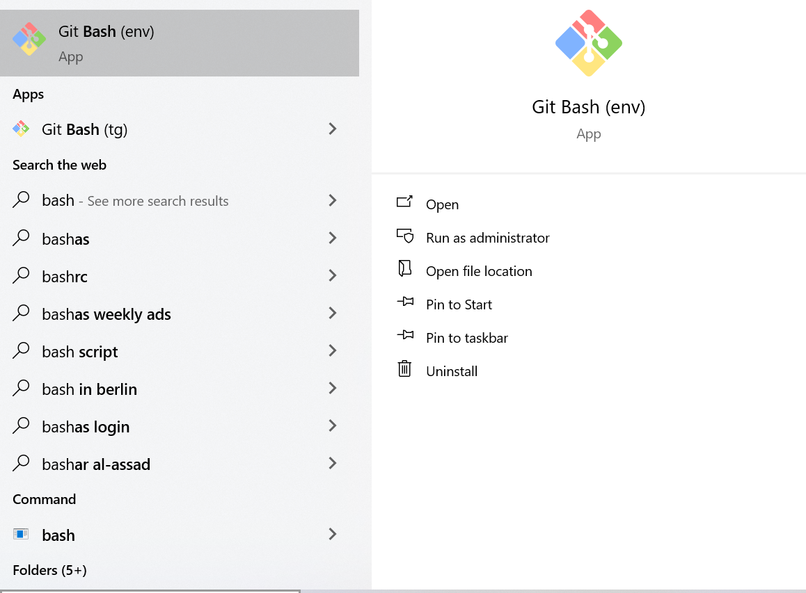

* Open the Git Bash terminal as the administrator.

Step 2:

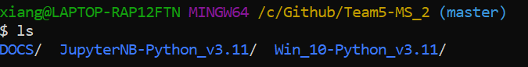

* Navigate to the location of the downloaded program.

Step 3: Installing the necessary packages for running the python pipeline:

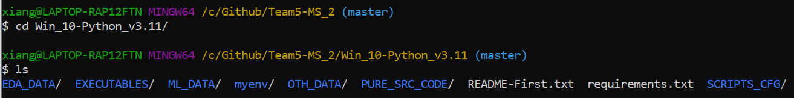

* Navigate to the Win_10-Python_v3.11 directory by entering the command:
  + cd Win_10-Python_v3.11
* Ensure that you have the files and folders shown in the figure by entering the command:
  + ls



* Install the necessary packages by entering the command:
  + pip install -r requirements.txt

Step 4: Installing the necessary packages for running the jupyter notebook pipeline:

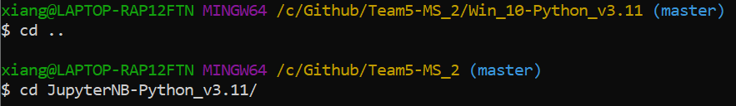

* Once the packages for the python pipeline has been installed, go back to the program home directory by entering:
  + cd..
* Navigate to the JupyterNB-Python_v3.11 directory by entering the command:
  + cd JupyterNB-Python_v3.11



* Ensure that you have the files and folders shown in the figure by entering the command:
  + Ls



* Install the necessary packages by entering the command:
  + pip install -r requirements.txt

## **6 Additional Hardware Requirements (If Applicable)**

* Webcam: Logitech C920 or equivalent for data visualization or prediction tasks
* Other peripherals: Ensure additional hardware like fingerprint readers or portable microphones are compatible.

## **7 MacOS Compatibility and Setup**

For macOS users, follow these guidelines for installation and execution:

* **Development Environment**: Use Visual Studio Code or PyCharm, ensuring Python extensions are installed.
* **Dependencies**: macOS includes Python 3 by default. Verify the version with:  
  bash  
  python3 --version
* Install **libraries** with:  
  pip3 install -r requirements.txt
* **File Paths**: Use macOS-style paths (e.g., /Users/username/project/) in configuration files.
* **Permissions**: Resolve permission issues using:  
  chmod +x pipeline.sh
* **Hardware**: Ensure connected devices, such as webcams, are supported on macOS.

## 

## **8 Extending the Software with Custom Features**

Users can enhance the software with additional functionality, follow these steps:

**8.1 Understand the Codebase**

Review the PURE_SRC_CODE directory, where all core Python scripts are stored.

Identify the script or module related to the functionality you want to modify or extend.

**8.2 Plan the Feature**

Clearly define the new feature's purpose and how it integrates with the existing pipeline.

Check dependencies and ensure compatibility with existing workflows.

**8.3 Implement the Feature**

Create a new Python script or update an existing one in the PURE_SRC_CODE directory.

Follow the existing coding standards and structure in the project for consistency.

**8.4 Update Configuration Files**

If the new feature requires additional parameters or paths, update the config.txt file in the SCRIPTS_CFG directory.

Add descriptive comments to ensure clarity for future users.

**8.5 Test the Feature**

Use test data stored in the OTH_DATA directory to validate the new feature.

Ensure outputs are generated correctly and saved in the appropriate subdirectories of ML_DATA.

**8.6 Integrate the Feature**

Update the pipeline.sh script to include the new feature in the execution sequence.

Ensure the sequence aligns with the order of dependencies and functionality.