**A**

**MINI PROJECT REPORT**

**ON**

**Quadcopter Drone**

SUBMITTED BY

**Mr. Raosaheb Dhotre**

**Ms. Gayatri Gurav**

**Ms. Nikita Kabade**

**Mr. Shankar patil**

**Mr. Deepak mench**

**Mr. Brijesh patange**

**Ms. Shrawani Burla**

UNDER THE GUIDANCE OF

**Prof. Kshirsagar A.**



DEPARTMENT OF ELECTRONICS & TELECOMMUNICATION ENGINEERING

PRADNYA NIKETAN EDUCATION SOCIETY, PUNE.

NAGESH KARAJAGI ORCHID COLLEGE OF ENGINEERING & TECHNOLOGY,

SOLAPUR 413002

(AFFILIATED TO DR. BABASAHEB AMBEDKAR TECHNOLOGICAL UNIVERSITY, LONERE)

2019 – 2020

**CERTIFICATE**

This is to certify that the mini project entitled **Quadcopter Drone**  has been completed by following students of T.E.-I (E&TC) class in satisfactory manner under my guidance.

**Mr. Raosaheb Dhotre**

**Ms. Gayatri Gurav**

**Ms. Nikita Kabade**

**Mr. Shankar patil**

**Mr. Deepak mench**

**Mr. Brijesh patange**

**Ms. Shrawani Burla**

The project is found to be complete in partial fulfillment for the award of Degree of Bachelor of Electronics

and Telecommunication Engineering of DBATU, Lonere.

Prof .Kshirsagar A. Prof. S. S. DHOTRE Dr. J. B. DAFEDAR

 PROJECT GUIDE HOD PRINCIPAL

DEPARTMENT OF ELECTRONICS & TELECOMMUNICATION ENGINEERING

PRADNYA NIKETAN EDUCATION SOCIETY, PUNE.

NAGESH KARAJAGI ORCHID COLLEGE OF ENGINEERING & TECHNOLOGY, SOLAPUR 413002

(AFFILIATED TO DR. BABASAHEB AMBEDKAR TECHNOLOGICAL UNIVERSITY, LONERE)

2019 – 2020

**MINI PROJECT APPROVAL SHEET**

The mini project entitled **Quadcopter Drone** submitted by the following students -

**Mr. Raosaheb Dhotre**

**Ms. Gayatri Gurav**

**Ms. Nikita Kabade**

**Mr. Shankar patil**

**Mr. Deepak mench**

**Mr. Brijesh patange**

**Ms. Shrawani Burla**

is hereby approved in partial fulfillment for the award of Degree of Bachelor of Electronics &

Telecommunication Engineering of DBATU, Lonere.

EXAMINERS

1. _________________________________

DEPARTMENT OF ELECTRONICS & TELECOMMUNICATION ENGINEERING

PRADNYA NIKETAN EDUCATION SOCIETY, PUNE.

NAGESH KARAJAGI ORCHID COLLEGE OF ENGINEERING & TECHNOLOGY,

SOLAPUR 413002

(AFFILIATED TO DR. BABASAHEB AMBEDKAR TECHNOLOGICAL UNIVERSITY, LONERE)

2019 – 2020



**Abstract**

The control system of a quadcopter is the most important part. Control system governing quadcopter stability and control movement by correcting measurement errors and comparing to the desired values achieving pilot desired and safe flight.

This thesis concerned with the implementation of a quadcopter control system that is tested through visual simulation with real physics then hardware capabilities test that describes the capabilities of the hardware mounted on the quadcopter after the construction is over.

This work was divided into two subsections: simulation and construction; the simulation was conducted using Protues circuit simulation software that failed and was replaced by unity 3D due to its limitation to simulate electronic speed controller ( ESCs) and Inertial Measurement Unit (IMU) which are essential to simulate the quadcopter system, Unity 3D simulation software provided 3D visual simulation of the quadcopter depending only on the code and no components simulation was need only the mass and drag properties of the frame.

The construction of the quadcopter consisted of choosing a suitable frame to carry the load of the quadcopter that was plastic foam due its light weight and flexibility casted with fiber glass to reinforce to ensure strength. The quadcopter components were mounted on it with distributed load to ensure equilibrium then the transmitter was setup to determine what position of the transmitter sticks belonged to which flight movement and all the ESCs were calibrated to operate at the same speed then the Proportional-Integral-Derivative (PID) controller code was uploaded and operation was successful which gives us the time to add auto leveling.

Auto leveling of the quadcopter were possible by taking the readings of the gyroscope and applying correction when there is no user input received; the Proportional-Integral- Derivative (PID) applies gyroscope correction to stabilize the aircraft which is zero gyroscope orientation in all axes.

# 

I

**Acknowledgement**

Many thanks and appreciation to our supervisor and everyone helped make this thesis see the light of day and to all who dedicated their time, knowledge and resources to grow our knowledge and skills.

II

**Dedication**

So much love to our families and friends whom stood by our side when times were hard and those whom were with us every step of our way and those who loved us and believed in us more than others.

III

|  |  |  |
| --- | --- | --- |
|  |  |  |

# Table of Contents

**Contents**

Abstract I

Acknowledgement II

Dedication III

Chapter One 1

Introduction 1

* 1. Overview 1
  2. Aim & Objectives 1
     1. Aim 1
     2. Objectives 1
  3. Problem Statement 1
  4. Proposed Solution 2
  5. Methodology 2
  6. Thesis Outline 2

Chapter Two 3

Literature Review and Background 3

* 1. Introduction 3
  2. History of Quadcopter 4
  3. Dynamic Model 5
     1. Quad-rotor Characteristics 5
     2. System Description 6
  4. Quadcopter Block Diagram 7
     1. Microprocessing Unit (MPU) 7
     2. RF Receiver 8
     3. Brushless DC Motor 8
     4. Electronic Speed Controller (ESC) 8
     5. Flight Controller 9
  5. Tools 9
     1. Arduino 9
     2. Proteus 8 Labcenter 9
     3. Unity 3D 9

Chapter Three 10

Construction 10

* 1. Overall hardware connection to the microcontroller 10
  2. Hardware Components 11
     1. The Frame of the Quadcopter 11
     2. The Microcontroller – Arduino Uno 12
     3. Electronic Speed Controllers 13
     4. Microprocessor Unit 13
     5. interface with ARDUINO 16
     6. The Battery Pack 17
     7. The Brushless Motors 19
     8. Propellers 22
  3. Software Implementation 22
     1. Quadcopter Flowchart 22
     2. Transmitter and Receiver 23

Chapter Four

Results and Discussion 23

Chapter Five 24

Conclusion and Recommendations 24

* 1. Conclusion 25
  2. Recommendations 25

References 26

**Chapter One** **Introduction**

* 1. Overview

Study and development of unmanned aerial vehicles (UAV) and micro aerial vehicles (MAV) are getting high encouragement nowadays, since the application of UAV and MAV can apply to variety of areas such as rescue mission, military, film making, agriculture and others [1].

Quadcopter has advantages over the conventional helicopter where the mechanical design is simpler. Besides that, Quadcopter changes direction by manipulating the individual propeller’s speed and does not require cyclic and collective pitch control [2].

## 

1.2 Aim and objective

### Aim

### This work Aim to fly the quadcopter using hand gestures on a Leap Motion hand gesture sensors each hand gesture has a unique instruction programmed on the motion sensor transmitted to the quadcopter flight controller with Wi-Fi wireless signals.

### Objectives

* + - * Run a successful visual simulation of the controller in Unity3D software.
      * Implementation of the PID controller to the Arduino microcontroller as flight controller unit
      * Construct the quadcopter and record a successful flight time of at least 1 minute

## Problem Statement

The stability and control of a quadcopter is a challenging matter and the most fundamental feature in UAVs to sustain a balanced well controlled flight when building it instead of ready manufactured flight controllers.

1

## Proposed Solution

PID controller allows you to change the UAVs flight characteristics, including how it responds to user input, how well and how quickly it stabilizes.

## Methodology

The method applied on choosing the proper PID controller gains is trial and error method to set the values that results in balanced, stable and controlled flight. A collection of hardware components was used to build the quadcopter model providing the hardware to implement the PID flight controller.

## Thesis Outline

Chapter 2 is the literature review and background discussing the UAVs historically and providing a background of the components that are essential in the operation of the quadcopter; relative reports that discussed building a quadcopter controller are also included in the literature review.

Chapter 3 includes the modeling of the quadcopter and the simulation of implementing the PID controller to a quadcopter flight controller.

Chapter 4 shows the steps that were followed in constructing the hardware of the quadcopter model that was used to implement the PID controller.

Chapter 5 discusses the result and discusses those results that were observed during building the hardware and implementing the software.

Chapter 6 is the conclusion of the thesis that includes the recommendations for our successors to solve the problems we could not and start their work where we finished.

2

# Chapter Two

# Literature Review and Background

## Introduction

A quad copter flying machine also known as quad rotor is a rotary wing aircraft powered by four motors mounted on each edge of the structure in a an x or + formation depending on the formation.

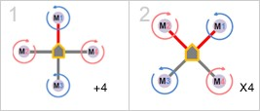

**Figure: Shows the x and + structure configurations of a quadcopter**

However the quadcopter concept isn’t introduced recently considering that it existed since 1921; in January 1921 a US Army Corps. Contract of developing a vertical flying Machine was awarded to Dr. George de Bothezat and Ivan Jerome. The 1678 kg X-shaped structure supported 8.1 m diameter 6 blade rotor at each end of the 9 m arms and a 180 hp Le Rohne radial engine. At the ends of the lateral arms, two small propellers with variable pitch were used for thrusting and yaw control; each rotor had individual collective pitch control to produce differential thrust through vehicle inclination for translation.

3

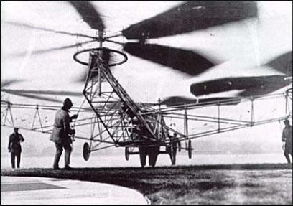

**Figure: shows the quadcopter rotorcraft of Bothezat**

On the aircraft first flight in October 1922, the rotor craft weighed 1700 kg at take-off; the engine was soon upgraded to a 220 hp Bentley BR-2 rotary, about 100 flights were made by the end of 1923. Although the contract called for a 100 m hover, the highest it ever reached was 5 m. After expanding $200,000 de Bothezat demonstrated that his vehicle could be quite stable and that the practical helicopter, it was however unpowered, unresponsive, mechanically complex, susceptible to reliability problems and pilot work load was too high during hover to attempt lateral motion [3].

## History of Quadcopter

Only few works were reported in the literature of a helicopter having four rotors. Young et al [4]. Sponsored by the Directorate Aerospace in NASA Ames Research Center present new configuration s of mini-drones and their applications among which the helicopter with four rotors called the Quad-rotor Tail-Sitter.

Pounds et al [5]; Conceived and developed a control algorithm for a prototype of an aerial vehicle having four rotors; they considered using an MIU (Measurement Inertial Unit) to measure the speed and acceleration. They use a linearization of the dynamic model to conceive the control algorithm; the result of the control law was tested in the simulation.

Altug et al [6]; Proposed a control algorithm to stabilize the quad-rotor using vision as principal sensor. They studied two methods, the first uses a control algorithm of linearization and the other uses the technique of back-stepping. They have tested the control laws in the simulation; they also present an experience using vision to measure yaw angle and the altitude.

4

## Dynamic Model

### Quad-rotor Characteristics

Consider Figure 3 below; the front and rear motors rotate counter-clockwise while the other two rotate clockwise, gyroscopic effects and aerodynamic torques tend to cancel in trimming flight.

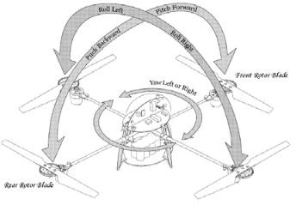

**Figure: shows the Quad-rotor rotorcraft**

This four-rotor rotor-craft does not have a swash plate; in fact, it doesn’t need any blade pitch control. The collective input or throttle input is the sum of the thrusts of each motor (Figure4).

5

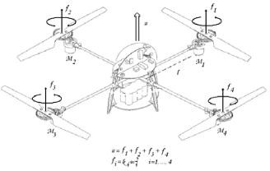

**Figure 4: shows throttle control input**

Pitch movement is obtained by increasing/reducing the speed of the rear motor while reducing/increasing the speed of the front motor. The roll movement is obtained similarly using the lateral motors. The yaw movement is obtained by increasing/decreasing the speed of the front and rear motors while decreasing/increasing the speed of the lateral motors; this should be done while keeping the total thrust constant.

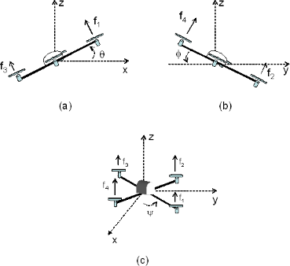

**Figure: (a) Pitch (b) Roll (c) Yaw**

6

## Quadcopter Block Diagram

The quadcopter rotorcraft consists of an Inertial Measurement Unit (IMU), flight control unit, Electric Speed Controllers (ESC) for the motors and a Radio Frequency (RF) receiver; as shown on figure 7 below the IMU consists of an accelerometer, gyroscope and a magnetometer.

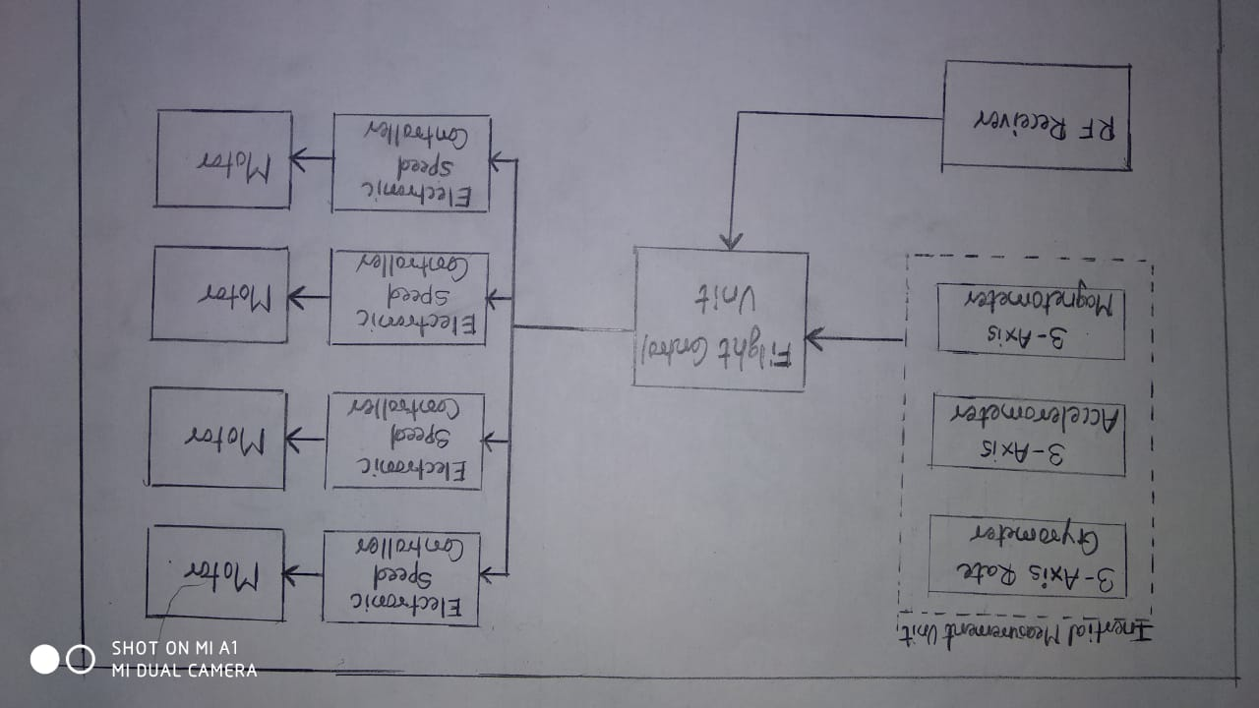

**Figure: Quadcopter Block Diagram**

### Inertial Measurement Unit (IMU)

Accelerometers are devices that measure acceleration. A gyroscope is a device consisting of a wheel or disk m0ounted so that it can spin rapidly about an axis that is itself free to alter in direction. The orientation of the axis is not affected by tilting of the mounting; so, gyroscopes can be used to provide stability or maintain a reference direction in navigation systems,

7

automatic pilots, and stabilizers. A magnetomete**r** is an instrument used for measuring magnetic forces, especially the earth's magnetism.

### RF Receiver

A quadcopter consists of a communication system to transmit pilot commands to the copter flight controller to carry out a pitch, roll or a yaw; this system consists of a transmitter which is the R/C controller the pilot uses to control the rotorcraft and a Radio Frequency receiver on the quad copter (RF) to receive information signals sent by the R/C controller.

### Brushless DC Motor

BLDC motors are a type of synchronous motor. This means the magnetic field generated by the stator and the magnetic field generated by the rotor rotates at the same frequency. The stator of a BLDC motor consists of stacked steel laminations with windings placed in the slots that are axially cut along the inner periphery, the stator resembles that of an induction motor; however, the windings are distributed in a different manner. Most BLDC motors have three stator windings connected in star fashion. Each of these windings is constructed with numerous coils interconnected to form a winding. One or more coils are placed in the slots and they are interconnected to make a winding. Each of these windings is distributed over the stator periphery to form even numbers of poles.

The rotor is made of permanent magnet and can vary from two to eight pole pairs with alternate North (N) and South (S) poles. Based on the required magnetic field density in the rotor, the proper magnetic material is chosen to make the rotor. Ferrite magnets are traditionally used to make permanent magnets. As the technology advances, rare earth alloy magnets are gaining popularity. The ferrite magnets are less expensive but they have the disadvantage of low flux density for a given volume. In contrast, the alloy material has high magnetic density per volume and enables the rotor to compress further for the same torque. Also, these alloy magnets improve the size-to-weight ratio and give higher torque for the same size motor using ferrite magnets. Neodymium (Nd), Samarium Cobalt (SmCo) and the alloy of Neodymium, Ferrite and Boron (NdFeB) are some examples of rare earth alloy magnets. Continuous research is going on to improve the flux density to compress the rotor further.

### Electronic Speed Controller (ESC)

An electronic speed controller or ESC is an electronic circuit that vary an electric motor's speed, its direction and possibly also to act as a dynamic brake. ESCs most often used for brushless motors essentially providing an electronically generated three-phase electric power low voltage source of energy for the motor.

8

### Flight Controller

A Flight Controller Unit is the block responsible of receiving the flight commands, stabilizing the quad copter, executing pilot commands, controlling the speed of the motors and performing flight movements.

## Tools

### Arduino

Arduino is an open-source electronics platform based on easy-to-use hardware and software. Arduino boards are able to read inputs - light on a sensor, a finger on a button, or a Twitter message - and turn it into an output - activating a motor, turning on an LED, publishing something online. You can tell your board what to do by sending a set of instructions to the

microcontroller on the board. [7]

### Proteus 8 Labcenter

Protues software by Labcenter enabling powerful features to design, test and layout professional PCB layouts and supports the schematics and simulation of 800 microcontrollers.

### Unity 3D

Unity3D is a powerful cross-platform 3D engine and a user-friendly development environment for developing 3D projects and simulations equipped with graphical and programmatic documentation and scripting guide to simulate real world physics and variables making it easy for the user to run their simulations and see the result visually rather than tables and figures.

9

# Chapter Four Construction

## Overall hardware connection to the microcontroller

**Figure: Overall Quadcopter hardware connection**

10

## Hardware Components

### The Frame of the Quadcopter

Typical quad-rotors utilize a four-spar method, with each spar anchored to the central hub. The frame of the quad copter is composed of a combination of materials chosen for their strength, weight and flexibility.

When designing an autonomous quad-rotor, there are several material options which must be considered. When designing a machine capable of flight, weight must be greatly well thought- out.

The airframe is the mechanical structure of an aircraft that supports all the components, much like a “skeleton” in Human Beings. Designing an airframe from scratch involves important concepts of physics, aerodynamics, materials engineering and manufacturing techniques to achieve certain performance, reliability and cost criteria.

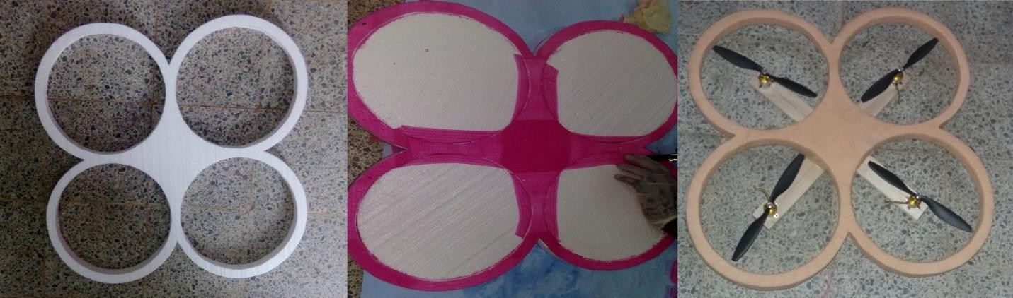

**Figure: Plastic foam frame incase in fiber glass**

11

**4.2.2 Arduino UNO**

Arduino uno is a small, compatible, flexible and breadboard friendly microcontroller board, developed by

Arduino.cc in Italy, based on ATmega328p.

It comes with exactly same functionality as in arduino UNO but quite small in size.

It comes with an operating voltage of 5v,however the input voltage can vary from 7 to 12v.

Arduino uno pin out contains 14 digital pins,8 analog pins,2 reset pins and 6 power pins

Each of these digital and analog pins are assigned with multiple functions but their main function is to be

configured as input and output.

The analog pins come with a total resolution of 10 bits which measure the value from 0 to 5v.

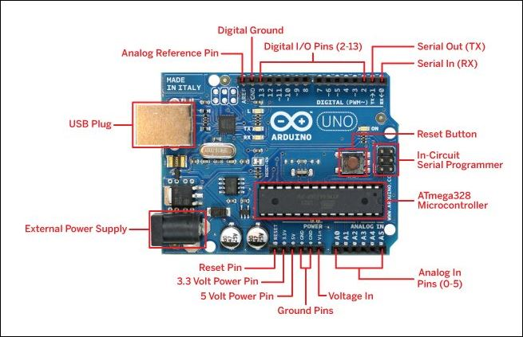

Figure: Arduino UNO pin diagram

**4.2.3 MPU6050**

MEMS 3-aixs accelerometer and 3-axis gyroscope values combined

Measure acceleration, velocity, orientation, displacement and many other motion related parameter of a system or object.

Can be used to interface with other IIC devices like magnetometer

12

Configurable IIC Address

In-built Temperature sensor

Built-in DMP provides high computational power

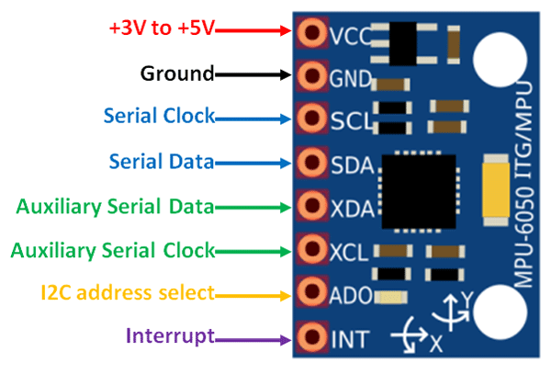

Figure: MPU6050

### Electronic Speed Controllers

An electronic speed control or ESC is a circuit with the purpose to control an electric motor's speed, its direction and possibly also to act as a dynamic brake in some cases. ESCs are often used on electrically powered brushless motors essentially providing an electronically- generated three phase electric power, with a low voltage source.

An ESC interprets control information in a way that varies the switching rate of a network of field effect transistors (FETs), not as mechanical motion as would be the case of a servo. The quick swiching of the transistors is what causes the motor itself to emanate its characteristic high-pitched whine, which is especially noticeable at lower speeds. It also allows much smoother and more precise variation of motor speeds in a far more efficient manner than the mechanical type with a resistive coil and moving arm once in common use.

13

Reversing the motor's direction may also be accomplished by switching any two of the three leads from the ESC to the motor.

Ideally the ESC controller should be paired to the motor and rotor craft with the following considerations.

* + - 1. Temperature and thermal characteristics.
      2. Max Current output and Impendence.
      3. Needs to be Equipped with a BEC (Battery Eliminator Circuit) to eliminate the need of a second battery.
      4. Size and Weight properties.
      5. Magnet Rating.

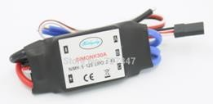

Figure : 30A Brushless ESC

14

Additionally, the speed controller has fixed throttle settings so that the "stop" and "full throttle” points of all the various modes which can be cut through cleanly. The controller produces audible beeps to assist in navigating through the program modes and troubleshooting logs.

Table 1 : Specification for 30A Brushless ESC

|  |  |  |
| --- | --- | --- |
| **30A Brushless ESC Output** | | **Continuous 30A, burst 40A up to 10 Sec** |
| **Input voltage** | | 2-4 cells lithium battery or 5-12 cells NiCd/NiMH battery |
| **BEC** | | 2A / 5V (Linear mode). |
| **Max speed** | 210,000rpm for 2 poles BLM, 70,000rpm for 6 poles BLM, 35,000rpm for 12 poles BLM. (BLM: Brushless Motor | | |
| **Size** | | 45 * 24 * 11mm / 1.8 * 0.9 * 0.4in |
| **Weight** | | 25g / 0.9oz |
| **Item total weight** | | 480g / 1.06Lbs |

### 

### 15

### MPU interface with ARDUINO

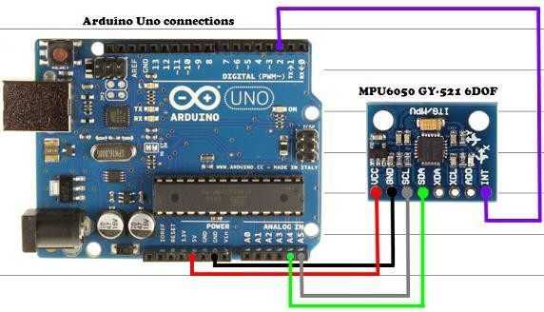

Figure : MPU6050 Interface with Arduino

16

### The Battery Pack

Selecting the proper battery for our rotor copter was a challenging task. Nickel Cadmium (NiCd), Nickel Metal Hydride (NiMH), and Lithium Polymer (LiPo) were common choices with the advantages and disadvantages of each battery pack.

NiCd batteries are reasonably inexpensive, but they have a number of negatives. NiCd batteries need to be fully discharged after each use. If they aren’t, they will not discharge to their full potential (capacity) on following discharge cycles, causing the cell to develop what’s commonly referred to as a memory. Additionally, the capacity per weight (energy density) of NiCd cells is commonly less than NiMH or LiPo cell types as well. Finally, the Cadmium that is used in the cell is quite destructive to the environment, making disposal of NiCd cells an issue.

NiMH cells have many advantages over their NiCd counterparts. NiMH cell manufacturers are able to offer significantly higher capacities in cells approximately the same size and weight of equivalent NiCd cells. NiMH cells have an advantage when it comes to cell memory as well, as they do not develop the same issues as a result of inappropriate discharge care.

Lithium Polymer (LiPo) cells are one of the newest and most revolutionary battery cells Available. LiPo cells maintain a more consistent voltage over the discharge curve when compared to NiCd or NiMH cells. The higher nominal voltage of a single LiPo cell (3.7V vs. 1.2V for a typically NiCd or NiMH cell); making it possible to have an equivalent or even higher total nominal voltage in a much smaller package LiPo cells typically offer very high capacity for their weight, delivering upwards of twice the capacity for ½ the weight of comparable NiMH cells.

Lastly, a LiPo cell battery needs to be carefully monitored during charging since overcharging and the charging of a physically damaged or discharged cell can be a potential fire hazard and possibly even fatal.

LiPo Pro's:

* Highest power/weight ratio.
* Very low self-discharge.

17

* Less affected by low temperatures than some.

LiPo Con's:

* Intolerant of over-charging.
* Intolerant of over-discharging Battery.
* significant fire risk

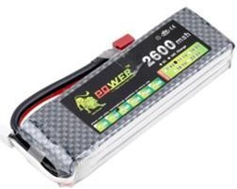

Figure: 3S LiPo Battery

18

Table 2: LiPo batteries 3S 11.1V 2600MAH 30C packs

|  |  |
| --- | --- |
| **Capacity** | **2600mAh** |
| **Configuration** | 3S1P |
| **Dimensions** | 116X34X26mm |
| **Weight** | 200g |
| **Constant Discharge** | 30C |
| **Burst Discharge** | 60C |
| **Balance connector** | ST-XHR |
| **Discharge plug** | T plug |
| **Use** | Vehicles & Remote-Control  Toys |
| **Material** | EVA |

### The Brushless Motors

Each of the four rotors comprises of a Brushless DC Motor attached to a propeller. The Brushless motor differs from the conventional Brushed DC Motors in their concept essentially in that the commutation of the input voltage applied to the armature's circuit is done electronically, whereas in the latter, by a mechanical brush. As any rotating mechanical device, it suffers wear during operation, and as a consequence it has a shorter nominal life time than the newer Brushless motors.

19

In spite of the extra complexity in its electronic switching circuit, the brushless design offers several advantages over its counterpart, to name a few: higher torque/weight ratio, less operational noise, longer lifetime, less generation of electromagnetic interference and much more power per volume. Virtually limited only by its inherent heat generation, whose transfer to the outer environment usually occurs by conduction.

20

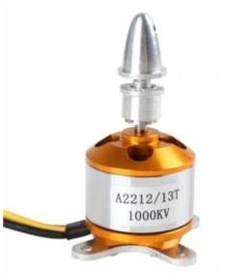

Figure : A2212/13T 1000 KV BLDC (Brushless DC Motor)

Table 2 : Specifications of A2212 / 920 KV out runner motor

|  |  |
| --- | --- |
| **No. of Cells:** | **2 - 3 Li-Poly**  **6 - 10 NiCd/NiMH** |
| **Kv:**  **Max Efficiency:**  **Max Efficiency Current:** | 1000 RPM/V  80%  4 - 10A (>75%) |
| **No Load Current: Resistance:**  **Max Current:** | 0.5A @10V  0.090 ohms 13A for 60S |
| **Max Watts: Weight:**  **Size:** | 150W  52.7 g / 1.86 oz.  28 mm diameter x 28 mm bell length |
| **Shaft Diameter: Poles:**  **Model Weight:** | 3.2 mm 14  300 - 800g / 10.5 - 28.2 oz. |

21

### Propellers

Propeller is a set of rotating blades design to convert the power (torque) of the Engine in to thrust.

The Quadrotor consists of four propellers coupled to the brushless motor. Among These four propellers, two clockwise and the remaining other two are counter clockwise. Clockwise and anticlockwise propellers cancel their torque from each other.

Propellers are specified by their diameter and pitch. The propeller used is 1045

Fixed-pitch, symmetric, tapered Normal Rotation Carbon Fiber Propeller, shown in (figure):

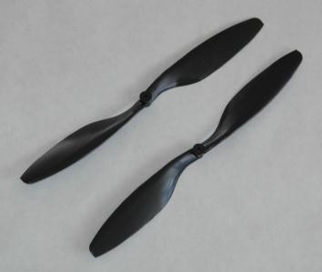

Figure: 1045 fixed-pitch, Carbon fiber Propeller

## Software Implementation

### Quadcopter Flowchart

The operation flow of the quadcopter is illustrated in figure below demonstrating steps at which quadcopter flows in order to fly and satisfy pilot commands.

22

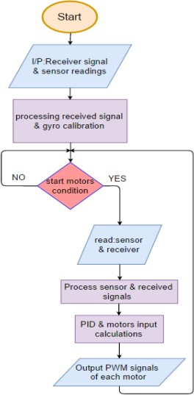

Figure : Quadcopter flow chart

### Transmitter and Receiver

A four channel RC transmitter is used for the purpose of giving freedom to control throttle, pitch, roll and yaw individually. To obtain an accurate response set points and minimum and maximum ranges must be determined before transmission execution.

Since the main loop of the code executes sequentially - one line at a time- an interrupt needs to occur enabling receiving signals transmitted from the RC; Arduino allows pins to allow interrupt only if the interrupt for a specific pin was declared in the code.

23

Chapter Four

# Results and Discussion

The results that will be discussed in this chapter will include notice of unnatural behavior by the quadcopter during construction and after unnatural here is defined as any error or fault that can endanger the safety of the quadcopter.

It has been noticed that the motors had a variation of speed resulting from the ESCs; the voltage supplied from the battery to the ESCs- with only the battery connected to the ESCs without any software code or even Arduino connected- vary from one ESC to the other, this was resolved by ESC calibration meaning all ESCs start the motors at the same time with the same speed on the condition that all ESCs has the same current rating, if the ESCs had different current rating overheat will if the rating of ESC is less than the others due because it will try to compensate the difference by operating the motor at a higher speed.

A power regulator must be used and the mounting, isolation and soldering of the components must be accurate and tight, at one point one of the ESCs experienced excessive overheat without and obvious reason however when the isolation was removed it was found that the soldering was loose; if the mounting of the propellers and motor is not tight a high degree of vibration occurs in the quadcopter and will also cause the propellers to detach itself from the quadcopter body.

A high vibration was clearly noticed in the propellers that was perceived at first to be a vibration problem so the propeller was re-mounted at the center of the propeller shaft and a square piece of duct tape was added to them as load to reduce vibration which reduced the vibration to a minimal value measured by computer code implemented to the quadcopter (Appendix-X).

The trial and error method in choosing the PID parameters that result in the stability of the quadcopter; the ease of control was noticed in the quadcopter however a negative roll angle kept occurring however a successful flight time of 53 seconds was recorded in the process of finding the suitable PID gains for a stable flight without any drifts.

24

# Chapter Five

## Conclusion

# Conclusion and Recommendations

The research phase of the thesis aided in understanding the mathematical model of the quadcopter which is a step required before control and a background of the PID controller and it operation theory in order to transform its equations to equations that are applicable to the quadcopter and were implemented in the Arduino microcontroller.

The choice of the unity software was made upon the fact that it provided an environment with no limitation on executing and constructing a PID controller with code based on its basic equations and theory of operation.

In conclusion the construction of the circuit that connected the hardware components and implementation of the software was the initial work however troubleshooting and tuning the PID gains was challenging and the trial and error method proved to be a failure in choosing the proper PID parameters that provide stable flight without any offsets or deviations.

## Recommendations

1. Another method should be used to choose the proper PID gains for a more stable flight
2. Wires can be connected with jacks instead of soldering wires together.
3. Power distribution boards are more helpful in mounting the IMU properly on the frame beneath the microcontroller and placing the battery safely.
4. Replacing the RC transmitter with a motion sensor that captures hand gestures transmitted as movement commands with a wireless Wi-Fi communication.

25

# References

1. Allison Ryan and J. Karl Hedrick (2005). “A mode-switching path planner for UAV- assisted search and rescue.” 44th IEEE Conference on Decision and Control, and the European Control Conference 2005.
2. Kong Wai Weng (2011). “Quadcopter” Robot Head To Toe Magazine September 2011 Volume 3, pp. 1-3.
3. Modeling and Control of mini flying machines, springer
4. Young L. A., Aiken E. W., Johnson J. L., Demblewski R., Andrews J. and Klem J., “ New concepts and perspectives on micro-rotorcraft and small autonomous rotary-wing vehicles”,

Proceedings of the 20th AIAA Applied Aerodynamics Conference, St. Louis, MO, 2002

1. Pounds P., Mahony R., Hynes P. and Roberts J., “Design of a four rotor aerial robot”, Proceedings of the Australasian Conference on Robotics and Automation, Auckland, Australia, 2002.
2. Altu E., Ostrowski J. P. and Mahony R., “Control of a quadrotor helicopter using visual

feedback”, Proceedings of the 2002 IEEE International Conference on Robotics and Automation,

ICRA 2002, May 11–15, 2002, Washington, DC

1. <https://www.arduino.cc/en/Guide/Introduction>
2. en.wikipedia.org/wiki/PID_controller #PID_controller_theory

26