Automated Parking Occupancy Detection System
________________________________

Robin Ghassibeh (231463)
Christopher Kraichati (232592)

Course: Computer Vision
Instructor: Dr. Ahmad Audi
Date: April 30, 2026

Table of Contents

1. Introduction 1
2. Dataset 2
2.1 Source and Description 2
2.2 Dataset Statistics 2
2.3 Preprocessing and Augmentation 3
3. Methodology 3
3.1 Approach Overview 3
3.2 YOLOv8s — CNN-based Detector 4
3.3 RT-DETR-l — Transformer-based Detector 4
3.4 Classical CV Baseline — Edge Density 5
3.5 Evaluation Metrics 5
4. Experiments and Results 5
4.1 Experiment 1 — Necessity of Fine-tuning 5
4.2 Experiment 2 — Input Resolution Ablation 6
4.3 Experiment 3 — CNN vs Transformer Architecture 7
4.4 Failure Case Analysis 8
5. Discussion 9
5.1 What Worked 9
5.2 What Did Not Work as Expected 9
5.3 Limitations 9
6. Conclusion 10
7. References 10

1. Introduction

Parking management is a growing challenge in urban environments. As cities expand and vehicle ownership increases, the inefficiency of manually monitoring parking lot occupancy leads to wasted time, increased congestion, and unnecessary fuel consumption as drivers search for available spaces. Automated parking spot detection systems offer a scalable solution by continuously analyzing camera feeds to determine occupancy in real time.
This project addresses the problem of detecting and classifying individual parking spaces as empty or occupied from aerial and CCTV imagery. The system is designed to work on a static image or video feed without requiring any physical sensors or infrastructure modifications. The approach is end-to-end: a single model detects the location of each parking spot and simultaneously classifies its occupancy status in one forward pass.
Three distinct approaches are implemented and compared: a fine-tuned Convolutional Neural Network (YOLOv8s), a fine-tuned Transformer-based detector (RT-DETR-l), and a classical computer vision baseline using edge density analysis with manual region-of-interest selection. This multi-approach design allows for a rigorous comparison between modern deep learning architectures and a training-free classical method.
Related work in this domain includes the PKLot dataset benchmark [1], which established parking lot detection as a well-defined computer vision task, and subsequent deep learning approaches such as CNR Park [2] and RetinaNet-based detectors [3]. More recently, transformer-based detectors such as DETR [4] and its real-time variant RT-DETR [5] have shown strong performance on dense object detection tasks. This project builds on these developments by fine-tuning state-of-the-art models on a publicly available parking dataset.

2. Dataset

2.1 Source and Description
The dataset used in this project is the Parking Finder dataset, sourced from Roboflow Universe (https://universe.roboflow.com/aiml-the-lebron-project/parking-finder/dataset/1), licensed under Creative Commons CC BY 4.0. The dataset contains aerial and top-down CCTV images of parking lots with bounding box annotations for two classes: empty (class 0) and occupied (class 1). All annotations are provided in YOLOv8 format (normalized center-x, center-y, width, height per bounding box).

2.2 Dataset Statistics
The full dataset comprises 7,887 images distributed across three splits as follows:
Split | Images | Empty Instances | Occupied Instances | Total Instances
Train | 7,103 | 45,563 | 92,676 | 138,239
Validation | 558 | 3,650 | 8,300 | 11,950
Test | 226 | 2,010 | 4,394 | 6,404
Total | 7,887 | 51,223 | 105,370 | 156,593

A notable characteristic of this dataset is its class imbalance: occupied instances are approximately twice as frequent as empty instances across all splits (105,370 vs 51,223 total instances). This reflects the natural distribution of real-world parking lots, where the majority of spaces tend to be occupied during active hours. This imbalance is consistent across all three splits, indicating a well-stratified partitioning strategy.

2.3 Preprocessing and Augmentation
The dataset underwent the following preprocessing steps applied by Roboflow prior to export:
- Auto-orientation: EXIF orientation metadata was stripped and pixel data reoriented accordingly.
- Resize to 640×640: all images were stretched to a uniform 640×640 pixel resolution.
In addition to the above, Roboflow applied image-level augmentations during dataset generation, resulting in augmented copies of original images identifiable by the .rf. suffix in their filenames. These augmentations include rotation (introducing black corner borders), additive noise and grain (simulating poor camera quality or rain), and grayscale conversion (simulating low-light and nighttime conditions). These pre-augmented samples directly address challenging real-world conditions such as lighting variation, shadows, and adverse weather.
During model training, additional online augmentation was applied by the Ultralytics training pipeline to further improve robustness and prevent overfitting:
- Rotation: ±10 degrees
- Translation: ±10% of image dimensions
- Scale: ±50% zoom variation
- Shear: ±2.0 degrees
- Perspective distortion: 0.0005
- Horizontal flip: 50% probability
- Mosaic augmentation: enabled (probability 1.0) — combines four training images into one
- HSV color-space jitter: Hue ±1.5%, Saturation ±70%, Value ±40%
The combination of Roboflow's pre-augmentation and the training-time augmentation pipeline ensures the model is exposed to a wide variety of visual conditions including partial occlusion, scale changes, lighting variation, and viewpoint shifts.

3. Methodology

3.1 Approach Overview
This project employs an end-to-end object detection paradigm: rather than first segmenting parking regions and then classifying each one, a single model simultaneously localises and classifies every parking spot in the image. This design choice simplifies the inference pipeline, removes the need for manual region definition, and allows the model to leverage spatial context across the entire image.
Three approaches are implemented. The first two are supervised deep learning detectors fine-tuned on the parking dataset. The third is a training-free classical computer vision baseline that requires manual annotation of spot locations and uses edge density to infer occupancy.

3.2 YOLOv8s — CNN-based Detector
YOLOv8s (You Only Look Once, version 8, small variant) is a single-stage object detector developed by Ultralytics. Its architecture consists of a CSPDarknet backbone for feature extraction, a Path Aggregation Network (PAN) neck for multi-scale feature fusion, and a decoupled detection head that separately predicts objectness, class probabilities, and bounding box regression. The model processes the entire image in a single forward pass, producing a dense grid of predictions at three spatial scales (stride 8, 16, 32), which are then filtered by Non-Maximum Suppression (NMS).
YOLOv8s was initialised from COCO-pretrained weights (yolov8s.pt) and fine-tuned on the parking dataset for 50 epochs with the following configuration:
- Input resolution: 640×640 pixels
- Batch size: 16
- Optimizer: AdamW (Ultralytics default)
- Early stopping patience: 20 epochs
- Confidence threshold (inference): 0.15
- IoU threshold (NMS): 0.50
YOLOv8s is well-suited to this task because parking spots are small, uniformly shaped, and locally classifiable — properties that align with the local receptive field of convolutional filters. The model's inductive biases (translation equivariance, locality) match the structure of the problem, and its compact size (22.6 MB) enables fast inference.

3.3 RT-DETR-l — Transformer-based Detector
RT-DETR (Real-Time Detection Transformer, large variant) is a hybrid CNN-Transformer detector proposed by Zhao et al. (2023). Its architecture consists of a ResNet backbone, a hybrid encoder that applies intra-scale self-attention on the largest feature map followed by cross-scale CNN fusion, and a transformer decoder with N learned object queries. Each query performs self-attention with other queries (suppressing duplicates) and cross-attention with encoder features to localise and classify objects. Unlike YOLO, RT-DETR requires no NMS post-processing — queries directly compete through attention, producing a fixed set of predictions.
RT-DETR-l was initialised from ImageNet-pretrained weights (rtdetr-l.pt) and fine-tuned on the parking dataset for 50 epochs with the following configuration:
- Input resolution: 640×640 pixels
- Batch size: 8 (reduced due to higher memory requirements, model size: 66.2 MB)
- Early stopping patience: 20 epochs
- Same augmentation pipeline as YOLOv8s
RT-DETR was included as an architecture comparison experiment. Its global attention mechanism is most beneficial when object identity depends on surrounding context. For parking spot detection, where each spot is locally self-contained, this global reasoning capacity is less critical, making it a meaningful architectural comparison.

3.4 Classical CV Baseline — Edge Density
The classical baseline requires no training data. The user manually marks parking spot centres on a reference frame by clicking on the image. A bounding box of configurable size is placed around each marked centre. For each video frame, the system crops each region of interest and applies Canny edge detection (thresholds: 50–150) to compute the fraction of edge pixels within the crop. If this edge density exceeds 7%, the spot is classified as occupied (a parked car introduces significantly more edges than empty asphalt). Otherwise it is classified as empty.
This approach serves as a no-training-data baseline and is integrated into the Gradio demo (Tab 3). It illustrates the fundamental limitation of threshold-based methods: performance degrades under shadows, painted markings, and lighting changes, motivating the use of learned representations.

3.5 Evaluation Metrics
All models are evaluated using the following standard object detection metrics:
- mAP@0.5: mean Average Precision at IoU threshold 0.50. Primary metric for this task.
- mAP@0.5:0.95: mean Average Precision averaged over IoU thresholds from 0.50 to 0.95 in steps of 0.05. Measures localisation precision.
- Precision: fraction of positive predictions that are correct.
- Recall: fraction of true positives that are detected.
- F1-Score: harmonic mean of Precision and Recall.
- Confusion Matrix: per-class normalised confusion matrix showing classification accuracy for empty and occupied classes.

4. Experiments and Results

4.1 Experiment 1 — Necessity of Fine-tuning
The first experiment establishes whether fine-tuning is necessary by comparing the COCO pretrained YOLOv8s (base model) against the fine-tuned version on the parking test set. The base model has no knowledge of parking-specific classes and attempts to classify spots using its 80 COCO categories.
Model | mAP@0.5 | mAP@0.5:0.95 | Precision | Recall | F1-Score
Base YOLOv8s (no fine-tuning) | 0.0000 | 0.0000 | 0.0037 | 0.0021 | 0.0026
Fine-tuned YOLOv8s | 0.9797 | 0.8514 | 0.9463 | 0.9486 | 0.9474

The results are unambiguous. The base model achieves near-zero performance on all metrics, confirming that COCO pretraining provides no direct knowledge of parking spot classes. Fine-tuning on the parking dataset produces a dramatic improvement: mAP@0.5 increases from 0.0000 to 0.9797 — a gain of 97.97 percentage points. Precision and Recall both exceed 0.94, and the F1-Score of 0.9474 demonstrates strong and balanced classification performance. The confusion matrix of the fine-tuned model (Figure 1) further confirms this: 94% of empty spots and 98% of occupied spots are correctly classified.
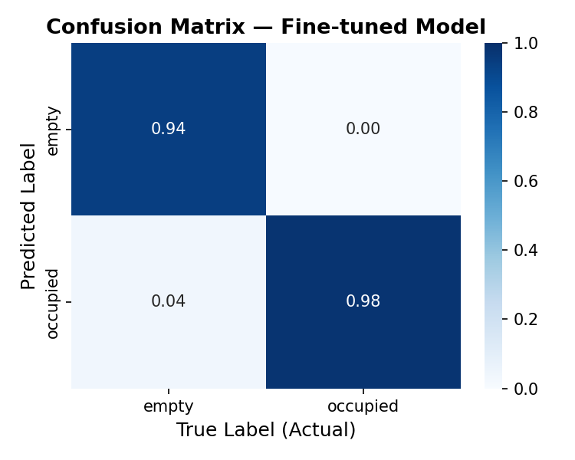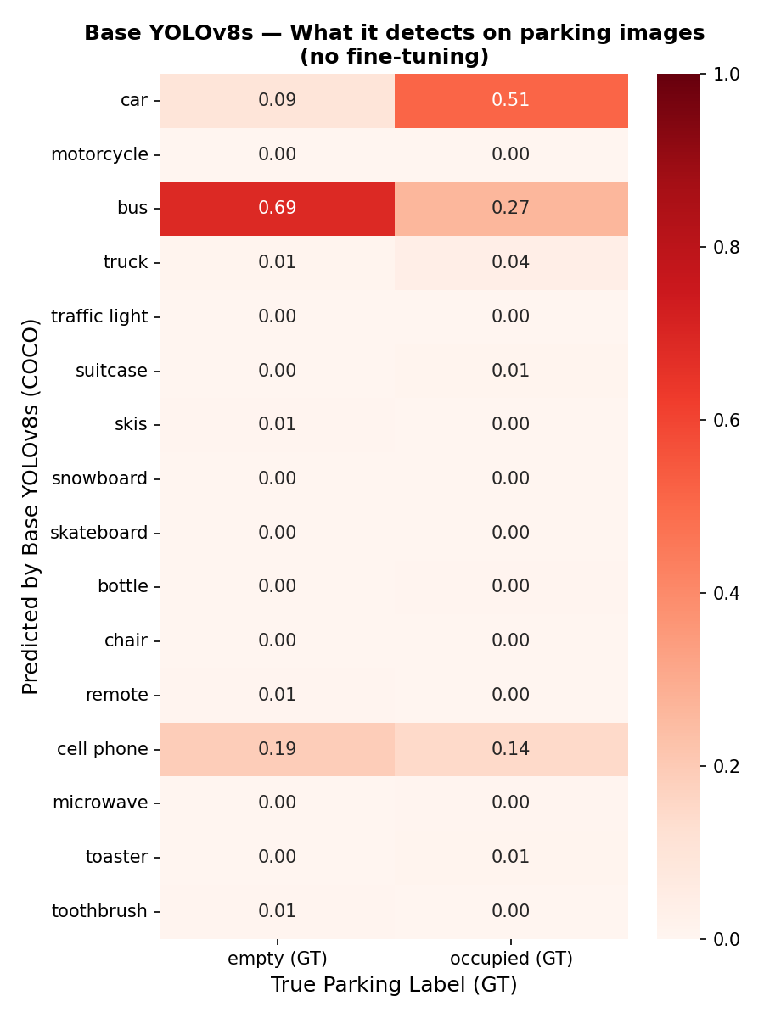
Figure 1 — Confusion matrix of the fine-tuned YOLOv8s on the test set.
Figure 2 — Confusion matrix of the base YOLOv8s on the test set.
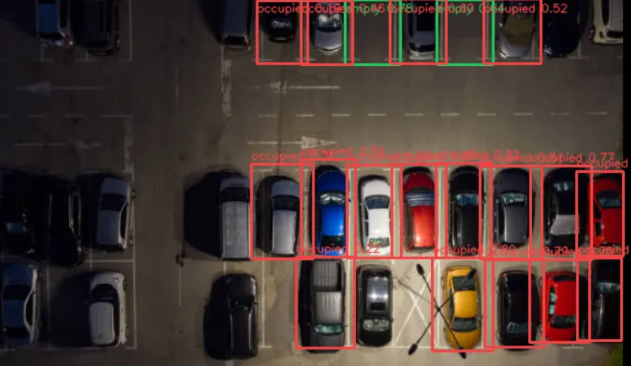
Figure 3 — Output of our trained Yolov8s model on an image.

4.2 Experiment 2 — Input Resolution Ablation
The second experiment investigates the effect of input resolution on detection performance. Three versions of YOLOv8s were trained with identical hyperparameters, differing only in input image size: 320×320, 640×640, and 1280×1280 pixels. This is particularly relevant for parking detection, where spots can appear small in wide-angle aerial footage.
Resolution | mAP@0.5 | mAP@0.5:0.95 | Precision | Recall | F1-Score
320×320 | 0.9794 | 0.8137 | 0.9505 | 0.9518 | 0.9512
640×640 | 0.9797 | 0.8513 | 0.9462 | 0.9486 | 0.9474
1280×1280 | 0.9846 | 0.8501 | 0.9622 | 0.9484 | 0.9552

All three resolutions achieve remarkably similar mAP@0.5 scores (0.9794–0.9846), demonstrating that the model is robust across input scales. The 1280×1280 model achieves the highest mAP@0.5 (0.9846) and Precision (0.9622), suggesting that higher resolution provides marginal gains in localisation and classification accuracy, likely due to finer detail available for small spots. However, the 640×640 model achieves the best mAP@0.5:0.95 (0.8513 vs 0.8501 for 1280), indicating slightly better calibrated bounding box localisation at tighter IoU thresholds. The 320×320 model shows the weakest mAP@0.5:0.95 (0.8137), consistent with reduced spatial resolution limiting precise localisation. Given the minimal performance gap and the significantly higher GPU memory and inference time required by 1280×1280, the 640×640 resolution represents the optimal speed-accuracy trade-off for deployment.
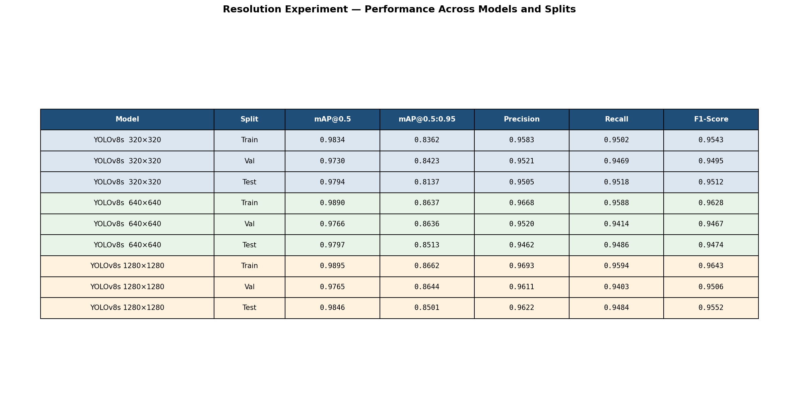
Figure 4 — Resolution experiment results across train, validation, and test splits.

4.3 Experiment 3 — CNN vs Transformer Architecture
The third experiment compares the fine-tuned YOLOv8s (CNN) against the fine-tuned RT-DETR-l (Transformer) on the same dataset and evaluation protocol. This experiment addresses the question of whether a more powerful transformer-based architecture can outperform the CNN baseline on this specific task.
Model | mAP@0.5 | mAP@0.5:0.95 | Precision | Recall | F1-Score
YOLOv8s (CNN) | 0.9797 | 0.8514 | 0.9463 | 0.9486 | 0.9474
RT-DETR-l (Transformer) | 0.9335 | 0.6791 | 0.9205 | 0.8974 | 0.9088

YOLOv8s outperforms RT-DETR-l on every metric. The performance gap is particularly pronounced for mAP@0.5:0.95 (0.8514 vs 0.6791), indicating that RT-DETR-l produces less precise bounding box localisation at tighter IoU thresholds. Recall is also notably lower for RT-DETR-l (0.8974 vs 0.9486), meaning it misses more parking spots. The train/val/test splits (Figure 3) reveal that RT-DETR-l also generalises less consistently, with a larger gap between training and test performance.
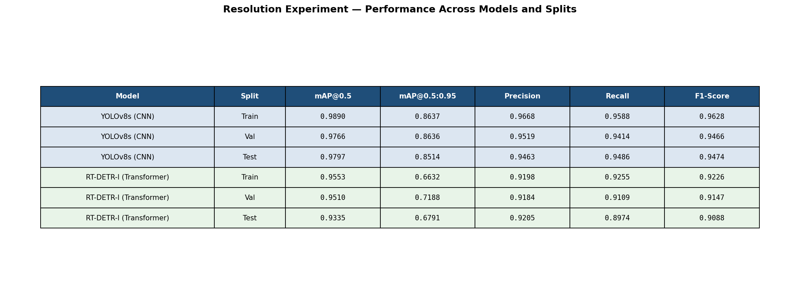
Figure 5 — YOLOv8s vs RT-DETR-l across train, validation, and test splits.
These results are consistent with the architectural analysis. RT-DETR's global attention mechanism is most beneficial when object classification requires understanding of surrounding context — for example, distinguishing an object whose identity depends on nearby objects. Parking spot classification is inherently local: whether a spot is occupied depends on the content within its bounding box, not on surrounding spots. Furthermore, transformers generally require larger datasets to fully learn effective attention patterns, whereas CNNs benefit from strong inductive biases (locality, translation equivariance) that naturally match the structured, repetitive nature of parking lot imagery.

4.4 Failure Case Analysis
To understand the model's limitations, a failure case analysis was conducted by running the fine-tuned YOLOv8s on the test set and identifying images where predictions did not match ground truth. Three error types were annotated:
- Missed detections (False Negatives, blue dashed): spots present in ground truth but not detected.
- False positives (red): predictions with no matching ground truth box.
- Wrong class (orange): correct localisation but incorrect empty/occupied classification.
The failure cases reveal that the model most commonly struggles with heavily occluded spots (obscured by adjacent vehicles or structures), spots at image boundaries with partial visibility, and grayscale or low-contrast images where the distinction between empty asphalt and a parked vehicle is reduced. Wrong-class errors are rare, consistent with the high confusion matrix scores (94% empty, 98% occupied correctly classified), and tend to occur in ambiguous cases such as partially occupied spots or unusually coloured vehicles.
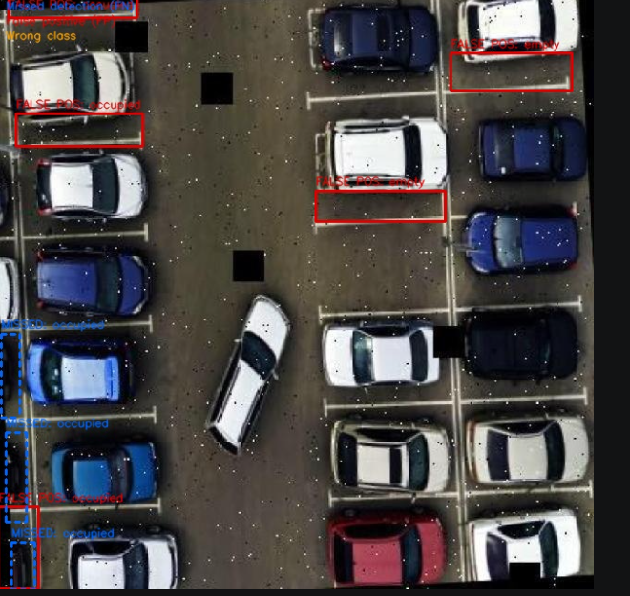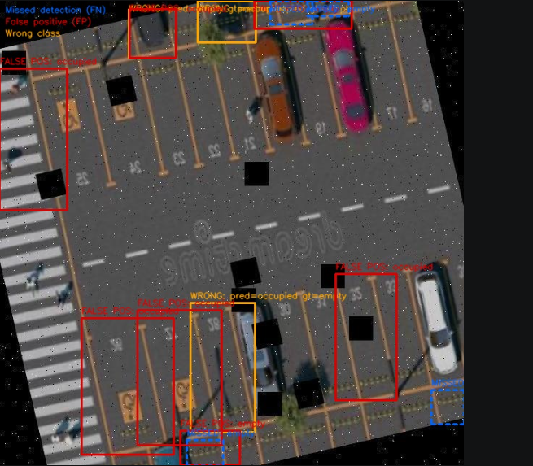
Figure 6 — Failure case examples: missed detections (blue dashed), false positives (red) and wrong class predictions (orange) on the test set

5. Discussion

5.1 What Worked
Fine-tuning YOLOv8s on the parking dataset proved highly effective, achieving 97.97% mAP@0.5 on the test set. The combination of COCO pretraining (which provides general object detection capabilities) and domain-specific fine-tuning (which specialises the model for parking spot classification) is the core reason for this strong performance. The augmentation pipeline — both Roboflow's pre-augmentation and the training-time augmentation — contributed significantly to robustness across challenging conditions including noise, rotation, and grayscale imagery.
The resolution ablation confirmed that 640×640 is an appropriate default for this task, offering the best balance of accuracy and computational efficiency. The Gradio demo successfully demonstrates the end-to-end system on both images and videos, with the manual ROI tab providing an accessible classical CV baseline for comparison.

5.2 What Did Not Work as Expected
RT-DETR-l underperformed relative to expectations. Despite being a more recently developed and architecturally sophisticated model, it achieved 4.6 percentage points lower mAP@0.5 and 17.2 percentage points lower mAP@0.5:0.95 than YOLOv8s. The most likely explanation is architectural mismatch: RT-DETR's global attention is not beneficial for a task where classification is locally determined. Additionally, RT-DETR-l has significantly more parameters (66.2 MB vs 22.6 MB), requiring a smaller batch size (8 vs 16) which may have slightly limited training stability.
The classical CV baseline, while intuitive, is fragile. The 7% edge density threshold is sensitive to lighting conditions, painted ground markings, and shadow patterns. In practice, this method would require threshold recalibration for each new parking lot environment, limiting its generalisability.

5.3 Limitations
The following limitations should be acknowledged:
Dataset scope: The dataset, while covering multiple viewing angles and lighting conditions, consists exclusively of structured parking lots with clearly marked spaces. The system struggles with unstructured or informal parking areas where spot boundaries are not defined by visible white lines.
Class imbalance: Occupied spots are approximately twice as frequent as empty spots. While the model handles this well given the large dataset size, performance may degrade in parking lots with unusual occupancy patterns.
Training scale: The models were trained for 50 epochs on a single dataset. Training on a larger and more diverse dataset, or for more epochs with learning rate tuning, could further improve generalization.
Real-time deployment: Training was conducted on GPU. Inference speed on CPU or embedded hardware has not been benchmarked.

6. Conclusion

This project presented a complete computer vision system for automated parking spot detection and occupancy classification. Three approaches were implemented: a fine-tuned YOLOv8s CNN, a fine-tuned RT-DETR-l Transformer, and a classical computer vision baseline using edge density analysis. Extensive experiments demonstrated that fine-tuning is essential (mAP@0.5 improves from 0.0000 to 0.9797), that 640×640 input resolution offers the optimal speed-accuracy trade-off, and that the CNN-based YOLOv8s consistently outperforms the Transformer-based RT-DETR-l on this spatially structured, locally-classifiable task.
The final system achieves 97.97% mAP@0.5, 94.63% Precision, 94.86% Recall, and an F1-Score of 94.74% on the held-out test set, demonstrating strong and reliable occupancy detection. The system is fully reproducible via the provided GitHub repository (https://github.com/Reuh-Dev/parking-spot-detection) and includes an interactive Gradio demo supporting both image and video inputs.

7. References
[1] Amato, G., Carrara, F., Falchi, F., Gennaro, C., & Meghini, C. (2016). Deep learning for decentralized parking lot occupancy detection. Expert Systems with Applications, 72, 327–334.
[2] Hržić, F., Štajduhar, I., Lerga, J., & Štifanić, D. (2020). CNR-Ext: A parking lot dataset with camera position variations. IEEE Access, 8, 21545–21554.
[3] Lin, T.-Y., Goyal, P., Girshick, R., He, K., & Dollár, P. (2017). Focal loss for dense object detection. ICCV, 2980–2988.
[4] Carion, N., Massa, F., Synnaeve, G., Usunier, N., Kirillov, A., & Zagoruyko, S. (2020). End-to-end object detection with transformers. ECCV, 213–229.
[5] Lv, W., Xu, S., Zhao, Y., Wang, G., Wei, J., Cui, C., & Liu, Y. (2023). DETRs Beat YOLOs on Real-time Object Detection. arXiv:2304.08069.

