A READER'S GUIDE
Marginalia
A local English reader for close reading
Why the name — and how to use it
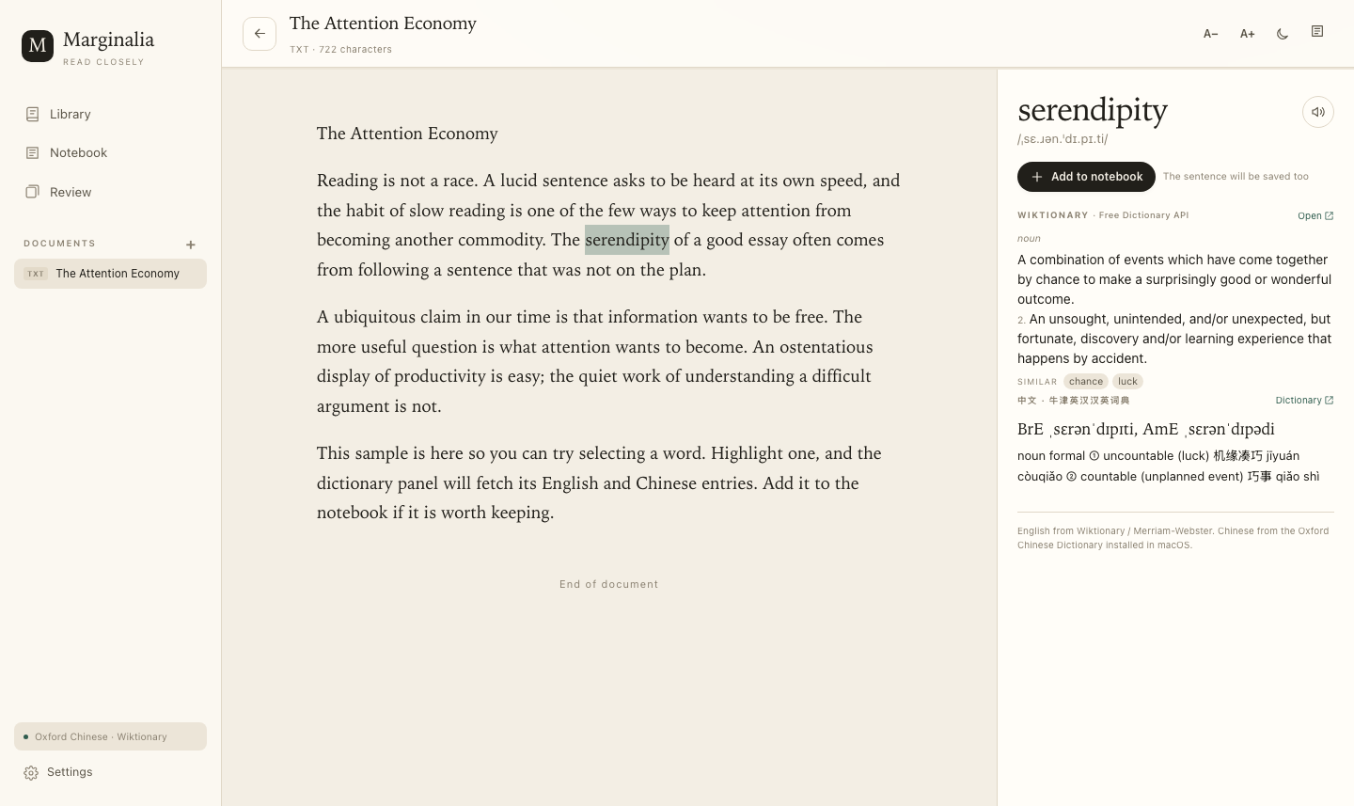
The reading view: the page on the left, the dictionary margin on the right.
Marginalia · Reader's Guide · 2026

THE NAME

01 Why “Marginalia”?
Marginalia are the notes a reader leaves in the margin of a book: a gloss, a question, a translation, a disagreement, a line worth returning to. The word comes from the Latin marginalis, “of the margin,” and for centuries it has described the small, personal layer of writing that grows around a text.
The name is not decorative. It states a view of reading: understanding is not passive reception. A reader who stops, looks up a word, notices a strange collocation, or copies a sentence into a notebook is doing something with the text. The margin is where that work becomes visible.
THE NAME IN ONE SENTENCE
Marginalia are the notes a reader leaves beside a text — and this app gives you a digital margin for every text you read.

Three ideas behind the name
The margin is active. It is not empty space around the “real” content. It is where the reader answers back.
The margin is selective. You do not annotate everything. Marginalia record the words and passages that resisted you, surprised you, or seemed worth keeping.
The margin is a record. Over time, those small notes become a portrait of what you have read and how your attention has changed.
One clarification: Marginalia does not literally draw on the PDF page. It reflows the text into a clean reading column and rebuilds the margin as a side panel and a notebook. The metaphor is deliberate: the app cares about the reading relationship, not about reproducing a page image.
What it is, at a glance
Question | Answer
What is it? | A local English reader with dictionary lookup and spaced review.
Where does it run? | On this Mac, in your browser, served from 127.0.0.1.
How do I start it? | Double-click Marginalia.command. The browser opens automatically.
What can I open? | PDF, DOCX, EPUB, TXT, Markdown, and HTML.
Where is my data? | In reader/data/reader.db on this Mac. Nothing is uploaded.
Which dictionaries? | Oxford Chinese Dictionary locally; Wiktionary or Merriam-Webster for English.

The guide moves from the name, to the mechanics of reading, to the dictionary sources, and ends with the limits of the tool and a short closing note.
FIRST LAUNCH

02 Getting started
Marginalia lives in a folder on your Mac. It is not a cloud service, and it does not need an account. The first launch creates a small Python environment and builds a helper for the local Oxford dictionary; later launches are much faster.
1. Place the app. Open the folder that contains Marginalia.command.
2. Start it. Double-click Marginalia.command. A Terminal window will open, then your browser.
3. Let it load. Wait for the browser to open http://127.0.0.1:8765/. The first run may take a minute.
4. Stop it. Close the Terminal window when you are finished. That stops the local server.
If macOS blocks the launcher
Right-click Marginalia.command, choose Open, and confirm. macOS may show this warning for any unsigned local script; it does not mean the app needs an internet connection. You can also run the script from Terminal if you prefer.
The first screen
The Library is your home. The drop zone accepts a file, and the document cards below it show what you have opened and how far you have read. The sidebar gives you Notebook, Review, and Settings; the status line at the bottom tells you which dictionary sources are active.
THE CORE LOOP

03 Reading a text
Open a document and the text is reflowed into a single reading column. PDF page breaks are preserved as thin markers; Word, EPUB, and text files become clean paragraphs. The original page is not shown, because the point is to read and look up words, not to reproduce a facsimile.
1. Add a text. Drop a file onto the drop zone, or click Add document and choose one.
2. Select a word. Highlight a word, or a short phrase of up to four words.
3. Read the margin. The right-hand panel fills with English definitions, Chinese equivalents, phonetics, and examples.
4. Keep it. Click Add to notebook. The word, both definitions, and the sentence around it are saved.
Useful details
- Progress. The reader remembers your place. Scroll position is saved per document.
- Type size. Use A− and A+ in the top bar to change the reading size. Settings also offers six sizes.
- Theme. The sun/moon button toggles light and dark. Settings offers System, Light, and Dark.
- PDF text. The app strips PDF line-end hyphenation and preserves paragraph breaks where it can. Complex layouts may still need patience.
- Scans. A scanned PDF has no selectable text and no OCR. The app will tell you when this happens.
What selection looks up
A single word is the normal unit. The app also accepts short phrases, and it tries common inflected forms: “abated” is looked up through “abate,” “studies” through “study.” If the first form misses, it walks through a small set of base-form candidates before giving up.
SOURCES, HONESTLY

04 Where the definitions come from
A dictionary panel is only as good as its sources. Marginalia keeps the source labels visible and avoids pretending that every entry has the same authority.
Source | Language | How it works
Oxford Chinese Dictionary | Chinese ↔ English | Installed in macOS Dictionary; read locally through DictionaryServices. Authoritative and offline.
Wiktionary | English → English | Free Dictionary API. Good coverage and examples; community-edited. Used by default.
Merriam-Webster Learner's | English → English | Optional. Add a free API key in Settings to switch the English side to MW.

The Chinese side is the strongest claim: it reads the same Oxford Chinese Dictionary that Dictionary.app uses, without scraping a website. If that dictionary is not installed on your Mac, the panel says so rather than inventing a translation.
The English side starts with Wiktionary because it is free and broadly available. For genuinely authoritative English definitions, open Settings, paste a Merriam-Webster Learner's key, and save. Keys are free at dictionaryapi.com.
Why not offer Oxford or Cambridge English definitions out of the box? Their APIs are licensed and paid. Scraping their pages would be brittle and would misrepresent the source. The honest design is to let you choose a licensed source when you have one.
Offline and cached behaviour
- Offline. Chinese lookups are local and work without a network.
- Cached. English lookups need a network the first time. Successful results are cached in the local database for seven days.
- After a key change. The cache is cleared when you change the Merriam-Webster key, so a new source takes effect immediately.

FROM READING TO RECALL

05 The notebook and review
Saving a word is not the end of the loop. Each notebook entry keeps the word, its phonetics, the English and Chinese definitions, and the sentence in which you met it. That sentence is often more useful than a generic example: it is the trace of your own reading.

01  READ  Meet a word in context. | 02  SELECT  See both definitions. | 03  SAVE  Keep the word and sentence. | 04  REVIEW  Recall it on schedule.

Reviewing
Review draws from words that are due. The card shows the word and, when available, the sentence you saved. Say the meaning to yourself before revealing it. Then grade your recall:
- Again. You could not retrieve it. It comes back very soon.
- Hard. You retrieved it, but with effort. The interval grows slowly.
- Good. You retrieved it cleanly. The interval grows by the current ease factor.
- Easy. It was immediate and effortless. The interval grows fastest.
Space reveals the definition, and 1–4 grade the card. The schedule is a familiar SM-2-style algorithm with short learning steps: a new word returns in minutes, then days, then weeks. You can mark a word as known, which removes it from review without deleting it.
Finding things again
The Notebook can be searched by word, definition, Chinese text, or the saved context. Each row shows its status and next review. Click a row for the full entry, the original sentence, review statistics, and actions: review now, mark known, or delete.
EVERYTHING LOCAL

06 Data, privacy, and backup
Documents, words, definitions, contexts, and review schedules live in one SQLite file: reader/data/reader.db. There is no account and no cloud sync. The local server listens only on 127.0.0.1, so it is not exposed to your local network.
Settings → Notebook → Export downloads a JSON copy of your notebook, including definitions, context, and review state. The exported file does not include the full text of your documents; those remain in the database. If you move the app to another Mac, copy the whole reader folder and export a notebook backup first.
A practical backup habit
- Weekly. Export the notebook after a serious reading session or before changing machines.
- Off-site. Keep the export outside the app folder, such as iCloud Drive or an external disk. While the app is closed, a copy of reader.db is also a complete backup.

READ THIS BEFORE YOU BLAME THE DICTIONARY

07 Limits and quick fixes
Marginalia is deliberately a local reading tool, not a publishing platform or a full PDF annotator. A few limits are worth knowing in advance.
Symptom | What is happening | What to do
A PDF opens but shows no text | It is a scan or an image-only PDF. There is no OCR layer. | Use a text-based PDF, or run OCR in another tool first.
Chinese definitions are missing | The Oxford Chinese Dictionary is not available to DictionaryServices. | Install it in Dictionary.app, then reopen Marginalia.
English definitions are missing | No network, or the word is not in Wiktionary. | Check the connection; try the base form; add a Merriam-Webster key.
The page is still starting | The first launch builds a Python environment and the dictionary helper. | Wait a minute. Later launches are fast.
The browser shows nothing | The server was closed, or the port is in use. | Double-click the launcher again; the Terminal window shows the actual URL.

The Chinese lookup uses a private macOS DictionaryServices interface. It works on the Mac this guide was written for, but Apple could change it in a future release. The English side is independent and would continue to work.
WHY THE MARGIN MATTERS

08 A closing note
Marginalia is built around a simple wager: the words you stop for are the words you remember. A dictionary lookup takes a second; a saved sentence takes a few more; a review a week later takes less than a minute. Those small interruptions are not distractions from reading. They are how reading becomes yours.
The name is a promise about attention. The margin is small, but it is where the reader lives.
— Marginalia, 2026

