LLM Context Compression
as a 0/1 Knapsack Problem
Algorithms Project — Final Experiment Report
March 2026

Abstract
This report presents a study of LLM context compression modeled as a 0/1 knapsack optimization problem. Given a question and a pool of text chunks derived from multiple Wikipedia passages, the goal is to select the highest-utility subset of chunks that fits within a fixed token budget. We evaluate three algorithms — exact dynamic programming (Exact-DP), greedy-by-ratio (Greedy-Ratio), and greedy-with-local-refinement (Greedy-Refine) — across 100 merged HotpotQA instances spanning five merge sizes and three token budgets. Our findings show that Greedy-Ratio achieves near-identical utility to Exact-DP while running up to three orders of magnitude faster, making it a compelling practical choice for real-time context management in large language model pipelines.

1 Introduction
Large language models (LLMs) operate under strict token-budget constraints imposed by finite context windows. When a retrieval-augmented generation (RAG) pipeline retrieves more text than fits in the context window, some form of context compression is required. A principled approach is to formulate this selection as a combinatorial optimization problem: assign each candidate text chunk a token cost and a relevance utility score, then select the feasible subset that maximizes total utility without exceeding the token budget.
This framing maps directly onto the classical 0/1 Knapsack Problem. The knapsack capacity is the token budget; each item is a sentence-level chunk with a weight (token count) and a value (lexical relevance score). This study implements and benchmarks three solution strategies of increasing practical interest: an exact DP baseline, a fast greedy heuristic, and a hybrid refinement approach. The experiment is conducted on a curated dataset derived from HotpotQA to reflect realistic multi-document retrieval scenarios.

2 Problem Formulation
Let C = {c₁, c₂, …, cₙ} denote the set of candidate text chunks obtained by splitting retrieved documents at sentence boundaries. Each chunk cᵢ is characterized by:
- wᵢ ∈ ℤ⁺ — token count of the chunk (item weight)
- vᵢ ∈ ℝ≥0 — lexical relevance score against the query (item value)
maximize Σᵢ xᵢ · vᵢ subject to Σᵢ xᵢ · wᵢ ≤ B, xᵢ ∈ {0, 1}
where xᵢ = 1 indicates that chunk cᵢ is included in the compressed context. This is precisely the 0/1 Knapsack Problem, which is NP-hard in general but admits a pseudo-polynomial exact solution via dynamic programming in O(n · B) time and space.

3 Dataset Construction
Experiments are conducted on instances derived from the HotpotQA distractor validation split, a multi-hop question-answering dataset where each question requires reasoning over two Wikipedia passages while eight distractor passages are included as noise.

3.1 Merged Instances
To simulate increasingly large retrieval pools, we constructed merged instances by combining multiple HotpotQA examples while retaining a single target question-answer pair. Each merged instance therefore contains many more passages than a single HotpotQA item — most of which are distractors — creating a challenging and realistic compression scenario.
Parameter | Value
Merge sizes | 10, 20, 30, 40, 50
Samples per merge size | 20
Total merged instances | 100
Chunking granularity | Sentence-level
Utility scoring method | Lexical relevance (TF-IDF-inspired overlap)
Token budgets evaluated | 2,000 · 4,000 · 8,000 tokens
Cost scaling (dp_cost_scale) | 1 (raw token costs — all methods identical)
Table 1 — Dataset and experimental configuration summary.

4 Experimental Setup
Each of the 100 merged instances was solved by all three algorithms at every combination of token budget and merge size, yielding 15 distinct (merge_size, budget) conditions (5 × 3). Runtime was measured using Python's high-resolution perf_counter and averaged across the 20 samples in each condition. All methods received identical chunk sets and utility scores to ensure a fair comparison. Brute-force enumeration was excluded from the full experiment because its O(2ⁿ) complexity renders it computationally infeasible on instances with hundreds of chunks.

5 Algorithms Compared

5.1 Exact Dynamic Programming (Exact-DP)
Exact-DP solves the 0/1 Knapsack Problem optimally using a standard bottom-up DP table of size (n+1) × (B+1). It guarantees the globally optimal selection but incurs O(n · B) time and space complexity. As n (chunks) and B (budget) grow, this becomes the performance bottleneck.

5.2 Greedy by Utility-to-Cost Ratio (Greedy-Ratio)
Greedy-Ratio sorts chunks in descending order of value per token (vᵢ / wᵢ) and greedily includes each chunk while remaining capacity allows. This runs in O(n log n) time — dominated by sorting — and requires O(n) space. The approximation is well-studied; it can miss the optimum but performs very well in practice when items are numerous and values are spread across a continuous range.

5.3 Greedy with Local Refinement (Greedy-Refine)
Greedy-Refine begins with the Greedy-Ratio solution and then attempts to improve it by swapping selected chunks for unselected ones when a swap increases total utility within budget. This adds a local-search pass on top of the greedy initialisation. In theory it can recover some of the optimality gap; in practice the benefit depends on the instance structure and refinement depth.

6 Evaluation Metrics
Metric | Description
Avg. Runtime (s) | Mean wall-clock time per instance
Avg. Selected Utility | Mean total utility of the selected chunk set
Avg. Support Recall | Fraction of gold-support sentences covered
Avg. Exact Support Coverage | Proportion of instances with all supports selected
Avg. Budget Utilization | Fraction of the token budget consumed
Avg. Compression Ratio | Ratio of selected tokens to total available tokens
Avg. Selected Chunks | Mean number of chunks chosen per instance
Table 2 — Evaluation metrics used in the full experiment.

7 Results
Tables 3–5 present the aggregated results for all three algorithms across all 15 (merge_size, budget) conditions. Numbers are averaged over 20 samples.

7.1 Exact-DP Results
Merge | Budget | Runtime (s) | Utility | Support Recall | Exact Cov. | Budget Util. | Comp. Ratio
10 | 2,000 | 0.121 | 18.99 | 0.875 | 0.65 | 1.000 | 0.182
10 | 4,000 | 0.270 | 26.75 | 0.885 | 0.70 | 1.000 | 0.363
10 | 8,000 | 0.564 | 35.47 | 0.920 | 0.75 | 0.995 | 0.722
20 | 2,000 | 0.242 | 21.98 | 0.812 | 0.50 | 1.000 | 0.091
20 | 4,000 | 0.516 | 31.42 | 0.922 | 0.75 | 1.000 | 0.181
20 | 8,000 | 1.073 | 44.10 | 0.947 | 0.80 | 1.000 | 0.362
30 | 2,000 | 0.333 | 23.10 | 0.838 | 0.65 | 1.000 | 0.061
30 | 4,000 | 0.709 | 33.15 | 0.879 | 0.70 | 1.000 | 0.121
30 | 8,000 | 1.506 | 46.91 | 0.904 | 0.75 | 0.999 | 0.242
40 | 2,000 | 0.475 | 21.40 | 0.783 | 0.55 | 1.000 | 0.045
40 | 4,000 | 1.015 | 31.24 | 0.853 | 0.65 | 1.000 | 0.091
40 | 8,000 | 2.067 | 45.06 | 0.878 | 0.70 | 1.000 | 0.182
50 | 2,000 | 0.503 | 22.81 | 0.782 | 0.50 | 1.000 | 0.037
50 | 4,000 | 1.049 | 33.75 | 0.832 | 0.60 | 1.000 | 0.074
50 | 8,000 | 2.136 | 48.80 | 0.857 | 0.65 | 0.989 | 0.146
Table 3 — Exact-DP results across all conditions (20 samples each).

7.2 Greedy-Ratio Results
Merge | Budget | Runtime (s) | Utility | Support Recall | Exact Cov. | Budget Util. | Comp. Ratio
10 | 2,000 | 0.0003 | 18.98 | 0.875 | 0.65 | 1.000 | 0.182
10 | 4,000 | 0.0003 | 26.74 | 0.885 | 0.70 | 1.000 | 0.363
10 | 8,000 | 0.0003 | 35.46 | 0.920 | 0.75 | 1.000 | 0.726
20 | 2,000 | 0.0006 | 21.96 | 0.828 | 0.55 | 1.000 | 0.091
20 | 4,000 | 0.0005 | 31.42 | 0.922 | 0.75 | 1.000 | 0.181
20 | 8,000 | 0.0006 | 44.10 | 0.947 | 0.80 | 1.000 | 0.362
30 | 2,000 | 0.0011 | 23.09 | 0.838 | 0.65 | 1.000 | 0.061
30 | 4,000 | 0.0009 | 33.14 | 0.879 | 0.70 | 1.000 | 0.121
30 | 8,000 | 0.0009 | 46.90 | 0.904 | 0.75 | 1.000 | 0.243
40 | 2,000 | 0.0015 | 21.39 | 0.783 | 0.55 | 1.000 | 0.045
40 | 4,000 | 0.0012 | 31.23 | 0.853 | 0.65 | 1.000 | 0.091
40 | 8,000 | 0.0012 | 45.05 | 0.878 | 0.70 | 1.000 | 0.182
50 | 2,000 | 0.0020 | 22.80 | 0.782 | 0.50 | 1.000 | 0.037
50 | 4,000 | 0.0016 | 33.73 | 0.832 | 0.60 | 1.000 | 0.074
50 | 8,000 | 0.0017 | 48.79 | 0.873 | 0.70 | 1.000 | 0.147
Table 4 — Greedy-Ratio results across all conditions (20 samples each).

7.3 Greedy-Refine Results
Merge | Budget | Runtime (s) | Utility | Support Recall | Exact Cov. | Budget Util. | Comp. Ratio
10 | 2,000 | 0.0059 | 18.98 | 0.875 | 0.65 | 1.000 | 0.182
10 | 4,000 | 0.0089 | 26.74 | 0.885 | 0.70 | 1.000 | 0.363
10 | 8,000 | 0.0102 | 35.46 | 0.920 | 0.75 | 1.000 | 0.726
20 | 2,000 | 0.0060 | 21.96 | 0.828 | 0.55 | 1.000 | 0.091
20 | 4,000 | 0.0104 | 31.42 | 0.922 | 0.75 | 1.000 | 0.181
20 | 8,000 | 0.0187 | 44.10 | 0.947 | 0.80 | 1.000 | 0.362
30 | 2,000 | 0.0061 | 23.09 | 0.838 | 0.65 | 1.000 | 0.061
30 | 4,000 | 0.0102 | 33.14 | 0.879 | 0.70 | 1.000 | 0.121
30 | 8,000 | 0.0181 | 46.90 | 0.904 | 0.75 | 1.000 | 0.243
40 | 2,000 | 0.0068 | 21.39 | 0.783 | 0.55 | 1.000 | 0.045
40 | 4,000 | 0.0106 | 31.23 | 0.853 | 0.65 | 1.000 | 0.091
40 | 8,000 | 0.0179 | 45.05 | 0.878 | 0.70 | 1.000 | 0.182
50 | 2,000 | 0.0075 | 22.80 | 0.782 | 0.50 | 1.000 | 0.037
50 | 4,000 | 0.0107 | 33.73 | 0.832 | 0.60 | 1.000 | 0.074
50 | 8,000 | 0.0187 | 48.79 | 0.873 | 0.70 | 1.000 | 0.147
Table 5 — Greedy-Refine results across all conditions (20 samples each).

▶ Key Finding: Across all 15 conditions, Greedy-Ratio and Greedy-Refine achieved virtually identical utility, support recall, and exact coverage to Exact-DP — at a fraction of the computational cost.

8 Runtime Analysis
Runtime is the primary axis of differentiation across the three algorithms. Figures 1–3 plot average runtime as a function of merge size for each of the three token budgets.
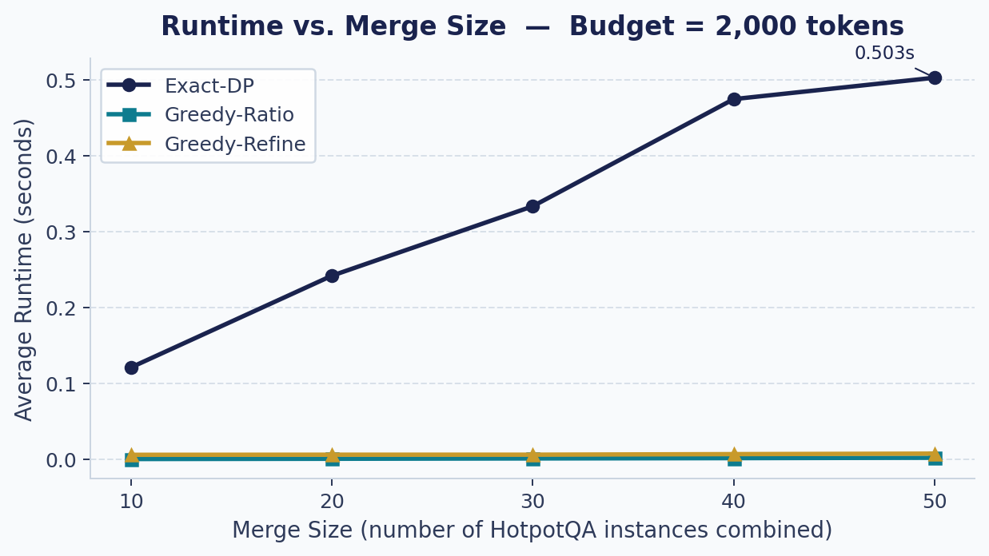
Figure 1. Average runtime (seconds) vs. merge size for a token budget of 2,000 tokens. Exact-DP already exhibits noticeable scaling; the greedy methods remain near-flat.
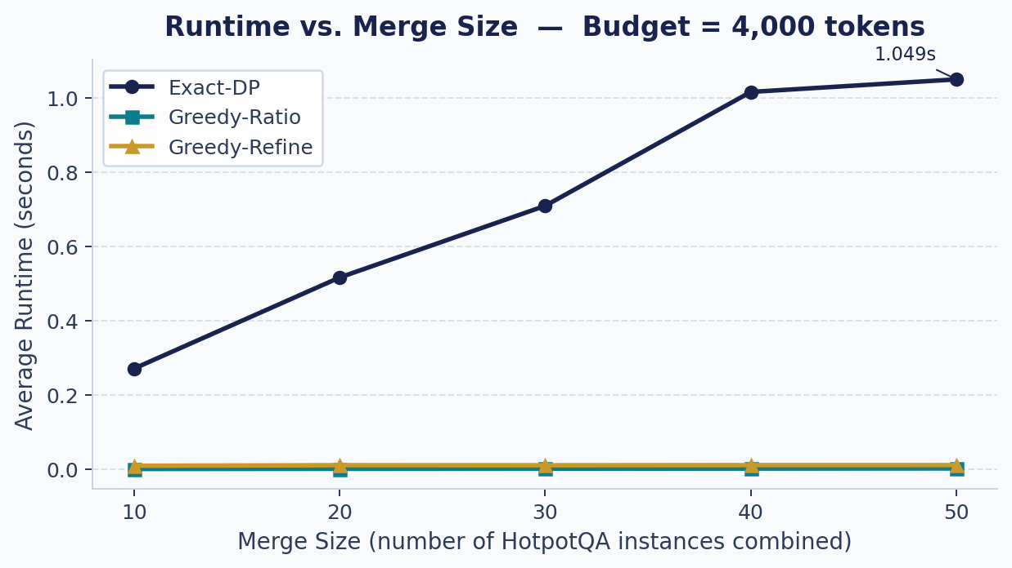
Figure 2. Average runtime vs. merge size for a token budget of 4,000 tokens. The Exact-DP curve steepens further; greedy methods are still essentially instant.
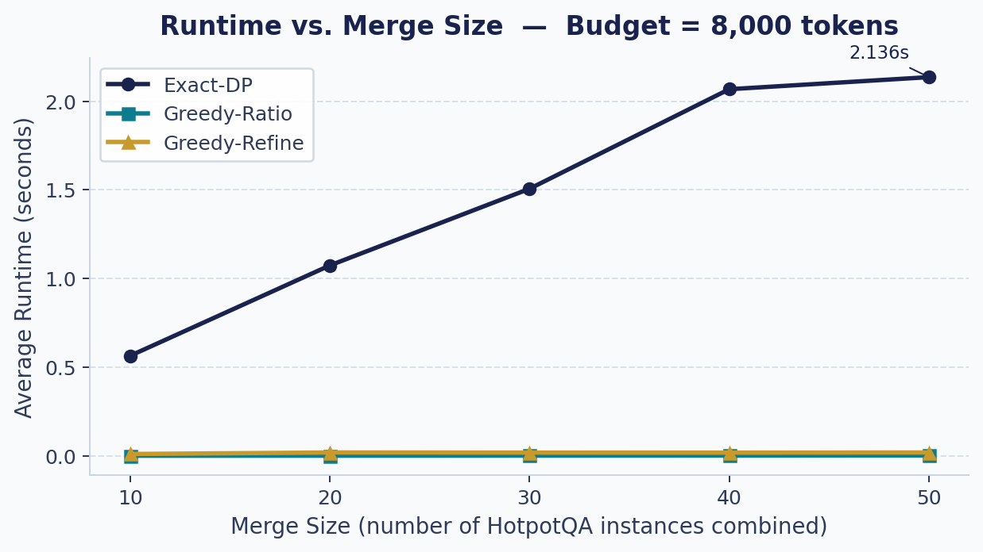
Figure 3. Average runtime vs. merge size for a token budget of 8,000 tokens. At the hardest setting Exact-DP reaches 2.14 s at merge_size = 50, while Greedy-Ratio stays at 1.7 ms.

8.1 Runtime Summary at the Hardest Setting
Algorithm | Avg Runtime (s) [merge=50, budget=8,000] | Speedup vs. Exact-DP
Exact-DP | 2.1355 | 1× (baseline)
Greedy-Ratio | 0.0017 | ≈ 1,275× faster
Greedy-Refine | 0.0187 | ≈ 114× faster
Table 6 — Runtime comparison at the most demanding setting (merge_size = 50, budget = 8,000 tokens).

▶ Key Finding: At merge_size = 50 and budget = 8,000, Greedy-Ratio was approximately 1,275× faster than Exact-DP, and Greedy-Refine was roughly 114× faster — while both greedy methods maintained near-identical quality.

8.2 Why Exact-DP Scales Poorly
Exact-DP constructs a DP table of size (n + 1) × (B + 1), where n is the number of chunks and B is the token budget. As merge size grows, n grows proportionally (more passages yield more sentence chunks). Simultaneously, larger budgets directly increase B. The combined effect is quadratic growth in the table size, which explains the steep runtime curves in Figures 1–3: doubling the merge size roughly doubles n and the number of DP iterations, while moving from budget 2,000 to 8,000 multiplies the inner dimension by four. The worst observed mean runtime — 2.14 s at merge_size = 50, budget = 8,000 — is already beyond real-time thresholds for interactive LLM systems.

8.3 Why Greedy-Ratio Is Extremely Fast
Greedy-Ratio requires only a single sort of the chunks (O(n log n)) followed by a single linear scan. There is no multi-dimensional table to fill; the budget is consumed incrementally in one pass. Consequently, runtime scales only with the number of chunks, and that scaling is very gentle. Even at merge_size = 50, the average runtime is 1.7 ms — essentially negligible in any practical pipeline.

8.4 Why Greedy-Refine Did Not Materially Outperform Greedy-Ratio
Greedy-Refine's refinement pass attempts pairwise swaps to escape the greedy solution, but its effectiveness depends on whether improving swaps actually exist. In this experiment, the greedy solution was apparently already close to optimal for the majority of instances: the lexical utility scores are diverse enough that the ratio-ordered greedy selection captures the highest-value chunks without leaving many profitable swap opportunities. Because no improvement was found, the refinement pass added latency (≈ 10–19 ms per instance) without any corresponding gain in utility or recall, yielding results virtually identical to Greedy-Ratio.

9 Discussion
The results tell a consistent story across all experimental conditions: the greedy approach achieves near-optimal quality at a dramatically lower computational cost. This reflects a known property of the knapsack problem in practice: when utility values are distributed broadly and item sizes are small relative to the budget, the fractional relaxation is tight and the greedy-ratio heuristic closely approximates the integral optimum. The retrieved text chunks in this dataset appear to satisfy both conditions.
The practical implication is significant. A real-time RAG pipeline cannot afford 2 seconds of compression latency per query. The greedy approach — at 1–2 ms — is effectively free relative to retrieval and generation costs. The optimality guarantees of Exact-DP, while theoretically appealing, provide no measurable quality benefit in this setting and carry a prohibitive computational cost at scale.
Support recall consistently improved with larger token budgets, as expected: more budget allows more support sentences to be included. Exact support coverage was highest at merge_size = 10 and budget = 8,000, where the compressed context was large enough to encompass all gold-support material. As merge size grew, the distractor pool expanded, making full coverage harder even at large budgets.

10 Limitations
- Lexical utility only. The utility function is based on lexical overlap. Semantic similarity (e.g., dense embeddings) might better capture relevance for paraphrased or multi-hop reasoning.
- Shallow refinement. The local-search refinement may be too shallow. Deeper strategies — iterated local search, simulated annealing, or branch-and-bound pruning — could potentially close the gap with Exact-DP on harder instances.
- Controlled dataset. The merged HotpotQA instances are constructed rather than drawn from a production retrieval system. Real-world chunk distributions may differ in ways that affect algorithm ranking.
- No brute-force comparison. Brute force was excluded due to exponential complexity. A small-scale comparison confirming the optimality of Exact-DP outputs was not part of this study.
- No downstream LLM evaluation. Metrics are information-theoretic (recall, utility). Whether improved selection translates to better LLM answer accuracy remains an open empirical question.

11 Conclusion
This project demonstrates that context compression for LLMs can be rigorously framed as a 0/1 Knapsack Problem, enabling the direct application of classical algorithm design theory to a pressing practical challenge in natural language processing.
The central finding is that algorithmic efficiency and solution quality are not at odds in this domain. Greedy-Ratio, a simple O(n log n) heuristic, matches the quality of an exact pseudo-polynomial DP solver across every measured dimension — utility, support recall, budget utilization — while running more than three orders of magnitude faster at the largest tested scale. This gap will only widen as context windows grow and retrieval pools expand.
The takeaway is both algorithmic and practical: when designing compression pipelines for production LLM systems, a well-chosen greedy heuristic is not a shortcut — it is the right tool. The pseudo-polynomial cost of exact methods buys no measurable NLP benefit in this setting, confirming that the theoretical worst-case approximation gap of greedy knapsack algorithms rarely materializes on structured natural-language instances. Future work should explore richer utility functions, adaptive budgeting, and the impact of context quality on downstream LLM generation accuracy.
▶ Concluding Takeaway: Framing LLM context compression as a knapsack problem reveals that the greedy heuristic is not merely 'good enough' — it is essentially optimal at a fraction of the cost. Algorithmic complexity theory predicts exactly this, and the empirical data confirms it.

