Knapsack Context Compression
Hybrid Utility Report
Full experiment summary with lexical vs hybrid comparison

1. Overview
- Dataset: merged HotpotQA distractor validation set
- 100 merged instances across merge sizes 10, 20, 30, 40, and 50
- Budgets: 2000, 4000, 8000
- Algorithms: exact_dp, greedy_ratio, greedy_refine
- Hybrid utility: 0.7 semantic + 0.3 lexical
- Semantic model: sentence-transformers/all-MiniLM-L6-v2

2. Key Findings
- At merge size 50 and budget 8000, hybrid exact_dp averaged 1.8256s, greedy_ratio averaged 0.0016s, and greedy_refine averaged 0.0529s.
- Greedy_ratio was about 1125x faster than exact_dp in that hardest setting.
- Greedy_refine was about 35x faster than exact_dp in that hardest setting.
- Hybrid generally improved support recall and exact support coverage compared with lexical.
- Greedy_refine remained close to greedy_ratio in aggregate quality, so the extra runtime yielded limited additional benefit.

3. Lexical vs Hybrid Comparison
Algorithm | Lexical Recall | Hybrid Recall | Lexical Exact Coverage | Hybrid Exact Coverage
exact_dp | 0.864 | 0.867 | 0.660 | 0.727
greedy_ratio | 0.867 | 0.866 | 0.667 | 0.723
greedy_refine | 0.867 | 0.866 | 0.667 | 0.723
Interpretation: hybrid scoring appears to align more closely with the supporting evidence than lexical-only scoring. The strongest gains show up in exact support coverage, which is a strict metric and therefore meaningful for this project.

4. Runtime Analysis
The runtime story remains clean. Exact dynamic programming scales the worst as merge size and budget increase. Greedy ratio remains extremely fast, while greedy refinement adds noticeable overhead but stays far below DP.
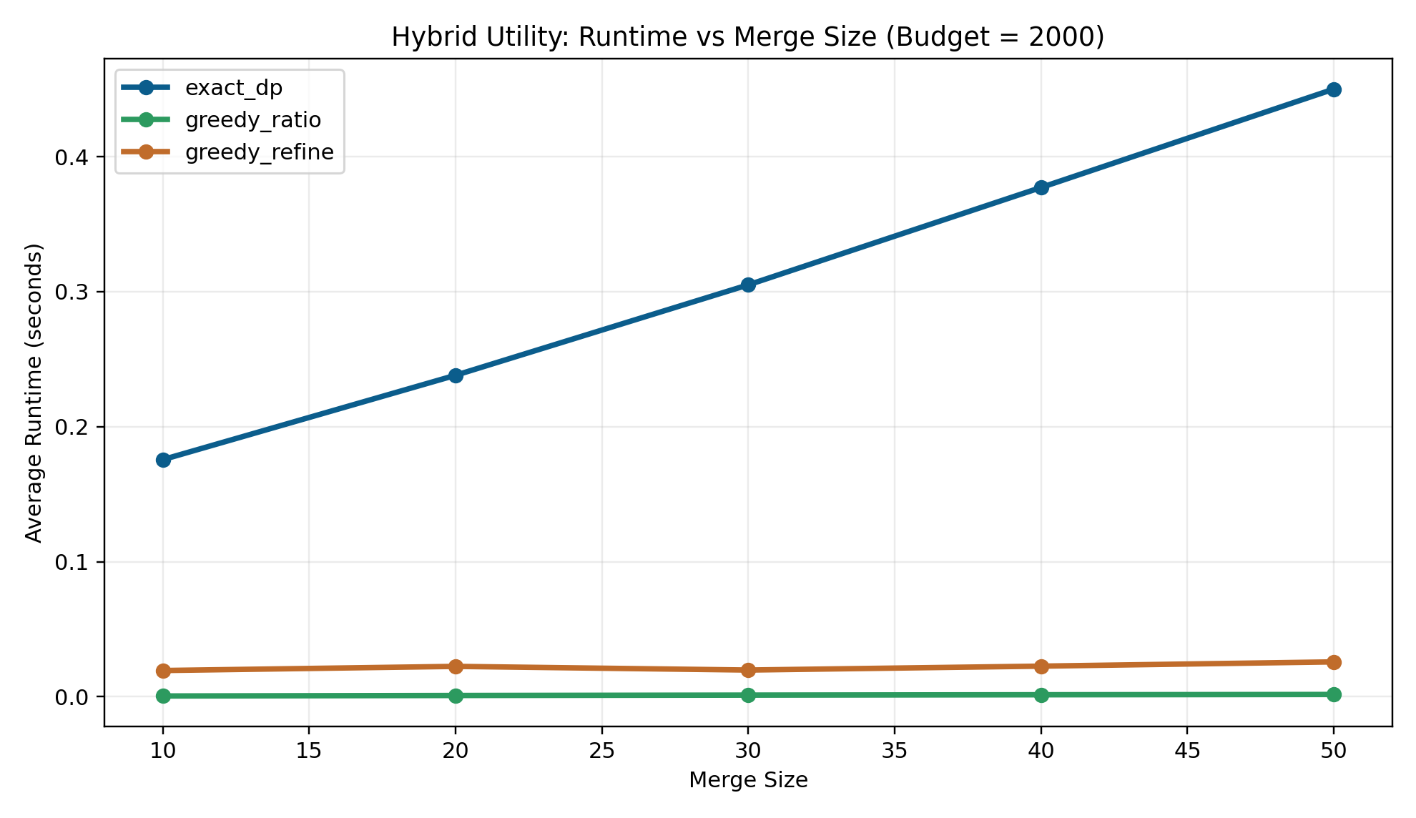
Figure 1. Hybrid utility runtime vs merge size at budget 2000.
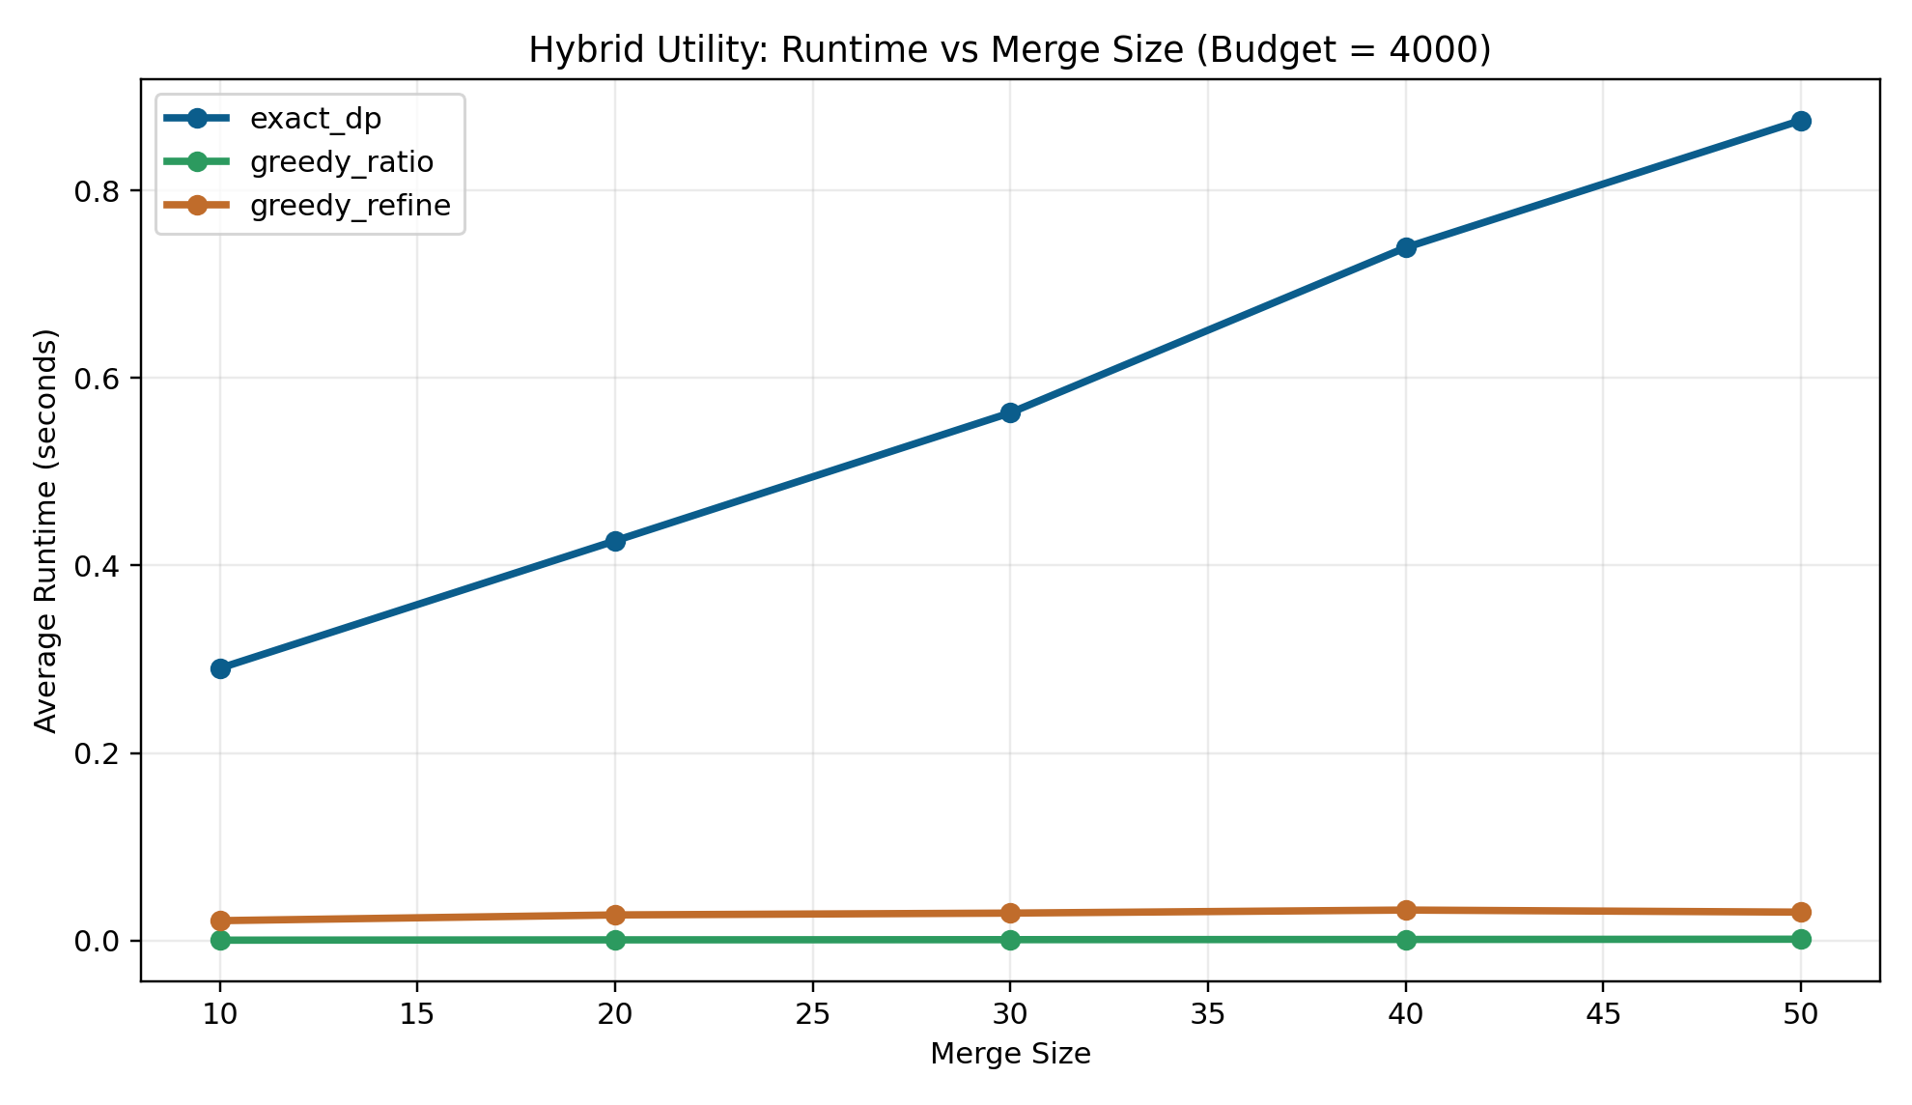
Figure 2. Hybrid utility runtime vs merge size at budget 4000.
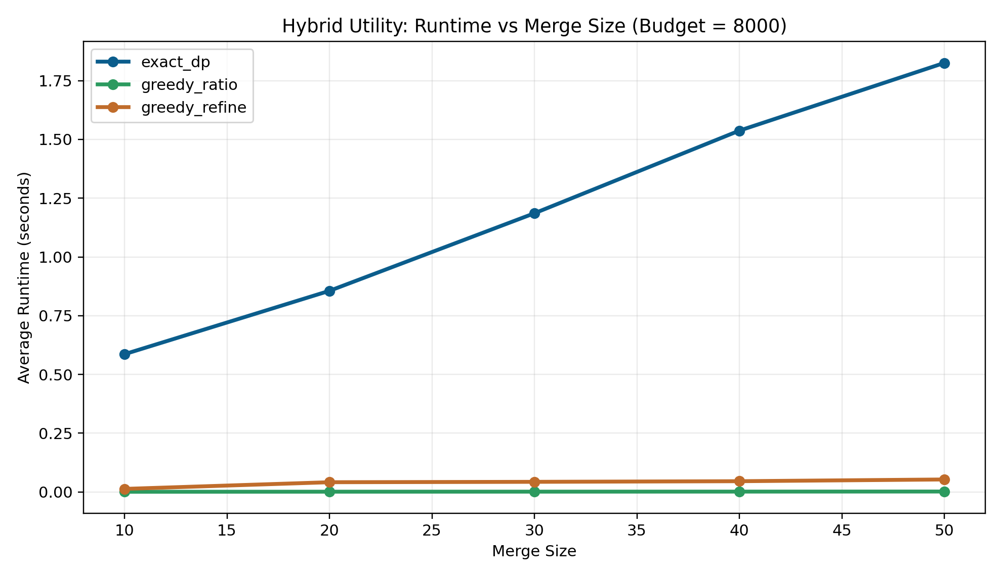
Figure 3. Hybrid utility runtime vs merge size at budget 8000.
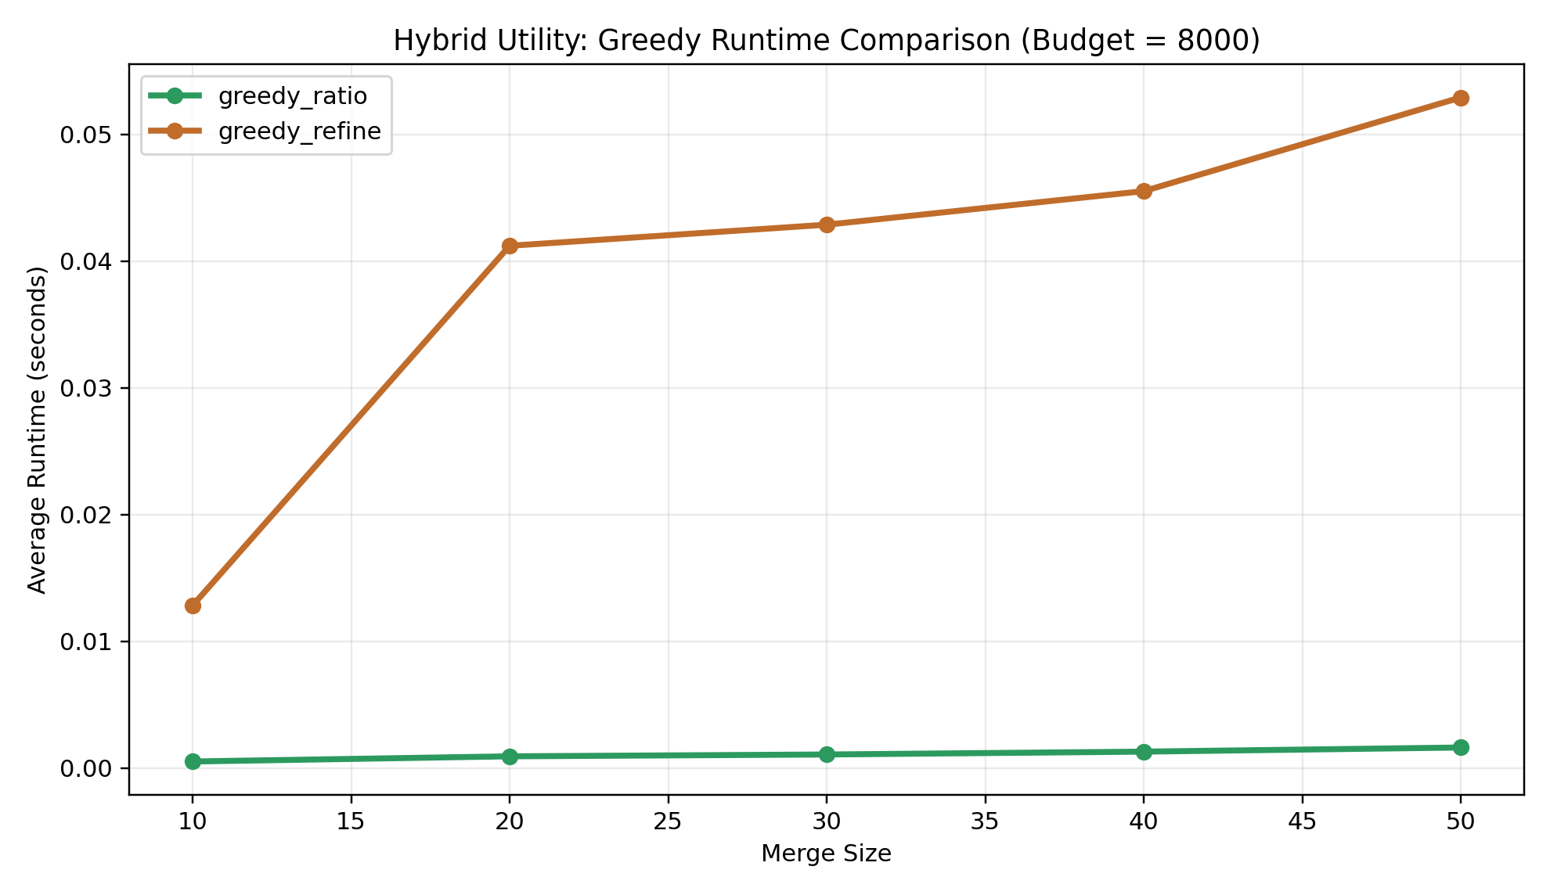
Figure 4. Greedy-only runtime comparison at budget 8000, shown separately so the difference is visible without DP dominating the scale.

5. Utility Comparison Figures
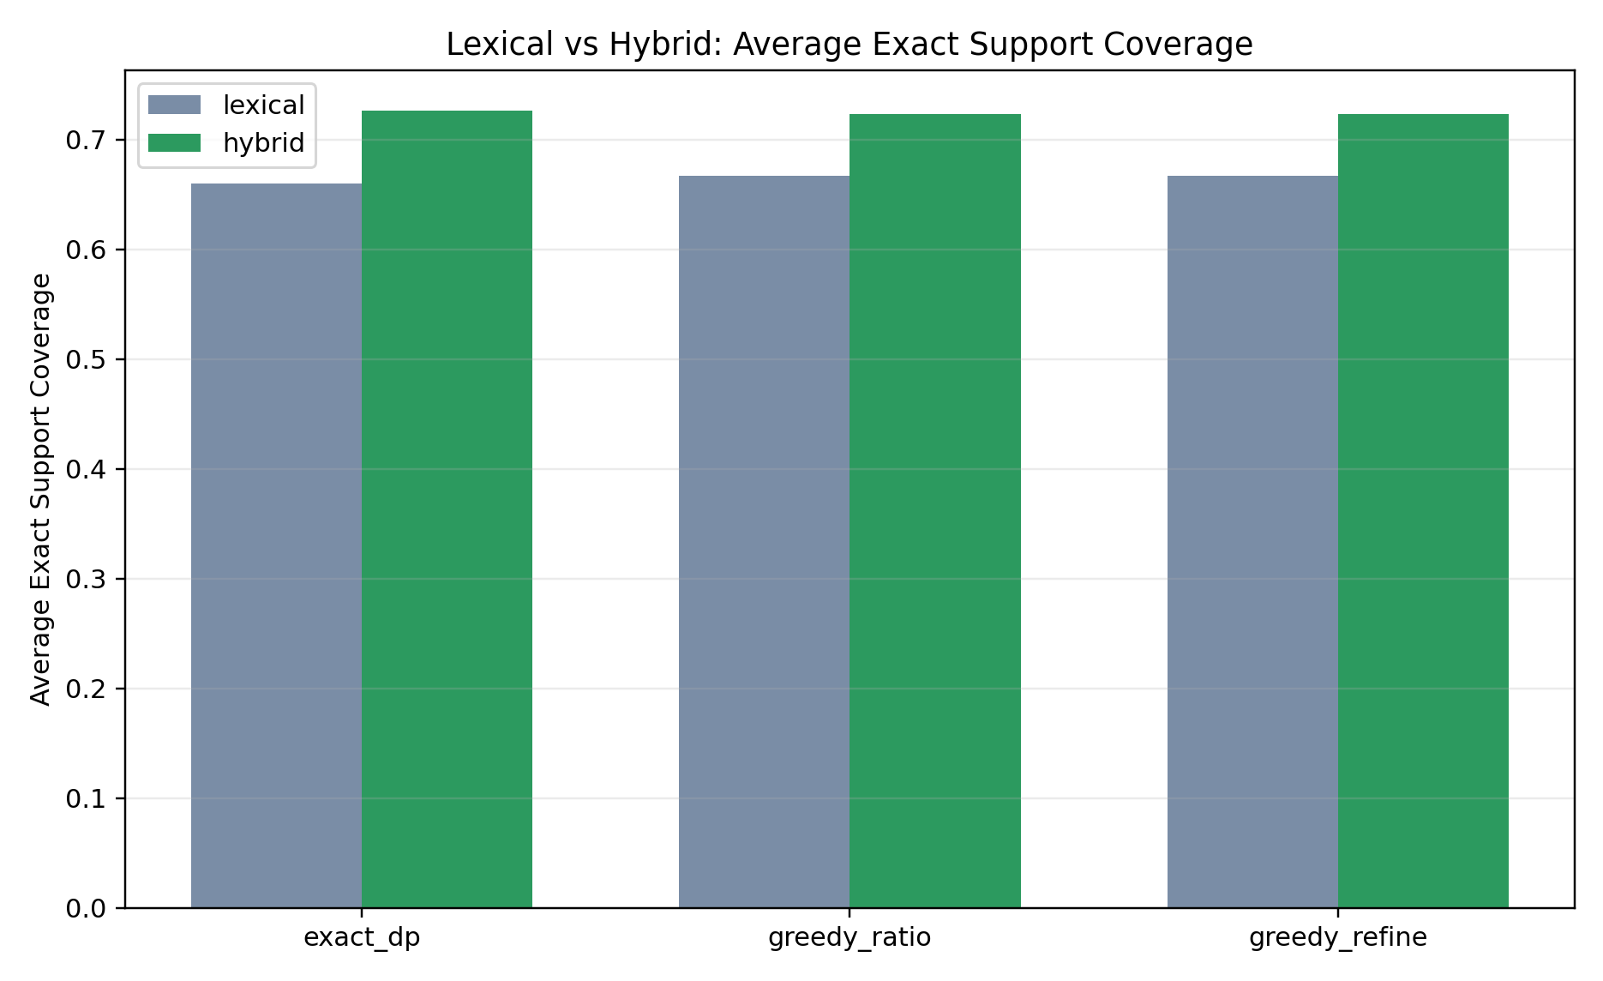
Figure 5. Average exact support coverage: lexical vs hybrid.
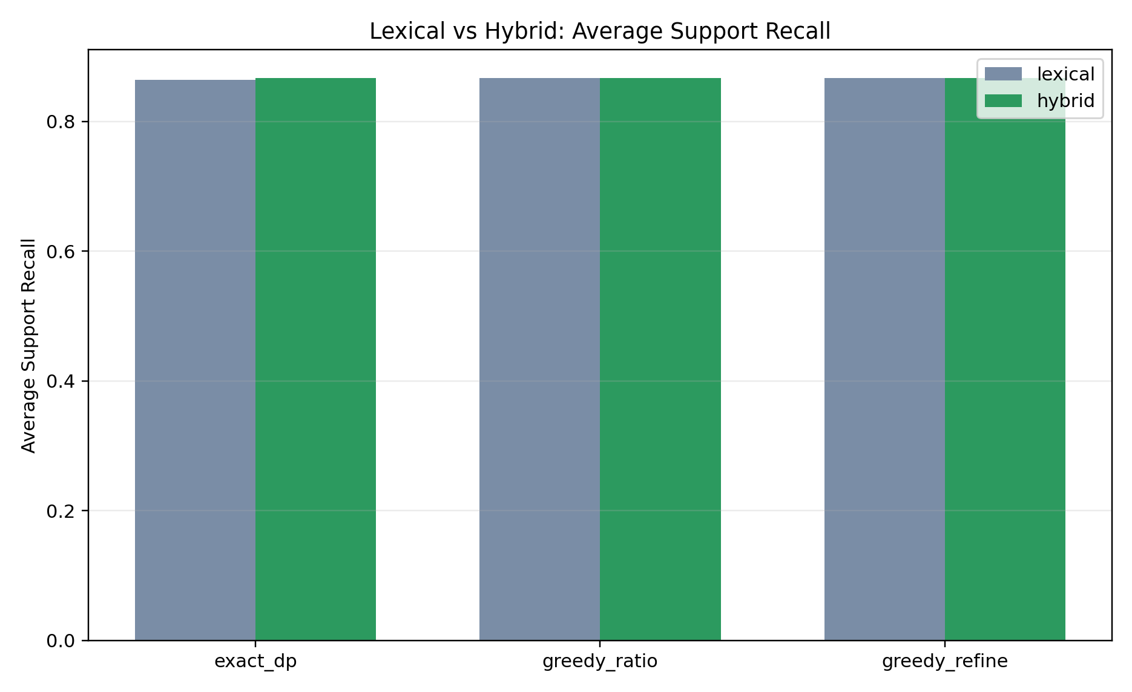
Figure 6. Average support recall: lexical vs hybrid.

6. Conclusion
The new hybrid utility results strengthen the project. They preserve the same overall runtime hierarchy while improving evidence-retention metrics over lexical-only scoring. For this implementation, greedy_ratio remains the best practical speed-quality tradeoff, while greedy_refine does not yet show a strong enough improvement to justify its extra runtime.

