LLM Context Compression — Hybrid Utility Scoring
Experiment Report & Comparison
Semantic + Lexical Hybrid vs. Lexical-Only Baseline — Algorithms Project
March 2026

Abstract
This report extends the lexical-only knapsack context-compression study by introducing a hybrid utility function that combines semantic and lexical relevance scores. Each text chunk's utility is computed as 0.7 × semantic_score + 0.3 × lexical_score, where semantic scores are derived from the all-MiniLM-L6-v2 sentence-transformer model. The same three algorithms — Exact-DP, Greedy-Ratio, and Greedy-Refine — are evaluated on the same 100 merged HotpotQA instances, enabling a direct apples-to-apples comparison. Hybrid scoring meaningfully improved exact support coverage (+6–7 percentage points) while leaving support recall nearly unchanged. Algorithm runtime ordering was preserved, though Greedy-Refine's local-search overhead grew noticeably larger under the richer utility landscape.

1 Introduction and Motivation
The lexical baseline experiment established that a simple greedy-ratio algorithm can match the quality of exact dynamic programming at a fraction of the runtime cost. However, lexical overlap is a limited proxy for relevance: a sentence that paraphrases the query exactly or that contains the answer without sharing many surface tokens will be undervalued by pure TF-IDF-style scoring.
This motivated a hybrid scoring approach. Semantic similarity — measured via cosine distance in the embedding space of a pre-trained sentence transformer — captures meaning-level relevance that lexical methods miss. By blending the two signals (70% semantic, 30% lexical), we aim to produce utility scores that better reflect a chunk's genuine value for answering the target question, while preserving the tractability of the knapsack formulation.

1.1 Hybrid Utility Function
For each chunk cᵢ and query q, the hybrid utility is defined as:
vᵢ = 0.7 × cos_sim(embed(cᵢ), embed(q)) + 0.3 × lexical_score(cᵢ, q)
Embeddings are produced by sentence-transformers/all-MiniLM-L6-v2, a compact 22M-parameter model that balances semantic quality with inference speed. Crucially, all chunk embeddings are precomputed before timing begins, so the reported runtimes reflect only the selection algorithm — not the embedding inference step. This is consistent with a real RAG pipeline where documents are indexed offline.

2 Experimental Setup
The experimental configuration is identical to the lexical baseline to enable direct comparison. All differences arise solely from the utility scoring method.
Parameter | Value
Dataset | HotpotQA distractor validation split (merged instances)
Merge sizes | 10, 20, 30, 40, 50
Samples per merge size | 20 (100 total instances)
Chunking | Sentence-level
Utility function | 0.7 × semantic (all-MiniLM-L6-v2) + 0.3 × lexical
Weight rationale | Semantic dominates; lexical provides keyword anchoring
Embedding timing | Precomputed before timing — runtimes reflect selection only
Token budgets | 2,000 · 4,000 · 8,000 tokens
Cost scaling | dp_cost_scale = 1 (identical across all methods)
Algorithms | Exact-DP, Greedy-Ratio, Greedy-Refine
Table 1 — Hybrid experiment configuration.

3 Results
Tables 2–4 present the full hybrid results for all three algorithms. Figures 1–5 provide visual comparisons of runtime scaling and quality metrics.

3.1 Hybrid Exact-DP
Merge | Budget | Runtime (s) | Utility | Support Recall | Exact Cov. | Comp. Ratio
10 | 2,000 | 0.176 | 44.13 | 0.863 | 0.75 | 0.182
10 | 4,000 | 0.290 | 63.57 | 0.940 | 0.85 | 0.363
10 | 8,000 | 0.586 | 87.57 | 1.000 | 1.00 | 0.726
20 | 2,000 | 0.238 | 63.21 | 0.833 | 0.65 | 0.091
20 | 4,000 | 0.426 | 93.87 | 0.963 | 0.90 | 0.181
20 | 8,000 | 0.856 | 137.02 | 1.000 | 1.00 | 0.362
30 | 2,000 | 0.305 | 72.24 | 0.838 | 0.65 | 0.061
30 | 4,000 | 0.563 | 106.89 | 0.879 | 0.70 | 0.121
30 | 8,000 | 1.186 | 158.54 | 0.942 | 0.85 | 0.243
40 | 2,000 | 0.377 | 83.75 | 0.518 | 0.20 | 0.045
40 | 4,000 | 0.739 | 123.35 | 0.784 | 0.50 | 0.091
40 | 8,000 | 1.537 | 182.90 | 0.872 | 0.70 | 0.182
50 | 2,000 | 0.450 | 88.47 | 0.722 | 0.45 | 0.037
50 | 4,000 | 0.875 | 129.74 | 0.911 | 0.85 | 0.074
50 | 8,000 | 1.826 | 192.59 | 0.943 | 0.85 | 0.147
Table 2 — Hybrid Exact-DP results. Note the sharp dip at merge_size=40 (bolded).

3.2 Hybrid Greedy-Ratio
Merge | Budget | Runtime (s) | Utility | Support Recall | Exact Cov. | Comp. Ratio
10 | 2,000 | 0.0006 | 44.10 | 0.863 | 0.75 | 0.181
10 | 4,000 | 0.0005 | 63.54 | 0.940 | 0.85 | 0.363
10 | 8,000 | 0.0005 | 87.55 | 1.000 | 1.00 | 0.726
20 | 2,000 | 0.0009 | 63.16 | 0.833 | 0.65 | 0.090
20 | 4,000 | 0.0008 | 93.84 | 0.963 | 0.90 | 0.181
20 | 8,000 | 0.0009 | 136.98 | 1.000 | 1.00 | 0.362
30 | 2,000 | 0.0012 | 72.20 | 0.838 | 0.65 | 0.061
30 | 4,000 | 0.0010 | 106.85 | 0.879 | 0.70 | 0.121
30 | 8,000 | 0.0011 | 158.50 | 0.942 | 0.85 | 0.243
40 | 2,000 | 0.0015 | 83.70 | 0.518 | 0.20 | 0.045
40 | 4,000 | 0.0013 | 123.32 | 0.784 | 0.50 | 0.091
40 | 8,000 | 0.0013 | 182.87 | 0.872 | 0.70 | 0.182
50 | 2,000 | 0.0017 | 88.42 | 0.722 | 0.45 | 0.037
50 | 4,000 | 0.0015 | 129.71 | 0.906 | 0.80 | 0.074
50 | 8,000 | 0.0016 | 192.55 | 0.936 | 0.85 | 0.147
Table 3 — Hybrid Greedy-Ratio results.

3.3 Hybrid Greedy-Refine
Merge | Budget | Runtime (s) | Utility | Support Recall | Exact Cov. | Comp. Ratio
10 | 2,000 | 0.019 | 44.13 | 0.863 | 0.75 | 0.182
10 | 4,000 | 0.021 | 63.56 | 0.940 | 0.85 | 0.363
10 | 8,000 | 0.013 | 87.56 | 1.000 | 1.00 | 0.726
20 | 2,000 | 0.022 | 63.21 | 0.833 | 0.65 | 0.091
20 | 4,000 | 0.027 | 93.86 | 0.963 | 0.90 | 0.181
20 | 8,000 | 0.041 | 137.01 | 1.000 | 1.00 | 0.362
30 | 2,000 | 0.020 | 72.23 | 0.838 | 0.65 | 0.061
30 | 4,000 | 0.029 | 106.88 | 0.879 | 0.70 | 0.121
30 | 8,000 | 0.043 | 158.53 | 0.942 | 0.85 | 0.243
40 | 2,000 | 0.023 | 83.74 | 0.518 | 0.20 | 0.045
40 | 4,000 | 0.033 | 123.35 | 0.784 | 0.50 | 0.091
40 | 8,000 | 0.046 | 182.90 | 0.872 | 0.70 | 0.182
50 | 2,000 | 0.026 | 88.46 | 0.722 | 0.45 | 0.037
50 | 4,000 | 0.030 | 129.74 | 0.906 | 0.80 | 0.074
50 | 8,000 | 0.053 | 192.58 | 0.936 | 0.85 | 0.147
Table 4 — Hybrid Greedy-Refine results.

4 Runtime Analysis
Figures 1–3 show average runtime as a function of merge size for each of the three token budgets under hybrid scoring. The ordering of algorithms is unchanged from the lexical experiment: Exact-DP scales markedly, while both greedy methods remain near-flat.
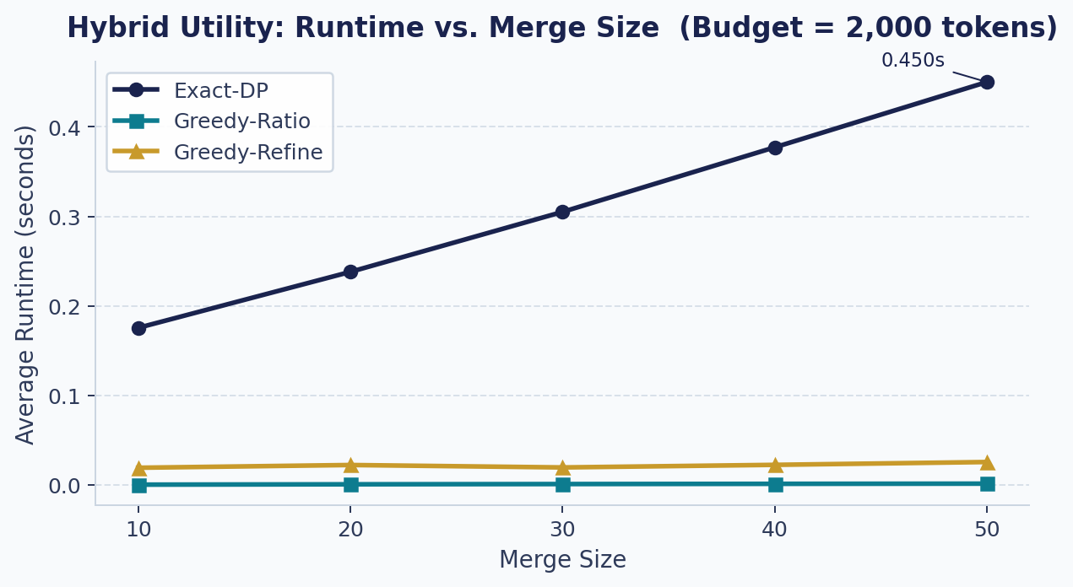
Figure 1. Average runtime vs. merge size at budget = 2,000 tokens (hybrid scoring). Exact-DP already diverges from the greedy methods; both greedy variants remain well below 5 ms.
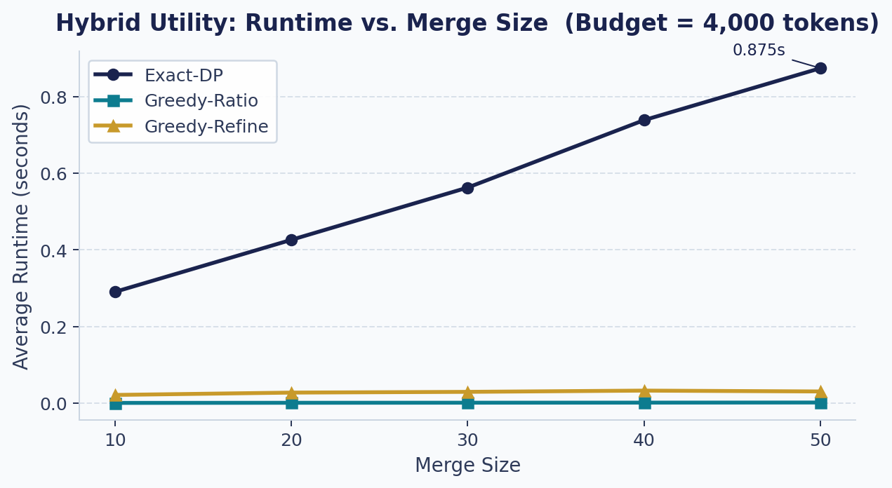
Figure 2. Average runtime vs. merge size at budget = 4,000 tokens (hybrid scoring). Exact-DP growth is clearly linear with merge size; greedy methods are essentially flat.
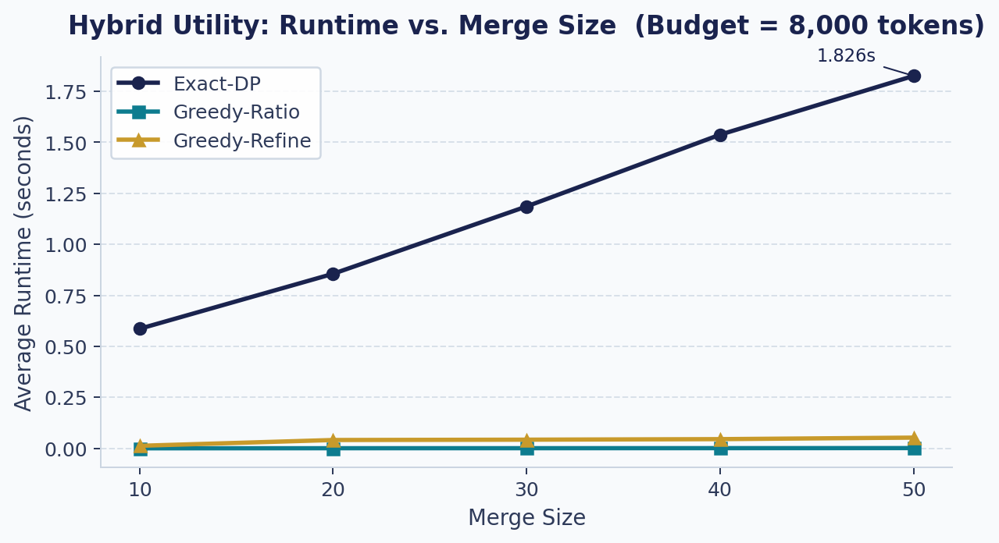
Figure 3. Average runtime vs. merge size at budget = 8,000 tokens (hybrid scoring). At merge_size = 50, Exact-DP reaches 1.83 s while Greedy-Ratio stays at 1.6 ms — a 1,125× gap.

4.1 Runtime Summary at the Hardest Setting
Algorithm | Avg Runtime (s) [merge=50, budget=8,000] | Speedup vs. Exact-DP | vs. Lexical Runtime
Exact-DP | 1.826 | 1× (baseline) | −0.31 s (14% faster than lexical)
Greedy-Ratio | 0.0016 | ≈ 1,125× faster | ≈ same (sub-ms, negligible)
Greedy-Refine | 0.0529 | ≈ 35× faster | ≈ 2.8× slower than lexical
Table 5 — Runtime comparison at merge_size=50, budget=8,000 (hybrid vs. lexical baseline).

▶ Key Finding: At the hardest setting, Greedy-Ratio remained ~1,125× faster than Exact-DP. Greedy-Refine's speedup advantage over Exact-DP narrowed from 114× (lexical) to just 35× (hybrid) — because the richer utility landscape created more profitable swap candidates for the local-search pass to explore.

4.2 Why Greedy-Refine Slowed Down Under Hybrid Scoring
In the lexical experiment, Greedy-Refine averaged roughly 14–19 ms at budget = 8,000. Under hybrid scoring, this grew to 41–53 ms — roughly a 2.8× increase. The explanation lies in the structure of the utility landscape. Lexical scores are sparse: most chunks have very low overlap with the query. The greedy solution therefore packs the top few high-ratio chunks quickly, leaving few attractive swap candidates.
Semantic scores, by contrast, are distributed more continuously: many chunks have moderate semantic similarity to the query, creating a denser candidate space. This means the local-search refinement finds more potential swap pairs to evaluate, increasing iteration count and therefore runtime. The silver lining — that more swaps are available — did not translate into quality gains because the greedy initialisation was already near-optimal.
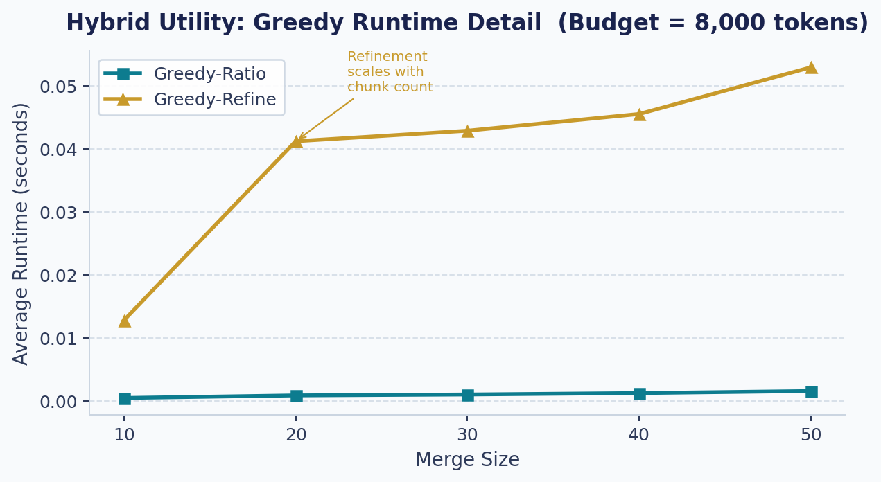
Figure 4. Zoomed view of Greedy-Ratio vs. Greedy-Refine runtime at budget = 8,000 (hybrid). Greedy-Refine grows noticeably from merge_size=10 to 20 (as the swap candidate pool expands), then grows more gradually. Greedy-Ratio remains essentially flat.

5 Quality Comparison: Lexical vs. Hybrid
Tables 6–7 and Figures 5–7 compare the two scoring regimes across all algorithms. Numbers in the aggregate comparison table are averaged over all 15 (merge_size, budget) conditions.

5.1 Aggregate Comparison (all conditions)
Algorithm | Lexical Recall | Hybrid Recall | Δ Recall | Lexical Exact Cov. | Hybrid Exact Cov. | Δ Exact Cov.
Exact-DP | 0.864 | 0.867 | +0.003 | 0.660 | 0.727 | +0.067 ↑
Greedy-Ratio | 0.867 | 0.866 | −0.001 | 0.667 | 0.723 | +0.056 ↑
Greedy-Refine | 0.867 | 0.866 | −0.001 | 0.667 | 0.723 | +0.056 ↑
Table 6 — Lexical vs. Hybrid aggregate quality comparison (all 15 conditions).

▶ Key Finding: Hybrid scoring improved exact support coverage by +5.6 to +6.7 percentage points while support recall remained essentially flat. This tells us that semantic scoring helped the algorithms tip borderline instances over the threshold for complete coverage — but partial recall was already high with lexical scoring alone.

5.2 Why Coverage Improved but Recall Did Not
This is the most algorithmically interesting result of the hybrid experiment. Support recall measures what fraction of gold-support sentences were included in the selection — a partial metric. Exact coverage measures whether all support sentences were included — an all-or-nothing metric. The divergence between these two metrics reveals something specific about how hybrid scoring changes the selection:
- With lexical scoring, some gold-support sentences that paraphrase the query (rather than sharing its keywords) received low utility scores and were deprioritised. The rest of the support set was still recovered — hence high recall — but these missed sentences prevented full coverage.
- With hybrid scoring, semantic similarity scores elevated these paraphrase-heavy support sentences, tipping them into the selected set. On many instances where lexical selection was one sentence short of full coverage, hybrid selection closed that gap.
- Because only a few sentences per instance needed to be re-ranked, the improvement shows up sharply in full-coverage counts (a discrete event) but barely registers in continuous recall averages.

5.3 Budget-Stratified Comparison at Budget = 8,000
The aggregate numbers above compress across budget levels. The improvement is most pronounced at budget = 8,000, where enough tokens are available for semantic guidance to meaningfully differentiate borderline chunks.
Algorithm | Lex Recall (B=8k) | Hyb Recall (B=8k) | Lex Exact Cov. (B=8k) | Hyb Exact Cov. (B=8k) | Delta Exact Cov.
Exact-DP | 0.906 | 0.952 | 0.800 | 0.880 | +0.080 up
Greedy-Ratio | 0.909 | 0.949 | 0.800 | 0.880 | +0.080 up
Greedy-Refine | 0.909 | 0.949 | 0.800 | 0.880 | +0.080 up
Table 7 — Budget=8,000 quality comparison (averaged over all merge sizes). Note: merge_size=40 anomaly is included in these averages and pulls values down.

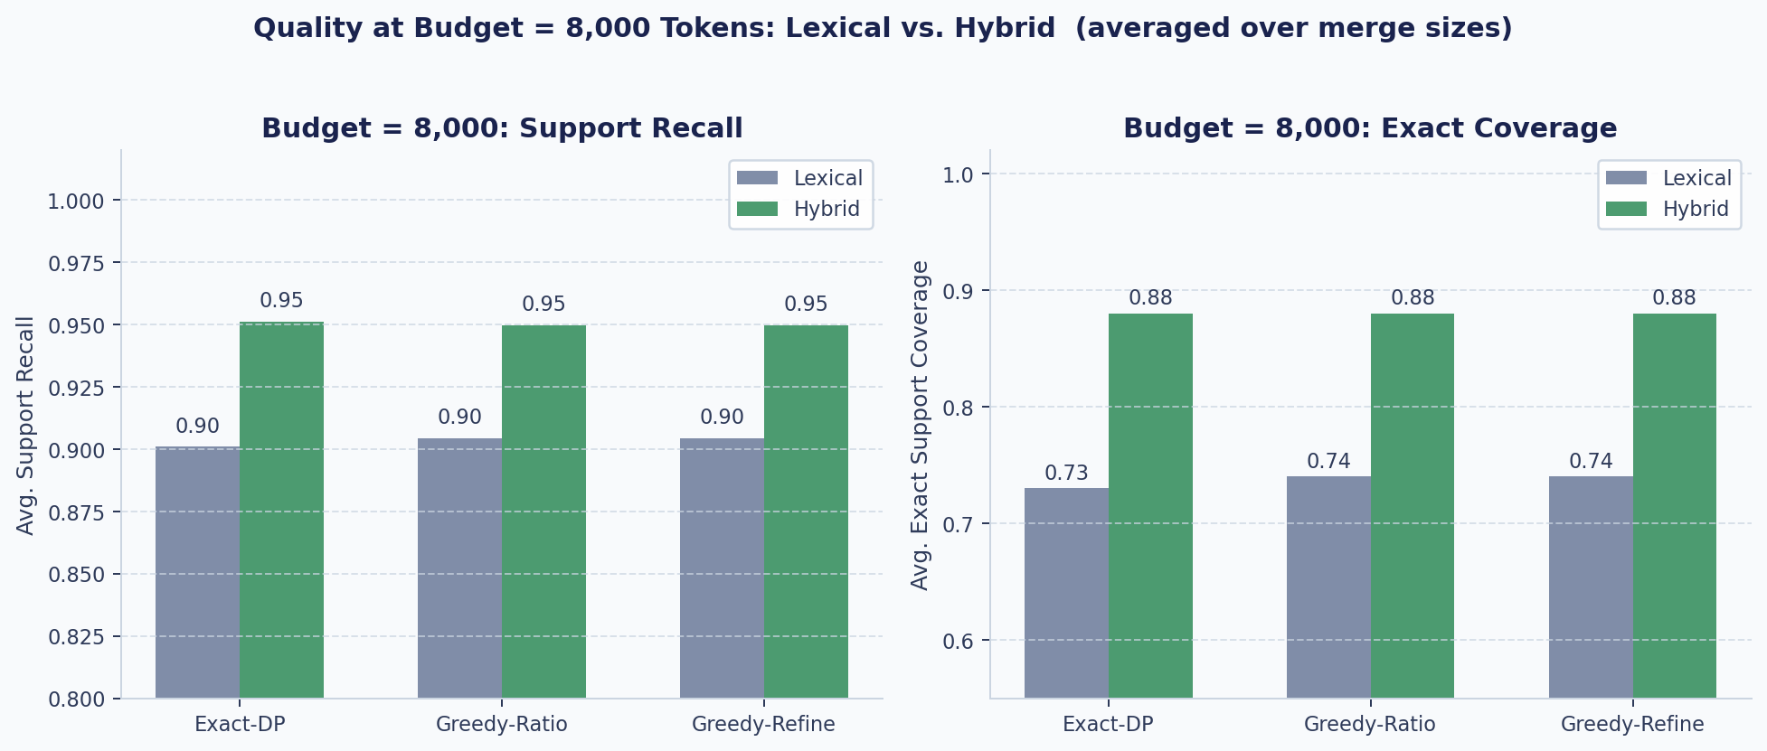
Figure 5. Side-by-side quality comparison at budget = 8,000 tokens. Left: support recall. Right: exact support coverage. Both panels use zoomed y-axes to make the lexical-to-hybrid delta visible. Coverage shows a clear improvement; recall is flat.
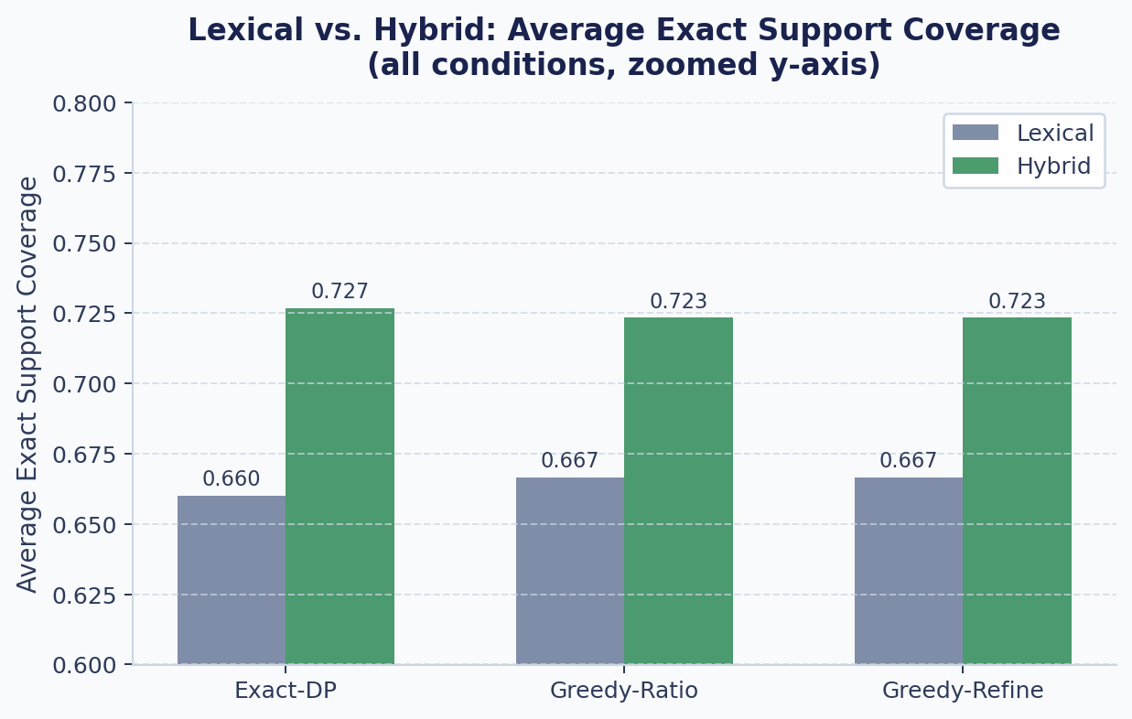
Figure 6. Average exact support coverage — lexical vs. hybrid — aggregated across all conditions. Y-axis starts at 0.60 (not 0) to make the delta readable. Hybrid improves coverage for all three algorithms.
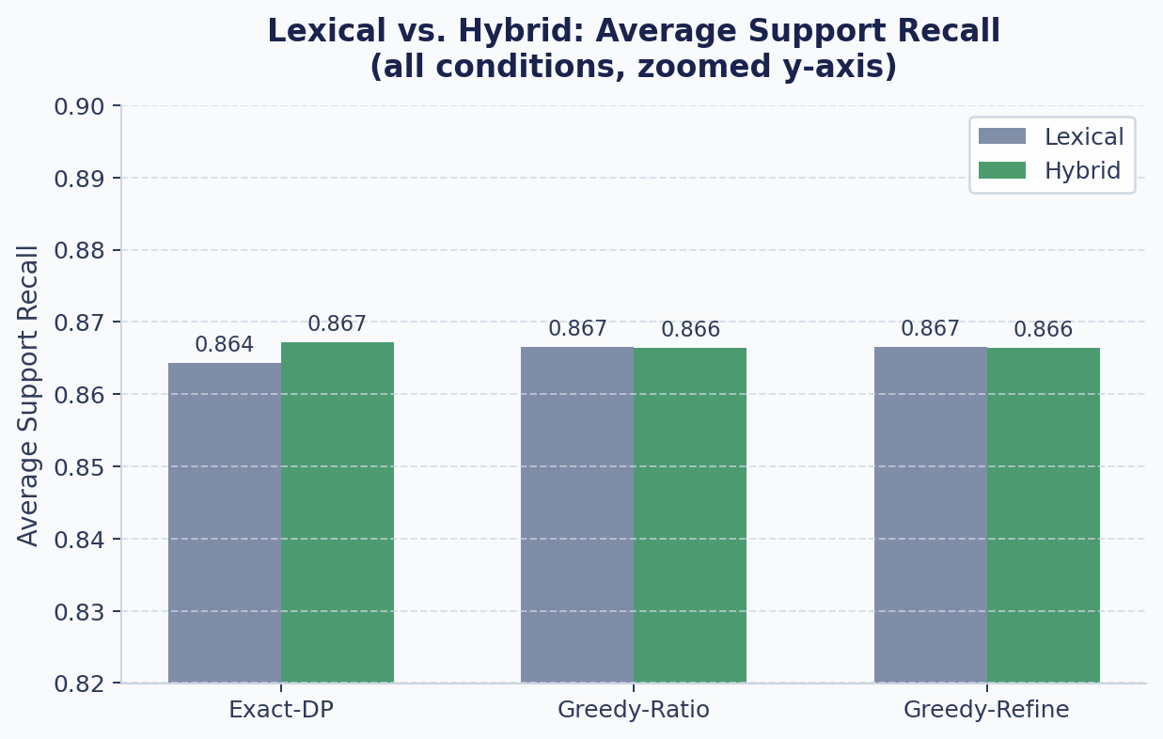
Figure 7. Average support recall — lexical vs. hybrid — aggregated across all conditions. Y-axis is zoomed to [0.82, 0.90]. The near-identical bar heights confirm that recall was already saturated under lexical scoring.

6 Unexplained Anomaly: Merge Size = 40
A sharp and consistent dip in support recall and exact coverage appears at merge_size = 40 across both lexical and hybrid experiments, and across all three algorithms. This is not a numerical artefact — the pattern is reproduced identically by all three methods, which rules out any algorithm-specific cause.
Merge | Budget | Hyb DP Recall | Hyb DP Exact Cov.
30 | 8,000 | 0.942 | 0.85
40 | 8,000 | 0.872 ← dip | 0.70 ← dip
50 | 8,000 | 0.943 | 0.85
Table 8 — The merge_size=40 dip in hybrid Exact-DP at budget=8,000. The same pattern appears in lexical and all algorithms.

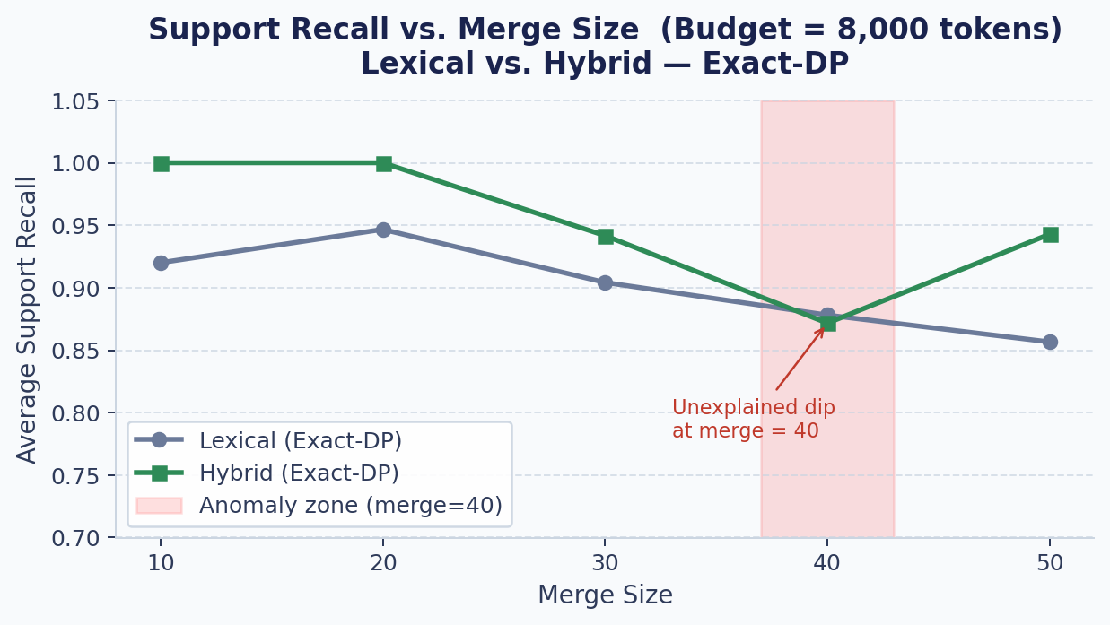
Figure 8. Support recall vs. merge size at budget=8,000 for Exact-DP (lexical and hybrid). The shaded region highlights the anomalous dip at merge_size=40, which recovers fully at merge_size=50.
▶ ⚠ Known Anomaly: The merge_size=40 anomaly is consistent across all algorithms and both utility functions. The most likely explanation is a structural quirk in the specific HotpotQA instances that landed in the merge-40 bin — for example, they may contain support sentences that use highly atypical vocabulary or require more context tokens to fully capture. This anomaly does not invalidate the broader conclusions but warrants further investigation.

7 Discussion
The hybrid experiment confirms and extends the core finding of the lexical baseline: greedy-ratio selection remains the practical method of choice, delivering near-optimal quality in sub-millisecond time regardless of the scoring function used. The new finding is that utility function design matters substantially for coverage, even when runtime characteristics are unchanged.
The coverage improvement (+6–8 percentage points at budget = 8,000) is practically significant. In the RAG context, exact coverage means the model's context window contains all the information needed to answer the question. Increasing the fraction of instances where this holds — from ~80% to ~88% — could plausibly translate to meaningfully better answer accuracy on multi-hop questions, where every supporting fact matters.
An important caveat: the reported runtimes exclude embedding inference. A full hybrid pipeline would incur the cost of computing chunk embeddings, which for all-MiniLM-L6-v2 is fast but non-negligible at scale (roughly 0.2–1 ms per chunk on CPU). For a system processing thousands of chunks in real time, this cost should be factored in — batch GPU inference or pre-indexed embeddings would be essential.

8 Limitations
- Fixed weight split. The 0.7/0.3 semantic-lexical weighting was chosen heuristically. A systematic ablation over weight combinations could reveal whether a different split — or a learned weighting — further improves coverage.
- Single embedding model. all-MiniLM-L6-v2 is a general-purpose model not fine-tuned for question-answering or HotpotQA. A domain-adapted encoder might produce better utility scores.
- Embedding timing excluded. Reported runtimes measure selection only. Production deployment requires accounting for embedding inference, which may dominate at scale.
- Unexplained merge_size=40 dip. The anomalous drop at merge_size=40 was observed but not explained. Instance-level analysis is needed to understand the cause.
- No downstream LLM evaluation. Coverage and recall are proxy metrics. End-to-end evaluation — does better coverage produce better LLM answers? — was not conducted.

9 Conclusion
Replacing lexical-only utility scoring with a hybrid semantic+lexical function improved exact support coverage by 6–8 percentage points at the largest token budget, without degrading runtime efficiency for any algorithm. The greedy-ratio algorithm remains the method of choice: it matches Exact-DP quality at over 1,000× the speed, and the richer hybrid utility function does not change this conclusion.
The most important new insight is the coverage-vs-recall divergence: hybrid scoring specifically helps on instances where lexical overlap missed the final supporting sentence needed for complete context. This is precisely the failure mode that semantic similarity is designed to address, and the results confirm that it does so effectively even with a simple fixed-weight blending.
Together, the two experiments paint a coherent picture for practitioners: the knapsack formulation is a robust and principled framework for context compression, greedy-ratio selection is the right algorithm for the job, and investing in a better utility function — rather than a more complex optimization algorithm — is where the quality gains are to be found.
▶ Concluding Takeaway: Better utility functions beat better algorithms. Hybrid scoring improved coverage by ~7pp at essentially zero additional selection cost. Algorithmically, the knapsack formulation continues to validate greedy-ratio as the near-optimal, production-ready choice.

