1. Introduction

RevPlay is a full-stack music streaming web application designed to provide an interactive platform for users to discover, stream, and manage music while enabling artists to publish and monitor their content. The system allows listeners to explore songs across different genres, create and manage personalized playlists, mark favourite tracks, and enjoy seamless music playback through an intuitive and responsive interface.
For artists, RevPlay provides dedicated features such as uploading tracks, creating albums, and monitoring performance through analytics like streams and followers. This helps artists manage their music content efficiently and understand audience engagement within the platform.
The application is developed using modern technologies such as Spring Boot for backend development, Thymeleaf for server-side rendering of dynamic web pages, and Oracle Database for reliable data storage and management. The system also integrates Spring Security to ensure secure authentication and role-based access for users and artists.
RevPlay follows a modular and layered architecture that separates concerns into controllers, services, repositories, and models. This approach improves code maintainability, scalability, and ease of future enhancements. By combining modern backend frameworks, secure authentication mechanisms, and a database-driven architecture, RevPlay demonstrates how a complete music streaming platform can be designed and implemented in a real-world web application environment.

2. Objectives of the Project

The primary objectives of the RevPlay project are:
• To develop a web-based music streaming platform.
• To allow users to discover, play, and manage songs.
• To provide artists with tools to upload and manage their music.
• To implement secure user authentication and role-based access control.
• To enable playlist management and favourites functionality.
• To provide analytics insights for artists.
• To demonstrate full-stack development using modern technologies.

3. Scope of the Project
The scope of RevPlay includes the development of a web application capable of handling music streaming functionalities for both listeners and artists.

The platform allows users to:
• Register and log in securely
• Browse songs and artists
• Play music through a web-based player
• Create and manage playlists
• Mark songs as favourites

Artists can:
• Upload songs and album artwork
• Manage their albums
• View analytics related to song popularity and listeners.
The system is designed primarily for educational and demonstration purposes but can be extended to support larger music streaming platforms.

4. Technology Stack

The RevPlay application uses the following technologies:
Backend
• Java 17
• Spring Boot 3.x
Security
• Spring Security 6
ORM
• Spring Data JPA
• Hibernate
Template Engine
• Thymeleaf
• Thymeleaf Spring Security Extras
Database
• Oracle Database
• OJDBC 11 Driver
Frontend
• Bootstrap 5.3
• Vanilla CSS
• JavaScript
Build Tool
• Maven (Maven Wrapper)

5. System Architecture (3-Tier Architecture)
RevPlay follows a three-tier architecture, which separates the system into three layers.
The diagram represents the three-tier architecture of the RevPlay Music Streaming Application. This architecture separates the system into three layers to improve scalability, maintainability, and security.
The three layers are:
- Presentation Layer
- Application Layer
- Database Layer
Each layer performs specific responsibilities in the system.

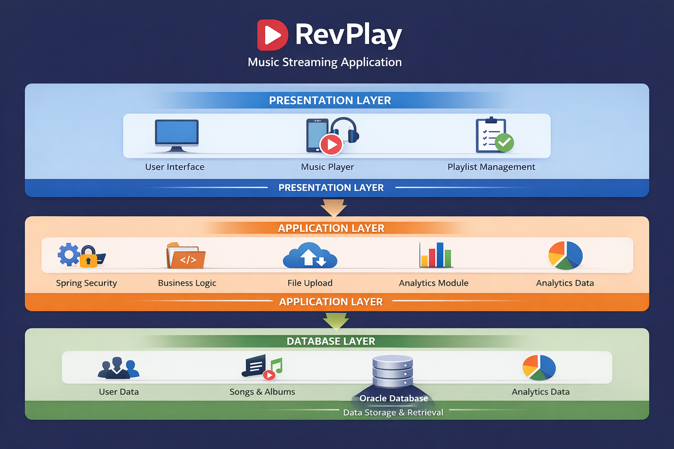
Figure 1: RevPlay Project Architecture

1. Presentation Layer (User Interface)
The Presentation Layer is the top layer where users interact with the application. It provides the graphical interface that allows users to browse songs, play music, and manage playlists.
Functions in this layer include:
- User Interface for login and registration
- Music player interface
- Playlist management interface
- Artist profile pages
- Search and discovery pages
Technologies used in this layer include:
- HTML
- CSS
- JavaScript
- Bootstrap
- Thymeleaf
This layer sends user requests to the application layer and displays responses returned by the system.

2. Application Layer (Business Logic)
The Application Layer processes the logic of the system. It handles user requests, performs validations, and communicates with the database.
Main components in this layer include:
- Security and authentication
- Business logic processing
- File upload handling for songs and images
- Analytics processing
Technologies used in this layer include:
- Spring Boot
- Spring Security
- Hibernate
Responsibilities of this layer:
- User authentication and authorization
- Processing music playback requests
- Managing playlists and favourites
- Handling artist uploads
- Generating analytics insights

3. Database Layer (Data Storage)
The Database Layer stores all persistent data of the system. It manages user information, songs, playlists, and analytics data.
Data stored includes:
- User accounts and profiles
- Song details and audio files
- Album information
- Playlist data
- Listening history
- Analytics metrics
The database used is:
- Oracle Database
Images such as profile pictures and album covers are stored as BLOB data and served using Base64 encoding.

Data Flow in the System
- The flow of data in the RevPlay architecture works as follows:
- The user interacts with the presentation layer through the web interface.
- The request is sent to the application layer, where the system processes business logic and security validation.
- The application layer communicates with the database layer to retrieve or store data.
- The results are returned back to the presentation layer and displayed to the user.
- This layered structure ensures a clear separation between user interface, business logic, and data storage.
6. Project Structure
The project follows a structured directory layout.
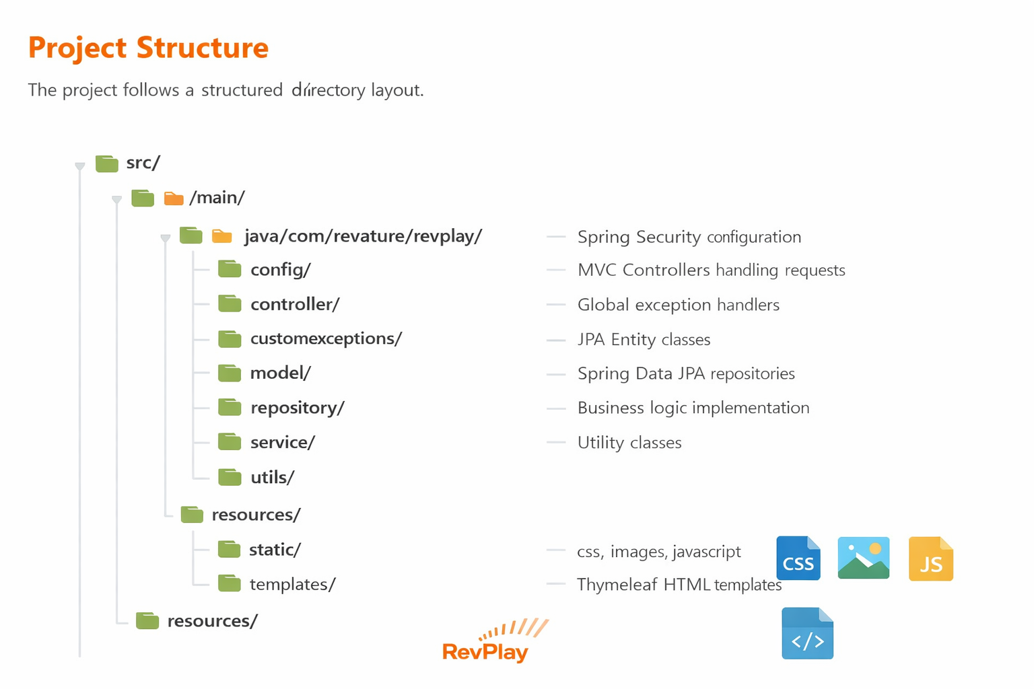
Figure 2: RevPlay Project Structure
RevPlay is a full-stack music streaming web application designed to provide an interactive platform for users to discover, stream, and manage music while enabling artists to publish and monitor their content. The system allows listeners to explore songs across different genres, create and manage personalized playlists, mark favorite tracks, and enjoy seamless music playback through an intuitive and responsive interface.
For artists, RevPlay provides dedicated features such as uploading tracks, creating albums, and monitoring performance through analytics like streams and followers. This helps artists manage their music content efficiently and understand audience engagement within the platform.
The application is developed using modern technologies such as Spring Boot for backend development, Thymeleaf for server-side rendering of dynamic web pages, and Oracle Database for reliable data storage and management. The system also integrates Spring Security to ensure secure authentication and role-based access for users and artists.
RevPlay follows a modular and layered architecture that separates concerns into controllers, services, repositories, and models. This approach improves code maintainability, scalability, and ease of future enhancements. By combining modern backend frameworks, secure authentication mechanisms, and a database-driven architecture, RevPlay demonstrates how a complete music streaming platform can be designed and implemented in a real-world web application environment.

7. User Roles
RevPlay supports two main roles:
Subscriber (Listener)
Subscribers can:
• Browse music library
• Play songs
• Manage playlists
• Add songs to favourites
• View listening history
• Manage user profile

Artist
Artists have all subscriber permissions plus:
• Upload songs
• Manage albums
• View analytics dashboard
• Track song performance
• Manage artist profile

8. Functional Modules

The system is divided into several modules.
8.1 Authentication and Profile Management
Users can create and manage accounts.
Features include:
• User registration
• Login authentication
• Profile management
• Profile picture upload
• Artist account registration
Spring Security is used to secure login and manage user roles.

8.2 Music Discovery Module
This module allows users to explore music available in the platform.
Features include:
• Browse music library
• View song details
• View artist profiles
• View album details
• Search songs, artists, albums, and playlists
• Filter songs by genre or artist

8.3 Music Player Module
The application provides an integrated web music player.
Features include:
• Play and pause songs
• Skip forward and backward
• Seek through track progress
• Volume control
• Shuffle mode
• Repeat mode
• Playback queue management

8.4 Playlist and Favourites Module
Users can organize their music through playlists and favourites.
Features include:
• Create playlists
• Edit playlist details
• Add songs to playlists
• Remove songs from playlists
• Reorder songs
• Delete playlists
• Mark songs as favourites
• View favourite songs
Users can also follow public playlists created by others.

8.5 Listening History Module
This module records songs played by users.
Features include:
• Recently played songs
• Complete listening history
• History timestamp tracking
• Ability to clear listening history

8.6 Artist Studio Module
Artists can manage their music content.
Features include:
• Upload songs
• Upload album artwork
• Create albums
• Add songs to albums
• Update song details
• Update album information
• Delete songs or albums
• Set song visibility

8.7 Analytics and Insights Module
Artists can view insights about their music.
Analytics include:
• Total number of songs
• Total plays
• Total favourites
• Individual song play count
• Popular songs ranking
• Listener statistics
• Listening trends over time
• Top listeners

9. Database Design

The application uses an Oracle database to store system data.
Main database entities include:
• Users
• Artists
• Songs
• Albums
• Playlists
• Favourites
• Listening History
• Analytics
Relationships between these entities allow the system to manage user interactions with music and track performance metrics.
Images such as profile pictures and album artwork are stored as BLOB data and served as Base64 Data URIs.

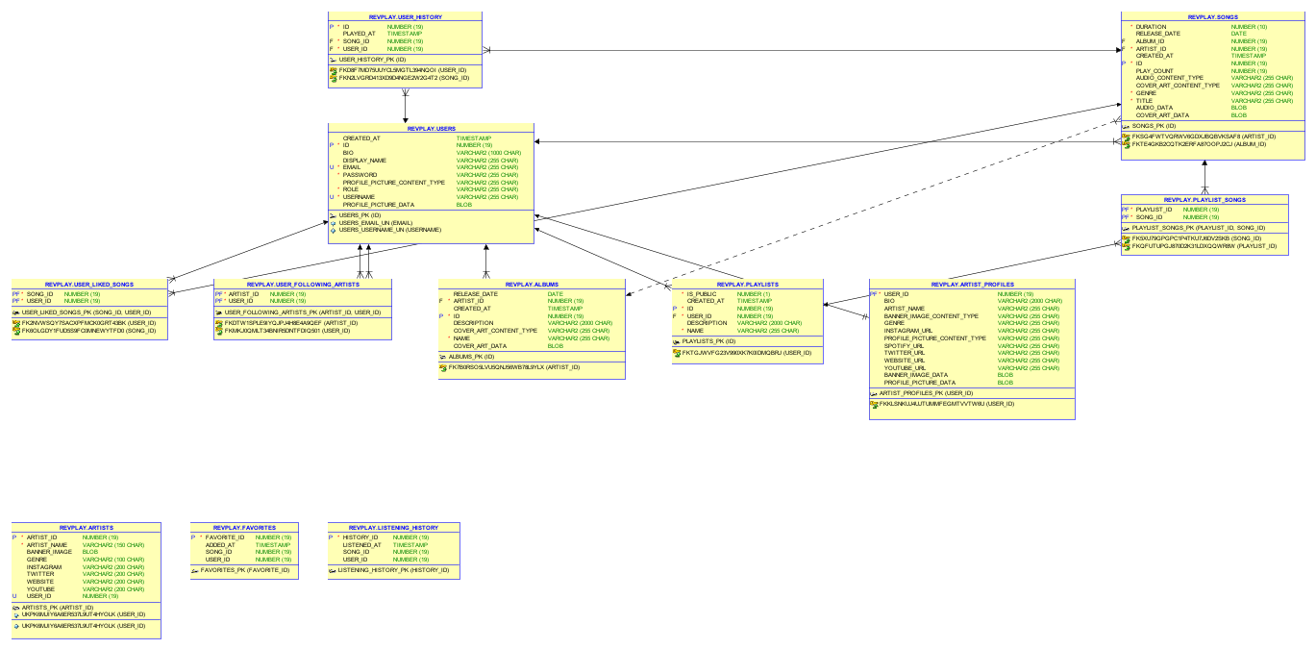
Figure 3: Entity Relationship Diagram (ERD) of RevPlay

10. Implementation

The implementation phase of the RevPlay Music Streaming Application focuses on building the system using modern web development technologies. The application follows a layered architecture where the frontend handles user interaction, the backend manages business logic, and the database stores application data.
The system is developed using Java-based frameworks and a relational database to ensure scalability, security, and efficient data management.

10.1 Backend Technologies

The backend of the RevPlay application is developed using Java-based enterprise frameworks that handle request processing, business logic, and data communication.
Java
The core programming language used for the backend development is Java (Java 17). Java provides platform independence, strong security features, and high performance, making it suitable for building scalable web applications.
Java is used to implement the application logic, handle user requests, and manage communication between the user interface and the database.

Spring Boot
The backend framework used is Spring Boot.
Spring Boot simplifies the development of Java applications by providing:
- Auto-configuration
- Embedded servers
- Dependency management
- Rapid application development
Spring Boot enables the creation of RESTful web applications and provides built-in support for dependency injection and modular architecture.

In RevPlay, Spring Boot is used to:
- Build controllers for handling HTTP requests
- Implement services for business logic
- Manage database communication through repositories

Spring Security
To secure the application, Spring Security is used.
Spring Security provides authentication and authorization mechanisms to protect application resources.
Key security features implemented in RevPlay include:
- User login authentication
- Role-based access control
- Password encryption
- Secure session management
Two roles are defined in the system:
- Subscriber
- Artist
Each role has different permissions within the application.

10.2 Database

The system uses Oracle Database as the primary data storage solution.
Oracle Database is a powerful relational database that supports high-performance data storage and retrieval.
In RevPlay, the database stores information such as:
- User accounts
- Artist profiles
- Songs and albums
- Playlists and favourites
- Listening history
- Analytics data
Images such as profile pictures and album artwork are stored as BLOB objects in the database and served to the frontend using Base64 encoding.

10.3 ORM (Object Relational Mapping)

The application uses Hibernate as the Object Relational Mapping tool.
Hibernate simplifies database interaction by mapping Java objects to database tables.
Advantages of using Hibernate include:
- Reduced SQL coding
- Automatic table mapping
- Simplified database operations
- Improved development speed
Hibernate works together with Spring Data JPA to perform operations such as:
- Saving data
- Updating records
- Deleting records
- Fetching data from tables

10.4 Frontend Technologies
The frontend of the RevPlay application is responsible for presenting the user interface and handling user interactions.
HTML
HTML is used to structure the content of the web pages such as login forms, music library pages, playlists, and artist dashboards.
CSS
CSS is used to style the web pages and improve the visual appearance of the application.
Custom CSS is used to create a consistent design theme throughout the platform.
JavaScript
JavaScript is used to add interactivity to the web pages, such as controlling the music player, handling user actions, and dynamically updating page content.
Bootstrap
The user interface design is enhanced using Bootstrap.
Bootstrap provides pre-built responsive components such as:
- Navigation bars
- Buttons
- Forms
- Layout grids
This helps in creating a mobile-friendly and visually appealing interface.
Thymeleaf
The application uses Thymeleaf as the server-side template engine.
Thymeleaf integrates seamlessly with Spring Boot and allows dynamic rendering of HTML pages based on backend data.
It is used to:
- Display user information
- Show song lists and playlists
- Render artist dashboards
- Integrate Spring Security authentication details into pages

10.5 MVC Architecture Implementation
RevPlay follows the Model-View-Controller (MVC) architecture pattern.
Controllers
Controllers handle incoming HTTP requests from the user interface and send responses back to the client.
In RevPlay, controllers are responsible for:
- Handling login and registration requests
- Processing music playback requests
- Managing playlists and favourites
- Uploading songs and albums
Controllers act as the entry point for user requests.

Services
The service layer contains the business logic of the application.
Services perform operations such as:
- Processing user authentication
- Managing playlist operations
- Handling artist uploads
- Generating analytics data
The service layer ensures that the application logic is separated from the controllers.

Repositories
The repository layer manages communication with the database.
Repositories are implemented using Spring Data JPA and provide methods to perform CRUD operations such as:
- Create new records
- Retrieve data from tables
- Update existing records
- Delete records
This layer abstracts database queries and simplifies data access.

Security Configuration
Security configuration is implemented using Spring Security.
Key components include:
- Authentication manager for login verification
- Role-based access control for subscribers and artists
- Password encryption using secure hashing algorithms
- Secure endpoint protection
This ensures that only authorized users can access protected features such as uploading songs or managing playlists.

11. Testing

Testing is an essential phase in software development that ensures the system works correctly and meets the required specifications. In the RevPlay Music Streaming Application, testing was performed to verify that all modules function properly and that the system provides a reliable user experience.
Different types of testing methods were used to validate the functionality of the application.

11.1 Unit Testing
Unit testing focuses on testing individual components or modules of the application independently. Each unit of code is tested to ensure it performs the expected function.
In the RevPlay system, unit testing was performed on components such as:
- User authentication functions
- Playlist management operations
- Song upload functionality
- Music player controls
The purpose of unit testing is to detect errors early in the development process and ensure that each function behaves correctly.
Example:
Testing the login functionality to ensure that the system properly validates user credentials.

11.2 Integration Testing
Integration testing verifies that different modules of the application work together correctly. After individual modules are tested, they are combined to check whether data flows correctly between them.
In RevPlay, integration testing was performed to verify interactions between:
- Controllers and Services
- Services and Repositories
- Backend and Database
- Frontend and Backend components
For example, when a user selects a song to play, the system retrieves the song details from the database and sends the audio file to the music player interface.
Integration testing ensures that all modules interact correctly without errors.
11.3 User Testing
User testing focuses on evaluating the system from the end-user perspective. It ensures that the application is easy to use and functions as expected in real-world scenarios.
In RevPlay, user testing was performed to verify:
- User registration and login process
- Browsing and searching for songs
- Playing songs using the music player
- Creating and managing playlists
- Uploading songs by artists
User testing helps identify usability issues and ensures that the system provides a smooth and intuitive experience.

11.4 Test Cases
The following table shows some example test cases used to validate the system functionality.
Test Case | Expected Result
User Registration | New user account created successfully
Login | User logged in successfully
Search Song | Relevant songs displayed
Play Song | Audio starts playing in the music player
Create Playlist | Playlist created successfully
Add Song to Playlist | Song added to selected playlist
Upload Song (Artist) | Song uploaded successfully
View Artist Profile | Artist information displayed
Mark favourite Song | Song added to favourites list
Logout | User logged out successfully

11.5 Testing Outcome
After performing unit testing, integration testing, and user testing, the RevPlay system was verified to function correctly. All major modules including authentication, music streaming, playlist management, and artist uploads were tested successfully.

12. Results and Discussion
The Results and Discussion section presents the functioning of the RevPlay Music Streaming Application through screenshots of key modules. This section demonstrates how the system operates from the perspective of both users and artists, highlighting the implemented features and workflows.

12.1 Login Page
The login page is the secure entry point for RevPlay, allowing registered users to access the platform. Users enter their username and password, which are authenticated using Spring Security against the database. Options for password recovery and new user registration are provided. Upon successful login, users are redirected to their role-specific dashboard.

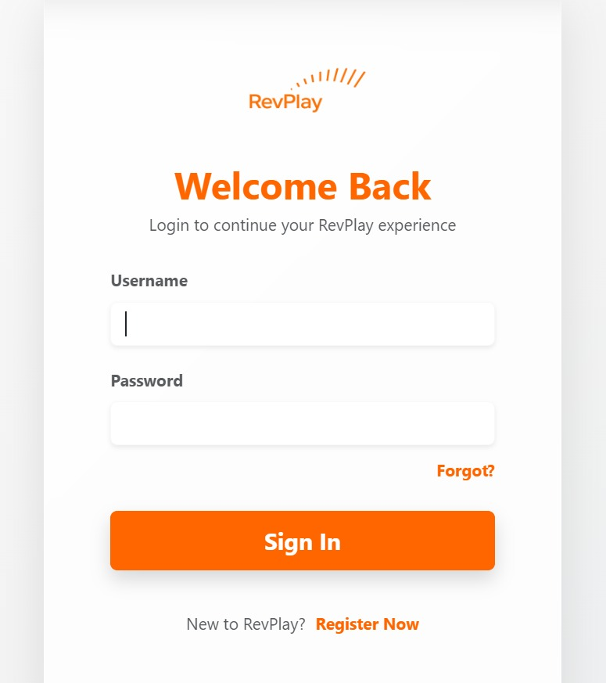
Figure 4.1: RevPlay Login Page Interface

12.2 RevPlay Navigation Bar
This screen shows the navigation bar of the RevPlay music streaming application. It provides quick access to main sections such as Home, Explore, Favourites, Playlists, and History. The navigation menu helps users easily move between different features of the application. The profile icon on the right allows users to access their account or profile settings.
Figure 4.2: RevPlay Navigation Bar

12.3 RevPlay Home Search Interface
This screen represents the main search section of the RevPlay music streaming application. Users can search for songs, artists, or albums using the search bar. The category dropdown allows filtering results based on different categories like genre, artist, or album. The Search button triggers the system to fetch and display relevant music content.

Figure 4.3: RevPlay Home Search Interface

12.4 RevPlay Music Player Interface
This screen shows the music player section of the RevPlay application. It displays the current song title, artist name, and album artwork. Users can control playback using options like play/pause, next, previous, and shuffle. It also includes a progress bar, volume control, and options to like or add the song to a playlist.
Figure 4.4: RevPlay Music Player Interface

12.5 RevPlay Playlist Management Interface
This screen displays the playlist management section of the RevPlay music streaming application. Users can view songs saved in their playlist along with details like artist and genre. The interface provides options to play tracks instantly or remove them from the playlist. A built-in music player at the bottom allows users to control playback, adjust volume, and manage listening controls seamlessly.
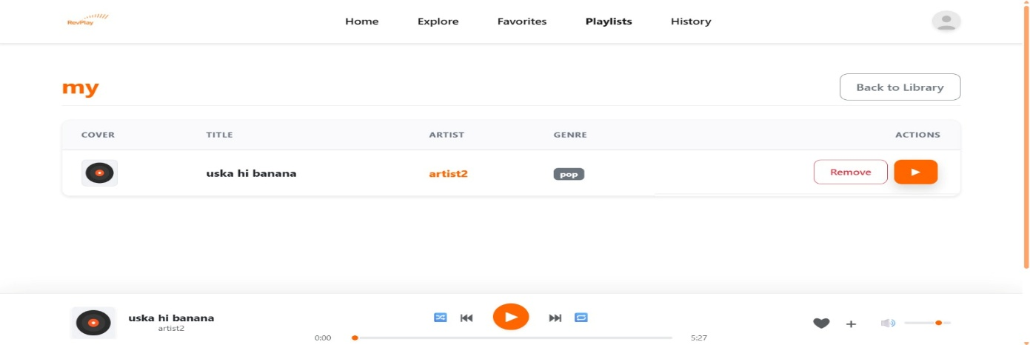
Figure 4.5: RevPlay Playlist Management Interface

12.6 RevPlay Artist Dashboard
This screen shows the Artist Dashboard in the RevPlay music streaming application. It provides artists with an overview of their content performance, including statistics such as total songs, active albums, streams, and followers. Artists can easily upload new tracks or create albums using the available action buttons. The dashboard also includes a track management section and an integrated music player for quick preview and control.
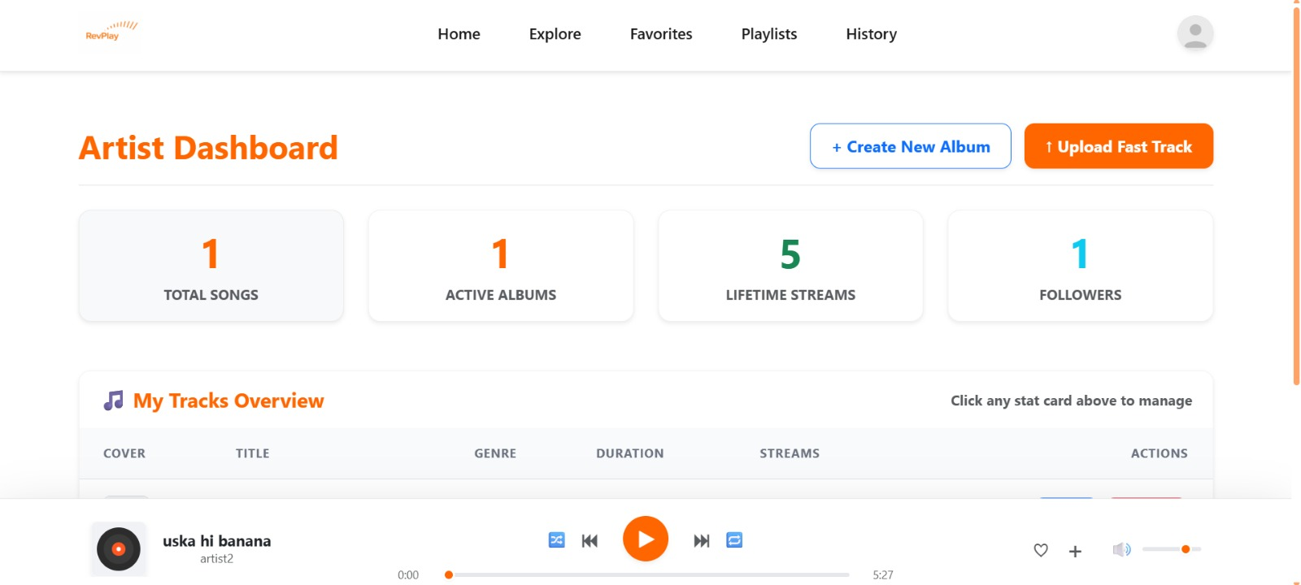
Figure 4.6: RevPlay Artist Dashboard

13. Advantages of the System

The RevPlay platform provides several advantages:
• Easy and user-friendly music streaming platform for discovering and playing songs
• Secure authentication system to protect user accounts and data
• Role-based functionality that separates features for listeners and artists
• Efficient playlist management allowing users to organize and access their favourite music
• Real-time analytics for artists to track streams, followers, and content performance
• Modular architecture that supports easy maintenance and future expansion
• Seamless integration between frontend and backend for smooth user interaction
• Structured database management for reliable storage and retrieval of music data
• Scalable design that can support a growing number of users and songs
• Interactive interface that enhances the overall user experience

14. Future Enhancements

Future improvements for RevPlay may include:
• AI-based music recommendation system
• Mobile application version
• Social media music sharing
• Subscription-based premium features
• Advanced music analytics
• Real-time chat between artists and listeners

15. Conclusion

RevPlay demonstrates the successful implementation of a full-stack music streaming platform using modern technologies such as Spring Boot, Thymeleaf, and Oracle Database. The application integrates backend services, database management, and dynamic user interfaces to deliver a complete and functional music streaming experience.
The system provides features for both listeners and artists, including music streaming, playlist management, artist uploads, and performance analytics. Through role-based authentication and secure access control, the platform ensures that different users interact with the system according to their permissions.
By following a layered and modular architecture, the project maintains clear separation between controllers, services, repositories, and models. This structure improves maintainability, scalability, and ease of development for future enhancements.
Overall, RevPlay showcases how a real-world music streaming platform can be designed and implemented using enterprise-level frameworks and best development practices, demonstrating the effective integration of modern web technologies in a full-stack application.

