Industrial Internship Report on
”HRMS(Human Resource Management System)”
Prepared by
Revathi V

Executive Summary
This report provides details of the Industrial Internship provided by upskill Campus and The IoT Academy in collaboration with Industrial Partner UniConverge Technologies Pvt Ltd (UCT).
This internship was focused on a project/problem statement provided by UCT. We had to finish the project including the report in 6 weeks’ time.
My project was HRMS (Human Resource Management System) is a software used to manage employee data and HR activities digitally.
It automates tasks like attendance, leave, payroll, and employee management.
The system improves efficiency, accuracy, and reduces manual paperwork.
This internship gave me a very good opportunity to get exposure to Industrial problems and design/implement solution for that. It was an overall great experience to have this internship.

TABLE OF CONTENTS
1 Preface 3
2 Introduction 4
2.1 About UniConverge Technologies Pvt Ltd 4
2.2 About upskill Campus 8
2.3 Objective 9
2.4 Reference 9
2.5 Glossary 10
3 Problem Statement 11
4 Existing and Proposed solution 12
5 Proposed Design/ Model 13
5.1 High Level Diagram (if applicable) 13
5.2 Low Level Diagram (if applicable) 13
5.3 Interfaces (if applicable) 13
6 Performance Test 14
6.1 Test Plan/ Test Cases 14
6.2 Test Procedure 14
6.3 Performance Outcome 14
7 My learnings 15
8 Future work scope 16

Preface
This report summarizes the six weeks of internship work completed as part of the academic curriculum. The internship provided practical exposure to industry practices and helped in understanding the application of theoretical concepts in real-world scenarios. During this period, I worked on the Human Resource Management System (HRMS) project.
A relevant internship plays an important role in career development by enhancing technical skills, professional awareness, and confidence. Working on the HRMS project helped me understand real-time HR processes and the challenges involved in automating them through software solutions.
The internship opportunity was provided by Upskill Campus (USC) in collaboration with UniConverge Technologies (UCT). The program was well structured with proper guidance, planned activities, and continuous mentor support throughout the internship period.
Through this internship, I gained valuable knowledge in software development, database management, and system design. I am grateful to Upskill Campus, UniConverge Technologies, and all the mentors who supported me during this internship.
I encourage my juniors and peers to actively participate in such internship programs, as they provide valuable hands-on experience and contribute significantly to career growth.

Introduction

About UniConverge Technologies Pvt Ltd
A company established in 2013 and working in Digital Transformation domain and providing Industrial solutions with prime focus on sustainability and RoI.
For developing its products and solutions it is leveraging various Cutting Edge Technologies e.g. Internet of Things (IoT), Cyber Security, Cloud computing (AWS, Azure), Machine Learning, Communication Technologies (4G/5G/LoRaWAN), Java Full Stack, Python, Front end etc.
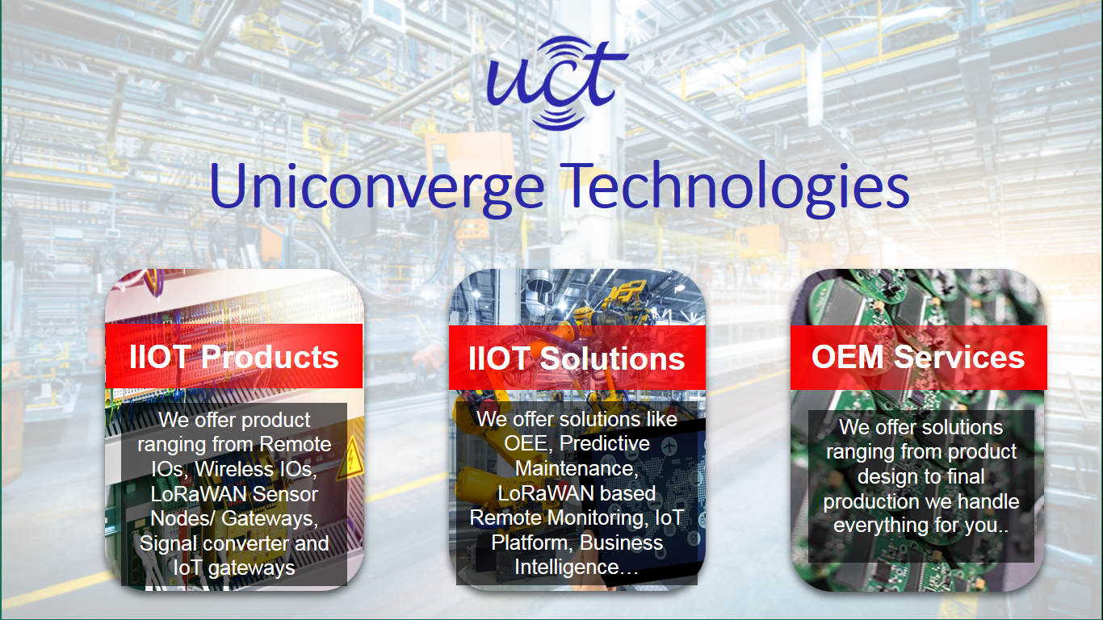
- UCT IoT Platform ()
UCT Insight is an IOT platform designed for quick deployment of IOT applications on the same time providing valuable “insight” for your process/business. It has been built in Java for backend and ReactJS for Front end. It has support for MySQL and various NoSql Databases.
- It enables device connectivity via industry standard IoT protocols - MQTT, CoAP, HTTP, Modbus TCP, OPC UA
- It supports both cloud and on-premises deployments.
It has features to
• Build Your own dashboard
• Analytics and Reporting
• Alert and Notification
• Integration with third party application(Power BI, SAP, ERP)
• Rule Engine

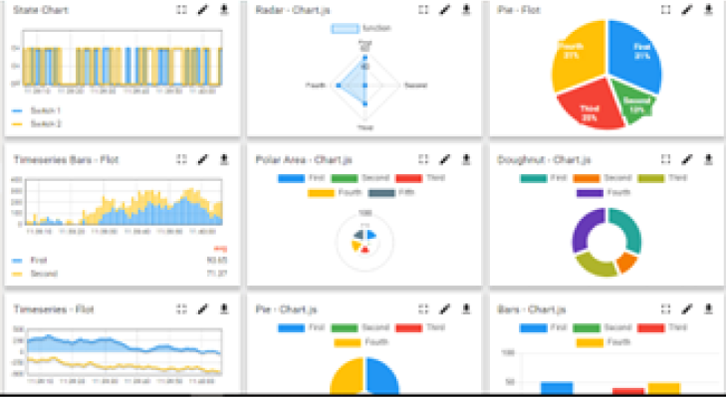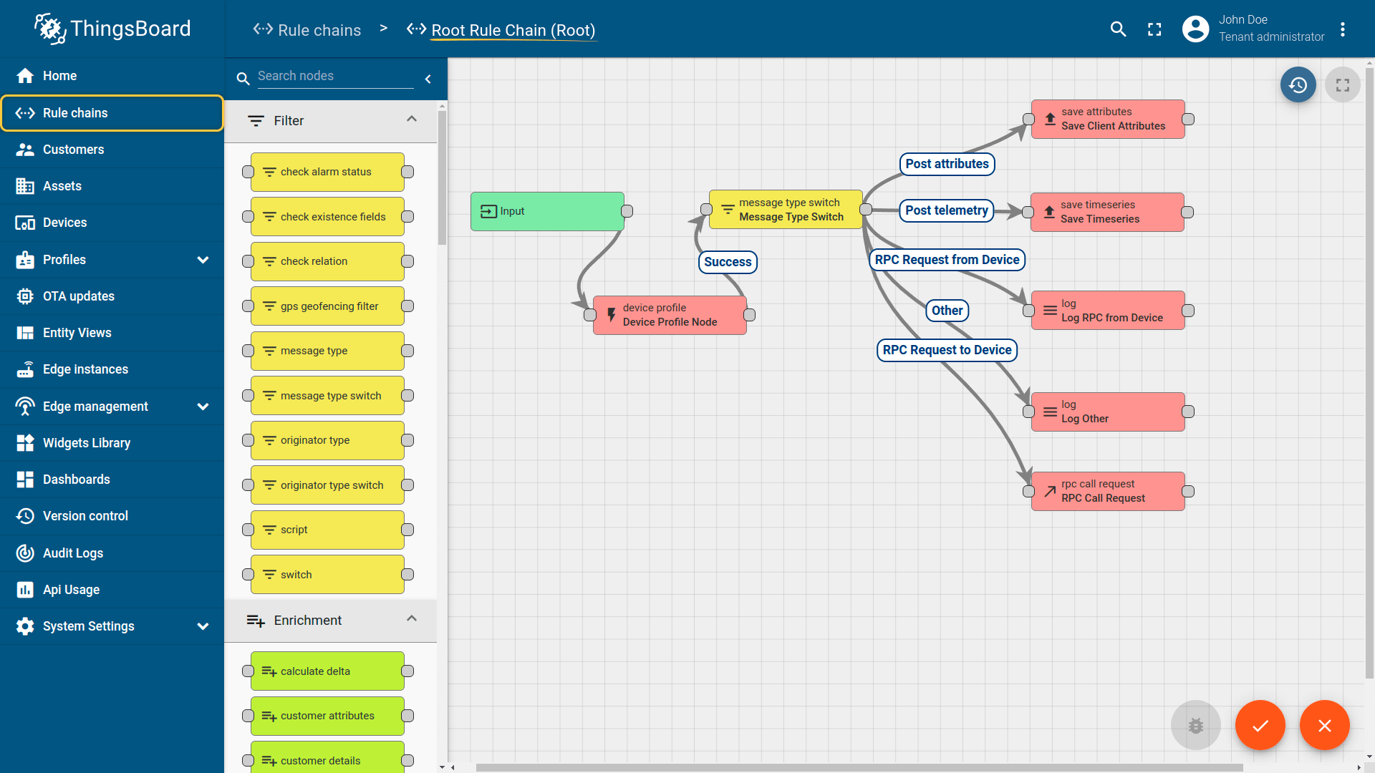

- Smart Factory Platform (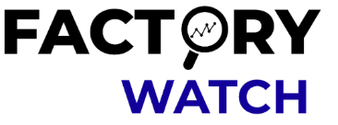)
Factory watch is a platform for smart factory needs.
It provides Users/ Factory
- with a scalable solution for their Production and asset monitoring
- OEE and predictive maintenance solution scaling up to digital twin for your assets.
- to unleased the true potential of the data that their machines are generating and helps to identify the KPIs and also improve them.
- A modular architecture that allows users to choose the service that they what to start and then can scale to more complex solutions as per their demands.
Its unique SaaS model helps users to save time, cost and money.
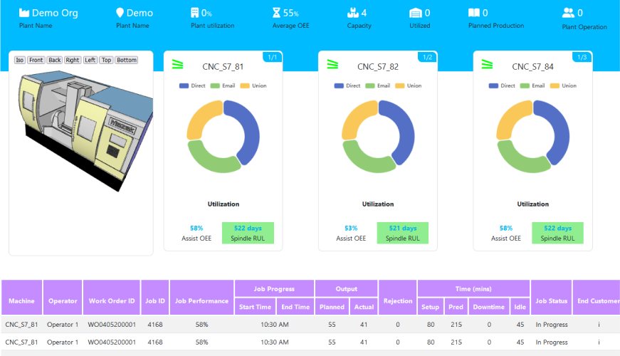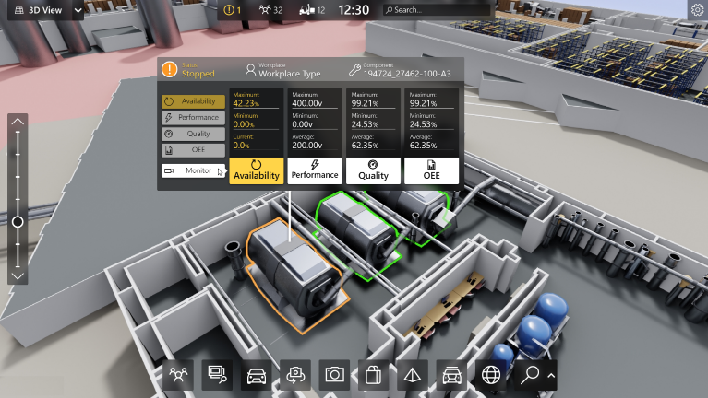

- 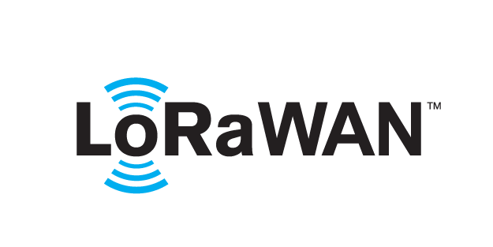 based Solution
UCT is one of the early adopters of LoRAWAN teschnology and providing solution in Agritech, Smart cities, Industrial Monitoring, Smart Street Light, Smart Water/ Gas/ Electricity metering solutions etc.
- Predictive Maintenance
UCT is providing Industrial Machine health monitoring and Predictive maintenance solution leveraging Embedded system, Industrial IoT and Machine Learning Technologies by finding Remaining useful life time of various Machines used in production process.
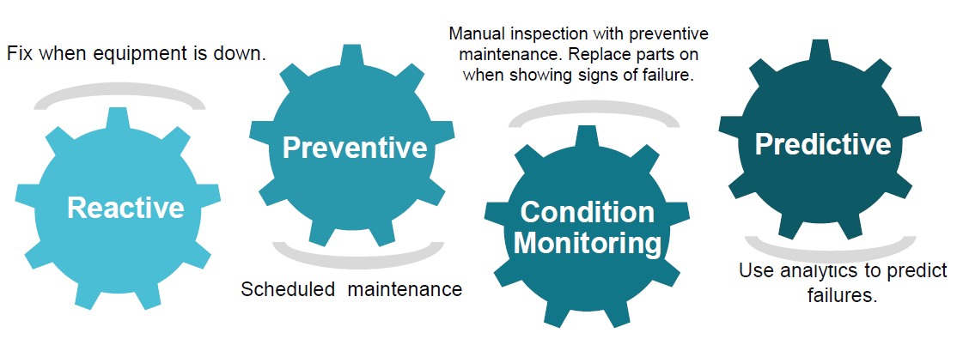

About upskill Campus (USC)
upskill Campus along with The IoT Academy and in association with Uniconverge technologies has facilitated the smooth execution of the complete internship process.
USC is a career development platform that delivers personalized executive coaching in a more affordable, scalable and measurable way.

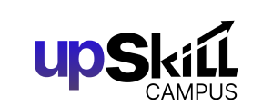


Seeing need of upskilling in self paced manner along-with additional support services e.g. Internship, projects, interaction with Industry experts, Career growth Services
https://www.upskillcampus.com/
upSkill Campus aiming to upskill 1 million learners in next 5 year

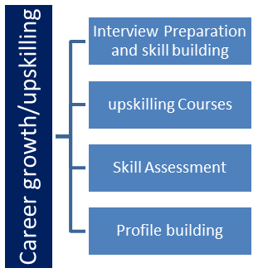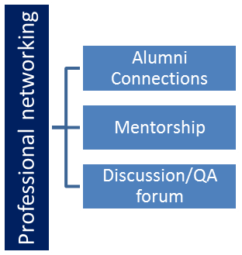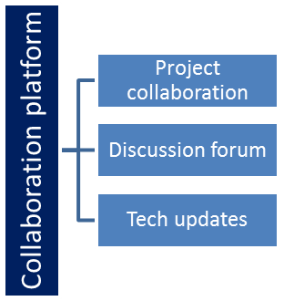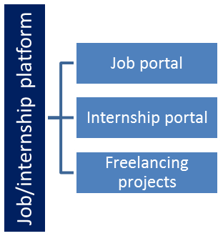

The IoT Academy
The IoT academy is EdTech Division of UCT that is running long executive certification programs in collaboration with EICT Academy, IITK, IITR and IITG in multiple domains.

Objectives of this Internship program
The objective for this internship program was to
☛ get practical experience of working in the industry.
☛ to solve real world problems.
☛ to have improved job prospects.
☛ to have Improved understanding of our field and its applications.
☛ to have Personal growth like better communication and problem solving.

Reference
[1]
[2]
[3]

Glossary
Terms | Acronym

Problem Statement
In many organizations, human resource activities such as maintaining employee records, attendance tracking, leave management, and payroll processing are handled manually or using basic tools like spreadsheets. These traditional methods are time-consuming, prone to errors, and difficult to maintain as the organization grows. Retrieving employee information and generating reports also becomes inefficient and unreliable.
The lack of a centralized system leads to data inconsistency, poor security, and increased administrative workload. Therefore, there is a need for an automated Human Resource Management System (HRMS) that can efficiently manage all HR-related operations in a centralized, secure, and user-friendly manner. The proposed system aims to reduce manual effort, improve accuracy, and enhance overall organizational productivity.

Existing and Proposed solution

Existing Solutions and Their Limitations
Several organizations currently use manual systems or basic digital tools such as spreadsheets and standalone HR software to manage human resource activities. Some companies use traditional HRMS tools that focus only on payroll or attendance management. While these systems provide basic functionality, they often lack integration between different HR modules. Data duplication, limited customization, and poor scalability are common issues.
Additionally, many existing solutions have complex user interfaces, high implementation costs, and limited accessibility. Manual and semi-automated systems are prone to errors, lack real-time updates, and provide minimal data security. These limitations reduce efficiency and increase administrative workload.

Code submission (Github link)
https://github.com/Reva2509/upskillCampus.git

Report submission (Github link) :.
https://github.com/Reva2509/upskillCampus.git

Proposed Design/ Model

The proposed solution is a web-based Human Resource Management System (HRMS) that integrates all major HR functions into a single platform. The system includes modules for employee management, attendance tracking, leave management, payroll processing, and role-based authentication. It provides centralized data storage, real-time updates, secure access, and easy report generation.
The proposed HRMS is designed to be user-friendly, scalable, and cost-effective, making it suitable for small and medium-sized organizations.

High Level Diagram (if applicable)
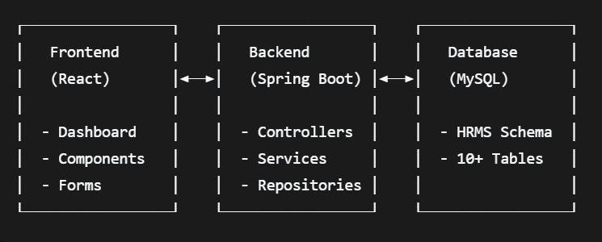

Figure 1: HIGH LEVEL DIAGRAM OF THE SYSTEM

Performance Test
Performance testing was carried out to evaluate whether the HRMS can function efficiently in real-world organizational conditions. Key constraints identified for the system include response time, memory usage, data accuracy, scalability, and system reliability. These constraints were considered during the design phase by using optimized database queries, modular architecture, and validation mechanisms.
Due to limited infrastructure, hardware-level constraints such as power consumption and processor-level metrics were not directly tested. However, their potential impact was analyzed, and the system was designed to support efficient resource utilization and scalability.

6.1 Test Plan / Test Cases
The test plan focused on evaluating system performance under normal usage. Test cases included user login, employee data entry, attendance marking, leave processing, payroll calculation, and report generation. Each test case was executed to verify response time, accuracy, and stability.

6.2 Test Procedure
Individual modules were tested using unit testing, followed by integration testing to ensure proper interaction between modules. Repeated operations were performed to simulate multiple user activities and observe system behavior.

6.3 Performance Outcome
The HRMS demonstrated stable performance with acceptable response times and accurate data processing. Memory usage remained within limits, and the system handled multiple operations without errors. Although advanced performance metrics were not measured, the results indicate that the system is suitable for real-world deployment with scope for future enhancements.

My learnings

This internship and HRMS project provided valuable practical exposure to real-world software development and organizational workflows. I gained hands-on experience in understanding requirements, designing system architecture, developing application modules, and testing the system. Working on the HRMS helped me improve my technical skills in web development, database management, and system integration.
In addition to technical knowledge, I developed important professional skills such as problem-solving, time management, and teamwork. These learnings have strengthened my confidence and prepared me to handle industry-level projects in the future, contributing positively to my overall career growth.

Future work scope

Due to time limitations, certain features and enhancements could not be implemented in the current version of the HRMS project. However, these ideas can be considered for future development. The system can be enhanced by integrating biometric or RFID-based attendance to improve accuracy. A mobile application can also be developed to allow employees to access HR services on the go.
Additional features such as advanced payroll analytics, performance evaluation modules, and automated notifications can further improve system efficiency. Deploying the application on a cloud platform and incorporating data backup and recovery mechanisms would enhance scalability and reliability. These improvements would make the HRMS more robust and suitable for large-scale organizational use.

