High Performance Rubik’s Cube Solver using
Optimized Search Algorithms

Ansh Oberoi  Department of Computer Science and Engineering  Chitkara University  Punjab, India  ansh138.be22@chitkara.edu.in | Ravneet Kaur  Department of Computer Science and Engineering  Chitkara University  Punjab, India  ravneet720.be22@chitkara.edu.in | Shikha Tuteja  Department of Computer Science and Engineering  Chitkara University  Punjab, India  shikha.1290@chitkara.edu.in

Abstract - The Rubik’s Cube is a complex combinatorial puzzle that presents many difficulties for automated solvers due to a large array of potential configurations. As the number of moves in scrambles increases, traditional exhaustive techniques are losing effectiveness on more complex problems due to the exponential growth of the search space.
In this paper, we present the design and implementation of a Rubik’s Cube solver using heuristic search algorithms. The main purpose is to implement a high-performance Rubik’s solver in java which ensure best solution by minimizing the complexity of the cube. The cube is represented as a state-space graph [6], where a node is used for each configuration, and transitions between the states are shown by each valid move.
This study compares three search algorithms: Breadth-First Search (BFS), Iterative Deepening Depth-First Search (IDDFS), and Iterative Deepening A* (IDA*). BFS finds optimal solutions but uses much memory. IDDFS uses less memory, but requires many repeated searches. IDA* is best and most efficient due to heuristics.
Cube is presented as a compact state to prevent the usage of memory. The performance of the algorithm is measured by time, memory used, and solution quality under some of the applied conditions [4]. BFS has done the deep searches, which consumed much memory. IDA* uses heuristics to avoid unnecessary searches, making it more efficient.
Keywords - Rubik’s Cube, BFS, IDDFS, IDA*, Heuristic search, Pattern database

1 INTRODUCTION
In computer science, a combinatorial puzzle is studied known as Rubik’s Cube. It is a very large and compact state space [6]. It has approximately 4.3×10^19 possible configurations in a standard 3×3 cube, which makes it a challenging problem for algorithmic solving approaches [5].
In this, each configuration corresponds to a node, and a transition is defined by each move, as this problem is stated as a state-space graph [2]. The main aim is to solve the scrambled cube by determining the number of moves. However, the enormous number of possible states and high branching factor make efficient state space exploration a significant challenge.
The older brute-force methods are not efficient as they use too much memory and time for solving the cube at higher depths. To overcome this, some more efficient strategies are required to explore the state space [2]. Algorithms like Breadth-First Search (BFS), Depth-First Search (DFS) and heuristic-based approaches have been explored for this problem.
This paper focuses on implementing and comparing different search algorithms, including Breadth-First Search (BFS), Iterative Deepening Depth-First Search (IDDFS), and Iterative Deepening A* (IDA*), to analyze their performance in solving the Rubik’s Cube. The comparison is based on factors such as execution time, memory usage, and solution efficiency under controlled conditions.

2 RELATED WORK
The Rubik’s Cube problem has been studied in the area of artificial intelligence and heuristic search due to its large state space and algorithmic complexity [2]. The two search methods, Breadth-First Search (BFS) and Depth-First Search (DFS), were the approaches primarily used. Breath-first search is known for its competence to identify the shortest path towards the solution, even though it has the drawback of high RAM consumption. On the other hand, Depth-first search struggles to locate the best paths on time, but it was beneficial in conserving a lot of memory.
To conquer these limitations, Iterative Deepening Depth-First Search (IDDFS) was introduced as a hybrid approach that combines the advantages of both BFS and DFS [3]. It is helpful as it maintains completeness by reducing the memory usage. It executes constant-depth-limited searches.
Korf was the one who invented the Iterative Deepening A* (IDA*) algorithm, a new advancement in solving the Rubik’s Cube [1]. This approach uses acceptable heuristics to guide the search process, also reducing the number of explored states compared to uninformed methods. Now, the algorithm focuses on promising paths and improves the overall efficiency by using these heuristic techniques.
The pattern databases are commonly engaged to store precomputed partial solutions, which also helps in providing informed estimates by reducing the search effort [4]. These databases help reduce the search time by providing heuristic estimates for reaching the goal state.
These large state space problems have been efficiently handled by the modern approaches, which have combined the heuristic search algorithms with pruning techniques [2]. These methods are very useful in making a balance between time complexity, memory usage and solution optimality.
In this work, provided on the already existing approaches by implementing and comparing BFS, IDDFS and IDA* algorithms within a common framework, focusing on their performance in terms of execution time, memory usage, and solution efficiency.

3 PROBLEM DEFINITION
The Rubik’s Cube can be understood as a state space search problem [2], where different cube configurations represent

different states. We are given a scrambled configuration of the cube; the aim is to determine a sequence of valid moves so that we can get a solved state of the cube. Each valid move corresponds to a deterministic transition between states, and each configuration of the cube represents a unique state [5].
A major problem in solving the Rubik’s Cube is due to its large state space, which contains approximately. $4.3×{10}^{19}$ possible configurations [5]. To explore all the configurations is computationally not practical as the depth of the search grows rapidly with the number of possible states. There is a need to implement those search strategies that are efficient and can easily navigate the state space.
The balance between execution time and memory usage is another problem. Algorithms with memory-efficient approaches increase the computation time during repeated exploration of states, resulting in optimal solutions, but much memory is used. To reach the solved state, we need to perform solution optimality, in which the minimum number of moves is required [8].
The problem considered in this work is to be solved while balancing time complexity, memory usage and solution quality with certain constraints, a scrambled Rubik’s Cube accepted as an input, which needs to be designed to find the minimum number of moves to solve it efficiently.

4 METHODOLOGY
The Rubik’s Cube is modeled as a state-space graph [2], where an edge connecting two nodes is a valid move that changes the cube’s state, and a node is each possible arrangement of the cube. The solver uses this graph to find a series of moves that change a scrambled cube into its answered state. To get this all done effectively, efficient methods are used for suitable search techniques and for representing cube states.

4.1 Cube Representation

The Nibble-based encoding method was used to represent a compact data structure. The full color details of each face were no longer required because this method is focused on efficient encoding, which helped in reducing the memory needed to store each cube state.

There are many benefits of using this approach, including less memory usage, comparison of the different cube states is

much faster, and the performance of the search operations has improved by using the computer’s memory more efficiently. As these algorithms work more with the graphs, allowed much quicker hashing and searching.

4.2 Algorithms Implemented

1) Breadth-First Search (BFS): It explores the state space in layers, which means that all configurations at a given depth
are analyzed before moving to deeper levels [14]. In this, the memory usage grows quickly, as it stores all the states at each level. So, the more complex or deeply scrambled cubes are not suitable for solving.

2) Iterative Deepening Depth-First Search (IDDFS): By executing a series of progressively deeper searches, IDDFS successfully blends the memory conservation of DFS with the completeness of BFS [2]. This method uses less memory than BFS and still guarantees finding a solution if one exists. However, it may explore the same states multiple times, which can slow down the process.

3) Iterative Deepening A* (IDA*): This uses cost evaluation, making it more efficient and also good for exploration. It is a search technique that uses a heuristic-guided method.

It calculates the cost of reaching a state using a formula that combines two parts:

f(n) = g(n) + h(n)

where g(n) is the actual cost to reach the current state and h(n) is an estimate of the cost to get from the current state to the solved state [1].

IDA* uses this information along with a depth limit to guide the search more effectively, reducing the number of states that need to be explored compared to other methods.

4.3 Heuristic Optimization

The heuristic approach of the pattern database is best to enhance the efficiency of the search process [4]. To solve different corner configurations of the cube with a minimum number of moves, a corner pattern database is used, which stores precomputed information. Breadth-first search is used in building this database, which provides the minimum number of moves needed to reach the solution.

For highly scrambled cubes, the search process can get more efficient, and unnecessary exploration of states can also be avoided in the search algorithm just by using these estimates.

5 IMPLEMENTATION

The proposed Rubik’s Cube solver is implemented in Java using object-oriented design principles.

The system is organized in a modular way, which separates the representation of the cube, the search algorithms, and the heuristic components. The design has already enhanced the maintainability and made it easy to solve various issues.

5.1 System Architecture

Some of the several forms of systems with functions are as follows:

1) Rubik’s Cube: This is the basic model of the cube. It has some functions, such as applying minimum moves and determining whether the cube is solved properly.

2) Bitboard Representation: This is the compact method of solving the cube’s state. It uses the least memory through the process and compares states more easily.

3) Solver Modules: These include various search algorithms such as BFS, IDDFS, and IDA*, each implemented as a separate class.

4) Pattern Database: This provides support for heuristics by storing precomputed data that is used in the IDA* algorithm.

The individual development and testing of these algorithms is allowed through this setup.

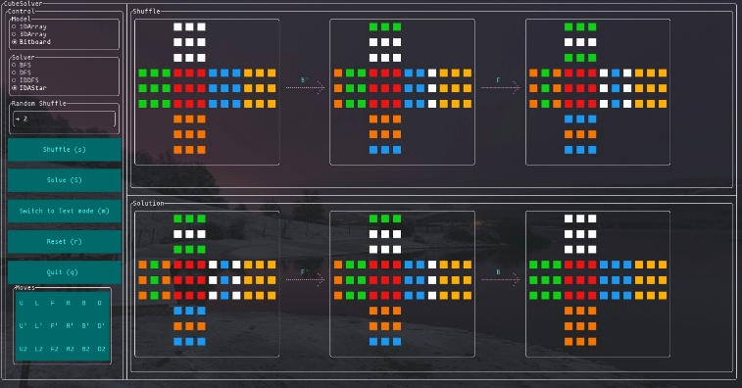

Fig. 1. User interface of the Rubik’s Cube solver showing cube visualization, shuffle operations, and solution steps.

5.2 Algorithm Implementation

Each of the search algorithms is implemented as a distinct
solver class. This solver interacts directly with the cube’s
representation by applying valid moves and also examining
the resulting states.

For instance, a depth-first search method explores possible move sequences recursively up to a predetermined depth.
The solver keeps track of the moves and uses backtracking to investigate other paths.

5.3 Pseudocodes

1) Pseudocode for BFS

BFS
function BFS (start):
Create an empty queue
Create an empty set for visited states

enqueue start into the queue
mark start as visited

while queue is not empty:
currentState = dequeue from queue

if currentState is cost:
return solution

for each nextState of currentState:
if nextState is not visited:
mark nextState as visited
enqueue nextState into the queue

return NOT_FOUND

2) Pseudocode for IDDFS

IDDFS
function IDDFS (start):
for depth = 0 to max_depth:
result = DLS (start, depth)
if result == FOUND:
return solution

return NOT_FOUND

function DLS (currentState, depth):
if depth == 0 and currentState is cost:
return FOUND

if depth > 0:
for each nextState of currentState:
result = DLS (nextState, depth - 1)
if result == FOUND:
return FOUND

return NOT_FOUND

3) Pseudocode for IDA*

function IDA*(start):
limit = heuristic(start)
while True:
t = exploreState (start, 0, limit)
if t == FOUND:
return solution
if t == infinity:
return NOT_FOUND
limit = t

function exploreState (currentState, cost, limit):
f = cost + heuristic(currentState)
if f > limit:
return f
if currentState equals goalState:
return FOUND
min = infinity
for each nextState generated from currentState
t = exploreState (nextState, cost+1, limit)
if t == FOUND:
return FOUND
if t < min:
min = t
return min

5.4 Complexity Analysis

The efficiency of the following algorithms is demonstrated below in terms of their time and space complexity [2].
Let b represent the branching factor (approximately 18 for the Rubik’s Cube), and d represent the depth of the solution.

1) Breadth-First Search
Time Complexity: O(b^{d})
Space Complexity: O(b^{d})

2) Iterative Deepening Depth-First Search
Time Complexity: O(b^{d})
Space Complexity: O(b*d)

3) Iterative Deepening A*
Time Complexity: O(b^{d})
Space Complexity: O(d)

Therefore, these complexities tell us that BFS becomes impractical for large depths due to high memory usage. On the other hand, IDA* provides much better scalability with reduced requirements for memory.

6 EXPERIMENTAL SETUP

The performance of the implemented algorithms was evaluated using a Java-based implementation executed on a standard computing environment. The system was tested on a machine equipped with an Intel i5 processor and 8 GB of RAM.

To dissect the behavior of the algorithms under different conditions, multiple test cases were generated using aimlessly climbed cell configurations. The scramble depth was varied within a controlled range (roughly 3 to 10 moves) to observe the performance of each algorithm in different situations of complexity. To obtain stable observations, each test case was executed multiple times.

The following metrics were grounded to evaluate the algorithms:

1) Execution Time: Time required to compute the solution.

2) Memory Usage: The Amount of memory consumed during the search process.

3) Solution Length: Number of moves required to solve the cube.

This setup allows a relative analysis of different algorithms in terms of effectiveness and scalability.

7 RESULTS

Based on execution time, memory usage and solution efficiency, the performance of the implemented algorithms was evaluated across different scrambled paths. The results demonstrate the comparative behavior of BFS, IDDFS, and IDA* as problems become more complex.

7.1 Comparative Performance

This represents a qualitative comparison of the algorithms based on observed performance characteristics.

Table I. Comparison of search algorithms based on performance metrics

Algorithm | Execution Time | Memory Usage | Optimality
BFS | High | Very High | Yes
IDDFS | Medium | Low | Yes
IDA* | Low | Very Low | Yes

7.2 Time v/s Depth Analysis

For each increasing scramble depth, all the algorithms’ execution time is evaluated. The observed values show us that for BFS, it is increasing promptly due to expanding growth in memory usage. IDDFS, due to repeated state exploration, has increased the computation, but performs better in terms of memory. IDA* shows the best results with consistent values due to heuristic-guided pruning.

Table II. Execution time of algorithms for different scramble depths

Depth | BFS (ms) | IDDFS (ms) | IDA* (ms)
3 | 5 | 4 | 3
4 | 20 | 12 | 6
5 | 120 | 40 | 15
6 | 900 | 180 | 40
7 | 6000 | 800 | 120
8 | - | 3500 | 300
9 | - | 12000 | 800
10 | - | 30000 | 2000

7.3 Graph Representation

The graph below shows a performance comparison between time and depth:

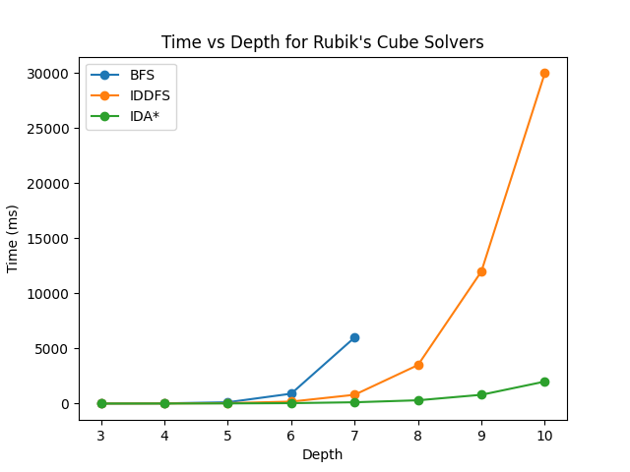

Fig. 2. Time vs Depth for Rubik’s Cube Solvers

7.4 Observations

The observation concluded from the result is as follows:

1) BFS, due to its exponential memory needs it becomes impractical for the higher depths.

2) IDDFS, due to its continuously repeated searches, increases the time but helps reduce memory.

3) IDA* using the heuristic-guided pruning gives better scalability and increased efficiency.

Overall, heuristic-based approaches such as IDA* provide a more balanced trade-off between time and memory usage for solving large state-space problems like the Rubik’s Cube.

8 CONCLUSIONS

This paper is focused mainly on the three algorithms, such as Breadth-First Search (BFS), Iterative Deepening Depth-First Search (IDDFS), and Iterative Deepening A* (IDA*). In this comparative study, the solved state of the Rubik’s cube. This is modeled as a state space search problem, and the evaluation of the algorithms was based on execution time, solution efficiency and memory usage under controlled supervised conditions.

The results depict that BFS, due to its high memory consumption, is impractical for larger scramble depths, although capable of producing the best solutions. IDDFS, due to repeated exploration of states, introduces additional computational overhead; however, it improves memory efficiency by using depth-limited search. In comparison, IDA* with adding depth allows the algorithm to gauge more effectively, demonstrating better overall performance by incorporating heuristic-grounded pruning.

The reduced memory operations and rapid state operations happened due to the use of compact state representation, which also contributed to increasing effectiveness. Overall, the study highlights that Rubik’s Cube provides a balanced relationship between time complexity and memory consumption, so to solve these large combinatorial problems, heuristic-grounded approaches are best suitable.

Future work may concentrate on enhancing the solver through better heuristic ways, optimisation strategies, or corresponding executions to further improve performance and scalability.

9 REFERENCES

[1] R. E. Korf, “Depth-first iterative-deepening: An optimal admissible tree search,” Artificial Intelligence, vol. 27, no. 1, pp. 97–109, 1985.

[2] S. Russell and P. Norvig, Artificial Intelligence: A Modern Approach, 3rd ed. Upper Saddle River, NJ, USA: Prentice Hall, 2010.

[3] D. Singmaster, Notes on Rubik’s Cube. Enslow Publishers, 1981.

[4] J. C. Culberson and J. Schaeffer, “Searching with pattern databases,” in Advances in Artificial Intelligence, 1996, pp. 402–416.

[5] T. Rokicki, H. Kociemba, M. Davidson, and J. Dethridge, “The diameter of the Rubik’s Cube group is twenty,” SIAM Journal on Discrete Mathematics, vol. 27, no. 2, pp. 1082–1105, 2013.
[6] R. E. Korf, “Finding optimal solutions to Rubik’s Cube using pattern databases,” AAAI, 1997.

[7] H. Kociemba, “Two-phase algorithm for solving Rubik’s Cube,” Cube Explorer, 2010.

[8] T. Rokicki, H. Kociemba, M. Davidson, and J. Dethridge, “The diameter of the Rubik’s Cube group is twenty,” SIAM Journal, 2013.

[9] S. Russell and P. Norvig, “Artificial Intelligence: A Modern Approach,” 3rd ed., Pearson, 2010.

[10] J. Pearl, “Heuristics: Intelligent search strategies,” Addison-Wesley, 1984.

[11] E. W. Dijkstra, “A note on two problems in connexion with graphs,” Numerische Mathematik, 1959.

[12] N. J. Nilsson, “Principles of Artificial Intelligence,” Morgan Kaufmann, 1980.

[13] J. Culberson and J. Schaeffer, “Pattern databases,” Computational Intelligence, 1998.

[14] P. E. Hart, N. J. Nilsson, and B. Raphael, “A formal basis for heuristic determination,” IEEE Transactions, 1968.

[15] M. Sipser, “Introduction to the theory of computation,” Cengage Learning, 2012.

[16] D. E. Knuth, “The art of computer programming,” Addison-Wesley, 1997.

[17] A. Newell and H. A. Simon, “Human problem solving,” Prentice Hall, 1972.

[18] G. Brassard and P. Bratley, “Fundamentals of algorithmics,” Prentice Hall, 1996.

[19] T. H. Cormen et al., “Introduction to algorithms,” MIT Press, 2009.

[20] I. Goodfellow, Y. Bengio, and A. Courville, “Deep learning,” MIT Press, 2016.

