Game Design Document

Fill up the following document

1. Write the title of your project.

Asteroid blaster

1. What is the goal of the game?

For a spaceship to destroy asteroids

1. Write a brief story of your game.

The story is about a spaceship that went on a space mission and

then the captain of the spaceship saw many asteroids coming their

way. Our goal is to blast the asteroids and save the astronauts.

1. Which are the playing characters of this game?

* Playing characters are the ones who respond to the user based on the input from the user.
* Cars, monkeys, dinos, wizards, etc., are the playing characters in the game.

|  |  |  |
| --- | --- | --- |
| Number | Character Name | What can this character do? |
| 1 | Spaceship | Shoot and destroy the asteroid  Can be moved left or right using arrow keys |
| 2 |  |  |
| 3 |  |  |
| 4 |  |  |
| 5 |  |  |
| 6 |  |  |
| 7 |  |  |
| 8 |  |  |

1. Which are the Non-Playing Characters of this game?

* Non-Playing characters are the ones that don't have an action or behavior when the user interacts with the game.
* Hurdles, stones, bananas, coins, etc., are non-playing characters in the game.

|  |  |  |
| --- | --- | --- |
| Number | Character Name | What can this character do? |
| 1 | Asteroids | Randomly spawn and make the game over if the spaceship hits it |
| 2 |  |  |
| 3 |  |  |
| 4 |  |  |
| 5 |  |  |
| 6 |  |  |
| 7 |  |  |
| 8 |  |  |

Draw your imagination of this game. What does this game look like?

* Draw the game either on your computer or on paper.
* Add images of the game scenes to show each of the playing and non-playing characters at least once.

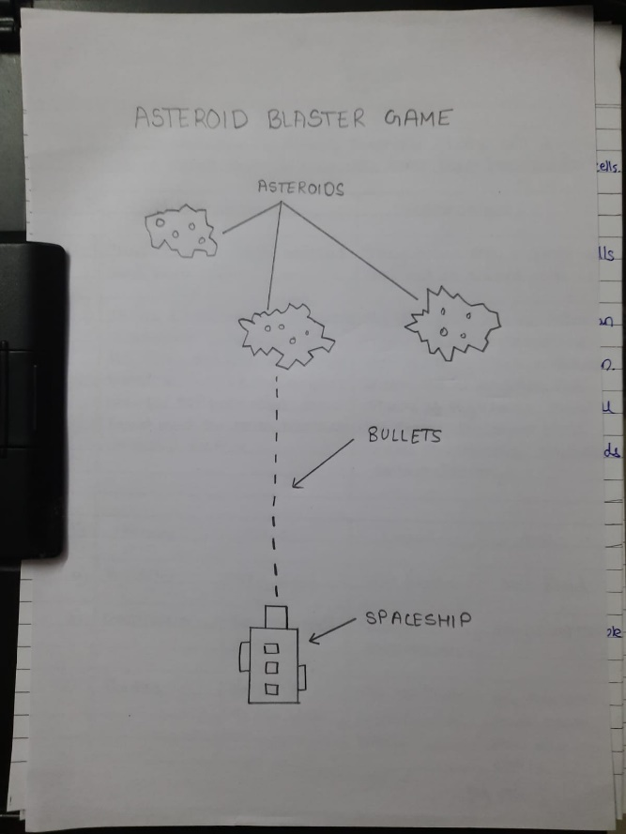

How do you plan to make your game engaging?

The speed of spawining of asteroids would increse as the game goes on making it HARDER