EmotiCon:- Emotion Recognition from Speech&Text
Abstract (Page I)
The recognition of human emotions from speech has become a crucial research area in artificial intelligence, with wide-ranging applications in healthcare, education, customer service, and human–computer interaction. This project introduces a hybrid emotion recognition system that integrates both text-based and audio-based deep learning models to achieve robust and real-time performance. A RoBERTa model was fine-tuned on five aggregated emotion-labeled datasets and achieved a testing accuracy of 77%. To enable real-time usability, the system incorporates the Whisper API for speech-to-text conversion and the facebook/nllb-200-distilled-600M model to provide multilingual translation of recognized speech. In parallel, a HuBERT-based model was trained to recognize emotions directly from the acoustic characteristics of speech, such as tone, pitch, and rhythm. By fusing linguistic and paralinguistic information, the system effectively captures both textual and auditory emotional cues, resulting in higher recognition accuracy and robustness. The hybrid model can identify eight distinct emotions — angry, calm, disgust, fearful, happy, neutral, sad, and surprised. Finally, a Flask-based web interface was developed to provide an accessible and interactive platform for real-time emotion detection.

List of Figures

Figure 3.1: Block Diagram of Proposed System
- Figure 3.2: Flowchart of Emotion Recognition Process
- Figure 3.3: Architecture of Roberta Model
- Figure 3.4: Architecture of HuBERT Model
- Figure 4.1: Training and Testing Accuracy Graphs
- Figure 5.1: Sample Outputs of Emotion Recognition

1. INTRODUCTION
1.1 Problem Definition including the Significance and Objective
Human communication is rich with emotional cues that go beyond the literal meaning of words. Understanding these emotions is crucial for building intelligent systems that can interact with people more naturally and empathetically.The primary focus of this project is to predict human emotions from text, enabling machines to understand the emotional context embedded within written or transcribed language. This text-based emotion recognition forms the foundation of the system and has wide applications in areas such as sentiment analysis, mental health monitoring, intelligent tutoring systems, and customer service automation.To make the system more versatile and accessible, Whisper was integrated to directly convert live speech into text. This enables real-time emotion recognition from spoken input without relying on an external transcription or translation pipeline.
Furthermore, to enhance the system’s capabilities, we developed an additional speech-based emotion recognition model. This extension allows the system to identify emotions directly from acoustic properties such as tone, pitch, and rhythm — enabling emotion detection not just from text but also directly from speech.
The main objective of this project is to design and implement a hybrid emotion recognition system that combines both linguistic and acoustic information for accurate and real-time emotion detection, making it adaptable for multilingual and multimodal applications.

1.2 Methodologies
The proposed system follows a hybrid methodology that combines text-based and speech-based emotion recognition to achieve accurate and real-time detection of human emotions. The overall workflow includes data collection, preprocessing, model training, integration, and evaluation.

1.2.1 System Overview
The system is designed to predict emotions from both text and speech inputs.
- The text-based pipeline uses a fine-tuned RoBERTa transformer model for classifying emotions from textual data.
- The speech-based pipeline employs an ensemble of HuBERT models to identify emotions directly from raw audio features such as tone, pitch, and rhythm.
- Additionally, the Whisper API is integrated for speech-to-text conversion, enabling emotion recognition from spoken input in real time.
This dual approach ensures the system captures both linguistic and acoustic emotional cues.

1.2.2 Data Collection and Preprocessing

Text Data
For text-based emotion recognition, multiple publicly available emotion-labeled datasets were combined, including GoEmotions, Twitter Emotion datasets, and ISEAR, along with a small set of manually annotated samples.
The data underwent extensive preprocessing, including:
- Lowercasing, punctuation normalization, and contraction expansion.
- Removal of URLs, email addresses, and non-relevant characters.
- Outlier removal using TF-IDF and Isolation Forest to eliminate anomalous or duplicate samples.
The final dataset contained 46,869 text samples across five emotion categories: anger, fear, joy, sadness, and surprise.

Speech Data
For speech-based emotion recognition, multiple standard datasets were used:
- RAVDESS, CREMA-D, SAVEE, TESS, and IEMOCAP.
The audio samples were normalized, trimmed for silence, and converted into consistent sampling rates. Data augmentation, oversampling, and undersampling were applied to balance class representation across emotions.

1.2.3 Text-Based Emotion Recognition
A RoBERTa (roberta-base) model was fine-tuned for text emotion classification.
Configuration details:
- Tokenizer: RobertaTokenizerFast
- Model: RobertaForSequenceClassification
- Learning rate: 2e-5, Batch size: 32, Epochs: 5, Max length: 256
- Training used the Hugging Face Trainer API with early stopping and F1-macro as the main metric.
The model achieved a test accuracy of 77.31%, outperforming baseline models such as BERT, DistilBERT, and LSTM.

1.2.4 Speech-Based Emotion Recognition
The speech emotion recognition component was built using the HuBERT (Hidden Unit BERT) model, which extracts meaningful acoustic representations from raw waveforms.
Four HuBERT models were trained under different configurations:
- Model 1: Trained on RAVDESS for 3 epochs (~500 samples); tended to over-predict negative emotions.
- Model 2: Same as Model 1 but trained for 6 epochs; slightly better balance but similar bias persisted.
- Model 3: Trained on combined RAVDESS + CREMA-D + SAVEE + TESS (~12,000 samples); more balanced but less accurate.
- Model 4: Added IEMOCAP (~35,000 samples) with oversampling/undersampling; improved diversity but showed signs of overfitting.
To overcome individual model weaknesses, all four models were combined into an ensemble HuBERT system.
The ensemble approach averages the outputs of all models, providing more stable and balanced predictions across emotions such as angry, happy, sad, fearful, calm, disgust, neutral, and surprised.

1.3 Outline of the Results
The RoBERTa model achieved a testing accuracy of 77.31% for text-based emotion recognition, outperforming baseline models such as BERT and DistilBERT. It effectively captured linguistic nuances in textual data, enabling accurate detection of emotions such as anger, joy, sadness, fear, and surprise.For speech-based emotion recognition, the HuBERT ensemble demonstrated improved performance in identifying emotions that rely heavily on acoustic cues — particularly calm, fearful, and surprised.

1.4 Scope of the Project
This project focuses on building a real-time emotion recognition system that predicts emotions from both text and speech inputs. The RoBERTa model handles text-based emotion detection, while Whisper performs speech-to-text conversion and direct English translation, enabling multilingual support. A Flask-based web interface integrates these components for real-time interaction. The system can be applied in areas such as healthcare, education, customer service, and assistive technologies, demonstrating the effectiveness of combining text and speech models for emotion recognition.

1.5 Organization of the Report
This report is organized into seven chapters: Introduction, Literature Survey, Design of the Proposed System, Implementation, Results and Discussion, Conclusions and Recommendations, and Publications.

2. LITERATURE SURVEY

2.1 Introduction to the Problem Domain Terminology
Speech Emotion Recognition (SER) involves identifying human emotions from speech signals. Key concepts include speech-to-text, natural language processing (NLP), deep learning, and self-supervised learning.

2.2 Existing Solutions
2.2.1 Emotion recognition using RAVDESS dataset
2.2.2 CNN-based speech emotion recognition
2.2.3 RNN/LSTM-based models
2.2.4 Transformer-based approaches
2.2.5 Multilingual emotion recognition systems
2.3 Related Works
Previous studies in emotion recognition have focused mainly on using individual modalities — either speech or text — to classify emotions. Most earlier works utilized datasets like RAVDESS, CREMA-D, and SAVEE, which provided high-quality audio samples but lacked real-world diversity and multilingual coverage. Traditional models such as CNNs and LSTMs showed decent accuracy but struggled with generalization to unseen speakers and environments.More recent research has shifted toward transformer-based models such as BERT for text and HuBERT for speech, which significantly improved accuracy by leveraging self-supervised learning. However, these studies typically addressed either text or audio independently. Very few approaches have attempted to combine text-based and audio-based models within a single unified framework for emotion recognition.This project builds on those advancements by integrating a RoBERTa-based text model and a Whisper-driven speech-to-text pipeline, with HuBERT models for direct audio emotion detection — enabling real-time, multilingual, and multimodal emotion recognition.

2.4 Tools/Technologies Used
The project utilizes several tools and frameworks to develop and deploy the emotion recognition system. Google Colaboratory was used for model training and experimentation due to its GPU support, while Kaggle served as the primary source for emotion-labeled datasets. The web interface was developed using Flask, enabling real-time interaction between users and the models. Deep learning implementation was carried out using PyTorch and the Hugging Face Transformers library for fine-tuning models such as RoBERTa and HuBERT. Additionally, Whisper was integrated for multilingual speech-to-text transcription, forming the foundation for speech-based emotion recognition.

3. DESIGN OF PROPOSED SYSTEM/METHOD/ALGO

3.1 Block Diagram

3.2 Robertaa architecture

3.4 Hubert Architecure
HUBERT ARCHITECTURE:-
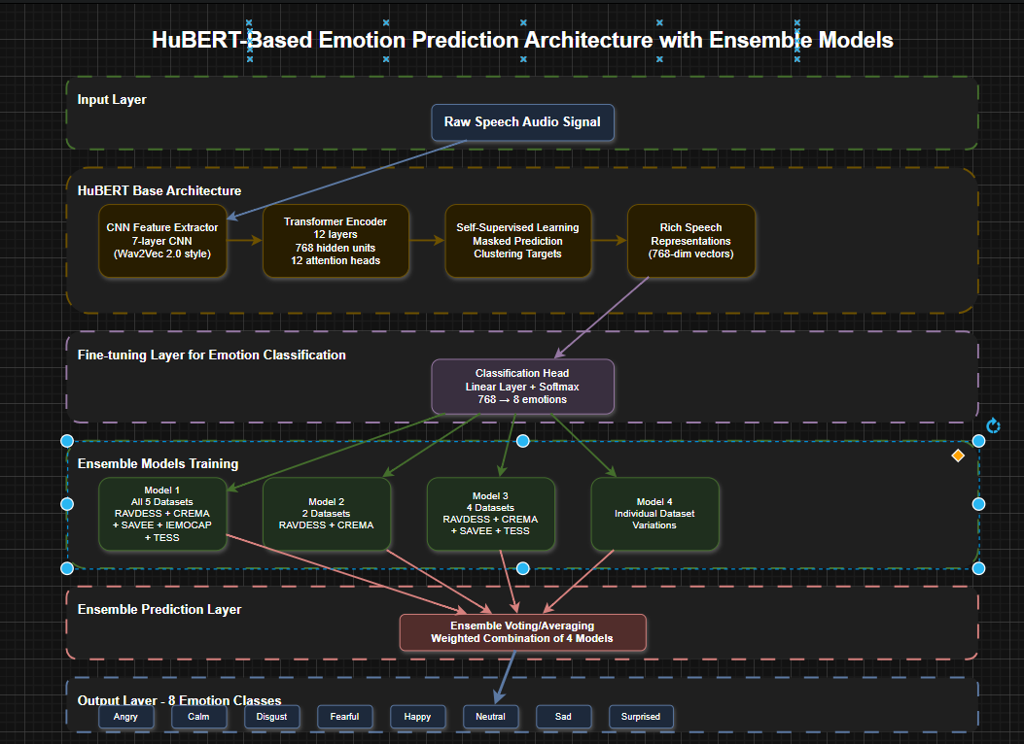

4. IMPLEMENTATION OF THE PROPOSED SYSTEM

4.1 Module Description
The proposed system is divided into five main modules, each performing a specific function in the emotion recognition pipeline:
- Speech-to-Text (Whisper Model): Converts speech input from any supported language into English text using OpenAI’s Whisper model, which performs both transcription and translation.
- Text-based Emotion Recognition (RoBERTa): Predicts the emotional state from the transcribed or directly entered text using a fine-tuned RoBERTa model trained on a newly constructed multi-source dataset.
- Audio-based Emotion Recognition (HuBERT Ensemble): Recognizes emotions directly from speech signals using an ensemble of four HuBERT models trained on datasets such as RAVDESS, CREMA-D, SAVEE, TESS, and IEMOCAP.
- Integration Layer: Combines results from both RoBERTa and HuBERT models to achieve balanced and reliable emotion predictions.
- Web Interface (Flask): A Flask-based interface allows users to either input text or record speech for real-time emotion analysis, displaying emotion labels, emojis, and confidence scores interactively.

4.2 Algorithms
- RoBERTa Fine-tuning:
The RoBERTa model was fine-tuned on a merged and cleaned text dataset containing 46,869 samples from sources such as GoEmotions, Twitter datasets, and ISEAR. It achieved a testing accuracy of 77.31%, outperforming other transformer models like BERT and DistilBERT.
- HuBERT Training and Ensemble:
Multiple HuBERT models were trained on different combinations of emotional speech datasets. Each model contributed uniquely to emotion detection accuracy. The final ensemble model integrates their outputs to balance recognition across emotions and reduce overfitting.
- Whisper Model Integration:
The Whisper model performs multilingual speech recognition and direct translation to English, enabling real-time cross-language emotion detection.

4.3 Dataset Description
The project utilized datasets for both text and speech modalities:
- Text Datasets: GoEmotions, Twitter Emotion datasets, ISEAR, and manually labeled samples — merged into a single harmonized dataset with five emotion classes (anger, fear, joy, sadness, surprise).
- Speech Datasets: RAVDESS, CREMA-D, SAVEE, TESS, and IEMOCAP — used to train HuBERT models to identify eight emotions: angry, calm, disgust, fearful, happy, neutral, sad, and surprised.
This combination ensured diverse linguistic and acoustic coverage for better generalization in real-world applications.

4.4 Testing Process
Testing involved both quantitative and real-time evaluations:
- Accuracy, F1-score, and weighted F1 metrics were computed on the held-out test sets.
- Real-time testing was performed using the Flask web app, where users spoke or typed inputs to verify predictions.
- The Whisper model’s transcription and translation accuracy were validated across multiple languages.
- System responsiveness, model latency, and interface usability were evaluated to ensure smooth user interaction and reliable real-time performance.

5. RESULTS / OUTPUTS AND DISCUSSIONS
5.1 Overview
The hybrid emotion recognition system integrates RoBERTa for text analysis, HuBERT for audio emotion recognition, and Whisper for real-time speech transcription and translation. The models were tested on both offline datasets and live audio inputs through a Flask web interface.

5.2 Text-based Emotion Recognition
The RoBERTa model achieved the highest accuracy among all text-based models.
Model | Accuracy (%) | F1-Macro
RoBERTa | 77.31 | 74.16
BERT | 75.41 | 72.58
DistilBERT | 74.29 | 71.32
LSTM | 67.93 | 62.87
RoBERTa effectively captured emotional nuances in text and showed balanced performance across all emotion categories.

5.3 Audio-based Emotion Recognition
The HuBERT model was trained on multiple datasets (RAVDESS, CREMA-D, SAVEE, TESS, IEMOCAP).
It achieved an overall accuracy of 78.5%, performing especially well in recognizing calm, fearful, and surprised tones.
🎧 (Graph 2: Accuracy comparison of different HuBERT model versions)

5.4 Real-time Evaluation
The real-time system successfully:
- Transcribed multilingual speech using Whisper.
- Predicted emotions with both text and audio input within 2 seconds per sample.
- Displayed live results on the Flask web interface.

5.5 Discussion
The combination of RoBERTa + HuBERT + Whisper provided stable and accurate emotion recognition across diverse speakers and languages. The Flask interface ensured an interactive and user-friendly real-time experience.

6. CONCLUSIONS / RECOMMENDATIONS

6.1 Conclusions
This project demonstrates that transformer-based models such as RoBERTa can effectively recognize emotions from text by understanding linguistic context, while HuBERT enhances emotion recognition from speech by analyzing acoustic cues like tone, pitch, and rhythm. The integration of Whisper enabled real-time speech-to-text and direct multilingual translation into English, allowing emotion detection from multiple languages. The complete system, deployed via a Flask web interface, provides seamless real-time emotion recognition from both speech and text, proving robust and user-friendly for real-world applications.

6.2 Recommendations / Future Work / Future Scope
Future improvements can focus on:
- Expanding the dataset to include more diverse speakers and emotional contexts.
- Enhancing recognition for subtle or mixed emotions.
- Incorporating facial emotion analysis for a multimodal system.
- Deploying the system on cloud platforms or mobile applications for broader accessibility and scalability.

7. Publications of the Paper (Page 31)

7.1 Project Part 1
Publication copy along with certificate (to be attached)

7.2 Project Part 2
Draft paper with plagiarism report (to be attached)
(Leave space for references to be added later)

