CSE3506 - Essentials of Data Analytics

Lab Task - 1(07/01/2022)

Regression

Name: Revanth Bhargava Boyidi

Reg. No.: 19BCE1177
Setting the path and Importing libraries
setwd("D:\\SEM-VI\\EDA_CSE3506\\Lab\\Lab-1(07-01)_Basics")
rm(list=ls()) #To clear the environment
library(dplyr) #dplyr is a library, which has functions related to data analysis
##
## Attaching package: 'dplyr'
## The following objects are masked from 'package:stats':
##
## filter, lag
## The following objects are masked from 'package:base':
##
## intersect, setdiff, setequal, union
library("ggplot2")
Importing Dataset
data <- read.csv("CreditWorthiness.csv",header=TRUE)
#data <- sample_n(data,15)
summary(data)
## Cbal Cdur Chist Cpur
## Length:1000 Min. : 4.0 Length:1000 Length:1000
## Class :character 1st Qu.:12.0 Class :character Class :character
## Mode :character Median :18.0 Mode :character Mode :character
## Mean :20.9
## 3rd Qu.:24.0
## Max. :72.0
## Camt Sbal Edur InRate
## Min. : 2380 Length:1000 Length:1000 Min. :1.000
## 1st Qu.: 13535 Class :character Class :character 1st Qu.:2.000
## Median : 23075 Mode :character Mode :character Median :3.000
## Mean : 32593 Mean :2.973
## 3rd Qu.: 39603 3rd Qu.:4.000
## Max. :184120 Max. :4.000
## MSG Oparties Rdur Prop
## Length:1000 Length:1000 Length:1000 Length:1000
## Class :character Class :character Class :character Class :character
## Mode :character Mode :character Mode :character Mode :character
##
##
##
## age inPlans Htype NumCred
## Min. :19.00 Length:1000 Length:1000 Min. :1.000
## 1st Qu.:27.00 Class :character Class :character 1st Qu.:1.000
## Median :33.00 Mode :character Mode :character Median :1.000
## Mean :35.55 Mean :1.407
## 3rd Qu.:42.00 3rd Qu.:2.000
## Max. :75.00 Max. :4.000
## JobType Ndepend telephone foreign
## Length:1000 Min. :1.000 Length:1000 Length:1000
## Class :character 1st Qu.:1.000 Class :character Class :character
## Mode :character Median :1.000 Mode :character Mode :character
## Mean :1.155
## 3rd Qu.:1.000
## Max. :2.000
## creditScore
## Length:1000
## Class :character
## Mode :character
##
##
##
Relation between Age of person and amount of credit
ggplot(data,aes(x=age,y=Camt))+geom_point() #To plot
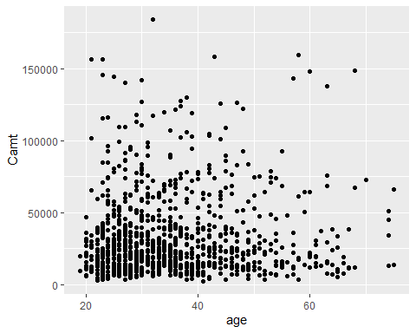
cor.test(data$age,data$Camt) # to find the correlation value
##
## Pearson's product-moment correlation
##
## data: data$age and data$Camt
## t = 1.0341, df = 998, p-value = 0.3013
## alternative hypothesis: true correlation is not equal to 0
## 95 percent confidence interval:
## -0.02933617 0.09451780
## sample estimates:
## cor
## 0.03271642
Relation between credit amount and duration of credit
ggplot(data,aes(x=Camt,y=Cdur))+geom_point() #To plot
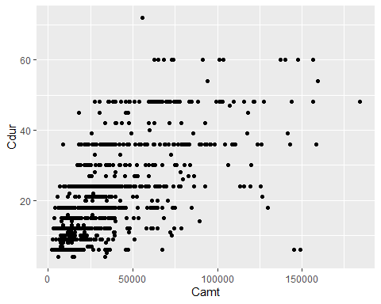 We can understand from the graph the that as the amount increases, duration also increases. So both are positively correlated.
cor.test(data$Camt,data$Cdur) # to find the correlation value
##
## Pearson's product-moment correlation
##
## data: data$Camt and data$Cdur
## t = 25.292, df = 998, p-value < 2.2e-16
## alternative hypothesis: true correlation is not equal to 0
## 95 percent confidence interval:
## 0.5856832 0.6613533
## sample estimates:
## cor
## 0.6249842
Simple Linear Regression
slr = lm(Camt~Cdur, data)
summary(slr)
##
## Call:
## lm(formula = Camt ~ Cdur, data = data)
##
## Residuals:
## Min 1Q Median 3Q Max
## -51516 -12600 -4329 6532 138050
##
## Coefficients:
## Estimate Std. Error t value Pr(>|t|)
## (Intercept) 2012.16 1395.69 1.442 0.15
## Cdur 1462.97 57.84 25.292 <2e-16 ***
## ---
## Signif. codes: 0 '***' 0.001 '**' 0.01 '*' 0.05 '.' 0.1 ' ' 1
##
## Residual standard error: 22050 on 998 degrees of freedom
## Multiple R-squared: 0.3906, Adjusted R-squared: 0.39
## F-statistic: 639.7 on 1 and 998 DF, p-value: < 2.2e-16
plot(slr$resid) # Residual plot
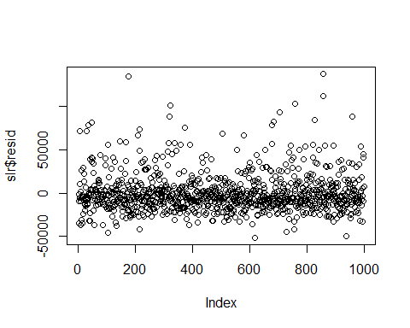
qqnorm(slr$resid) #Q-Q Plot
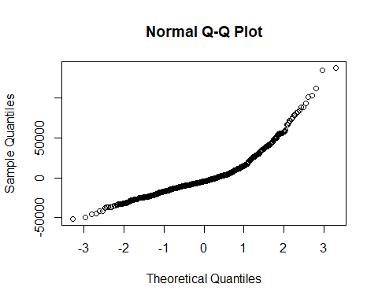
Multiple Linear Regression
mlr = lm(Camt~Cdur+age, data)
summary(mlr)
##
## Call:
## lm(formula = Camt ~ Cdur + age, data = data)
##
## Residuals:
## Min 1Q Median 3Q Max
## -50169 -12448 -4347 6604 136434
##
## Coefficients:
## Estimate Std. Error t value Pr(>|t|)
## (Intercept) -2969.94 2621.00 -1.133 0.2574
## Cdur 1467.65 57.76 25.408 <2e-16 ***
## age 137.40 61.23 2.244 0.0251 *
## ---
## Signif. codes: 0 '***' 0.001 '**' 0.01 '*' 0.05 '.' 0.1 ' ' 1
##
## Residual standard error: 22000 on 997 degrees of freedom
## Multiple R-squared: 0.3937, Adjusted R-squared: 0.3925
## F-statistic: 323.7 on 2 and 997 DF, p-value: < 2.2e-16
plot(mlr$resid) # Residual plot
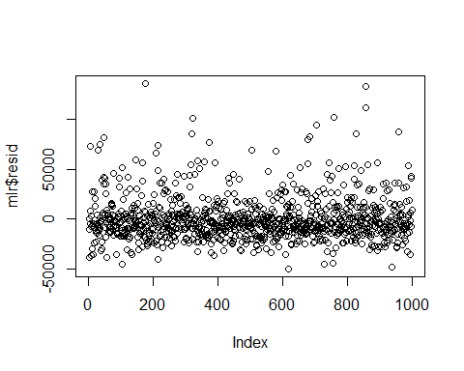
qqnorm(mlr$resid) #Q-Q Plot
