CSE3506 Essentials of Data Analytics

Name : Revanth Bhargava Boyidi
Reg. No. : 19BCE1177
Lab Exercise: 7 - K-Means
Objective: Apply K Means Clustering for the columns (variables) bore diameter and price of the vehicle. Identify the optimum number of clusters.
Methods:
- Display entire dataset
- Understand the data
- Apply K-Means clustering on the data
- Find the optimal K value
- Conclusions

Importing Libraries
rm(list=ls())
#install.packages('ClusterR')
#install.packages('cluster')
library(tidyverse) # data manipulation
library(cluster) # clustering algorithms
Importing Dataset
data <- read.csv("Lab Task 7_K-Means.csv",header=TRUE)
head(data, 10)
## fuel wb length weight size system bore CR hp city_mpg highway_mpg price
## 1 gas 88.6 168.8 2548 130 mpfi 3.47 9 111 21 27 13495
## 2 gas 88.6 168.8 2548 130 mpfi 3.47 9 111 21 27 16500
## 3 gas 94.5 171.2 2823 152 mpfi 2.68 9 154 19 26 16500
## 4 gas 99.8 176.6 2337 109 mpfi 3.19 10 102 24 30 13950
## 5 gas 99.4 176.6 2824 136 mpfi 3.19 8 115 18 22 17450
## 6 gas 99.8 177.3 2507 136 mpfi 3.19 8 110 19 25 15250
## 7 gas 105.8 192.7 2844 136 mpfi 3.19 8 110 19 25 17710
## 8 gas 105.8 192.7 2954 136 mpfi 3.19 8 110 19 25 18920
## 9 gas 105.8 192.7 3086 131 mpfi 3.13 8 140 17 20 23875
## 10 gas 101.2 176.8 2395 108 mpfi 3.50 8 101 23 29 16430
Understanding the data
dim(data)
## [1] 179 12
str(data)
## 'data.frame': 179 obs. of 12 variables:
## $ fuel : chr "gas" "gas" "gas" "gas" ...
## $ wb : num 88.6 88.6 94.5 99.8 99.4 ...
## $ length : num 169 169 171 177 177 ...
## $ weight : int 2548 2548 2823 2337 2824 2507 2844 2954 3086 2395 ...
## $ size : int 130 130 152 109 136 136 136 136 131 108 ...
## $ system : chr "mpfi" "mpfi" "mpfi" "mpfi" ...
## $ bore : num 3.47 3.47 2.68 3.19 3.19 3.19 3.19 3.19 3.13 3.5 ...
## $ CR : int 9 9 9 10 8 8 8 8 8 8 ...
## $ hp : int 111 111 154 102 115 110 110 110 140 101 ...
## $ city_mpg : int 21 21 19 24 18 19 19 19 17 23 ...
## $ highway_mpg: int 27 27 26 30 22 25 25 25 20 29 ...
## $ price : int 13495 16500 16500 13950 17450 15250 17710 18920 23875 16430 ...
summary(data)
## fuel wb length weight
## Length:179 Min. : 86.60 Min. :141.1 Min. :1488
## Class :character 1st Qu.: 94.50 1st Qu.:166.3 1st Qu.:2125
## Mode :character Median : 96.50 Median :172.4 Median :2395
## Mean : 98.43 Mean :173.3 Mean :2532
## 3rd Qu.:101.20 3rd Qu.:177.8 3rd Qu.:2838
## Max. :120.90 Max. :208.1 Max. :4066
## size system bore CR
## Min. : 61.0 Length:179 Min. :2.540 Min. : 7.00
## 1st Qu.: 97.5 Class :character 1st Qu.:3.150 1st Qu.: 8.00
## Median :110.0 Mode :character Median :3.310 Median : 9.00
## Mean :127.5 Mean :3.314 Mean : 9.81
## 3rd Qu.:146.0 3rd Qu.:3.580 3rd Qu.: 9.00
## Max. :326.0 Max. :3.940 Max. :23.00
## hp city_mpg highway_mpg price
## Min. : 48.0 Min. :13.00 Min. :16.00 Min. : 5118
## 1st Qu.: 70.0 1st Qu.:20.00 1st Qu.:25.00 1st Qu.: 7606
## Median : 92.0 Median :25.00 Median :31.00 Median : 9959
## Mean :102.2 Mean :25.58 Mean :31.09 Mean :12994
## 3rd Qu.:116.0 3rd Qu.:30.50 3rd Qu.:36.50 3rd Qu.:16214
## Max. :262.0 Max. :49.00 Max. :54.00 Max. :45400
# Checking for NULL values
sum(is.na(data))
## [1] 0
There are no missing values in the dataset.
data$system<-as.factor(data$bore)
str(data)
## 'data.frame': 179 obs. of 12 variables:
## $ fuel : chr "gas" "gas" "gas" "gas" ...
## $ wb : num 88.6 88.6 94.5 99.8 99.4 ...
## $ length : num 169 169 171 177 177 ...
## $ weight : int 2548 2548 2823 2337 2824 2507 2844 2954 3086 2395 ...
## $ size : int 130 130 152 109 136 136 136 136 131 108 ...
## $ system : Factor w/ 38 levels "2.54","2.68",..: 24 24 2 14 14 14 14 14 11 25 ...
## $ bore : num 3.47 3.47 2.68 3.19 3.19 3.19 3.19 3.19 3.13 3.5 ...
## $ CR : int 9 9 9 10 8 8 8 8 8 8 ...
## $ hp : int 111 111 154 102 115 110 110 110 140 101 ...
## $ city_mpg : int 21 21 19 24 18 19 19 19 17 23 ...
## $ highway_mpg: int 27 27 26 30 22 25 25 25 20 29 ...
## $ price : int 13495 16500 16500 13950 17450 15250 17710 18920 23875 16430 ...
Price distribution based on cylinder diameter(bore)
K-Means is an iterative algorithm that divides the unlabeled dataset into k different clusters in such a way that each dataset belongs only one group that has similar properties. It allows us to cluster the data into different groups and a convenient way to discover the categories of groups in the unlabeled dataset on its own without the need for any training.
pdt<-data[,c(7,12)]
plot(pdt, main="Price based on cyl bore")
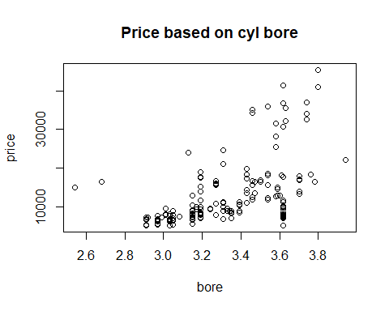
km<-kmeans(pdt,3)
plot(pdt,col=(km$cluster+2))
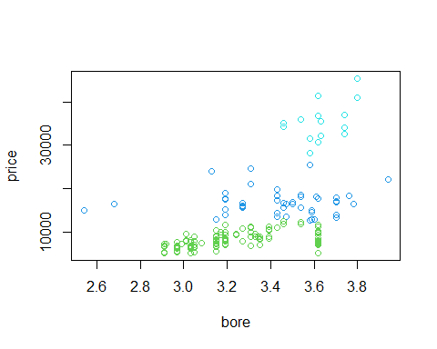
km
## K-means clustering with 3 clusters of sizes 114, 49, 16
##
## Cluster means:
## bore price
## 1 3.217895 8238.605
## 2 3.431633 16871.857
## 3 3.633750 34997.688
##
## Clustering vector:
## [1] 2 2 2 2 2 2 2 2 2 2 2 2 2 2 3 3 3 1 1 1 1 1 1 1 1 1 1 2 1 1 1 1 1 1 1 1 1
## [38] 1 1 2 1 1 1 3 3 3 1 1 1 1 1 1 1 1 1 1 2 2 2 3 3 3 3 3 3 3 2 1 1 1 1 1 1 2
## [75] 2 2 1 1 1 1 1 1 1 1 1 1 1 1 1 1 1 1 2 2 2 2 2 2 1 2 1 2 2 2 2 2 2 2 2 1 1
## [112] 1 1 1 1 2 2 3 3 3 1 1 2 2 2 2 1 1 1 1 1 1 1 1 1 1 1 1 1 1 1 1 1 1 1 1 1 1
## [149] 1 1 1 1 1 1 1 1 1 1 1 1 2 1 1 1 1 1 2 2 2 2 1 1 1 1 1 1 1 1 1
##
## Within cluster sum of squares by cluster:
## [1] 361687173 433093717 329491564
## (between_SS / total_SS = 90.8 %)
##
## Available components:
##
## [1] "cluster" "centers" "totss" "withinss" "tot.withinss"
## [6] "betweenss" "size" "iter" "ifault"
Checking for optimal ‘K’
A commonly used method for finding optimal K value is Elbow Method. In the Elbow method, we are actually varying the number of clusters ( K ) from 1 – 10. For each value of K, we are calculating WCSS ( Within-Cluster Sum of Square ). WCSS is the sum of squared distance between each point and the centroid in a cluster. When we plot the WCSS with the K value, the plot looks like an Elbow. As the number of clusters increases, the WCSS value will start to decrease. WCSS value is largest when K = 1. When we analyze the graph we can see that the graph will rapidly change at a point and thus creating an elbow shape. From this point, the graph starts to move almost parallel to the X-axis. The K value corresponding to this point is the optimal K value or an optimal number of clusters.
dt<-pdt
ss<-(nrow(dt)-1)*sum(apply(dt,2,var))
for(i in 2:10) ss[i]<-sum(kmeans(dt,centers = i)$withinss)
plot(1:10,ss,type='b',xlab='K',ylab='distortion')
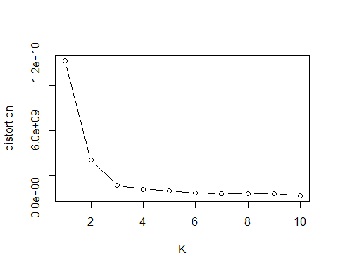
Conclusions

K Means Clustering is the simplest and commonly used iterative type unsupervised learning algorithm. In this, we randomly initialize the K, number of centroids in the data (the number of k is found using the Elbow method) and iterates these centroids until no change happens to the position of the centroid.
Here we can see a rapid change in distortion at K=2. So the optimal value for K is 2.

