DBMS ASSIGNMENT 1 (Cognitive disorders among senior citizens)

Requirements and Gathering:-

There are 5 tables needed to be created

Table1:-Senior citizen personal data table which includes the attributes “the id of the senior citizen, their name, their gender, their age, their phone number

Table2:About their medical history which includes medical id ,the number of surgeries undergone by them, the medication which was previously followed by them.

Table3:About the symptoms they’ve undergone which involves the attributes like symptom id, description about the symptom, the time duration from when the symptoms were encountered.

Table4:About their daily habits which involve their eating habits, exercise habits, sleeping pattern, drinking and smoking habits.



Table5:About the family history which includes whether some one from his/h bloodline have undergone any severe or the same diseases as they.

ER DIAGRAM:-

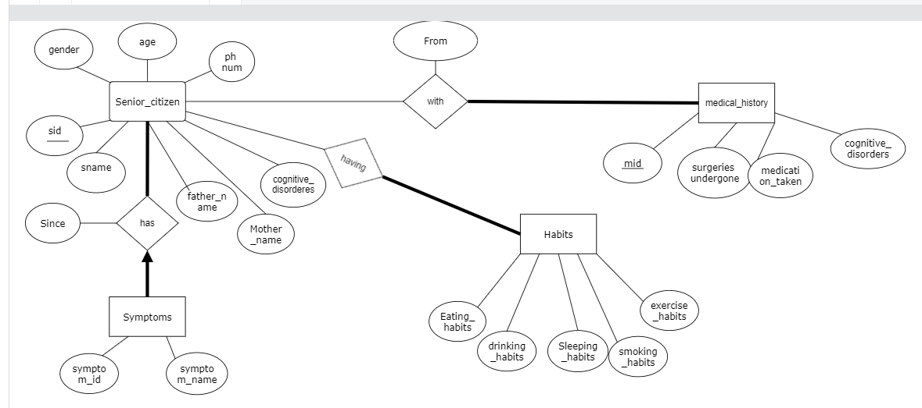

DDL OPERATIONS:

Table senior citizens:-

create table senior_citizens(

2 sid number(5),

3 sname varchar2(20),

4 age number(3),

5 gender varchar2(8),

6 mobile number(10)

7 father_name varchar2(30)

8 mother_name varchar2(30)

9 cognitive_disorders varcahr2(30));

Table Medical history :-

create table medical_history(

2 mid number(5),

3 surgeries number(3),

4 medication_taken varchar2(20)

5 cognitive_disorders varchar2(20));

Table Habits:-

create table habits(

2 eating_habits varchar2(10),

3 sleeping_habits varchar2(10),

4 exercise_habits varchar2(10),

5 drinking_habits varchar2(10),

6 smoking_habits varchar2(10));

Table Symptoms:-

create table symptoms(

2 symptom_id number(10),

3 symptom_name varchar2(10));

Relationship between citizen and medical history:-

create table senior_medical(

2 sid number(5),

3 mid number(5),

4 fromt date,

5 primary key(sid,mid),

6 foreign key(sid) references senior_citizens,

7 foreign key (mid) references medical_history);

Relationship between citizen and symptoms:-

create table senior_symptoms(

2 sid number(5),

3 symptom_id number(5),

4 since date,

5 primary key(sid,symptom_id),

6 foreign key(sid) references senior_citizens,

7 foreign key(symptom_id) references symptoms);

Relationship between citizen and their habits:-

create table senior_having_habits(

2 sid number(5),

3 fromt date,

4 primary key(sid),

5 foreign key(sid) references senior_citizens on delete cascade);

Screenshots:-

Ddl operations:-

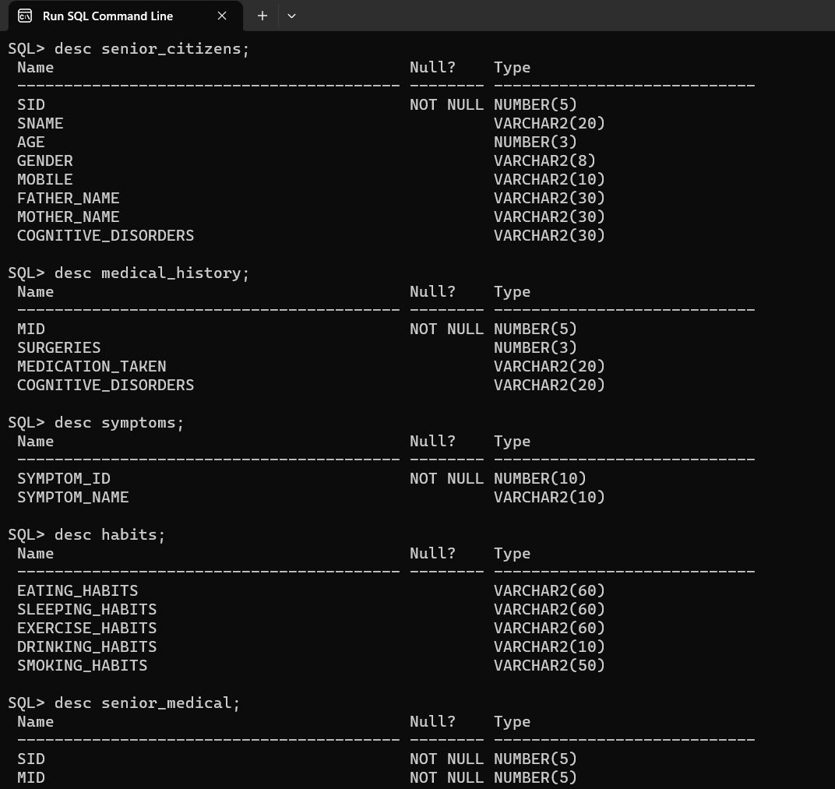



**DML OPERATIONS:-**

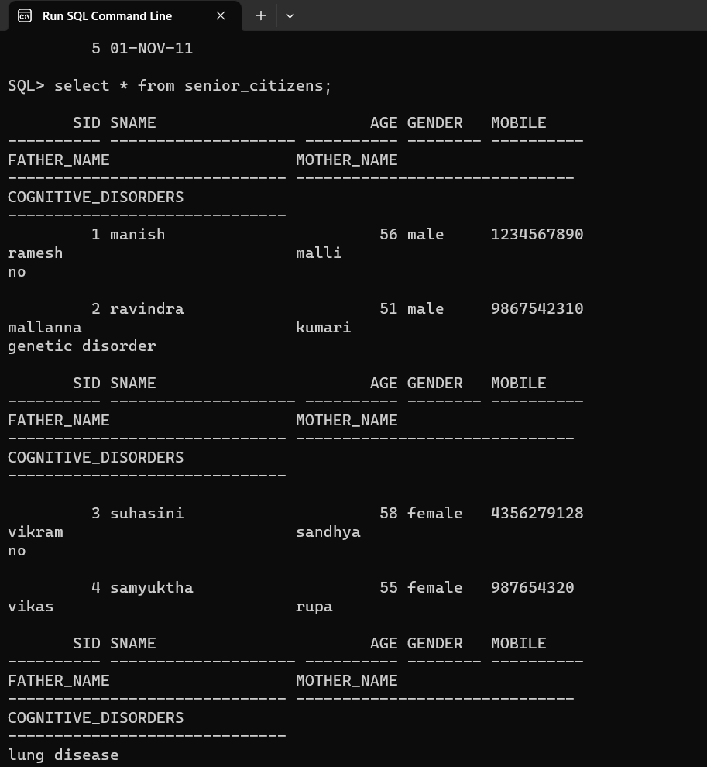

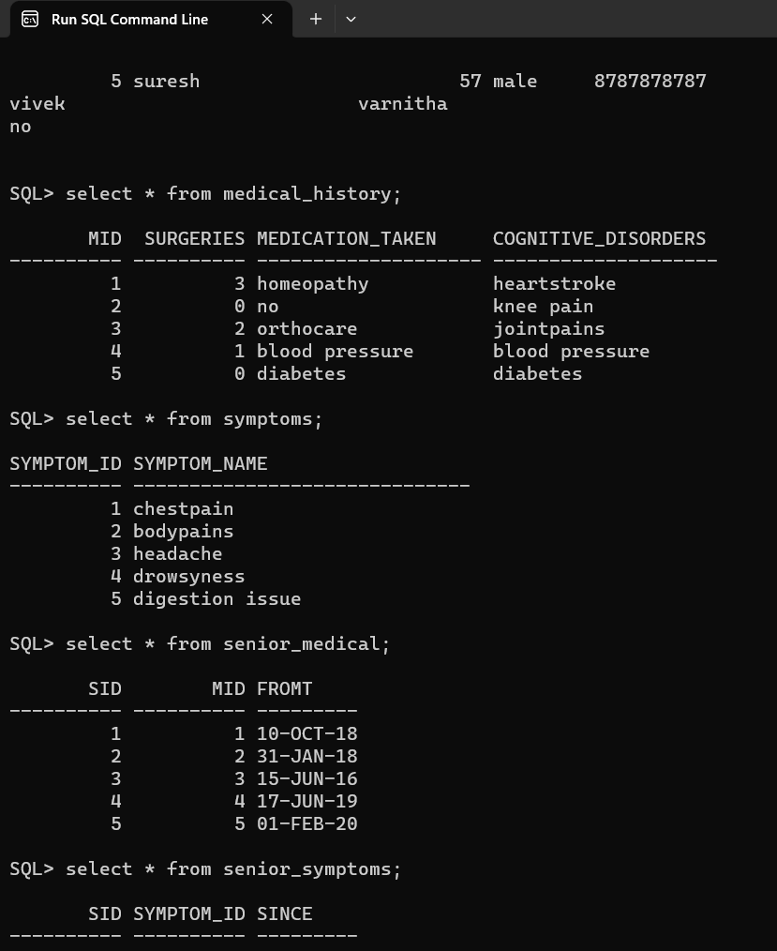

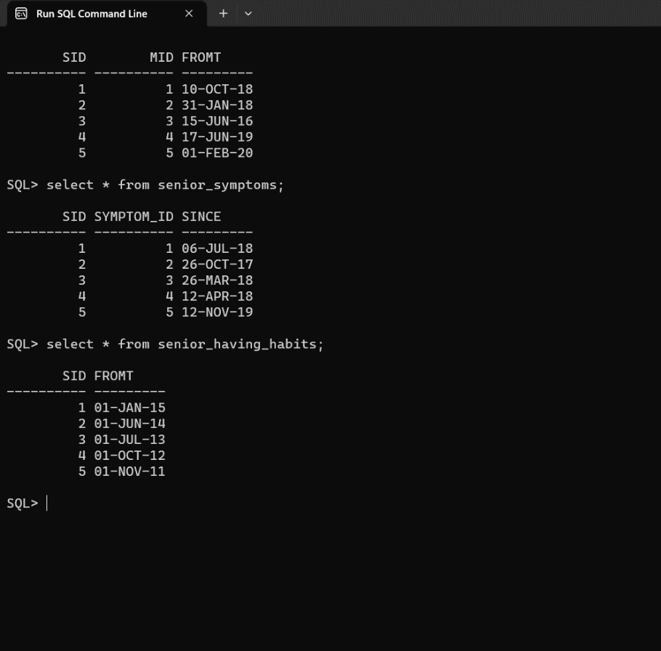

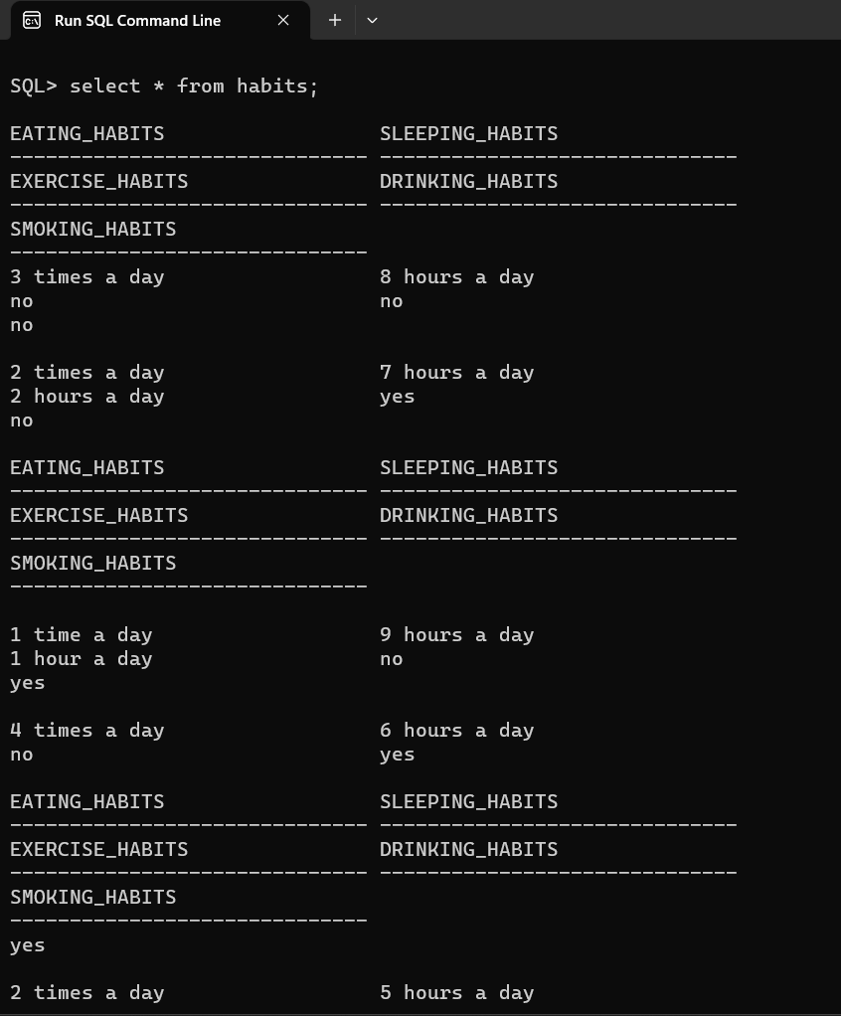

**https://github.com/Revanth-patloori/revanthpatloori.git**