**Project Tech Stack**:

* Eclipse IDE
* TestNG Framework
* HTML Reports – ExtentReports library
* Coding language – Java
* Project Build – Maven project
* Executed Platform – Chrome Browser

**Setup Instructions:**

1. Install Eclipse IDE.
2. Once the Eclipse is installed, download the project from Github account into Local drive.
3. Import the Project from File->Import->Maven->Existing Maven Projects-> Next-> Browse the project Folder->Click Finish

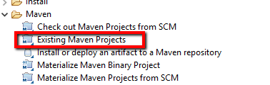

1. Once the project is loaded, Click on Project->Build All. This will install all the packages corresponding to the pom.xml library associated.
2. Open the Configuration.properties file located in project Explorer as below

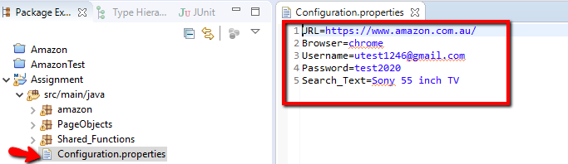

1. Please edit the respective Username,password parameter values if necessary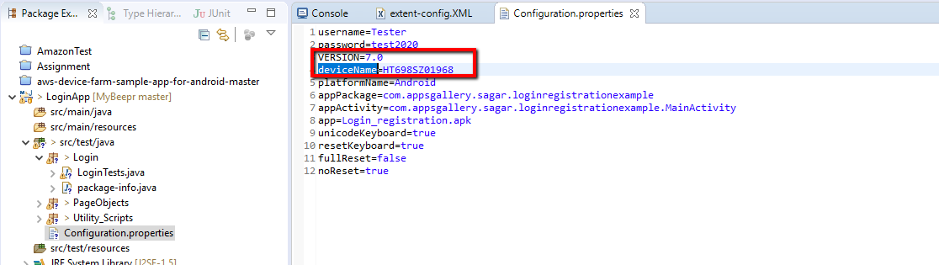

1. Once configuration is completed , Open the AmazonPurchase.java file from the Package explorer

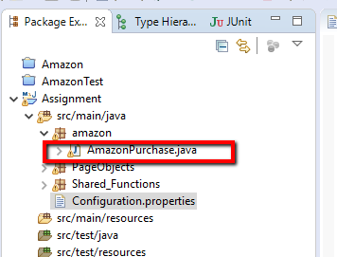

1. Right Click on the AmazonPurchase.java classfile and Select RunAs->TestNG Test option

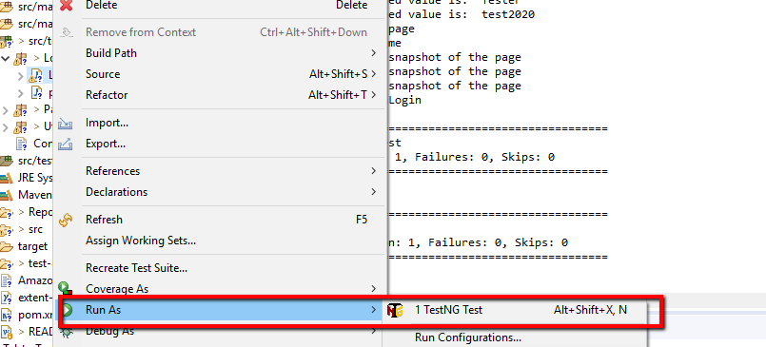

1. This will trigger the scripts to execute.
2. Once the execution is completed, please open Reports->AmazonTestResults folder and choose the most recent created folder.
3. Open the html result file and can be viewed as below

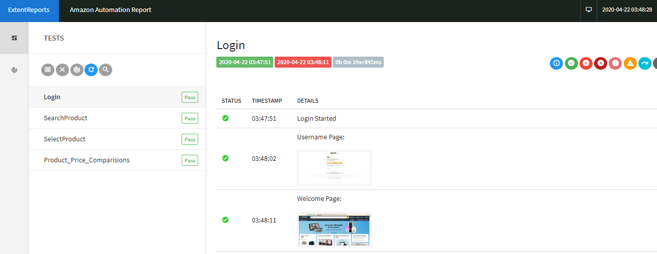

About Project:

Project built is based on the Page object model framework.

Consists of Following folders

1. Driver script- Main script where script will trigger execution.(AmazonPurchase.java)
2. Reusable Functions: Contains all the reusable functions across the project.(Utility_Scripts->Shared_Functions.java)
3. Page Objects: contains all the identified object definitions for each object captured from Application Under Test(AUT). ( PageObjects->LoginPage.java , SelectProductPage.java)
4. Configuration File: Contains all the application credentials like username, password, browser details ( Configuration.properties file)
5. Test Results: html results files are generated once the test execution is completed ( library- ExtentReports)

