**Setup Instructions:**

1. Install Visual Studio Community Edition 2019.
2. Once the Visual Studio is installed, download the project from Github account into Local drive(C: ) drive.
3. Open the Project from File->Open->Project/Solution
4. Once the project is loaded, Click on Build->Build Solution. This will install all the packages corresponding to the library associated.
5. Now from the Test Explorer tab, Right click on “Should-Send_Email” and

click on “Run” option.

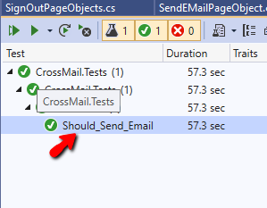

1. This will trigger the scripts to execute.

About Project:

Project built is based on the Page object model framework.

Consists of Following folders

1. Driver script- Main script where script will trigger execution.
2. Shared Functions: Contains all the reusable functions across the project.
3. Page Objects: contains all the identified object definitions for each object catured from Application Under Test(AUT).

