**Project Tech Stack**:

1. Eclipse IDE
2. Appium Library
3. TestNG Framework
4. HTML Reports – ExtentReports library
5. Coding language – Java
6. Project Build – Maven project
7. Executed Platform - Android

**Setup Instructions:**

1. Install Eclipse IDE.
2. Once the Eclipse is installed, download the project from Github account into Local drive.
3. Import the Project from File->Import->Maven->Existing Maven Projects-> Next-> Browse the project Folder->Click Finish

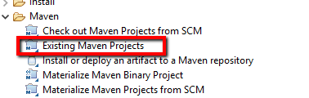

1. Once the project is loaded, Click on Project->Build All. This will install all the packages corresponding to the pom.xml library associated.
2. Open the Configuration.properties file located in project Explorer as below

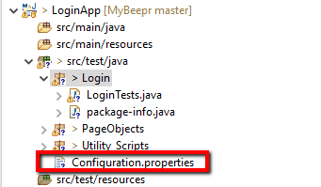

1. Please edit the respective deviceName, VERSION parameter values with respect to target device ( ensure the device is fully connected and can be accessible with ‘adb devices’ command)

deviceName

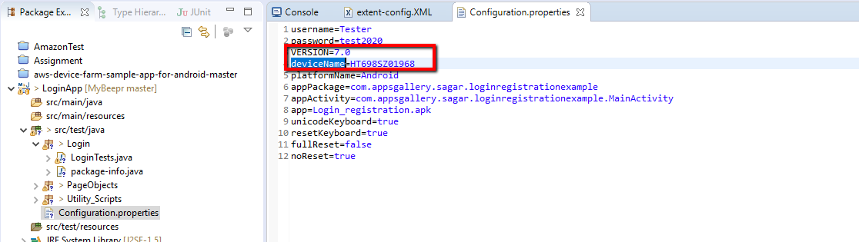

1. Once configuration is completed , Open the LoginTests.java file from the Package explorer

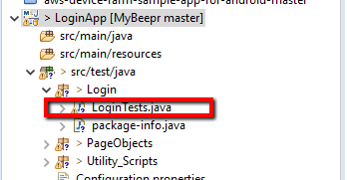

1. Right Click on the LoginTests.java classfile and Select RunAs->TestNG Test option

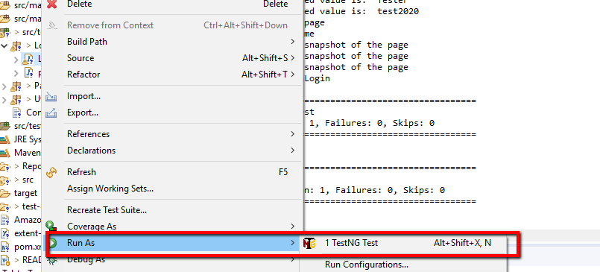

1. This will trigger the scripts to execute.
2. Once the execution is completed, please open Reports->LoginTestResults folder and choose the most recent created folder.
3. Open the html result file and can be viewed as below

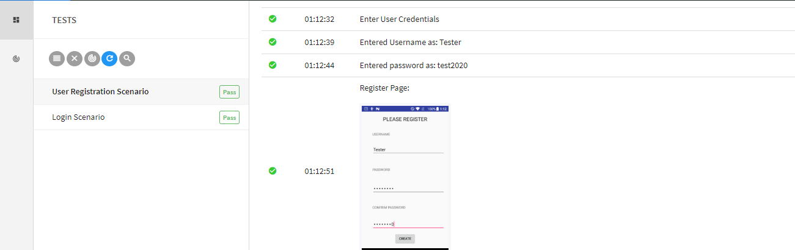

About Project:

Project built is based on the Page object model framework.

Consists of Following folders

1. Driver script- Main script where script will trigger execution.(LoginTests.java)
2. Shared Functions: Contains all the reusable functions across the project.(Utility_Scripts->Shared_Functions.java)
3. Page Objects: contains all the identified object definitions for each object captured from Application Under Test(AUT). ( PageObjects->LoginPage.java , SignUpPageObjects.java)
4. Configuration File: Contains all the application credentials like username, password, device details ( Configuration.properties file)
5. Test Results: html results files are generated once the test execution is completed ( library- ExtentReports)

