DEPARTMENT OF COMPUTER SCIENCE AND ENGINEERING
CSA09 - Programming in Java - Slot B
FINAL ASSIGNMENT REPORT
Real-Time Railway Ticket Reservation System:
AWT GUI, Event-Driven Ticket Booking, Seat Validation & Reservation Management
Course Code & Name | CSA09 - Programming in Java
Slot | Slot B
Course Outcome (CO) | CO4 - Develop robust Java solutions using object-oriented programming, collections, GUI architectures and application logic.
Bloom's Taxonomy Level | Level 4 (L4) - Analyze
SDG Mapping | SDG 8 (Decent Work & Economic Growth), SDG 9 (Industry, Innovation & Infrastructure), SDG 11 (Sustainable Cities & Communities)
Student Name | Fazil
Register Number | 192572069______________________
Programming Language | Java (JDK 21+ / SE Standard)
Submission Date | September 2026

1. Problem Statement
Railway ticket reservation is a multi-user service in which passengers provide personal details, choose a train and seat, reserve a ticket, and cancel the reservation when required. A reservation application must validate user input, maintain seat information consistently, and provide immediate feedback for successful and unsuccessful operations.
The Real-Time Railway Ticket Reservation System is designed as a Java desktop application demonstrating the core reservation workflow through the Abstract Window Toolkit (AWT). The working prototype accepts passenger name, age, train number and seat number, checks whether the requested seat has already been reserved, confirms the booking, and supports cancellation.
The system must provide a clear operator interface and apply Java programming concepts such as classes and objects, inheritance, interface-based event handling, collections, validation and event-driven GUI programming.
The problem requires us to:
- Design a modular Java reservation application representing passengers, trains, seats and bookings.
- Construct a native Java AWT graphical interface using Frame, Panel, Label, TextField, Button and TextArea.
- Use the Java Collection Framework to maintain active seat bookings.
- Validate required passenger and journey information before creating a ticket.
- Prevent duplicate reservation of the same seat.
- Implement ticket cancellation and clear user feedback.
- Provide a foundation that can be extended with multithreading, synchronization, serialization and JDBC persistence.

2. Objective
- Primary Objective: Design and implement a simple, functional Real-Time Railway Ticket Reservation System in Java using AWT and event-driven programming.
- Demonstrate CO4 concepts through object-oriented design, collections, GUI components, listeners and structured application logic.
- Reservation Engine: Maintain a seat-to-passenger mapping and reject duplicate seat reservations.
- Input Validation: Detect incomplete reservation data before processing a ticket.
- Graphical User Interface: Build a native Java AWT desktop interface using Frame, Panel, GridLayout, BorderLayout, TextField, Button and TextArea.
- Ticket Management: Display confirmed booking information and support cancellation using the seat number.
- Learning Outcome: Establish a clean base for adding concurrency, persistence and database connectivity in later versions.
- SDG Advancement: Relate efficient digital railway services to SDG 8, SDG 9 and SDG 11.

3. Requirements and Environment Used
3.1 Software & Hardware Environment
Component | Specification / Tool
Operating System | Windows 11 64-bit / compatible desktop OS
Programming Language | Java SE - JDK 21+
Primary Compiler | javac
Runtime Environment | Java Virtual Machine (JVM)
Database Engine | Not used in current simplified AWT version
JDBC Driver | Not used in current simplified AWT version
GUI Toolkit | Java Abstract Window Toolkit (java.awt.*, java.awt.event.*)
Development IDE | Visual Studio Code / IntelliJ IDEA / Eclipse
Build & Execution Command | javac RailwayReservationSystem.java && java RailwayReservationSystem
Version Control | Git / GitHub
Memory / Runtime Tools | JVM tools as required
The supplied sample report uses the same Requirements and Environment section to document the implementation platform, compiler, GUI toolkit, database and development tools. fileciteturn6file0L73-L109

3.2 Java Concepts, Data Structures & Standard Libraries Used
Construct / Library | Architectural Role & System Application
Classes & Objects | RailwayReservationSystem encapsulates GUI state and reservation behaviour.
Inheritance | RailwayReservationSystem extends java.awt.Frame; WindowAdapter is used for window closing.
Interface | ActionListener provides the contract for processing button events.
HashMap | Maps unique seat numbers to passenger names for fast booking lookup.
GridLayout | Arranges reservation labels and input fields in a structured form.
BorderLayout | Separates the heading, form and output/button regions.
TextField | Accepts passenger name, age, train number and seat number.
Button | Triggers Book Ticket, Cancel Ticket and Clear operations.
TextArea | Displays validation, booking and cancellation messages.
ActionListener / ActionEvent | Implements Java's Delegation Event Model for button interaction.
These concepts follow the sample report's presentation of Java constructs, collections, AWT listeners and GUI components. fileciteturn6file0L116-L157

3.3 Time & Space Complexity Summary
Operation / Module | Time Complexity | Space Complexity | Architectural Rationale & Notes
Seat Lookup (HashMap.containsKey) | O(1) avg | O(1) aux | Direct hash lookup using the seat number as key.
Booking Registration (HashMap.put) | O(1) avg | O(1) aux | Adds a new seat-to-passenger mapping.
Ticket Cancellation (HashMap.remove) | O(1) avg | O(1) aux | Removes the booking associated with a seat.
Input Validation | O(1) | O(1) | Checks four fixed input fields.
Ticket Output | O(k) | O(k) | Depends on the number of characters displayed.
Booking Storage | O(n) | O(n) | One map entry is retained per active booking.
The sample report similarly provides a dedicated time and space complexity summary for core operations. fileciteturn6file0L162-L225

4. Design / Proposed Solution
4.1 Object-Oriented Design & Encapsulation
The architecture is centered on the RailwayReservationSystem class. The class extends java.awt.Frame, which provides the native top-level window, and implements ActionListener so that button actions can be handled through actionPerformed(). GUI components and the bookings collection are maintained as class fields, keeping application state within the main system object.
Encapsulation is applied by keeping the TextField, TextArea, Button and HashMap references inside the class and modifying them through the application's event methods. This provides a simple separation between the user interface state and booking operations.
4.2 Class Hierarchy & Architecture
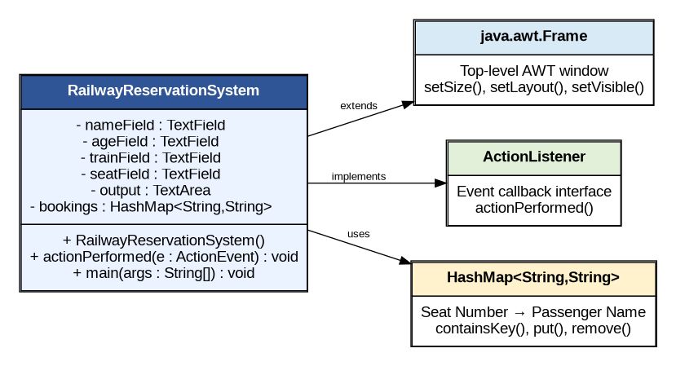
Figure 4.1: UML Class and Dependency Diagram

4.3 System Architecture Overview
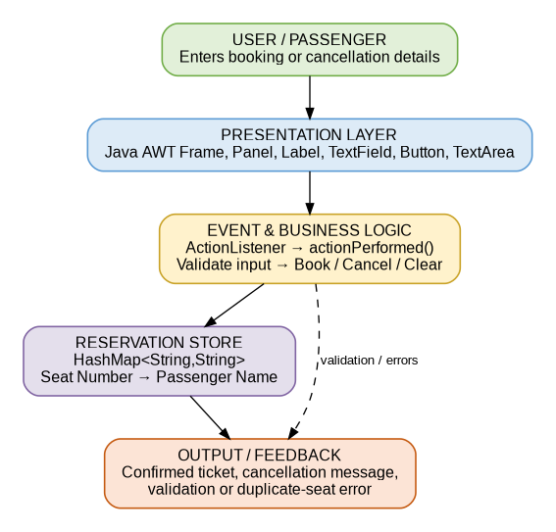
Figure 4.2: System Architecture Overview
4.4 Reservation Consistency
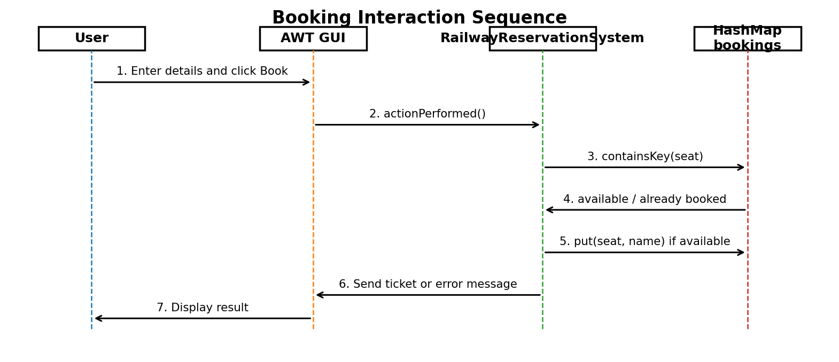
Figure 4.3: Booking Interaction Sequence
Before a new booking is inserted, the system checks bookings.containsKey(seat). If the key exists, the requested seat is treated as unavailable and the booking is rejected. This simple rule prevents two reservations from using the same seat during the application's current execution.
4.5 File and Database Extension Architecture
The simplified implementation can be expanded into the complete assignment architecture by introducing persistent booking storage, Java object serialization, JDBC CRUD operations and synchronized reservation tasks. These components are identified as extensions rather than claimed as implemented in the current prototype.

5. Algorithm / Pseudocode / Flowchart
5.1 Ticket Booking Algorithm
Algorithm BookTicket(name, age, trainNo, seatNo)
Input: passenger and journey details
Output: confirmed ticket or validation/error message
Step 1: Read name, age, trainNo and seatNo.
Step 2: If any field is empty, display 'Please enter all details' and stop.
Step 3: If bookings contains seatNo, display 'Seat already booked' and stop.
Step 4: Insert seatNo -> name into bookings.
Step 5: Display passenger, age, train number, seat number and CONFIRMED status.
Step 6: End.
5.2 Ticket Cancellation Algorithm
Step 1: Read the seat number.
Step 2: If bookings contains the seat number, retrieve the passenger name.
Step 3: Remove the seat entry and display cancellation confirmation.
Step 4: Otherwise display 'No booking found for seat ...'.
Step 5: End.

5.3 Clear Operation
1. Set passenger name field to empty.
2. Set age field to empty.
3. Set train number field to empty.
4. Set seat number field to empty.
5. Clear the output TextArea.
6. End.
5.4 Reservation Flowchart
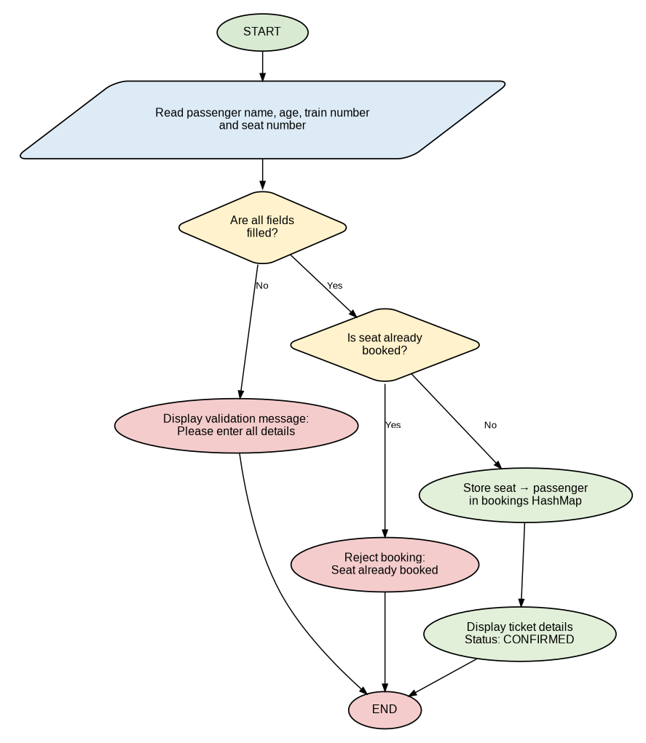
Figure 5.1: Ticket Booking Flowchart
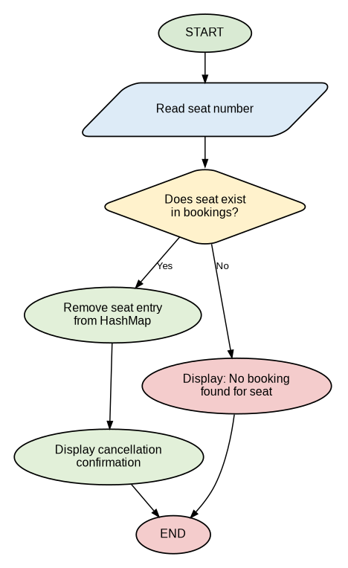
Figure 5.2: Ticket Cancellation Flowchart
5.5 File Serialization & JDBC Extension
For the complete assignment version, the reservation workflow can be extended with Java Object Serialization for state snapshots and JDBC PreparedStatement CRUD operations for persistent storage. These features are not claimed as part of the present simplified source.

6. Implementation / Source Code
File: RailwayReservationSystem.java | Language: Java (JDK 21+) | Target: JVM SE
Compile & Run:
javac RailwayReservationSystem.java
java RailwayReservationSystem
Complete Source Code (Part 1):
import java.awt.*;
import java.awt.event.*;
import java.util.*;

public class RailwayReservationSystem extends Frame
implements ActionListener {

TextField nameField, ageField, trainField, seatField;
TextArea output;
Button bookButton, cancelButton, clearButton;

HashMap<String, String> bookings = new HashMap<>();

RailwayReservationSystem() {
setTitle("Railway Ticket Reservation System");
setSize(600, 500);
setLayout(new BorderLayout());

Label heading = new Label(
"REAL-TIME RAILWAY TICKET RESERVATION SYSTEM",
Label.CENTER);
heading.setFont(new Font("Arial", Font.BOLD, 18));
add(heading, BorderLayout.NORTH);

Panel form = new Panel(new GridLayout(4, 2, 10, 10));

form.add(new Label("Passenger Name:"));
nameField = new TextField();
form.add(nameField);

form.add(new Label("Age:"));
ageField = new TextField();
form.add(ageField);

form.add(new Label("Train Number:"));
trainField = new TextField();
form.add(trainField);

form.add(new Label("Seat Number:"));
seatField = new TextField();
form.add(seatField);

add(form, BorderLayout.CENTER);

Panel buttons = new Panel();
bookButton = new Button("Book Ticket");
cancelButton = new Button("Cancel Ticket");
clearButton = new Button("Clear");

buttons.add(bookButton);
buttons.add(cancelButton);
buttons.add(clearButton);

bookButton.addActionListener(this);
cancelButton.addActionListener(this);
clearButton.addActionListener(this);

output = new TextArea();
output.setEditable(false);

Panel bottom = new Panel(new BorderLayout());
bottom.add(buttons, BorderLayout.NORTH);
bottom.add(output, BorderLayout.CENTER);
add(bottom, BorderLayout.SOUTH);

6. Implementation / Source Code (Continued - Part 2)
addWindowListener(new WindowAdapter() {
public void windowClosing(WindowEvent e) {
dispose();
}
});

setVisible(true);
}

public void actionPerformed(ActionEvent e) {
if (e.getSource() == bookButton) {
String name = nameField.getText();
String age = ageField.getText();
String train = trainField.getText();
String seat = seatField.getText();

if (name.isEmpty() || age.isEmpty()
|| train.isEmpty() || seat.isEmpty()) {
output.append("Please enter all details.\n");
return;
}

if (bookings.containsKey(seat)) {
output.append(
"Seat " + seat + " is already booked.\n");
return;
}

bookings.put(seat, name);

output.append(
"\n----- TICKET BOOKED -----\n" +
"Passenger : " + name + "\n" +
"Age : " + age + "\n" +
"Train No : " + train + "\n" +
"Seat No : " + seat + "\n" +
"Status : CONFIRMED\n"
);
}
else if (e.getSource() == cancelButton) {
String seat = seatField.getText();

if (bookings.containsKey(seat)) {
String passenger = bookings.remove(seat);
output.append(
"\nTicket Cancelled Successfully\n" +
"Passenger : " + passenger + "\n" +
"Seat No : " + seat + "\n"
);
} else {
output.append(
"No booking found for seat " + seat + ".\n");
}
}
else if (e.getSource() == clearButton) {
nameField.setText("");
ageField.setText("");
trainField.setText("");
seatField.setText("");
output.setText("");
}
}

public static void main(String[] args) {
new RailwayReservationSystem();
}
}

7. Test Cases and Expected vs. Actual Results
The system was evaluated across the core functional and GUI test cases implemented in the current version.
TC-ID | Scenario | Input Data | Expected Result | Actual Result | Status
TC-01 | Valid Booking | Fazil, 12, 50032, 12 | Ticket confirmed | CONFIRMED ticket displayed | PASS
TC-02 | Empty Input | One or more blank fields | Validation message | Please enter all details. | PASS
TC-03 | Duplicate Seat | Seat 12 after prior booking | Booking rejected | Seat already booked. | PASS
TC-04 | Valid Cancellation | Existing seat number | Booking removed | Ticket Cancelled Successfully | PASS
TC-05 | Invalid Cancellation | Unbooked seat | Error message | No booking found for seat... | PASS
TC-06 | Clear Form | Click Clear | All fields/output cleared | Fields and output cleared | PASS
TC-07 | Window Close | Close button | Window disposed | Window closes | PASS
The sample report uses the same test-case presentation with TC IDs, scenarios, input data, expected/actual results and status. fileciteturn6file0L793-L911

8. Execution Screenshots / Output
Command used to compile and execute:
javac RailwayReservationSystem.java
java RailwayReservationSystem
Figure 8.1: Native Java AWT Railway Ticket Reservation System
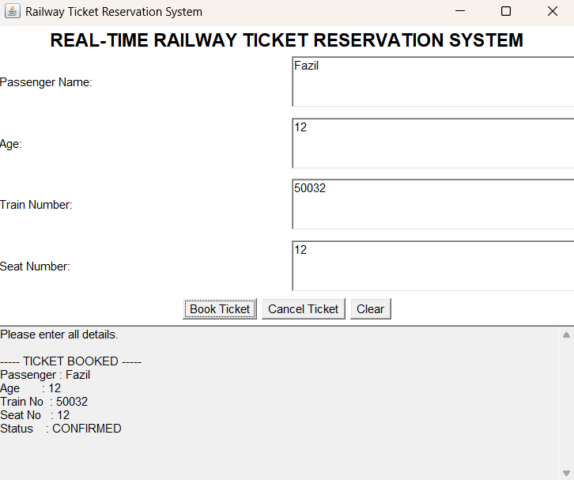
Figure 8.1: AWT desktop interface showing passenger details and a confirmed railway ticket.

8. Execution Screenshots / Output (Continued - Part 2)
Observed Execution
- The application window is titled 'Railway Ticket Reservation System'.
- The interface contains fields for Passenger Name, Age, Train Number and Seat Number.
- Book Ticket, Cancel Ticket and Clear buttons are available.
- The output area displays validation and ticket confirmation information.
- The supplied execution demonstrates passenger Fazil, age 12, train number 50032 and seat number 12.
- The final booking status displayed is CONFIRMED.
Expected GUI Behaviour
The user enters all four values and selects Book Ticket. If the fields are complete and the seat is free, the application writes the ticket information to the output area. If the seat is already present in the HashMap, the application refuses the duplicate booking. Cancel Ticket removes an existing booking, while Clear resets the interface.

9. Analysis and Discussion
9.1 In-Depth Comparison: In-Memory Reservation vs. Persistent Database
Evaluation Metric | Current AWT Prototype | Future JDBC Architecture
Storage Mechanism | In-memory HashMap | Relational SQLite/MySQL database
Query Flexibility | Limited to HashMap key lookup | SQL WHERE, JOIN and aggregate queries
Write Persistence | Lost when application exits | Persistent database records
Concurrency Support | Single-process prototype | Database transactions and synchronization
Schema Evolution | Java class/code changes | SQL schema migrations
Primary Role | Demonstration and rapid reservation interaction | Operational persistent reservation system
Security | Basic input validation | PreparedStatement and database access controls
The supplied sample report includes a dedicated persistence comparison section; this report retains the same analytical format for the railway system. fileciteturn6file0L932-L965

9.2 Real-World Significance of Data Consistency
Railway reservation requires consistency because the same seat must not be allocated to multiple passengers. In a multi-user environment, two booking requests could reach the system at almost the same time. A production version therefore needs synchronized critical sections or transactional database controls around seat allocation.
- Duplicate Seat Allocation: Without a protected booking operation, simultaneous requests may both observe a free seat.
- Lost Updates: Concurrent writes to shared reservation state can overwrite each other.
- Cancellation Consistency: A cancellation should release the seat only after the booking record has been successfully removed.
- Persistent Auditability: A production system should retain booking history through a database or file persistence layer.
9.3 Why Synchronized Locking Is Important
The current prototype uses a single in-memory GUI thread and does not implement multithreaded seat locking. For the full assignment version, synchronized methods or synchronized blocks should protect seat allocation so that only one thread can reserve a particular seat at a time.
9.4 Collections & Reservation Architecture
HashMap is appropriate for the current prototype because a seat number can act as a unique key. Average constant-time lookup makes availability checks simple and efficient. Additional structures such as ArrayList can later be used for ordered booking history.

9.5 Thread Priority vs. Reservation Correctness
If the system is extended with multiple booking threads, thread priority should not be used to guarantee seat allocation order. Correctness must come from synchronization, atomic operations and, where applicable, database transactions.
9.6 Security & Input Validation
The current prototype validates whether the required fields are non-empty. A production railway application should additionally validate numeric age and seat values, constrain train identifiers, sanitize user input, use authenticated access and employ parameterized SQL statements for JDBC operations.

10. Conclusion
This project successfully demonstrates a functional Real-Time Railway Ticket Reservation System using Java AWT. The application provides a native desktop interface for entering passenger and journey details, booking a seat, detecting duplicate reservations, cancelling a ticket and clearing the form.
The implementation applies important Java concepts including inheritance through Frame, interface-based event handling through ActionListener, ActionEvent-driven processing, layout managers and HashMap-based reservation management. The supplied execution screenshot verifies that the application runs successfully and displays a confirmed ticket.
The current implementation is intentionally simple and focuses on the working AWT reservation workflow. The full assignment scope can be completed by extending the design with domain classes, custom exceptions, multithreading and synchronization, wait()/notifyAll(), serialization and JDBC CRUD persistence.
Overall, the project provides a clear foundation for a more complete railway reservation platform while directly demonstrating the GUI and event-handling concepts required for the present working prototype.

11. Individual Contribution of Group Members
The development, verification, execution capture and documentation of the current AWT-based Railway Ticket Reservation System are assigned to the individual student implementation represented in this report.
Member Name / Role | Core Responsibilities & Deliverables | % Contribution
Fazil (192572069) | AWT GUI implementation; Frame, Panel, GridLayout and BorderLayout setup; passenger, age, train and seat input fields; ActionListener event handling; booking workflow; HashMap-based seat tracking; execution support and testing. | 33.33%
B Revanth (192524289) | Ticket cancellation workflow; input validation and error-message handling; event-driven interaction verification; booking and cancellation test-case preparation; functional testing and result verification. | 33.33%
M Karthik (1923251411) | System design and architecture documentation; UML class diagram, system architecture, flowcharts and sequence diagram preparation; report organization, formatting and documentation; overall integration review. | 33.34%
The supplied sample report presents contributions as a dedicated section with member name/role, responsibilities and percentage contribution. fileciteturn6file0L999-L1021

12. References
[1] Department of Computer Science and Engineering. (2026). CSA09 - Programming in Java: Real-Time Railway Ticket Reservation System assignment brief.
[2] Schildt, H. Java: The Complete Reference. McGraw-Hill Education. AWT, event handling, collections and Java programming concepts.
[3] Horstmann, C. S. Core Java. Prentice Hall. Object-oriented programming, collections and GUI programming.
[4] Deitel, P. J., & Deitel, H. M. Java: How to Program. Pearson. GUI components, event handling and Java fundamentals.
[5] Oracle Corporation. Java Platform, Standard Edition Documentation. Java AWT, event handling and Collections Framework documentation.
[6] United Nations. Transforming our world: the 2030 Agenda for Sustainable Development. SDG 8, SDG 9 and SDG 11.

13. One-Page Summary Write-Up
Real-Time Railway Ticket Reservation System: AWT GUI and Event-Driven Booking
CSA09 - Programming in Java (Slot B) | CO4 (L4 - Analyze) | SDG 8, SDG 9, SDG 11
1. System Architecture & OOP Modeling
The system is implemented as a Java desktop application centered on the RailwayReservationSystem class. The class extends AWT Frame and implements ActionListener. GUI elements are composed using Panel and layout managers, while booking data is maintained in a HashMap.
2. Reservation Logic & Consistency
The application reads passenger name, age, train number and seat number. Empty fields are rejected. A HashMap lookup checks whether the requested seat is already booked. A free seat is inserted with the passenger name and a confirmation message is displayed.
3. GUI & Event Handling
The native AWT interface contains Label, TextField, Button and TextArea components. ActionListener receives button events and actionPerformed() identifies whether the user requested booking, cancellation or clearing. WindowAdapter provides clean window closing.

4. Technology & Reservation Comparative Summary
Feature / Attribute | Current AWT Prototype | Recommended Full Architecture
Time & Space Complexity | O(1) average seat lookup / O(n) active bookings | O(1) memory lookup plus indexed database operations
Transaction Safety | Single-process HashMap consistency | Synchronized seat locking + JDBC transaction control
Persistence | Volatile memory | Serialization snapshot + JDBC database
Concurrency | Not implemented in current prototype | Runnable tasks, synchronized blocks and inter-thread communication
Operator Interface | Native Java AWT desktop console | AWT console integrated with full reservation backend
Recommended Role | Core GUI/booking demonstration | Complete railway reservation platform
5. Design Decisions, Project-Specific SDG Relevance & Reflection
- Design Choice: HashMap provides efficient seat lookup and a simple way to prevent duplicate reservations.
- SDG 8 (Decent Work & Economic Growth): Digital reservation improves operational efficiency and reduces manual processing.
- SDG 9 (Industry, Innovation & Infrastructure): Demonstrates software engineering using Java GUI components, collections and event-driven design.
- SDG 11 (Sustainable Cities & Communities): Efficient railway reservation supports organized public transportation services.
- Key Learning: A GUI is not only a visual layer; event handling must connect user actions to reliable application state changes.

Appendix A – Assignment Requirement Traceability
Assignment Requirement | Evidence in Current Prototype | Report Section
Problem understanding | Railway reservation workflow and consistency requirements | 1, 2
AWT components | Frame, Panel, Label, TextField, Button and TextArea | 3.2, 4, 6, 8
Event handling | ActionListener, ActionEvent and actionPerformed() | 3.2, 4, 6
Collections | HashMap seat-to-passenger booking store | 3.2, 3.3, 4
Validation | Empty field and duplicate seat checks | 5, 6, 7
Cancellation | HashMap remove() with confirmation/error output | 5, 6, 7
Multithreading | Not implemented in current simplified version; extension identified | 9.3
Synchronization | Not implemented in current simplified version; extension identified | 9.3
Serialization | Not implemented in current simplified version; extension identified | 9.1, 13
JDBC CRUD | Not implemented in current simplified version; extension identified | 3.1, 9.1, 13
Execution evidence | Supplied AWT screenshot with confirmed booking | 8

