Revanth Korrapolu

Documentation

**1. Download two datasets from the Uniprot database (**[**https://www.uniprot.org**](https://www.uniprot.org/)**), (a) all eukaryotic protein sequences and (b) all prokaryotic sequences**

to download all eukaryotic protein sequences:

uniparc proteome:(taxonomy:"Eukaryota [2759]")

to download all prokaryotic protein sequences:

uniparc proteome:(taxonomy:"Eukaryota [2759]")

**2. Compute two features for each of those sequences: (1) length and (2) amino acid composition**

Created a simple script using biopython to parse for amino acid composition and sequence length. (See FeatureDetector.py)

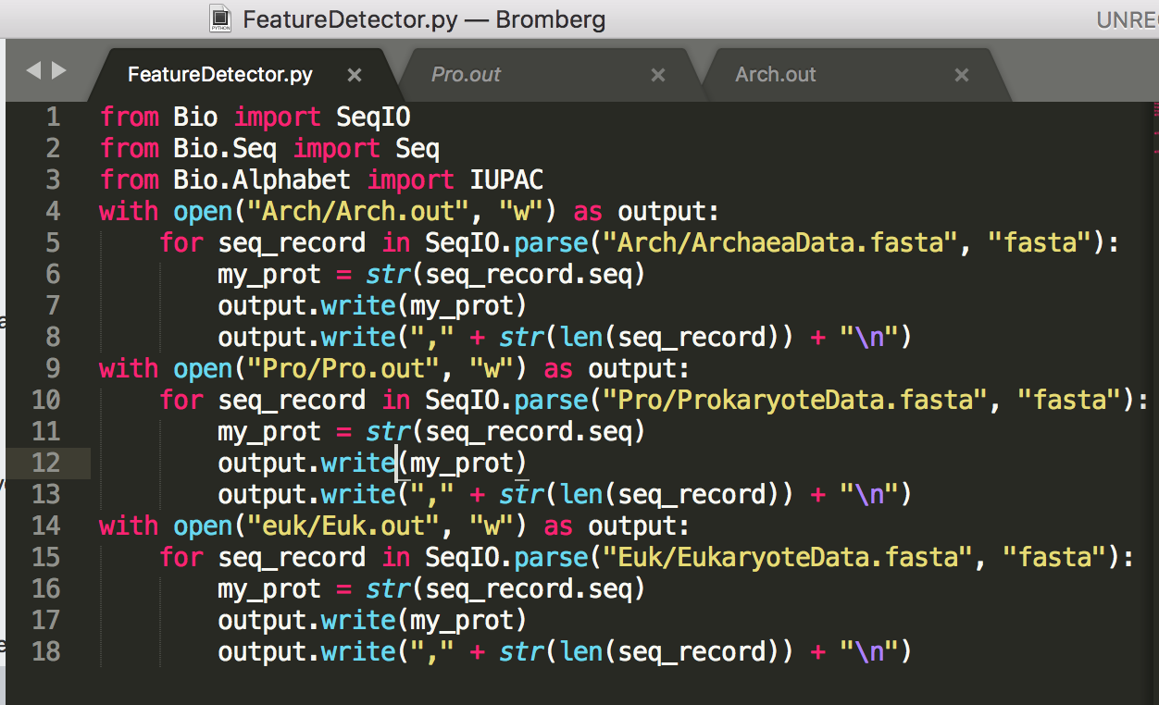

**3. Create a training set containing all features for both sets of sequences and a class label (0: prokaryotic, 1: eukaryotic)**

Yes: <https://github.com/RevanthK/ML-Protein-Classifier>

The prokaryotic training set is in Pro/Pro.csv

The Archaea training set is in Arch/Arch.csv

The eukaryotic training set is in Euk/Euk.csv

*the csv’s titled: “Arch_10.csv” just have 10% of the training data

**4. User weka to load this training set and**

1. **create a pipeline which uses 10-fold cross validation to train a model (appropriate for the input features)**

yes

**b) the pipeline should use a balancing filter to make sure the training dataset has an equal amount of class instances**

Using supervised class balancer filter

**c) report model performance**

=== Run information ===

Scheme: weka.classifiers.functions.MultilayerPerceptron -L 0.3 -M 0.2 -N 500 -V 0 -S 0 -E 20 -H a

Time taken to build model: 387.7 seconds

=== Stratified cross-validation ===

=== Summary ===

Correctly Classified Instances 127471.8658 83.9492 %

Incorrectly Classified Instances 24372.1342 16.0508 %

Kappa statistic 0.679

Mean absolute error 0.2094

Root mean squared error 0.3472

Relative absolute error 41.8857 %

Root relative squared error 69.4345 %

Total Number of Instances 151844

=== Detailed Accuracy By Class ===

TP Rate FP Rate Precision Recall F-Measure MCC ROC Area PRC Area Class

0.824 0.145 0.850 0.824 0.837 0.679 0.906 0.895 P

0.855 0.176 0.829 0.855 0.842 0.679 0.906 0.895 E

Weighted Avg. 0.839 0.161 0.840 0.839 0.839 0.679 0.906 0.895

=== Confusion Matrix ===

a b <-- classified as

62582.5 13339.5 | a = P

11032.63 64889.37 | b = E

**################################################################**

=== Run information ===

Scheme: weka.classifiers.trees.J48 -C 0.25 -M 2

Relation: compiled-weka.filters.supervised.instance.ClassBalancer-num-intervals10

Time taken to build model: 38.38 seconds

=== Stratified cross-validation ===

=== Summary ===

Correctly Classified Instances 123657.4438 81.4372 %

Incorrectly Classified Instances 28186.5562 18.5628 %

Kappa statistic 0.6287

Mean absolute error 0.1944

Root mean squared error 0.4266

Relative absolute error 38.8845 %

Root relative squared error 85.3236 %

Total Number of Instances 151844

=== Detailed Accuracy By Class ===

TP Rate FP Rate Precision Recall F-Measure MCC ROC Area PRC Area Class

0.716 0.088 0.891 0.716 0.794 0.641 0.816 0.785 P

0.912 0.284 0.763 0.912 0.831 0.641 0.816 0.746 E

Weighted Avg. 0.814 0.186 0.827 0.814 0.813 0.641 0.816 0.766

=== Confusion Matrix ===

a b <-- classified as

54393.93 21528.07 | a = P

6658.48 69263.52 | b = E

**################################################################**

Scheme: weka.classifiers.functions.Logistic -R 1.0E-8 -M -1 -num-decimal-places 4

Relation: compiled-weka.filters.supervised.instance.ClassBalancer-num-intervals10

Time taken to build model: 6.25 seconds

=== Stratified cross-validation ===

=== Summary ===

Correctly Classified Instances 123600.3662 81.3996 %

Incorrectly Classified Instances 28243.6338 18.6004 %

Kappa statistic 0.628

Mean absolute error 0.2845

Root mean squared error 0.3707

Relative absolute error 56.9097 %

Root relative squared error 74.1491 %

Total Number of Instances 151844

=== Detailed Accuracy By Class ===

TP Rate FP Rate Precision Recall F-Measure MCC ROC Area PRC Area Class

0.833 0.205 0.802 0.833 0.818 0.628 0.882 0.855 P

0.795 0.167 0.827 0.795 0.810 0.628 0.882 0.875 E

Weighted Avg. 0.814 0.186 0.814 0.814 0.814 0.628 0.882 0.865

=== Confusion Matrix ===

a b <-- classified as

63267.8 12654.2 | a = P

15589.44 60332.56 | b = E

**################################################################**

=== Run information ===

Scheme: weka.classifiers.meta.AdaBoostM1 -P 100 -S 1 -I 10 -W weka.classifiers.trees.DecisionStump

Relation: compiled-weka.filters.supervised.instance.ClassBalancer-num-intervals10

=== Detailed Accuracy By Class ===

TP Rate FP Rate Precision Recall F-Measure MCC ROC Area PRC Area Class

0.793 0.242 0.766 0.793 0.779 0.551 0.855 0.843 P

0.758 0.207 0.785 0.758 0.771 0.551 0.855 0.859 E

Weighted Avg. 0.775 0.225 0.776 0.775 0.775 0.551 0.855 0.851

=== Confusion Matrix ===

a b <-- classified as

60204.66 15717.34 | a = P

18386.14 57535.86 | b = E

**################################################################**

=== Run information ===

Scheme: weka.classifiers.functions.MultilayerPerceptron -L 0.3 -M 0.2 -N 100 -V 0 -S 0 -E 20 -H a -R

Relation: compiled-weka.filters.supervised.instance.ClassBalancer-num-intervals10

=== Stratified cross-validation ===

=== Summary ===

Correctly Classified Instances 126141.2437 83.0729 %

Incorrectly Classified Instances 25702.7563 16.9271 %

Kappa statistic 0.6615

Mean absolute error 0.2233

Root mean squared error 0.3545

Relative absolute error 44.657 %

Root relative squared error 70.8983 %

Total Number of Instances 151844

=== Detailed Accuracy By Class ===

TP Rate FP Rate Precision Recall F-Measure MCC ROC Area PRC Area Class

0.842 0.181 0.823 0.842 0.833 0.662 0.899 0.884 P

0.819 0.158 0.839 0.819 0.829 0.662 0.899 0.891 E

Weighted Avg. 0.831 0.169 0.831 0.831 0.831 0.662 0.899 0.887

=== Confusion Matrix ===

a b <-- classified as

63953.11 11968.89 | a = P

13733.86 62188.14 | b = E

**d) apply parameter optimization**