
CIVIC CONNECT
A Location-Aware Civic Issue Reporting and Resolution Mobile Application
Project Based Learning
IT4504 - Mobile Application Development
Submitted By
SANTHOSH KUMAR V - 24IT00142
&
REVANTH T - 24IT00127
in partial fulfillment for the award of the degree of
BACHELOR OF TECHNOLOGY
IN
INFORMATION TECHNOLOGY

DEPARTMENT OF INFORMATION TECHNOLOGY
CHENNAI INSTITUTE OF TECHNOLOGY
(Autonomous)
Sarathy Nagar, Kundrathur, Chennai-600069
SEPT – 2026
Vision of the Institute:
To be an eminent centre for Academia, Industry and Research by imparting knowledge, relevant practices and inculcating human values to address global challenges through novelty and sustainability.

Mission of the Institute:
IM1. To create next generation leaders by effective teaching learning methodologies and instill scientific spark in them to meet the global challenges.
IM2. To transform lives through deployment of emerging technology, novelty and sustainability.
IM3. To inculcate human values and ethical principles to cater the societal needs.
IM4. To contribute towards the research ecosystem by providing a suitable, effective platform for interaction between industry, academia and R&D establishments.
DEPARTMENT OF
INFORMATION TECHNOLOGY
Vision of the Department:
To excel in the emerging areas of Information Technology by imparting knowledge, relevant practices and inculcating human values to transform the students as potential resources to contribute innovatively through advanced computing in real time situations.

Mission of the Department:
DM1. To provide strong fundamentals and technical skills for Computer Science applications through effective teaching learning methodologies.
DM2. To transform lives of the students by nurturing ethical values, creativity and novelty to become Entrepreneurs and establish start-ups.
DM3. To habituate the students to focus on sustainable solutions to improve the quality of life and the welfare of the society.
DM4. To enhance the fabric of research in computing through collaborative linkages with industry and academia.
DM5. To include learning of the emerging technologies to pursue higher studies leading to lifelong learning.

BONAFIDE CERTIFICATE
This is to certify that the Project–Based Learning report titled “CIVIC CONNECT” is a Bonafide record of work carried out by SANTHOSH KUMAR V (24IT00142), REVANTH T (24IT00127) of the Department of Information Technology, Chennai Institute of Technology, as part of the continuous, mentor–guided Project-Based Learning (PBL) component of the Mobile Application Development course during the academic year 2026–2027. This report reflects the team's work across the PBL review cycles, not a single end-of-term submission.

Faculty Mentor  Mr. VASANTH RAO  Assistant Professor | Head of the Department  Dr. A.R. KAVITHA  Professor
Date:

Submitted for the PBL evaluation held on ……………………….

Faculty Mentor: ____________________ | PBL In–charge: ____________________
DECLARATION
We declare that this Project-Based Learning report titled “CIVIC CONNECT” reflects our own work carried out under the mentorship of Mr. VASANTH RAO across the PBL review cycle. All sources of information used have been duly acknowledged and cited.

Team Members:
SANTHOSH KUMAR V (24IT00142)
REVANTH T (24IT00127)
PBL COURSE AND TEAM DETAILS
Field | Details
Course | Mobile Application Development (IT4504) — Project-Based Learning (PBL)
Faculty Mentor | Mr. Vasanth Rao, Assistant Professor
Section / Team No. | [IT-B]
PBL Duration | 12 weeks
Project Track / Domain | Smart Infrastructure (Civic Technology)

Team Roles and Responsibilities
Name | Register No. | Role | Primary Responsibility
SANTHOSH KUMAR V | 24IT00142 | Backend & Database Lead | FastAPI services, PostGIS schema, routing, duplicate and SLA engines, API testing
REVANTH T | 24IT00127 | Mobile App & Documentation Lead | Flutter screens, state management, API integration, report and diagrams
ACKNOWLEDGEMENT
We would like to thank Mr. Vasanth Rao, Assistant Professor, Department of Information Technology, for mentoring this project across every review cycle of the PBL — from shaping our driving question in the early weeks to pushing us to test the complete application properly before submission. The feedback we got after each review changed the direction of our work more than once, and the project is better for it. We are also very much grateful to Dr. A.R. Kavitha, M.E., Ph.D., Head of the Department, for supporting the PBL structure itself, which gave us room to build something iteratively instead of rushing a single final version.
TABLE OF CONTENTS
Section | Title
Chapter 1 | Introduction
1.1 | Project Overview
1.2 | Problem Statement
1.3 | Objectives
1.4 | Scope of the Project
Chapter 2 | Literature Survey
2.1 | Related Existing Projects
2.2 | Review of Existing Technologies
2.3 | Comparison of Existing Systems
Chapter 3 | Existing System
3.1 | Description
3.2 | Drawbacks and Limitations
Chapter 4 | Proposed System
4.1 | Proposed Solution
4.2 | Features
4.3 | Advantages
Chapter 5 | System Design
5.1 | System Architecture / Block Diagram
5.1.1 | Physical Design
5.1.2 | Logical Design
5.2 | Working Principle
5.3 | UML / Use Case Diagram
5.4 | Flowchart
Chapter 6 | Development Tools and Technologies
6.1–6.7 | Platform, Language, UI, Database, Backend, Device, Tools
Chapter 7 | Software Implementation
7.1–7.4 | Requirements, Program, Database, API
Chapter 8 | Mobile Application Implementation
8.1–8.5 | Setup, Integration, Prototype, Working, Screenshots
Chapter 9 | Testing and Results
9.1–9.5 | Testing, Test Cases, Results, Output, Performance
Chapter 10 | Applications
Chapter 11 | Advantages and Limitations
Chapter 12 | Conclusion and Future Scope
Chapter 13 | References
Appendix | Supporting Project Material

ABSTRACT
Civic problems such as potholes, overflowing garbage bins, broken streetlights, open manholes and water pipeline leaks are usually reported through helplines, paper petitions or scattered online portals. Citizens rarely know which department is responsible, complaints arrive without precise locations or photos, the same problem is reported many times, and there is no clear deadline or proof that the work was done. This project presents Civic Connect, a mobile application that digitizes the complete civic issue lifecycle for three roles: Citizen, Department Officer and Field Worker.
The mobile client is developed using Flutter (Dart) with Provider for state management and flutter_map with OpenStreetMap for maps, and communicates through REST APIs with a Python FastAPI backend. Data is stored in Supabase PostgreSQL with the PostGIS spatial extension, and photos are stored in Supabase Storage. A citizen selects a category, pins the location on a map, attaches a photo and submits the report. The backend automatically resolves the ward, zone and authority, routes the report to the responsible department, assigns a Service Level Agreement (SLA) deadline and checks for duplicate reports within a category-specific radius. The officer triages and assigns the report, the field worker submits before and after photo proof, and the citizen verifies whether the issue was actually fixed; a negative response reopens the ticket. Every step is written to an immutable timeline.
The work shows that a location-aware, role-based mobile application can make civic issue reporting faster, route it to the right department without any knowledge of government structure, and make resolution more transparent and accountable.
Keywords: Civic Issue Reporting, Flutter, FastAPI, PostGIS, Geo-routing, SLA, Citizen Verification
LIST OF ABBREVIATIONS
Abbreviation | Expansion
API | Application Programming Interface
APK | Android Package
CRUD | Create, Read, Update, Delete
DTO | Data Transfer Object
GCC | Greater Chennai Corporation
GIS | Geographic Information System
GPS | Global Positioning System
HTTP | Hypertext Transfer Protocol
JSON | JavaScript Object Notation
OSM | OpenStreetMap
PBL | Project-Based Learning
PostGIS | Spatial database extension for PostgreSQL
REST | Representational State Transfer
SDK | Software Development Kit
SLA | Service Level Agreement
SQL | Structured Query Language
SRID | Spatial Reference System Identifier
UI/UX | User Interface / User Experience
UML | Unified Modeling Language
UUID | Universally Unique Identifier

CHAPTER 1
INTRODUCTION

1.1 Project Overview
Civic Connect is a mobile application that connects citizens directly with the government departments responsible for public infrastructure. When a citizen notices a civic problem — a pothole, an overflowing dumpster, a non-working streetlight, a clogged drain, a pipeline leak or a fallen tree — they can report it in a few steps from their phone. The application captures the exact GPS location, a photo and a short description, and the system takes care of everything else.
The system works with three roles. The Citizen reports issues, tracks them on a map and in a timeline, upvotes existing reports and finally verifies whether the repair was done. The Department Officer sees a command center with open, in-progress and overdue reports, acknowledges them and assigns them to field teams. The Field Worker sees assigned work orders, navigates to the site, starts work and submits before and after photo proof.
The core principle is “zero department knowledge required”. The backend automatically translates the location into the ward, zone and authority, routes the report to the correct department, assigns an SLA deadline based on the issue type and checks for nearby duplicates. The mobile application is built with Flutter and communicates through REST APIs with a Python FastAPI backend, and all data is stored in a Supabase PostgreSQL database with the PostGIS extension.
The overall flow of the system is: Citizen → Report (category, GPS, photo) → Duplicate Check → Ward & Department Routing → SLA Assignment → Officer Triage → Field Worker Repair → Photo Proof → Citizen Verification → Resolved / Reopened.

1.2 Problem Statement
Traditional civic complaint handling suffers from the following problems: (i) citizens do not know which authority or department is responsible for a location; (ii) complaints are made through helplines and portals that do not capture precise location or photo evidence; (iii) the same visible problem is reported many times, creating duplicate work; (iv) there is no deadline and no visible progress, so complaints disappear without updates; (v) an official can close a complaint even if the work was done poorly; and (vi) city leaders get no consolidated view of which wards or departments are failing. There is therefore a need for a location-aware, role-based mobile application that routes each report to the right department automatically, prevents duplicates, tracks deadlines and lets the citizen confirm the fix.

1.3 Objectives
- To design a cross-platform mobile application with separate interfaces for Citizen, Department Officer and Field Worker.
- To provide a guided reporting flow with category selection, map-based location, photo evidence and description.
- To automatically resolve the ward, zone and authority of a report from its GPS coordinates using PostGIS.
- To route every report to the responsible department using configurable routing rules.
- To detect nearby duplicate reports and allow citizens to upvote an existing report instead of creating a new one.
- To assign an SLA deadline to every report and show its SLA status (within SLA, due soon, overdue).
- To allow officers to acknowledge and assign reports and field workers to submit before/after photo proof.
- To close the loop through citizen verification, reopening the ticket when the issue is not fixed.
- To record every status change in an immutable timeline and provide an interactive civic map and analytics.

1.4 Scope of the Project
In scope: a Flutter mobile application with role-based screens; FastAPI REST APIs; Supabase PostgreSQL with PostGIS; Supabase Storage for photos; guided report submission; reverse geocoding; automatic ward and department routing; duplicate detection and upvoting; SLA assignment and tracking; civic map; officer triage and assignment; field worker resolution with photo proof; citizen verification; report timeline; and an analytics overview.
Target users: Citizens (residents, commuters, shop owners), Department Officers (ward and department engineers) and Field Workers (road crews, electricians, sanitation and water teams). The system is demonstrated with sample data for the Greater Chennai Corporation — three zones, four wards, six departments and six issue categories.
Out of scope (in this version): production authentication with OTP, push notifications, offline mode for field workers, automatic escalation and auto-closure timers, administrator configuration screens and integration with existing government grievance systems.

CHAPTER 2
LITERATURE SURVEY

2.1 Related Existing Projects
Civic complaint handling has been implemented in several forms. They can be grouped into three categories.
(a) Helplines and manual complaint registers. Most municipal bodies accept complaints over the phone, at ward offices or through letters to elected representatives. These need no technology from the citizen, but complaints lack precise location and photos, and progress cannot be tracked.
(b) Municipal web portals and grievance apps. Many city corporations and state governments provide online portals or apps where citizens select a department and type a complaint. They improve record keeping, but usually expect the citizen to choose the correct department and offer limited status updates or feedback on resolution.
(c) Map-based civic reporting platforms. Platforms such as FixMyStreet (mySociety) allow citizens to place a pin on a map, automatically determine the responsible authority from the location and category, publish reports publicly and detect possible duplicates. Authorities can receive reports by e-mail or through the Open311 standard. Civic Connect takes this model as a reference and adds SLA tracking, a dedicated field worker module and citizen verification in a single mobile application.

2.2 Review of Existing Technologies
- Cross-platform mobile frameworks. Flutter compiles a single Dart code base into Android, iOS and web applications with its own rendering engine, giving a consistent UI on every platform and faster development than separate native apps.
- State management. The Provider package with a ChangeNotifier lets screens rebuild automatically when shared state (logged-in role, active tab, selected report) changes.
- Maps. flutter_map with OpenStreetMap tiles provides interactive maps without paid API keys, and latlong2 handles coordinates.
- Backend frameworks. FastAPI is a Python framework for building REST APIs with automatic request validation (Pydantic) and interactive API documentation.
- Spatial databases. PostgreSQL with the PostGIS extension stores locations as geography points and provides functions such as ST_Distance and ST_DWithin for accurate distance and radius queries in metres.
- Cloud backend services. Supabase provides a hosted PostgreSQL database and object storage for uploaded photos.
- Geocoding. The OpenStreetMap Nominatim service converts coordinates into a readable street address.

2.3 Comparison of Existing Systems
Table 2.1: Comparison of Existing Systems
Feature | Helpline / manual | Municipal web portal | Map-based platform | Proposed Civic Connect
Mobile application | No | Sometimes | Yes | Yes (Flutter)
Automatic department routing | No | Rarely | Yes | Yes (ward + category)
GPS location and photo | No | Limited | Yes | Yes
Duplicate detection | No | No | Sometimes | Yes (PostGIS radius)
SLA deadline tracking | No | Limited | Rarely | Yes
Field worker module | No | No | Rarely | Yes
Public status timeline | No | Limited | Yes | Yes
Citizen verification of fix | No | No | Rarely | Yes
Analytics dashboard | No | Sometimes | Limited | Yes

CHAPTER 3
EXISTING SYSTEM

3.1 Description
In the existing arrangement, which is typical of most Indian cities, a citizen who notices a civic problem must first find out where to complain. They may call a corporation helpline, visit the ward office, post on social media, or use a web portal where they select a department and type a description such as “streetlight not working near the temple”. The complaint is registered with a number, if at all, and forwarded manually to the concerned section.
Inside the department, complaints from different channels are collected and sorted by staff. Engineers have to locate the problem from the text description, often by calling the complainant again. Repeated complaints about the same problem are recorded separately. When the work is done, the official marks the complaint as closed; the citizen is rarely informed and has no way to confirm whether the repair was actually carried out properly.

3.2 Drawbacks and Limitations
- Citizens must know which department or authority is responsible, which most people do not.
- Complaints lack precise GPS location and photo evidence, so field crews waste time locating the problem.
- The same problem generates many duplicate complaints and work orders.
- There is no deadline or SLA, and no visible progress or timeline for the citizen.
- Complaints can be closed by the department without any proof or citizen confirmation.
- Field workers have no dedicated tool to receive tasks and submit proof of work.
- Management cannot obtain quick statistics on overdue reports, wards or departments.

CHAPTER 4
PROPOSED SYSTEM

4.1 Proposed Solution
The proposed solution is Civic Connect, a role-based mobile application supported by a location-aware backend. The citizen opens the app, chooses a category and sub-category, pins the location on the map (the address is filled in automatically), attaches a photo and submits. Before submission the app checks for similar open reports nearby; if one exists, the citizen can upvote it instead of filing a duplicate.
On submission the backend finds the nearest ward and its zone and authority, looks up the routing rules to choose the department, reads the SLA hours and priority of the sub-category, stores the report with a PostGIS point and returns a tracking ID such as CC-2026-01846. The officer sees the report in the command center, acknowledges it and assigns a field team. The field worker starts work and submits resolution notes with before and after photos. The citizen then answers “Was the problem actually fixed?” — Yes marks it RESOLVED, No marks it REOPENED and sends it back to the officer.
The system has three layers: the Flutter mobile client, the FastAPI REST API layer with its service engines, and the Supabase PostgreSQL + PostGIS database with Supabase Storage for photos.

4.2 Features
Common: role-based login and navigation, civic map, report detail with photos and timeline, SLA status badges, logout.
Citizen: guided report wizard; map-based location with reverse geocoding; camera or gallery photo; duplicate check and upvote; nearby reports feed; track status; verify or reopen a resolution.
Department Officer: command center with total, in-progress, overdue and compliance tiles; filtered triage queue; acknowledge report; assign to field team; inspect details.
Field Worker: assigned work orders queue; navigate to site; start work; submit resolution proof with before and after photos and notes.
System (automatic): ward, zone and authority resolution; department routing; SLA assignment; duplicate detection; timeline entry for every status change; analytics overview.

4.3 Advantages
- Citizens can report an issue without knowing government structure.
- Every report has a precise location, photo evidence and a responsible department.
- Duplicate detection turns repeated complaints into upvotes on one work order.
- SLA deadlines and overdue indicators make departments accountable.
- Field workers receive tasks and submit photo proof from the same app.
- Citizen verification ensures a ticket is closed only when the problem is really fixed.
- A single Flutter code base serves Android, iOS and web.

CHAPTER 5
SYSTEM DESIGN

5.1 System Architecture / Block Diagram
The user interacts with the Flutter application through its role-based screens. The application sends REST requests (JSON over HTTP) to the FastAPI backend. The backend applies the business rules through its service engines, reads or writes the Supabase PostgreSQL database using SQL and PostGIS functions, stores photos in Supabase Storage, and returns the result to be displayed on the screen.
Figure 5.1: System Architecture / Block Diagram
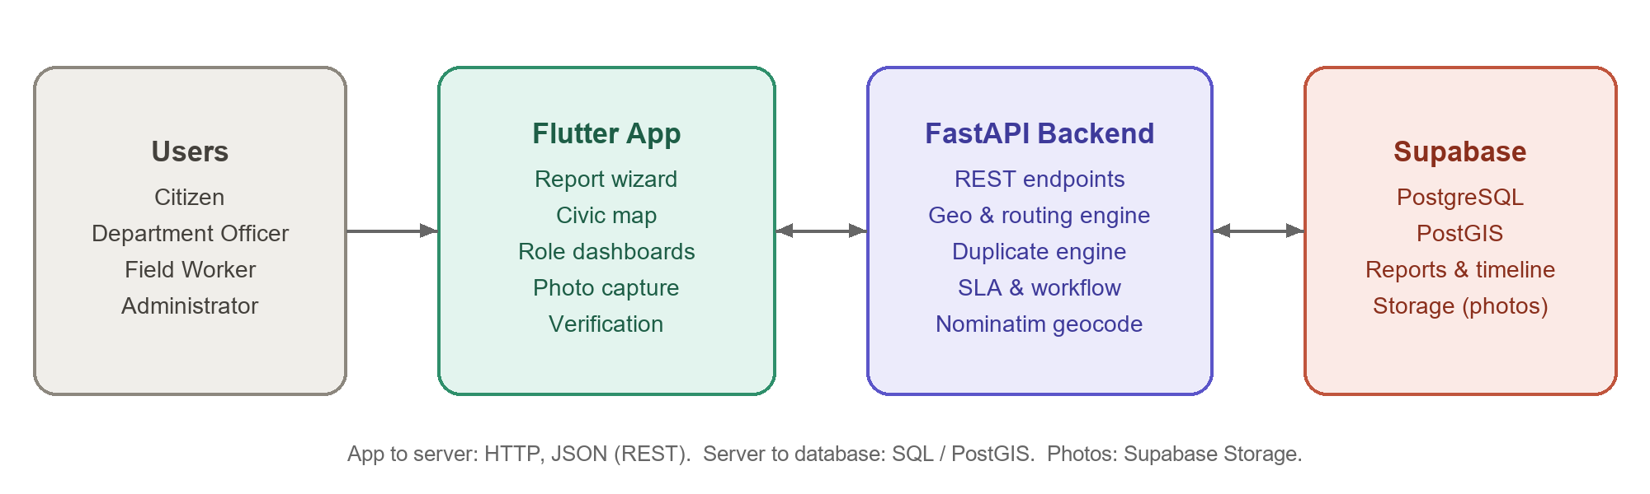
5.1.1 Physical Design
The physical design shows the devices and services used to run the application: an Android/iOS phone or a web browser running the Flutter application, the machine running the FastAPI server with Uvicorn, and the Supabase cloud project that hosts the PostgreSQL database with PostGIS and the storage bucket for photos. During development the backend ran on the development laptop and connected to the hosted Supabase database.
Figure 5.1.1: Physical Design
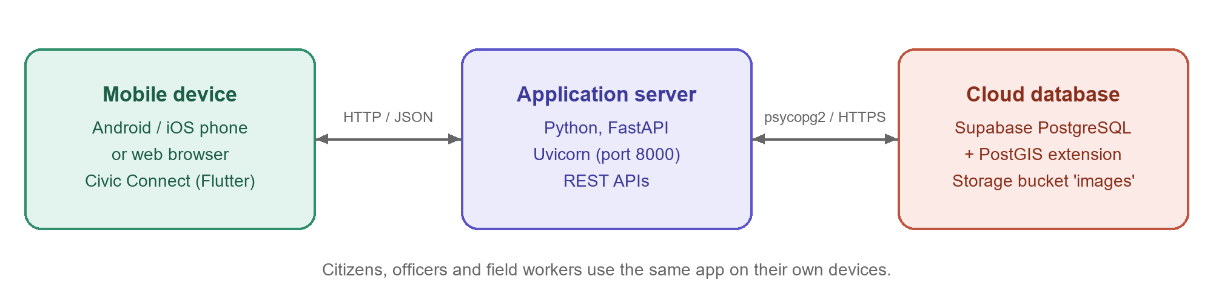
5.1.2 Logical Design
The logical design divides Civic Connect into layers and shows how they interact: User → Mobile App → API Layer → Service Engines → Database → Result.
Figure 5.1.2: Logical Design
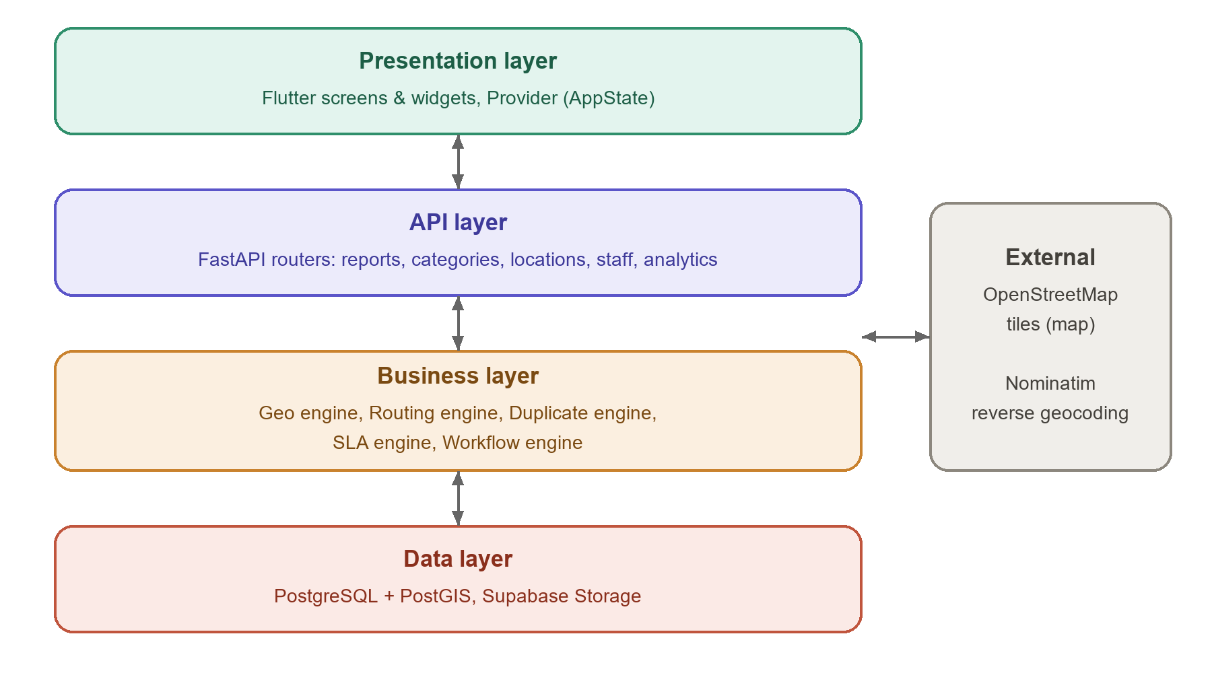

5.2 Working Principle
The application opens with the role-based sign-in screen, and each role is taken to its own home: the citizen home feed, the authority command center or the field operations screen. A citizen starts the report wizard, selects a category and problem type, pins the location (the backend reverse geocodes it to an address and ward), attaches a photo and enters a title and description. Before submitting, the app calls the duplicate check; nearby open reports of the same category are shown with their distance, and the citizen may upvote one instead.
When submitted, the backend creates the report with status SUBMITTED, routes it to a department, sets the SLA deadline and changes the status to ROUTED, writing both events to the timeline. The officer acknowledges and assigns it (ASSIGNED), the field worker starts work (IN_PROGRESS) and submits proof (RESOLUTION_SUBMITTED). The citizen then verifies it as RESOLVED or REOPENED. The status lifecycle and sample SLA policy are shown in Tables 5.1 and 5.2.
Basic Working Flow: Start → Sign in → Role Home → Report Wizard → Duplicate Check → Submit → Routing & SLA → Triage & Assign → Repair & Proof → Verification → End
Table 5.1: Report Status Lifecycle
Status | Meaning | Triggered By
SUBMITTED | Report filed by citizen | Citizen
ROUTED | Ward resolved and department assigned | System (automatic)
ACKNOWLEDGED | Officer has reviewed the report | Department Officer
ASSIGNED | Allocated to a field team | Department Officer
IN_PROGRESS | Work started on site | Field Worker
RESOLUTION_SUBMITTED | Repair completed with photo proof | Field Worker
RESOLVED | Citizen confirmed the issue is fixed | Citizen
REOPENED | Citizen reported the issue still exists | Citizen
Table 5.2: Sample SLA Policy (from seeded data)
Category | Sub-category | Priority | SLA
Roads & Footpaths | Open Manhole / Missing Cover | CRITICAL | 4 hours
Roads & Footpaths | Pothole on Carriageway | HIGH | 24 hours
Waste Management | Dumpster Overflowing | HIGH | 12 hours
Street Lighting | Exposed Wiring / Shock Hazard | CRITICAL | 6 hours
Street Lighting | Streetlight Completely Off | MEDIUM | 48 hours
Drainage & Floods | Sewage Overflow on Street | CRITICAL | 12 hours
Water Supply | Main Pipeline Burst / Major Leak | CRITICAL | 8 hours
Public Safety & Trees | Fallen Tree Blocking Road | HIGH | 6 hours

5.3 UML / Use Case Diagram
Figure 5.3: Use Case Diagram
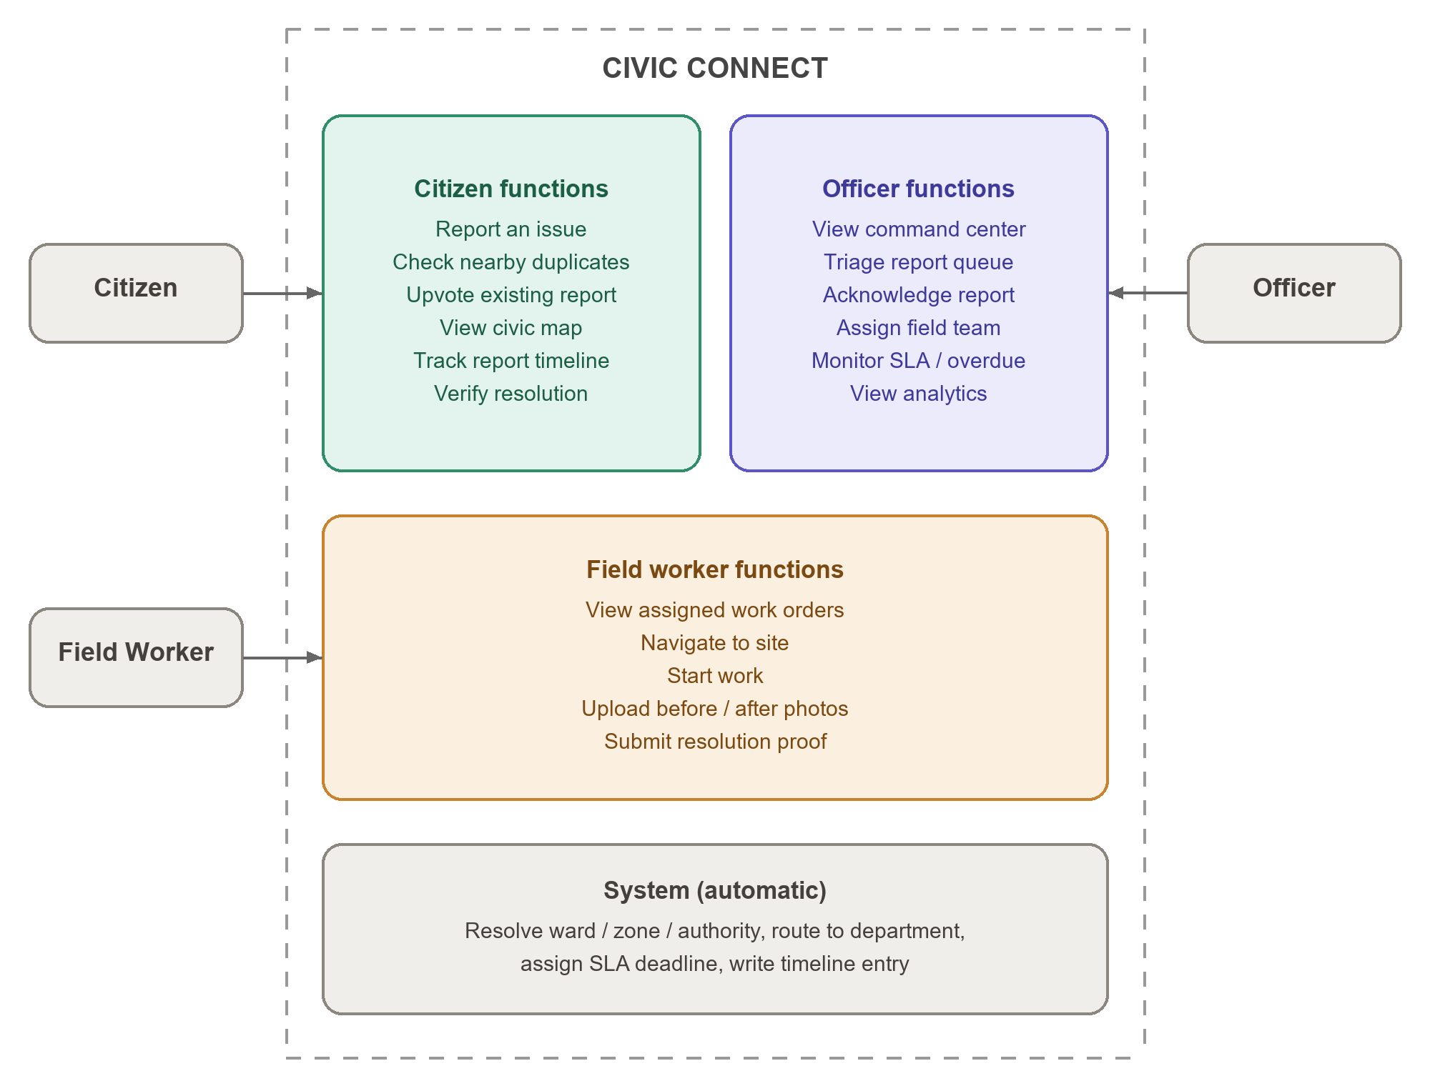

5.4 Flowchart
Figure 5.4: Flowchart
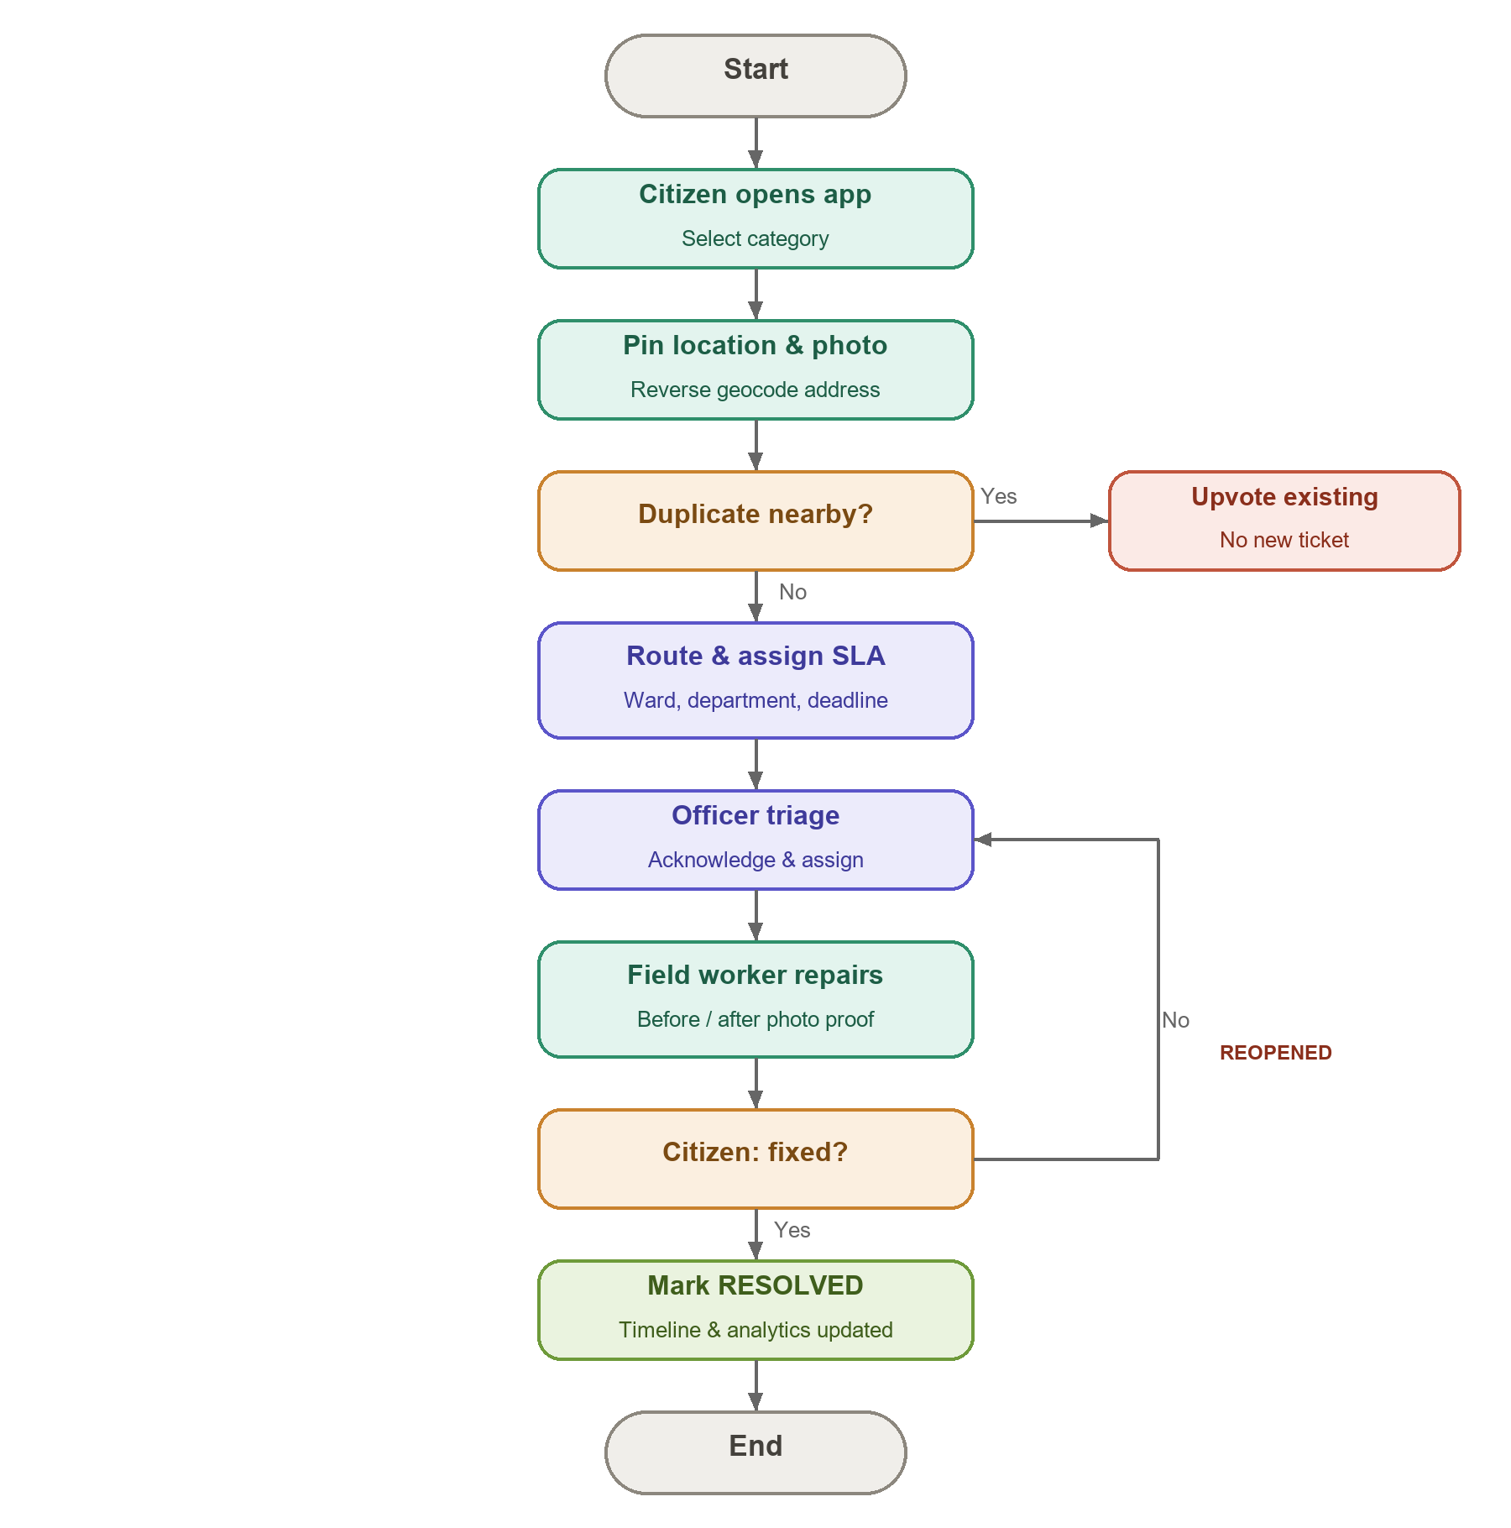
Simple Flow: Start → Select Category → Pin Location & Photo → Duplicate? (Yes: Upvote) → Route & Assign SLA → Officer Triage → Field Repair → Citizen Verification (No: Reopen) → Resolved → End

CHAPTER 6
DEVELOPMENT TOOLS AND TECHNOLOGIES

6.1 Mobile Application Development Platform
The mobile application is developed using Flutter. Flutter builds the interface from its own widget library and compiles one Dart code base for Android, iOS and the web. Visual Studio Code is the code editor and Android Studio provides the Android SDK and emulator. Navigation between screens is handled by the application state (AppState) together with a role-based bottom NavigationBar.

6.2 Programming Language
- Frontend: Dart with the Flutter framework.
- Backend: Python with the FastAPI framework, used for REST APIs, business logic and database access.
- Database language: SQL with PostGIS spatial functions for PostgreSQL.

6.3 User Interface Design
The interface is built with Flutter Material widgets such as Scaffold, NavigationBar, Card, ListView, TextField, ElevatedButton and showDialog, together with flutter_map for maps. The app uses a high-contrast dark theme with near-square (4 px) corners and Google Fonts so that it stays readable outdoors in direct sunlight. Status badges use consistent colours for each report status and SLA state.

6.4 Database
Supabase PostgreSQL with the PostGIS and uuid-ossp extensions is the database. It stores authorities, zones, wards, departments, users, categories, sub-categories, routing rules, reports, report media, the report timeline and subscriptions. Report locations are stored as geography points (SRID 4326) with a GIST spatial index. Queries are written in SQL and executed from Python using psycopg2.

6.5 API / Backend Services
The backend is a FastAPI application running on Uvicorn. It exposes REST APIs that exchange JSON, validates request bodies with Pydantic models, and contains five service engines: geo, routing, duplicate, SLA and workflow. Photos are uploaded from the app as base64 and stored in the Supabase Storage bucket images. FastAPI's built-in Swagger UI (/docs) is used to try the endpoints.

6.6 Development Device / Emulator
The application is run on the Android Emulator in Android Studio, a physical Android phone, and the Chrome browser (Flutter web build) during development.
Table 6.1: Hardware and Software Requirements for Application Development
Item | Requirement
Processor / RAM | AMD Ryzen 5 7535HS, 16 GB RAM
Operating system | Windows 11
Mobile device | Android emulator / physical Android phone / Chrome (web)
Flutter SDK | Flutter 3.38 (stable), Dart 3.10
Python | Python 3.13
Database | Supabase PostgreSQL with PostGIS

6.7 Other Tools and Libraries
Table 6.2: Software Development Tools and Technologies
Tool / Technology | Purpose
Flutter / Dart | Cross-platform mobile UI
provider | State management
flutter_map, latlong2 | Interactive OpenStreetMap maps
image_picker, file_picker | Camera and gallery photo capture
http, cached_network_image | REST calls and image caching
google_fonts, intl | Typography and date formatting
Python + FastAPI + Uvicorn | Backend REST API server
psycopg2, httpx, Pydantic | Database access, geocoding calls, validation
Supabase (PostgreSQL + PostGIS) | Database and spatial queries
Supabase Storage | Photo storage
OpenStreetMap Nominatim | Reverse geocoding
Visual Studio Code / Android Studio | Code editor, Android SDK and emulator

CHAPTER 7
SOFTWARE IMPLEMENTATION

7.1 Software Requirements
Operating system: Windows 11. Flutter SDK 3.38 with Dart 3.10; Android Studio with Android SDK and emulator; Google Chrome for the web build; Python 3.13 with fastapi, uvicorn, psycopg2, httpx and pydantic; a Supabase project with the PostGIS extension enabled and a public storage bucket named images; Visual Studio Code; Git.

7.2 Mobile Application Program
The Flutter program is organised by feature under lib/features, with shared code under lib/core (constants, models, state, API service, theme) and lib/shared (common widgets).
Table 7.1: Mobile Application Modules and Their Functionalities
Module | Functionality
Authentication (auth_screen) | Sign-in with name, password and role; quick demo profiles for Citizen, Officer and Field Staff
Home (home_screen) | Citizen feed: report shortcut, quick categories, ward statistics and nearby reports
Report Wizard (report_wizard_screen) | 5-step flow: category, location, photo evidence, details, duplicate check and submit
Explore Map (explore_map_screen) | OpenStreetMap view with status-coloured markers and filters
Report Detail (report_detail_screen) | Photos, SLA status, citizen verification and audit timeline
Authority (authority_dashboard_screen) | Command center tiles, triage queue, acknowledge and assign
Field Worker (field_worker_screen) | Work order queue, navigate, start work, submit resolution proof
Core (app_state, api_service, models) | Shared state, REST calls and JSON model classes

7.3 Database Tables / Data Entities
Table 7.2: Database Tables / Data Entities
Table (entity) | Main fields | Purpose
authorities, zones, wards | id, name, zone_number, ward_number, center_lat, center_lng | Administrative hierarchy
departments | id, authority_id, code, name, email, head_officer_name | Responsible departments
users | id, full_name, email, phone, role, department_id, ward_id | Citizens, officers, workers, admin
categories, subcategories | code, name, sla_hours, priority_level, duplicate_radius_meters | Issue taxonomy and SLA
routing_rules | category_id, ward_id, department_id, priority, active | Category → department mapping
reports | public_id, title, status, priority, location, sla_deadline, assigned_team, upvotes, citizen_verified | Core report record
report_media | report_id, url, stage, is_resolution_proof | Evidence and proof photos
report_timeline | report_id, actor_name, event_type, old_status, new_status, notes | Immutable audit history
report_subscriptions | report_id, user_id | Followers of a report

7.4 API / Web Service Details
Table 7.3: API / Web Service Details (prefix /api/v1)
Purpose | Method | Endpoint | Used by
List categories | GET | /categories | Citizen
Reverse geocode | GET | /locations/reverse-geocode | Citizen
Upload photo | POST | /reports/upload-image | Citizen, Field Worker
Check duplicates | GET | /reports/duplicates | Citizen
Create report | POST | /reports | Citizen
List / filter reports | GET | /reports | All roles
Report detail | GET | /reports/{id} | All roles
Update status | POST | /reports/{id}/status | Officer, Field Worker
Assign report | POST | /reports/{id}/assign | Officer
Submit resolution | POST | /reports/{id}/resolve | Field Worker
Verify resolution | POST | /reports/{id}/verify | Citizen
Upvote report | POST | /reports/{id}/upvote | Citizen
Analytics overview | GET | /analytics/overview | Officer
Departments / wards / workers | GET | /departments, /wards, /workers | Officer

CHAPTER 8
MOBILE APPLICATION IMPLEMENTATION

8.1 Application Setup and Configuration
The Flutter project was created and the required packages (provider, http, flutter_map, latlong2, image_picker, file_picker, cached_network_image, google_fonts, intl) were added in pubspec.yaml and installed with flutter pub get. The Android SDK and emulator were configured in Android Studio. On the server side, a Python FastAPI project was created with separate folders for API routers, core configuration and service engines. The Supabase database was initialised with the schema script (init_db.py), which enables PostGIS and creates all tables and indexes, and filled with realistic Chennai data using seed_data.py. The mobile application is configured with the base URL of the backend in api_constants.dart.

8.2 Module Integration
The category and location modules were integrated first: the report wizard loads categories from the API and calls the reverse-geocode endpoint whenever the map pin moves. Photo capture was then connected to the upload endpoint, which stores the image in Supabase Storage and returns its public URL. The duplicate check and report creation endpoints complete the citizen flow. The authority dashboard reads the analytics overview and the report list, and calls the status and assign endpoints. The field worker screen calls the resolve endpoint with before and after photos. Finally, the report detail screen reads the full report with media and timeline, and calls the verify endpoint for the citizen decision.

8.3 Prototype Development
Before final coding, the main screens were planned as a prototype covering sign-in, citizen home, the five-step report wizard, the civic map, report detail with timeline, the authority command center and the field worker queue. The prototype fixed the dark, high-contrast visual style and the role-based bottom navigation used in the final application.

8.4 Working of the Mobile Application
- The user opens Civic Connect and signs in, choosing the role (Citizen, Officer or Field Staff).
- Citizen: the home screen shows ward statistics and nearby reports. Tapping “Report an Issue” opens the wizard.
- The citizen selects a category and problem type, pins the location on the map (address and ward are filled automatically), attaches a photo and adds details.
- The app checks for nearby duplicates. If one exists, the citizen can upvote it; otherwise the report is submitted and a tracking ID is shown.
- Officer: the command center shows total, in-progress, overdue and compliance figures and the report queue. The officer acknowledges a report and assigns it to a field team.
- Field Worker: the work order queue shows assigned tasks; the worker navigates to the site, starts work and submits resolution notes with before and after photos.
- The citizen opens the report, sees the proof photos and timeline, and taps “Yes, Fixed” or “Still Exists”.
- The report becomes RESOLVED or REOPENED, the timeline and statistics are updated, and the user can sign out.

8.5 Screenshots
The following screenshots were captured from the running application connected to the live backend and database.
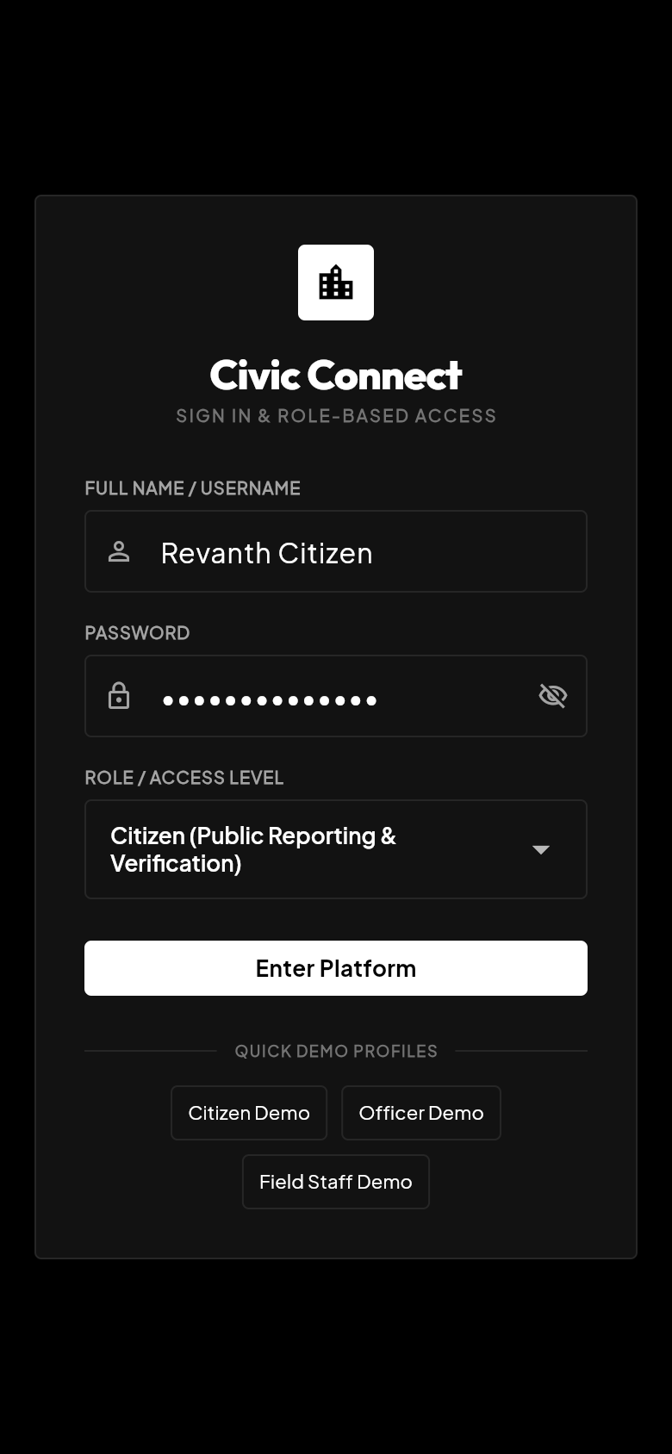  8.5(a) Sign-in screen | 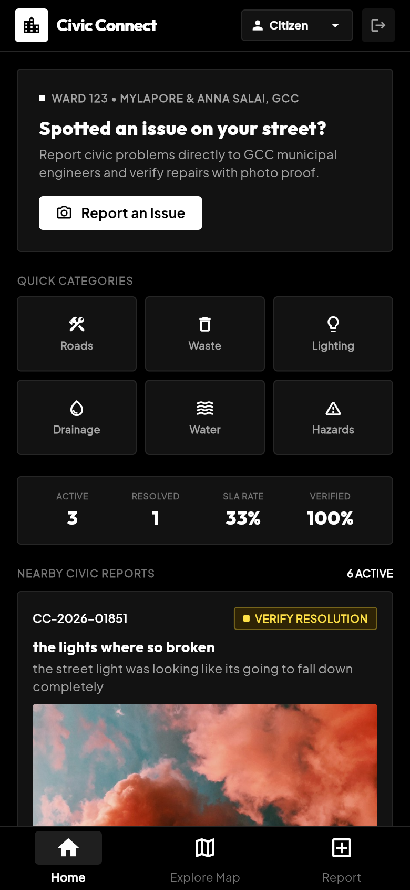  8.5(b) Citizen home | 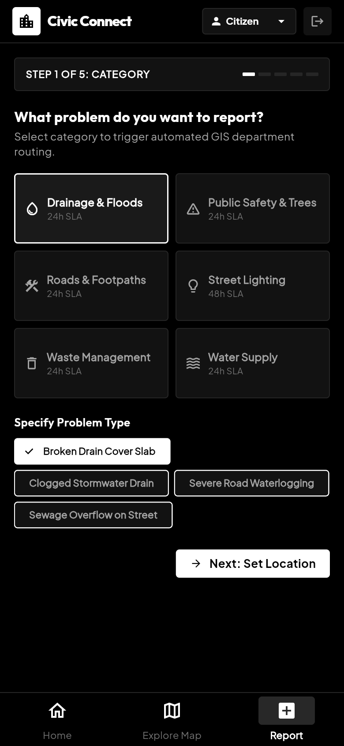  8.5(c) Wizard – category
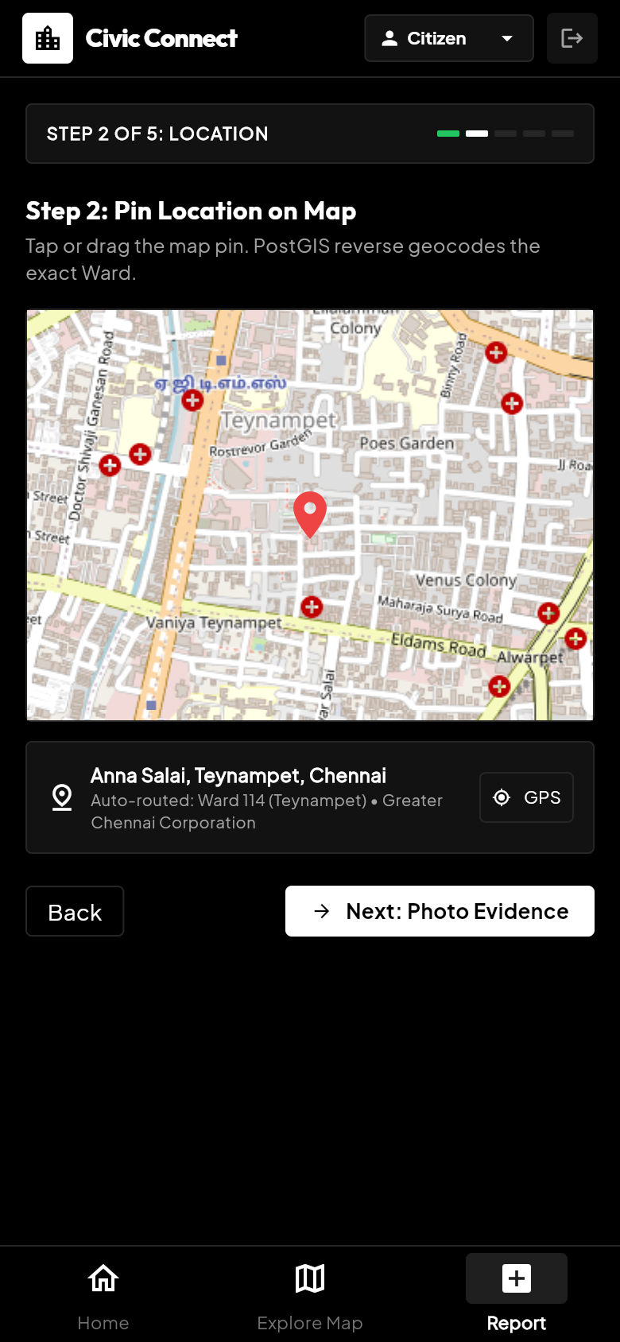  8.5(d) Wizard – location | 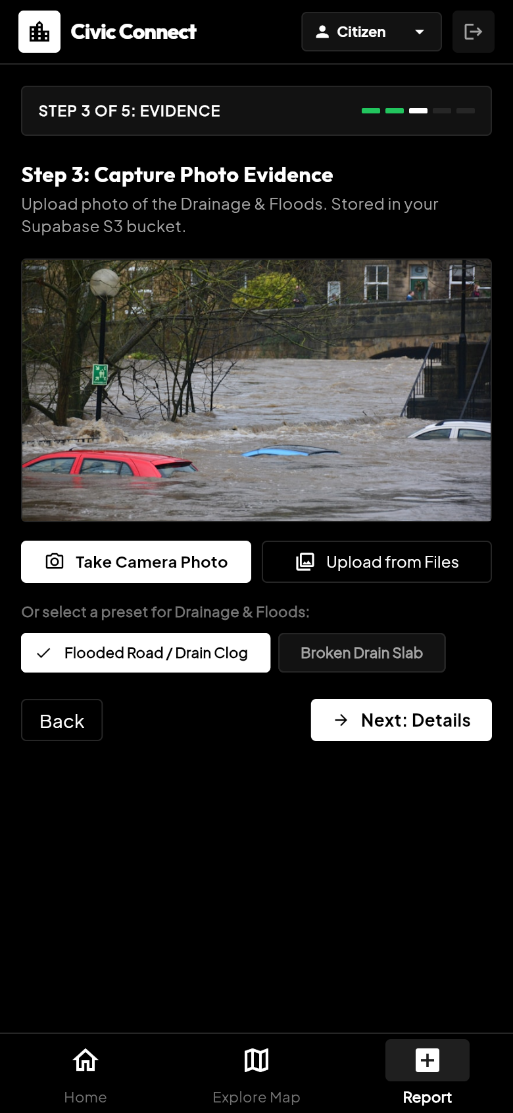  8.5(e) Wizard – photo evidence | 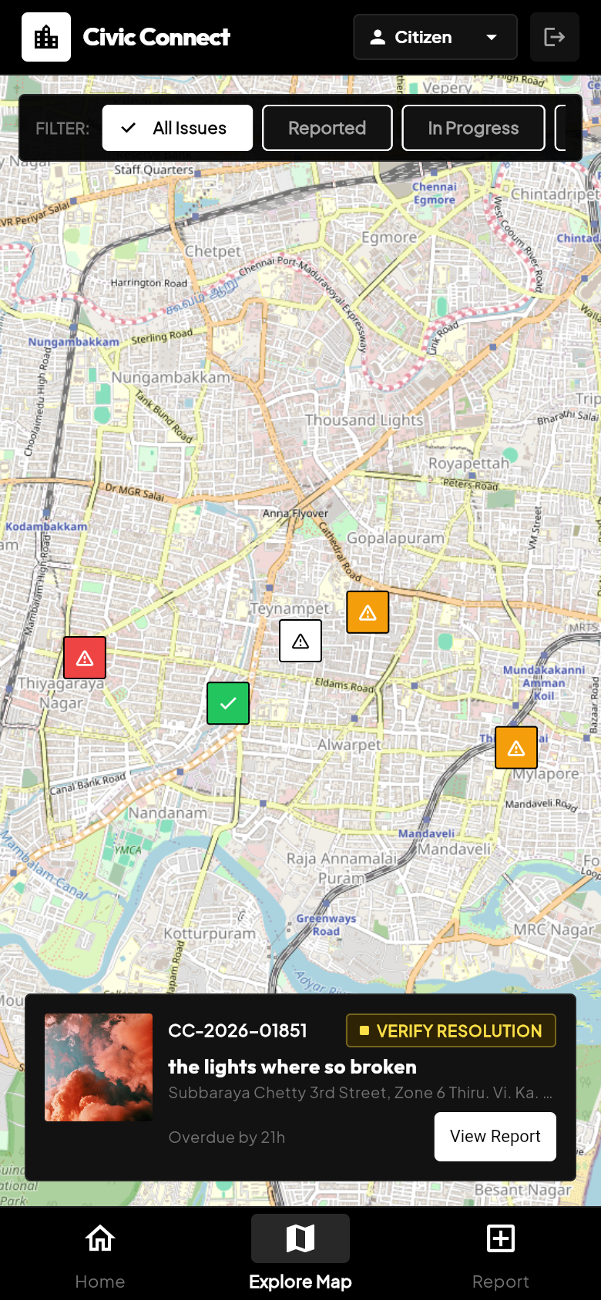  8.5(f) Explore map
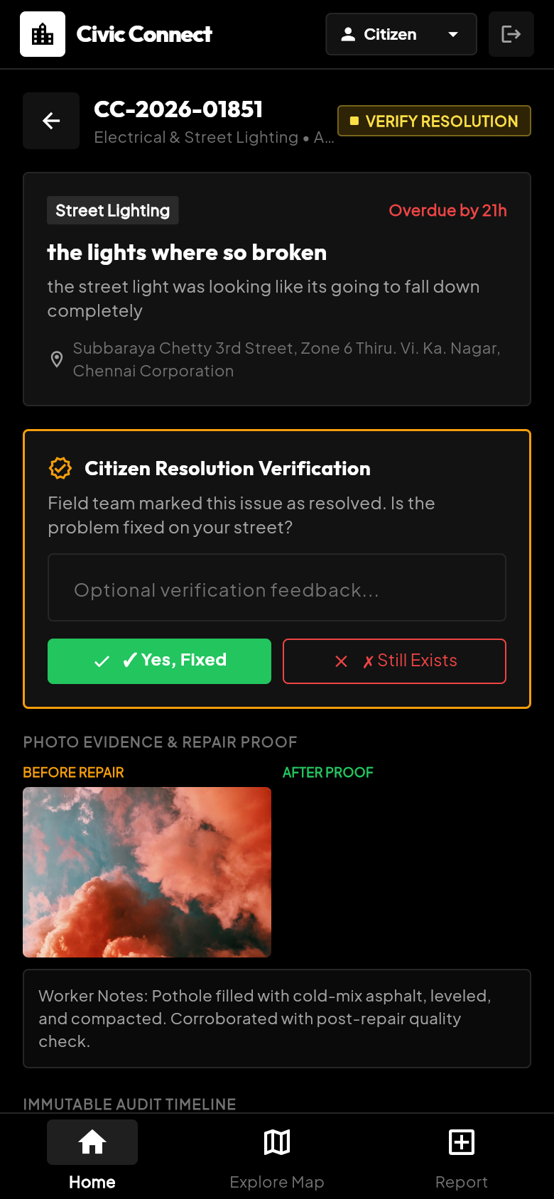  8.5(g) Report detail & verification | 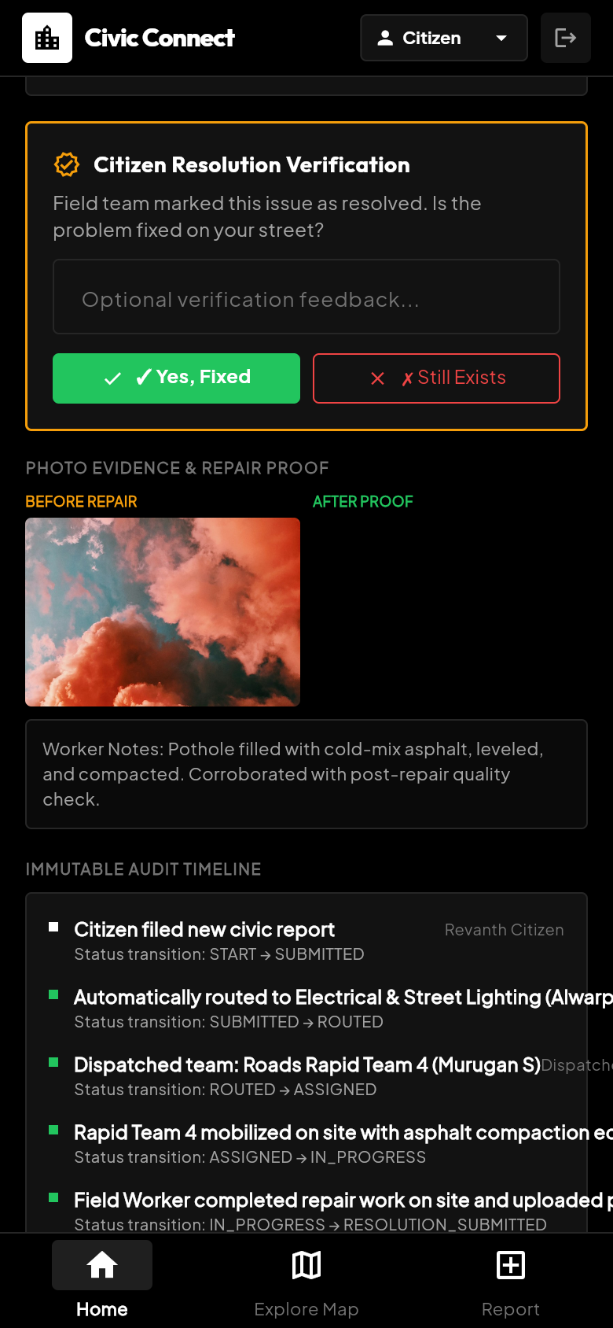  8.5(h) Audit timeline | 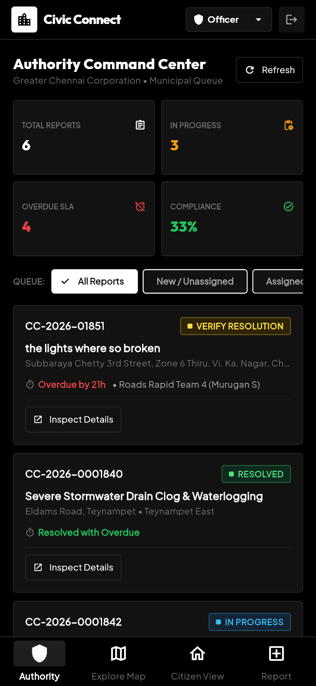  8.5(i) Authority command center
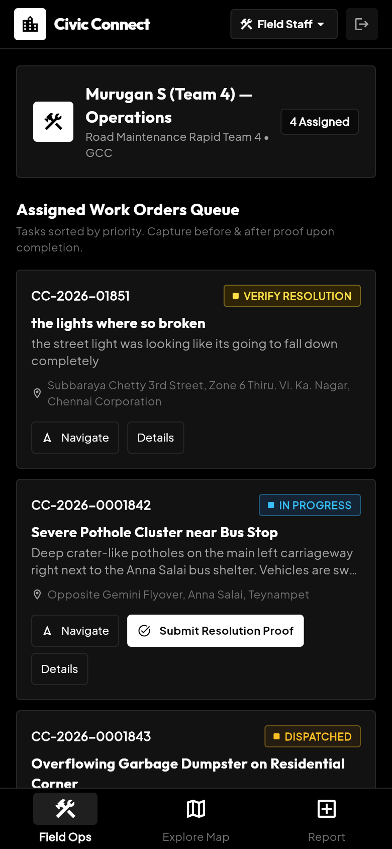
8.5(j) Field worker queue
Table 8.1: Application Screens and Their Functionalities
Screen | User role | Functionality
Sign-in | All | Authenticate and select role
Home | Citizen | Statistics, categories, nearby reports
Report Wizard | Citizen | Category, location, photo, details, submit
Explore Map | All | View reports on map by status
Report Detail | All | Photos, SLA, timeline, verification
Command Center | Officer | Triage, acknowledge, assign
Field Ops | Field Worker | Work orders, start work, submit proof

CHAPTER 9
TESTING AND RESULTS

9.1 Testing Procedure
Testing was carried out in three stages. (i) API testing: each REST endpoint was called through FastAPI's Swagger UI and from the browser with valid and invalid inputs, checking status codes and JSON responses. (ii) Functional and UI testing: the application was operated for each role, following the complete flow from report submission to verification. (iii) Integration testing: the Flutter app, FastAPI backend and Supabase database were tested together to confirm that data entered by one role appears correctly in the database and on the other roles' screens.

9.2 Test Cases
Table 9.1: Test Cases and Expected Results
ID | Module | Test description | Expected result
TC01 | Sign-in | Sign in as Citizen, Officer, Field Staff | Role-specific home and navigation open
TC02 | Categories | Open report wizard | Six categories with SLA hours load from API
TC03 | Location | Move map pin | Address and ward auto-filled
TC04 | Photo | Capture / upload photo | Image stored in Supabase; preview shown
TC05 | Duplicates | Report same category within radius | Existing report listed with distance
TC06 | Upvote | Upvote existing report | Upvote count increases; no new report
TC07 | Create report | Submit valid report | Tracking ID returned; status ROUTED
TC08 | Routing | Submit Street Lighting issue | Routed to Electrical & Street Lighting
TC09 | SLA | Open overdue report | SLA shown as “Overdue by N h”
TC10 | Assign | Officer assigns field team | Status ASSIGNED; timeline updated
TC11 | Resolve | Field worker submits proof | Status RESOLUTION_SUBMITTED; photos saved
TC12 | Verify – Yes | Citizen taps “Yes, Fixed” | Status RESOLVED
TC13 | Verify – No | Citizen taps “Still Exists” | Status REOPENED; back in officer queue
TC14 | Map | Open Explore Map | Markers coloured by status
TC15 | Analytics | Open command center | Counts match database
TC16 | Sign-out | Tap logout | Returns to sign-in screen

9.3 Results
The complete workflow was exercised with the live database. A report submitted from the wizard (CC-2026-01851, Street Lighting) was automatically routed to the Electrical & Street Lighting department with a 4-hour SLA, assigned to Roads Rapid Team 4, moved to IN_PROGRESS and then RESOLUTION_SUBMITTED by the field worker, as recorded in its audit timeline (Figure 8.5(h)). Because the deadline had passed before resolution, the report was correctly displayed as overdue.

9.4 Output
At the time of testing, the analytics overview returned by the backend showed 6 total reports: 3 in progress, 2 awaiting citizen verification and 1 resolved, with 4 overdue reports, 2 critical active reports and an SLA compliance of 33.3%. The same figures appeared on the authority command center (Figure 8.5(i)) and in the citizen home statistics (Figure 8.5(b)), confirming that the mobile screens reflect the database state correctly.

9.5 Performance
Response times of the main read endpoints were measured five times each with the backend running on the development laptop and the database hosted on Supabase.
Table 9.2: Measured API Response Times (average of 5 requests)
Endpoint | Average response time
GET /health (no database) | ≈ 2.5 ms
GET /api/v1/reports (list, up to 50) | ≈ 1.18 s
GET /api/v1/categories | ≈ 1.83 s
GET /api/v1/reports/{id} (detail with media and timeline) | ≈ 2.00 s
GET /api/v1/reports/duplicates (PostGIS radius search) | ≈ 2.14 s
GET /api/v1/analytics/overview | ≈ 2.60 s
The health check without database access returns in a few milliseconds, which shows that most of the response time is spent opening a new connection to the remote database for every request. Using a connection pool and hosting the backend closer to the database are expected to reduce these times significantly; this is listed as future work.

CHAPTER 10
APPLICATIONS
Civic Connect can be applied wherever public or shared infrastructure must be reported, routed, repaired and verified:
- Municipal corporations and city councils: roads, streetlights, drainage, waste collection and water supply complaints.
- Smart city programmes: a citizen-facing reporting layer feeding city command and control centres.
- Educational campuses: reporting broken lights, water leaks, damaged furniture and cleanliness issues to the estate office.
- Residential communities and apartments: maintenance requests routed to plumbers, electricians and housekeeping.
- Industrial parks and large campuses: facility maintenance with SLA tracking for contractors.
- Disaster and flood response: rapid geo-tagged reporting of waterlogging, fallen trees and hazards.
Target user groups: Citizens, Department Officers and Field Workers. In each setting the same workflow — report, route, assign, resolve and verify — can be used with changes only to the categories, departments and routing rules stored in the database.

CHAPTER 11
ADVANTAGES AND LIMITATIONS

Advantages
- Reporting takes only a few steps and needs no knowledge of the government structure.
- Automatic routing sends every report to the correct department and ward.
- GPS location and photo evidence remove ambiguity for field crews.
- Duplicate detection prevents repeated work orders and highlights public impact through upvotes.
- SLA deadlines and overdue indicators improve accountability.
- Before/after photo proof and citizen verification make resolution trustworthy.
- An immutable timeline provides a complete audit trail for every report.
- A single Flutter code base and a standard REST architecture make maintenance and extension easier.

Limitations
- Sign-in is a demonstration flow with preset roles; secure authentication and server-side role checks are not yet implemented.
- The ward is chosen as the nearest ward centre rather than by actual ward boundary polygons.
- Allowed status transitions are defined but not strictly enforced by the server.
- Push notifications are not implemented; users see updates when they open the app.
- Automatic escalation, 72-hour auto-closure and offline mode for field workers are designed but not implemented.
- Upvotes are counted but not yet restricted to one per user.
- The application needs a network connection, and response times depend on the remote database connection.

Security Considerations
For a real deployment, users should authenticate with OTP or password through a secure identity service, every API should check the user's role, database and storage credentials should be supplied through environment variables rather than source code, HTTPS should be used, and the reporter's personal details should be visible only to authorised officials.

CHAPTER 12
CONCLUSION AND FUTURE SCOPE

Conclusion
Civic Connect was developed as a mobile application that replaces scattered helplines and complaint portals with a transparent, location-aware digital workflow. Citizens can report an issue with its exact location and photo evidence; the backend automatically resolves the ward, routes the report to the responsible department, assigns an SLA deadline and detects duplicates; officers triage and assign; field workers submit photo proof; and citizens verify whether the problem was really fixed. Using Flutter for the client, and FastAPI, PostgreSQL, PostGIS and Supabase for the server, the project demonstrates a complete, role-based, three-tier mobile solution. Testing with the live database confirmed the full report → route → assign → resolve → verify workflow and consistent statistics across all role screens. Through this PBL, the team gained practical experience in cross-platform mobile UI development, state management, REST API design, spatial databases and testing.

Project Outcomes
- A working Flutter mobile application for Citizens, Department Officers and Field Workers.
- A FastAPI REST backend with geo, routing, duplicate, SLA and workflow engines.
- A PostGIS database with seeded Chennai data, plus documentation, diagrams and test records.

Future Scope
- Secure authentication with OTP login and server-side role-based access control.
- Push notifications, SMS and e-mail alerts for every status change and SLA breach.
- Ward boundary polygons for exact jurisdiction instead of nearest-centre lookup.
- Automation and offline support: escalation and auto-closure of overdue or unverified tickets, and offline mode for field workers.
- Administrator console for managing wards, departments, routing rules and SLA policies.
- AI/ML integration: image classification to suggest the issue category and severity, hotspot prediction, and Tamil/English support with Play Store release.

CHAPTER 13
REFERENCES
[1] Flutter Documentation. Google. https://docs.flutter.dev
[2] Provider package documentation. https://pub.dev/packages/provider
[3] flutter_map package documentation. https://docs.fleaflet.dev
[4] FastAPI Documentation. https://fastapi.tiangolo.com
[5] PostGIS Documentation (ST_DWithin, ST_Distance). https://postgis.net/documentation
[6] Supabase Documentation — Database and Storage. https://supabase.com/docs
[7] OpenStreetMap Nominatim API and Usage Policy. https://nominatim.org/release-docs/latest/api/Reverse
[8] mySociety. FixMyStreet Platform. https://fixmystreet.org
[9] Open311 GeoReport v2 Specification. https://wiki.open311.org/GeoReport_v2
[10] PostgreSQL Documentation. https://www.postgresql.org/docs
APPENDIX – SUPPORTING PROJECT MATERIAL

A.1 Project Folder Structure
Repository layout
mad_bro/
├── backend/
│ ├── app/
│ │ ├── api/ analytics, categories, locations, reports, staff
│ │ ├── core/ config.py, database.py
│ │ ├── services/ geo, routing, duplicate, sla, workflow engines
│ │ └── main.py FastAPI application
│ └── db/ init_db.py (schema), seed_data.py (demo data)
└── frontend/ (Flutter)
└── lib/
├── core/ constants, models, providers, services, theme
├── features/ auth, home, map, reports, authority, field_worker
├── shared/ custom_header, status_badge
└── main.dart

A.2 Key Source Code
1. Duplicate detection using PostGIS (backend/app/services/duplicate_engine.py)
query = """
SELECT r.id, r.public_id, r.title, r.status, r.upvotes,
ROUND(ST_Distance(
r.location,
ST_SetSRID(ST_MakePoint(%s, %s), 4326)::geography
)::numeric, 1) AS distance_meters
FROM reports r
WHERE r.category_id = %s
AND r.status NOT IN ('RESOLVED', 'REJECTED')
AND ST_DWithin(
r.location,
ST_SetSRID(ST_MakePoint(%s, %s), 4326)::geography,
%s)
ORDER BY distance_meters ASC LIMIT 5;
"""
2. Department routing engine (backend/app/services/routing_engine.py)
cur.execute("""
SELECT r.department_id, d.name AS department_name
FROM routing_rules r
JOIN departments d ON r.department_id = d.id
WHERE r.category_id = %s
AND (r.ward_id = %s OR r.ward_id IS NULL)
AND r.active = TRUE
ORDER BY r.ward_id NULLS LAST, r.priority ASC
LIMIT 1;
""", (category_id, ward_id))
3. API service in the Flutter app (frontend/lib/core/services/api_service.dart)
Future<List<DuplicateReportItem>> checkDuplicates(
double lat, double lng, String categoryId) async {
final uri = Uri.parse(
'$_baseUrl/reports/duplicates?lat=$lat&lng=$lng&category_id=$categoryId');
final response = await http.get(uri);
if (response.statusCode == 200) {
final data = jsonDecode(response.body);
final List<dynamic> list = data['duplicates'] ?? [];
return list.map((item) => DuplicateReportItem.fromJson(item)).toList();
}
return [];
}
4. Role-based state management (frontend/lib/core/providers/app_state.dart)
void login({required String name, required String role}) {
_isAuthenticated = true;
_currentRole = role;
if (role == 'OFFICER' || role == 'ADMIN') {
_activeTabIndex = 3; // Authority Console
} else if (role == 'FIELD_WORKER') {
_activeTabIndex = 4; // Field Operations
} else {
_activeTabIndex = 0; // Citizen Home
}
notifyListeners();
}

