6.

1. Find all files in the entire machine ending with .txt and remove them.

2) Find 10th record of var/log/audit/access.log file

3) Get only todays logs from access.log file

4) Get all ports which are running (Occupied Ports)

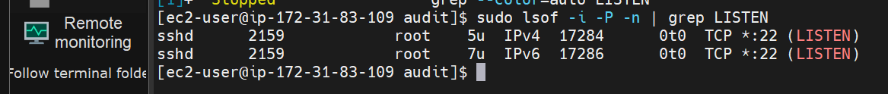

7.

1) Create a shell file which includes Installation of Tomcat 9(into new directory) and start tomcat

2. Create a file (test.txt) with content as ""I love machine, I am into devops cloud.” “

