**PL/SQL programming Mandatory Hands-on**

**Exercise 1: Control Structures**

**DATABASE CREATION:**

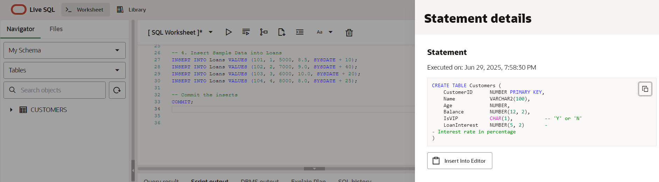

**Scenario 1:** The bank wants to apply a discount to loan interest rates for customers above 60 years old.

* + **Question:** Write a PL/SQL block that loops through all customers, checks their age, and if they are above 60, apply a 1% discount to their current loan interest rates.

**Code:**

BEGIN

FOR cust IN (SELECT CustomerID, LoanInterest, Age FROM Customers) LOOP

IF cust.Age > 60 THEN

UPDATE Customers

SET LoanInterest = LoanInterest - 1

WHERE CustomerID = cust.CustomerID;

END IF;

END LOOP;

COMMIT;

END;

**Output:**

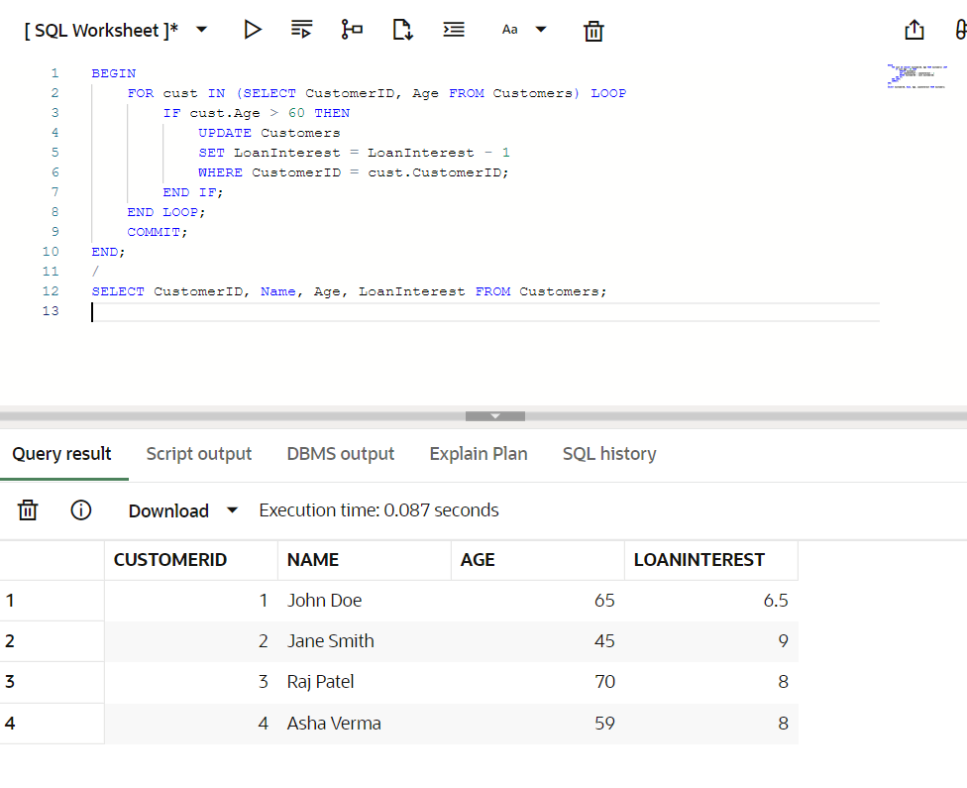

**Scenario 2:** A customer can be promoted to VIP status based on their balance.

* + **Question:** Write a PL/SQL block that iterates through all customers and sets a flag IsVIP to TRUE for those with a balance over $10,000.

**Code:**

BEGIN

FOR cust IN (SELECT CustomerID, Balance FROM Customers) LOOP

IF cust.Balance > 10000 THEN

UPDATE Customers

SET IsVIP = 'Y'

WHERE CustomerID = cust.CustomerID;

END IF;

END LOOP;

COMMIT;

END;

**Output:**

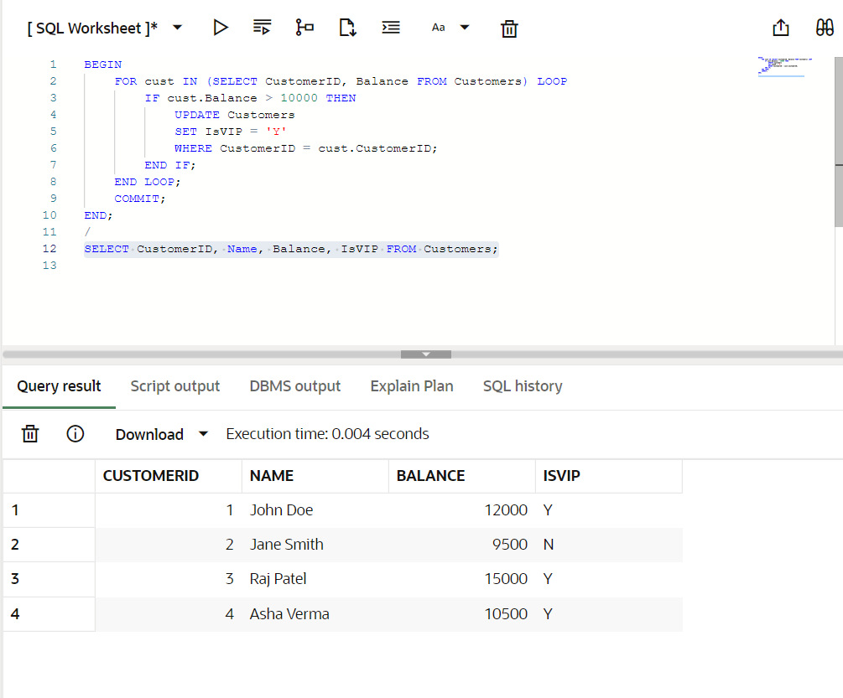

**Scenario 3:** The bank wants to send reminders to customers whose loans are due within the next 30 days.

* + **Question:** Write a PL/SQL block that fetches all loans due in the next 30 days and prints a reminder message for each customer.

**Code:**

SET SERVEROUTPUT ON;

BEGIN

FOR loan IN (

SELECT l.LoanID, c.Name, l.DueDate

FROM Loans l

JOIN Customers c ON l.CustomerID = c.CustomerID

WHERE l.DueDate <= SYSDATE + 30

) LOOP

DBMS_OUTPUT.PUT_LINE('Reminder: Loan ID ' || loan.LoanID ||

' for ' || loan.Name ||

' is due on ' || TO_CHAR(loan.DueDate, 'DD-MON-YYYY'));

END LOOP;

END;

**Output:**

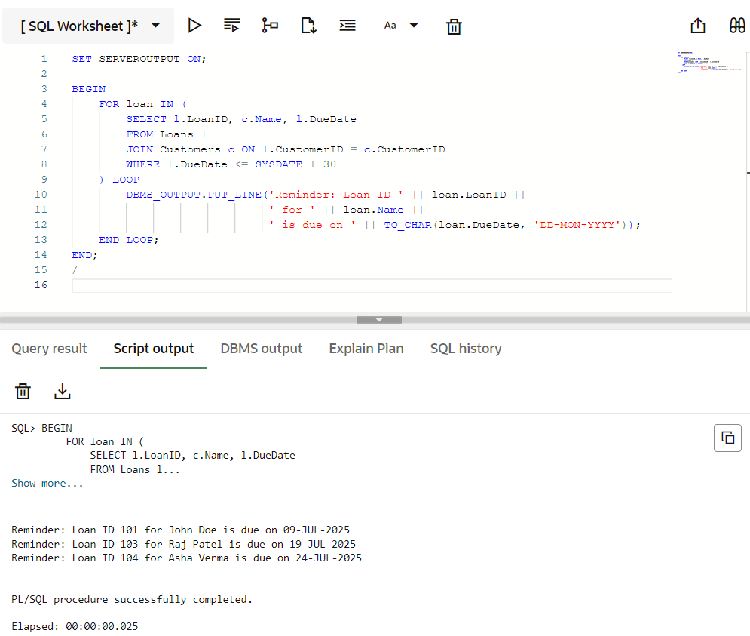

**Exercise 3: Stored Procedures**

**DATABASE CREATION**

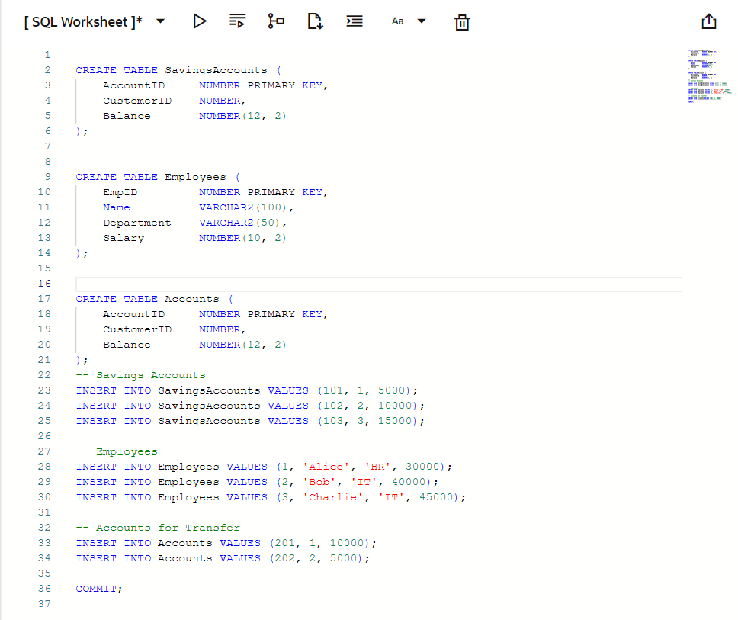

**Scenario 1:** The bank needs to process monthly interest for all savings accounts.

* + **Question:** Write a stored procedure **ProcessMonthlyInterest** that calculates and updates the balance of all savings accounts by applying an interest rate of 1% to the current balance.

**Code:**

CREATE OR REPLACE PROCEDURE ProcessMonthlyInterest IS

BEGIN

UPDATE SavingsAccounts

SET Balance = Balance + (Balance * 0.01);

COMMIT;

END;

/

**Output:**

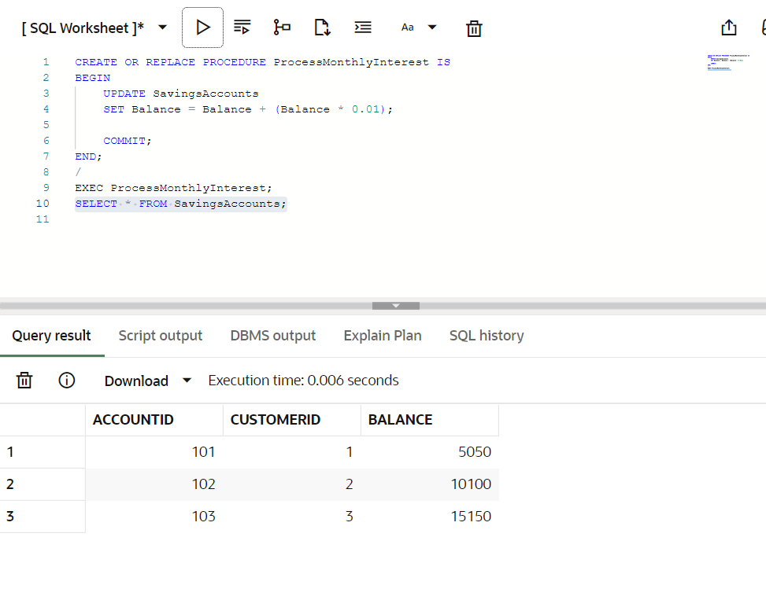

**Scenario 2:** The bank wants to implement a bonus scheme for employees based on their performance.

* + **Question:** Write a stored procedure **UpdateEmployeeBonus** that updates the salary of employees in a given department by adding a bonus percentage passed as a parameter.

**Code:**

CREATE OR REPLACE PROCEDURE UpdateEmployeeBonus (

dept_name IN VARCHAR2,

bonus_pct IN NUMBER

) IS

BEGIN

UPDATE Employees

SET Salary = Salary + (Salary * bonus_pct / 100)

WHERE Department = dept_name;

COMMIT;

END;

/

**Output:**

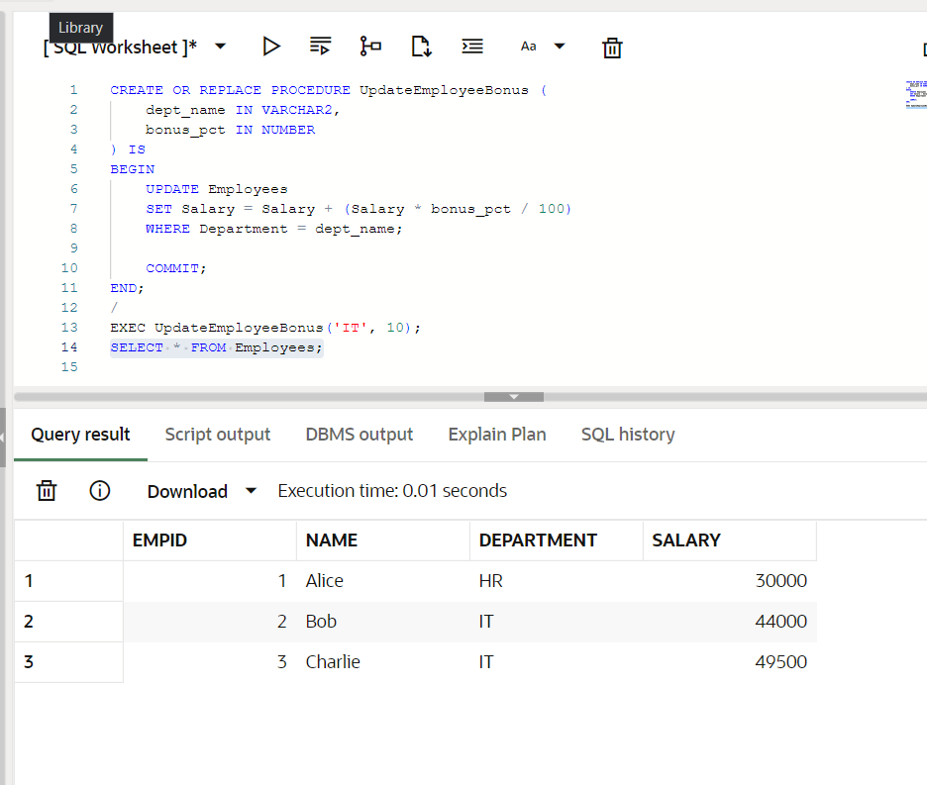

**Scenario 3:** Customers should be able to transfer funds between their accounts.

* + **Question:** Write a stored procedure **TransferFunds** that transfers a specified amount from one account to another, checking that the source account has sufficient balance before making the transfer.

**Code:**

CREATE OR REPLACE PROCEDURE TransferFunds (

from_acct IN NUMBER,

to_acct IN NUMBER,

amount IN NUMBER

) IS

insufficient_funds EXCEPTION;

from_balance NUMBER;

BEGIN

SELECT Balance INTO from_balance

FROM Accounts

WHERE AccountID = from_acct;

IF from_balance < amount THEN

RAISE insufficient_funds;

END IF;

UPDATE Accounts

SET Balance = Balance - amount

WHERE AccountID = from_acct;

UPDATE Accounts

SET Balance = Balance + amount

WHERE AccountID = to_acct;

COMMIT;

EXCEPTION

WHEN insufficient_funds THEN

DBMS_OUTPUT.PUT_LINE('Transfer failed: Insufficient balance.');

WHEN OTHERS THEN

DBMS_OUTPUT.PUT_LINE('Transfer failed: ' || SQLERRM);

END;

/

**Output:**

