Data structures and Algorithms Mandatory Hands-on

Exercise 2: E-commerce Platform Search Function
Scenario:
You are working on the search functionality of an e-commerce platform. The search needs to be optimized for fast performance.
Steps:
- Understand Asymptotic Notation:
  - Explain Big O notation and how it helps in analyzing algorithms.
  - Describe the best, average, and worst-case scenarios for search operations.
- Setup:
  - Create a class Product with attributes for searching, such as productId, productName, and category.
- Implementation:
  - Implement linear search and binary search algorithms.
  - Store products in an array for linear search and a sorted array for binary search.
- Analysis:
  - Compare the time complexity of linear and binary search algorithms.
  - Discuss which algorithm is more suitable for your platform and why.
SOLUTION:
- Big O notation is used to analyse the performance of an algorithm based on the change in size of the input.
- Big O notation helps in analysing the algorithms by comparing with different algorithms, finding the efficiency for large applications such as an E-commerce platform and understand the efficiency in the working of the algorithm with the change in the input size.

Product.java

package search;
public class Product {
int productId;
String productName;
String category;

public Product(int productId, String productName, String category) {
this.productId = productId;
this.productName = productName;
this.category = category;
}
}
SearchFunc.java

package search;
public class SearchFunc {

public static Product linearSearch(Product[] products, String targetName) {
for (Product product : products) {
if (product.productName.equalsIgnoreCase(targetName)) {
return product;
}
}
return null;
}

public static Product binarySearch(Product[] products, String targetName) {
int left = 0;
int right = products.length - 1;

while (left <= right) {
int mid = (left + right) / 2;
int cmp = products[mid].productName.compareToIgnoreCase(targetName);

if (cmp == 0) return products[mid];
else if (cmp < 0) left = mid + 1;
else right = mid - 1;
}
return null;
}
}

Main.java

package search;

import java.util.Arrays;
import java.util.Comparator;

public class Main {
public static void main(String[] args) {
Product[] products = {
new Product(1, "Mobile", "Electronics"),
new Product(2, "Shampoo", "Haircare"),
new Product(3, "Chair", "Furniture"),
new Product(4, "Phone", "Electronics")
};

// Linear Search
long startTime = System.nanoTime();
Product foundProduct = SearchFunc.linearSearch(products, "Phone");
long endTime = System.nanoTime();
long linearSearchTime = endTime - startTime;

if (foundProduct != null)
System.out.println("Linear Search Found: " + foundProduct.productName);
else
System.out.println("Product not found");
System.out.println("Time taken for Linear Search: " + linearSearchTime + " ns");
// Sort elements
Arrays.sort(products, Comparator.comparing(p -> p.productName.toLowerCase()));
// Binary Search
startTime = System.nanoTime();
foundProduct = SearchFunc.binarySearch(products, "Phone");
endTime = System.nanoTime();
long binarySearchTime = endTime - startTime;

if (foundProduct != null)
System.out.println("Binary Search Found: " + foundProduct.productName);
else
System.out.println("Product not found");
System.out.println("Time taken for Binary Search: " + binarySearchTime + " ns");
}
}

OUTPUT:
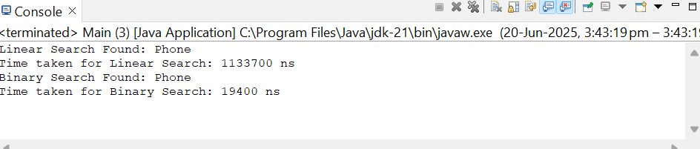

For an e-commerce platform, binary search is more suitable for better performance as it contains large data.

Exercise 7: Financial Forecasting
Scenario:
You are developing a financial forecasting tool that predicts future values based on past data.
Steps:
- Understand Recursive Algorithms:
  - Explain the concept of recursion and how it can simplify certain problems.
- Setup:
  - Create a method to calculate the future value using a recursive approach.
- Implementation:
  - Implement a recursive algorithm to predict future values based on past growth rates.
- Analysis:
  - Discuss the time complexity of your recursive algorithm.
  - Explain how to optimize the recursive solution to avoid excessive computation.
Code:
FF.java
package forecastTool;
public class FF {
public static double GrowthRate(double principal, double[] growthRates) {
for (double rate : growthRates) {
principal *= (1 + rate);
}
return principal;
}
public static double GrowthRatesRec(double principal, double[] growthRates, int year) {
if (year == growthRates.length) {
return principal;
}
return GrowthRatesRec(principal * (1 + growthRates[year]), growthRates, year + 1);
}
}

Main.java

package forecastTool;

public class Main {
public static void main(String[] args) {
double principal = 10000;
double[] growthRates = {0.05, 0.03, -0.02, 0.04, 0.06};
long startIter = System.nanoTime();
double futureValIter = FF.GrowthRate(principal, growthRates);
long endIter = System.nanoTime();
long timeIter = endIter - startIter;
long startRec = System.nanoTime();
double futureValRec = FF.GrowthRatesRec(principal, growthRates, 0);
long endRec = System.nanoTime();
long timeRec = endRec - startRec;
System.out.printf("Future Value using Iteration: ₹%.2f (Time: %d ns)%n", futureValIter, timeIter);
System.out.printf("Future Value using Recursion: ₹%.2f (Time: %d ns)%n", futureValRec, timeRec);
}
}

OUTPUT:

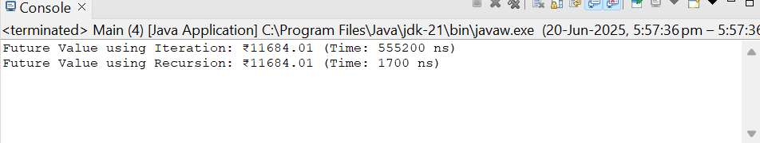
- The time complexity of recursion is O(n).
- Can optimize using tail recursion or iterative method for linear sequential priblems.

