Design Patterns and Principles Mandatory Hands-on

Exercise 1: Implementing the Singleton Pattern

Scenario:
You need to ensure that a logging utility class in your application has only one instance throughout the application lifecycle to ensure consistent logging.
Steps:
- Create a New Java Project:
  - Create a new Java project named SingletonPatternExample.
- Define a Singleton Class:
  - Create a class named Logger that has a private static instance of itself.
  - Ensure the constructor of Logger is private.
  - Provide a public static method to get the instance of the Logger class.
- Implement the Singleton Pattern:
  - Write code to ensure that the Logger class follows the Singleton design pattern.
- Test the Singleton Implementation:
  - Create a test class to verify that only one instance of Logger is created and used across the application.

Code:

public class LoggerTest {

// Singleton Logger class (inner static class)
static class Logger {
// private static instance of Logger
private static Logger instance;

// private constructor
private Logger() {
System.out.println("Logger initialized.");
}

// public static method to get the instance
public static Logger getInstance() {
if (instance == null) {
instance = new Logger();
}
return instance;
}

// Logging method
public void log(String message) {
System.out.println("LOG: " + message);
}
}

// Main method to test Singleton implementation
public static void main(String[] args) {
Logger logger1 = Logger.getInstance();
logger1.log("First log from logger1");

Logger logger2 = Logger.getInstance();
logger2.log("Second log from logger2");

if (logger1 == logger2) {
System.out.println("Singleton verified: Only one instance exists.");
} else {
System.out.println("Singleton FAILED: Multiple instances exist.");
}
}
}
Output:
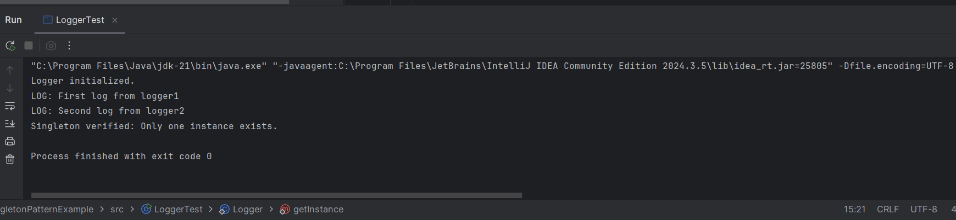

Exercise 2: Implementing the Factory Method Pattern
Scenario:
You are developing a document management system that needs to create different types of documents (e.g., Word, PDF, Excel). Use the Factory Method Pattern to achieve this.
Steps:
- Create a New Java Project:
  - Create a new Java project named FactoryMethodPatternExample.
- Define Document Classes:
  - Create interfaces or abstract classes for different document types such as WordDocument, PdfDocument, and ExcelDocument.
- Create Concrete Document Classes:
  - Implement concrete classes for each document type that implements or extends the above interfaces or abstract classes.
- Implement the Factory Method:
  - Create an abstract class DocumentFactory with a method createDocument().
  - Create concrete factory classes for each document type that extends DocumentFactory and implements the createDocument() method.
- Test the Factory Method Implementation:
  - Create a test class to demonstrate the creation of different document types using the factory method.
Code:
// Step 1: Document interface
interface Document {
void create();
}
//Step 2: Concrete document classes
class WordDocument implements Document {
public void create() {
System.out.println("Word document created!");
}
}
class PdfDocument implements Document {
public void create() {
System.out.println("PDF document created!");
}
}
class ExcelDocument implements Document {
public void create() {
System.out.println("Excel document created!");
}
}
// Step 3: Abstract factory
abstract class DocumentFactory {
public abstract Document createDocument();
}
// Step 4: Concrete factories
class WordFactory extends DocumentFactory {
public Document createDocument() {
return new WordDocument();
}
}
class PdfFactory extends DocumentFactory {
public Document createDocument() {
return new PdfDocument();
}
}
class ExcelFactory extends DocumentFactory {
public Document createDocument() {
return new ExcelDocument();
}
}
// Step 5: Test class
public class FactoryMethodPatternExample {
public static void main(String[] args) {
// Create factories
DocumentFactory wordFactory = new WordFactory();
DocumentFactory pdfFactory = new PdfFactory();
DocumentFactory excelFactory = new ExcelFactory();
// Create documents
Document word = wordFactory.createDocument();
Document pdf = pdfFactory.createDocument();
Document excel = excelFactory.createDocument();
// Use documents
word.create();
pdf.create();
excel.create();
}
}

Output:
