TDD Using JUnit5 and Mockito
Exercise 1 : Setting up JUnit

Setting Up JUnit with JAR Files (Without Maven/Gradle)
If you are not using Maven or Gradle, you can set up JUnit in your Java project manually by following these steps:
1. Download JUnit and Hamcrest JARs
- Go to the JUnit 5 Releases page or JUnit 4 Downloads.
- Download the required JAR files (for JUnit 4: junit-4.x.x.jar and hamcrest-core-x.x.x.jar; for JUnit 5, download junit-platform-console-standalone-x.x.x.jar).
2. Add JARs to Your Project
- Place the downloaded JAR files in a lib folder inside your project directory (or anywhere you prefer).
3. Add JARs to Classpath
- When compiling and running your tests, include the JAR files in your classpath.
- Example compile command (Windows):
javac -cp ".;lib/junit-4.13.2.jar;lib/hamcrest-core-1.3.jar" Calculator.java CalculatorTest.java

4. Write Your Test Classes
- Use @Test annotations and assertions as usual.
5. Run Your Tests
- Use the command line as shown above, or configure your IDE to include the JARs in the classpath.

NOTE : We can directly setup Jar in VS Code with the help of VS Code Extension such as Extension Pack for Java and Test Runner for Java. After selecting the jar icon on sidebar , click on enable Java Test and it will automatically download all required Junit Jupiter Test Packages and add It as .jar file in lib folder of source file

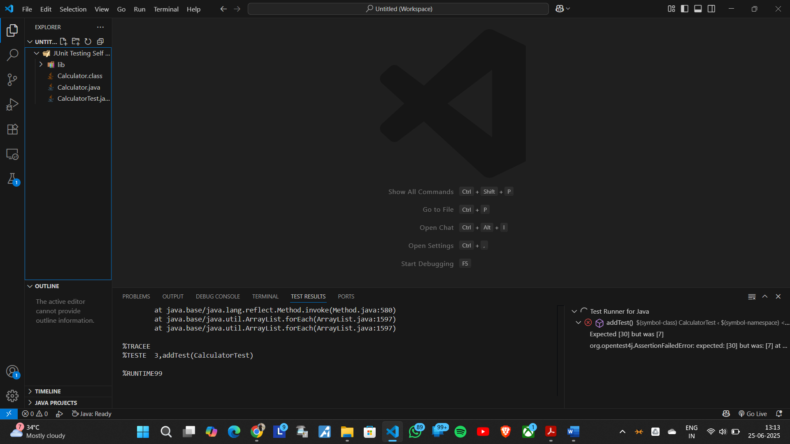

Exercise 3 : Assertions in JUnit
Key Points:
- JUnit 5 Imports:
  - @Test is used to mark the method as a test case.
  - Static imports from org.junit.jupiter.api.Assertions provide assertion methods.
Assertions Used:
- assertEquals(expected, actual):
Verifies that two values are equal.
- assertTrue(condition):
Checks that the condition is true.
- assertFalse(condition):
Checks that the condition is false.
- assertNull(object):
Asserts that the object is null.
- assertNotNull(object):
Asserts that the object is not null.
Example Test Method:
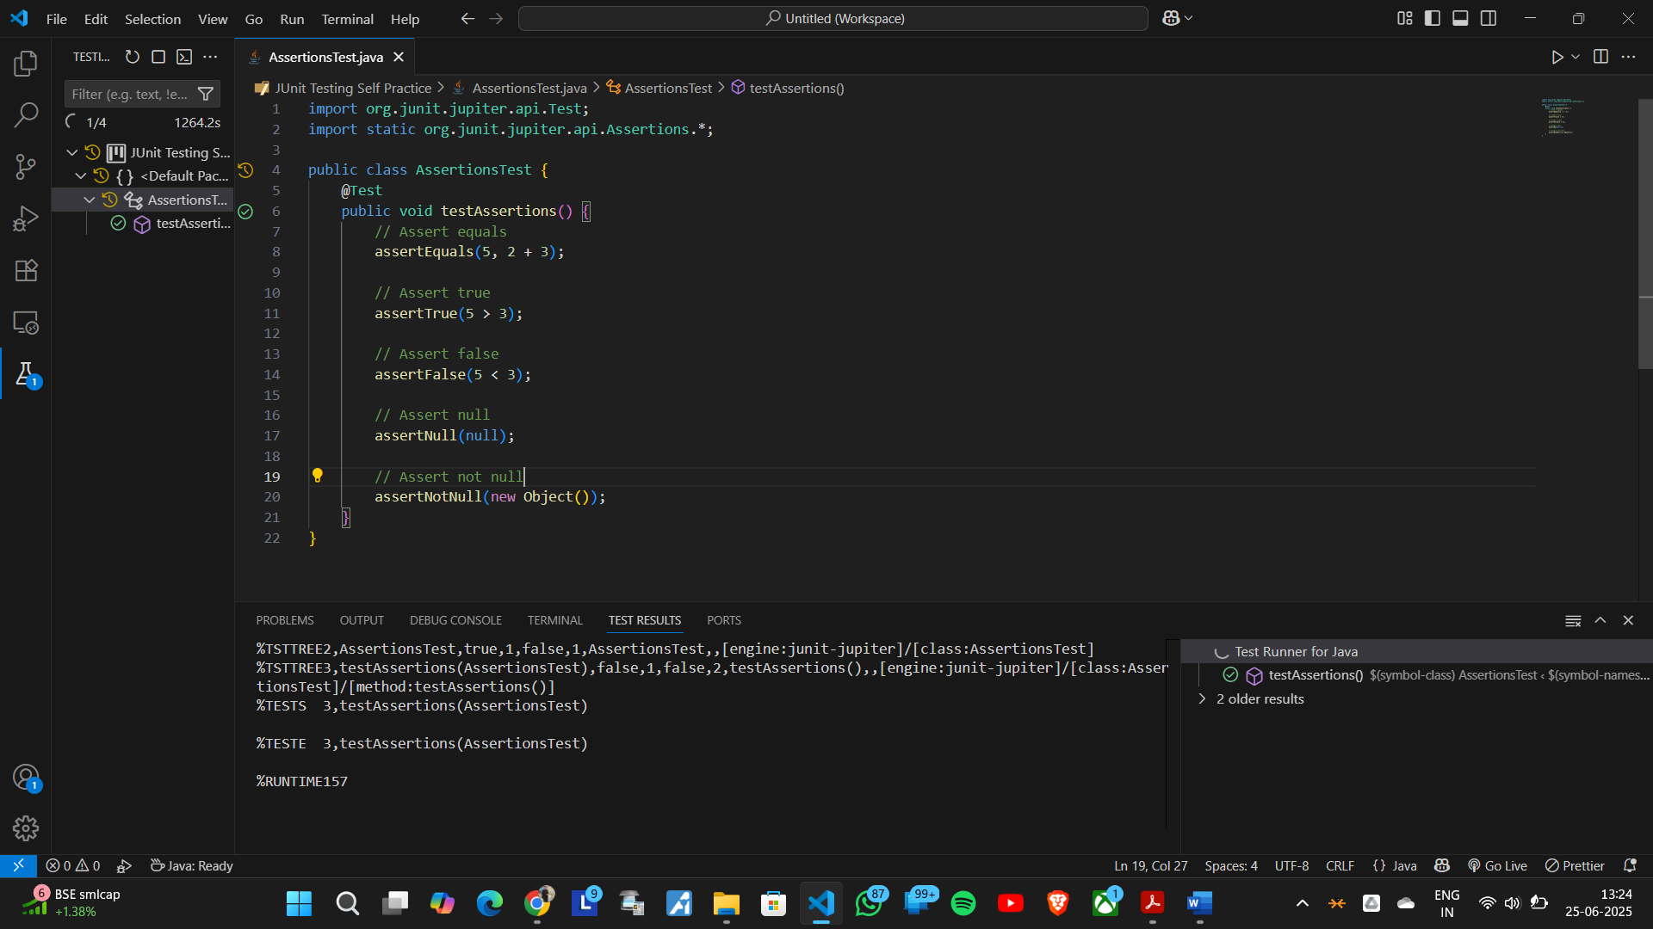
The testAssertions() method demonstrates all the above assertions with simple examples.

Exercise 3 : Arrange-Act-Assert (AAA) Pattern, Test Fixtures, Setup and Teardown Methods in JUnit
Scenario:
You need to organize your tests using the Arrange-Act-Assert (AAA) pattern and use setup
and teardown methods.
Steps:
1. Write tests using the AAA pattern.
2. Use @Before and @After annotations for setup and teardown methods.

Code Snippet :
import org.junit.Before;
import org.junit.After;
import org.junit.Test;
import static org.junit.Assert.*;
public class Exercise4 {
private int number;

@Before
public void setUp() {
number = 10;
}

@After
public void tearDown() {
number = 0;
}

@Test
public void testAdd() {
int result = number + 5;
assertEquals(15, result);
}

@Test
public void testSubtract() {
int result = number - 3;
assertEquals(7, result);
}
}
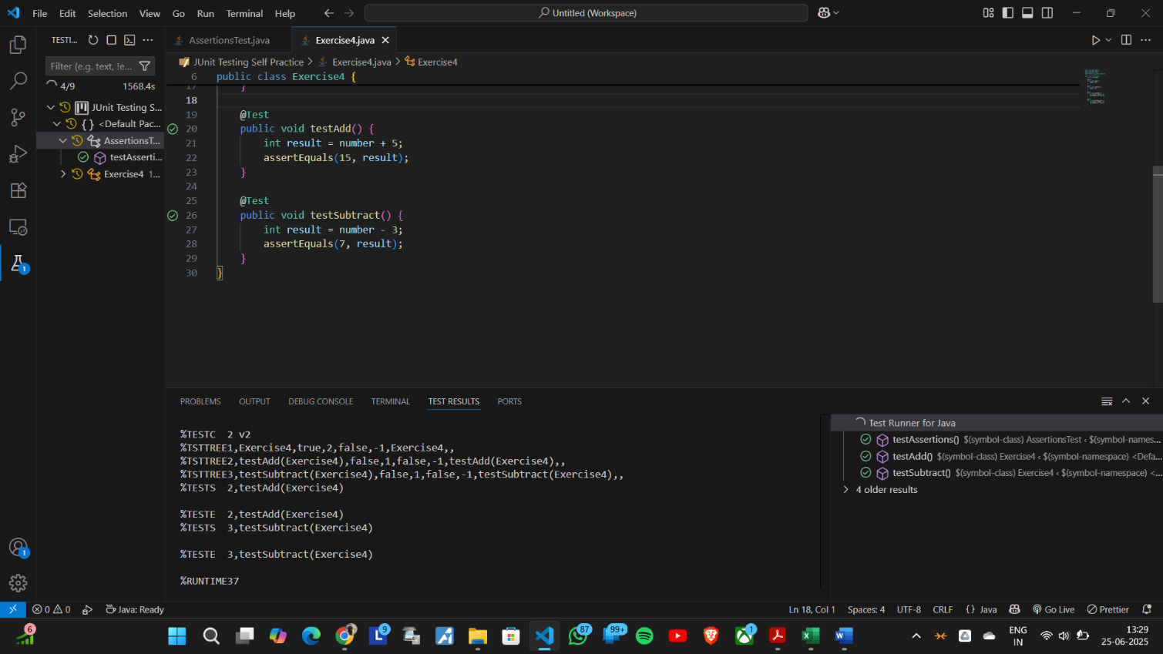
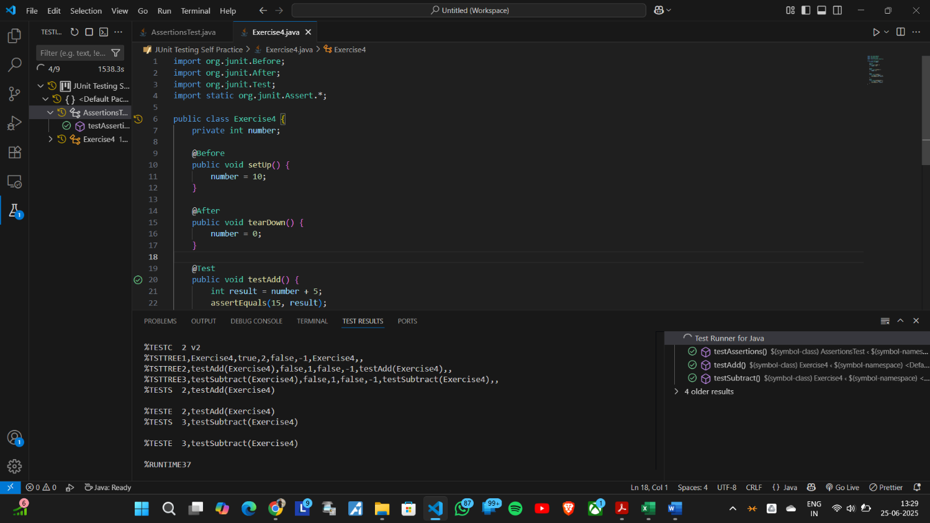

Mockito exercises

Exercise 1 : Mocking and Stubbing
This file demonstrates how to use Mockito with JUnit to test a service that depends on an external API.

Components

- ExternalApi:
A simple class simulating an external dependency with a `getData()` method.

- MyService:
A service class that depends on `ExternalApi`. It has a `fetchData()` method that calls `getData()` from the API.

- Ex1 (Test Class):
Contains a JUnit test method `testExternalApi()` that:
1. Creates a mock of `ExternalApi` using Mockito.
2. Stubs the `getData()` method to return `"Mock Data"`.
3. Injects the mock into `MyService`.
4. Calls `fetchData()` and asserts that the returned value is `"Mock Data"`.

Purpose

- Mocking: Isolates `MyService` from the real `ExternalApi` for testing.
- Stubbing: Controls the return value of `getData()` to test `MyService` behavior.
- Unit Testing: Ensures `MyService` interacts correctly with its dependency.

Code Snippet :
import org.junit.Test;
import static org.junit.Assert.*;
import static org.mockito.Mockito.*;

class ExternalApi {
public String getData() {
return "Real Data";
}
}

class MyService {
private ExternalApi api;

public MyService(ExternalApi api) {
this.api = api;
}

public String fetchData() {
return api.getData();
}
}

public class Ex1 {
@Test
public void testExternalApi() {
ExternalApi mockApi = mock(ExternalApi.class);
when(mockApi.getData()).thenReturn("Mock Data");
MyService service = new MyService(mockApi);
String result = service.fetchData();
assertEquals("Mock Data", result);
}
}

Exercise 2 : Verifying Interactions

Components
- ExternalApi
A simple class that simulates an external dependency with a getData() method.
- MyService
A service class that depends on ExternalApi. It has a fetchData() method that calls getData() from the API.
- Ex2 (Test Class)
Contains a JUnit test method testVerifyInteraction() that:
  - Creates a mock of ExternalApi using Mockito.
  - Injects the mock into MyService.
  - Calls fetchData() on the service.
  - Uses verify() to check that getData() was called on the mock.
Purpose
- Mocking: Isolates MyService from the real ExternalApi for testing.
- Interaction Verification: Ensures that MyService correctly calls the getData() method of its dependency.

Usage
- Run the test method testVerifyInteraction(). The test will pass if getData() is called as expected.

Code Snippet:
import org.junit.Test;
import static org.junit.Assert.*;
import static org.mockito.Mockito.*;

class ExternalApi {
public String getData() {
return "Real Data";
}
}

class MyService {
private ExternalApi api;

public MyService(ExternalApi api) {
this.api = api;
}

public String fetchData() {
return api.getData();
}
}

public class Ex2 {
@Test
public void testVerifyInteraction() {
ExternalApi mockApi = mock(ExternalApi.class);
MyService service = new MyService(mockApi);
service.fetchData();
verify(mockApi).getData();
}
}

SLF4J logging framework
Exercise 1 : Logging Error Messages and Warning Levels
Steps
- Add SLF4J and Logback dependencies to your project.
<dependency>
<groupId>org.slf4j</groupId>
<artifactId>slf4j-api</artifactId>
<version>1.7.30</version>
</dependency>
<dependency>
<groupId>ch.qos.logback</groupId>
<artifactId>logback-classic</artifactId>
<version>1.2.3</version>
</dependency>
If you use Maven, add the dependencies to your pom.xml.
If not, download the JAR files and add them to your classpath.

- Create a Java class and use SLF4J for logging.
Example:
import org.slf4j.Logger;
import org.slf4j.LoggerFactory;
public class LoggingExample {
private static final Logger logger = LoggerFactory.getLogger(LoggingExample.class);
public static void main(String[] args) {
logger.error("This is an error message");
logger.warn("This is a warning message");
}
}

Explanation
- The logger is created for the class.
- Use logger.error to log error messages.
- Use logger.warn to log warning messages.
- When you run the program, the messages will appear in the console.

Requirements
You need the SLF4J API and Logback Classic JARs in your classpath.
No extra configuration is needed for basic logging to the console.

