PL/SQL programming Mandatory Hands-on

Exercise 1: Control Structures
DATABASE CREATION:
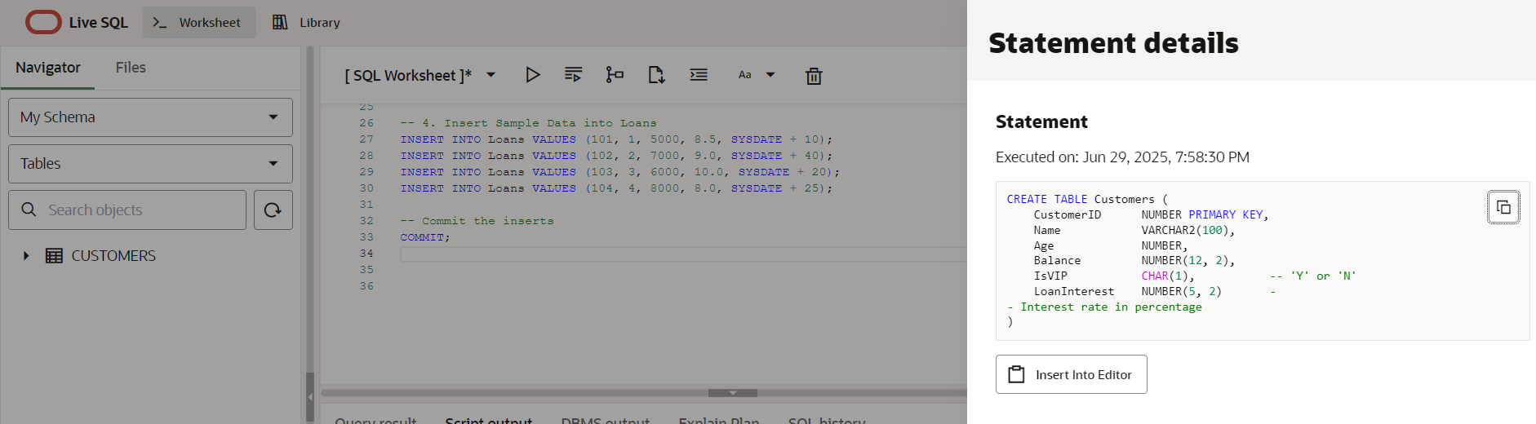

Scenario 1: The bank wants to apply a discount to loan interest rates for customers above 60 years old.
  - Question: Write a PL/SQL block that loops through all customers, checks their age, and if they are above 60, apply a 1% discount to their current loan interest rates.
Code:

BEGIN
FOR cust IN (SELECT CustomerID, LoanInterest, Age FROM Customers) LOOP
IF cust.Age > 60 THEN
UPDATE Customers
SET LoanInterest = LoanInterest - 1
WHERE CustomerID = cust.CustomerID;
END IF;
END LOOP;
COMMIT;
END;

Output:
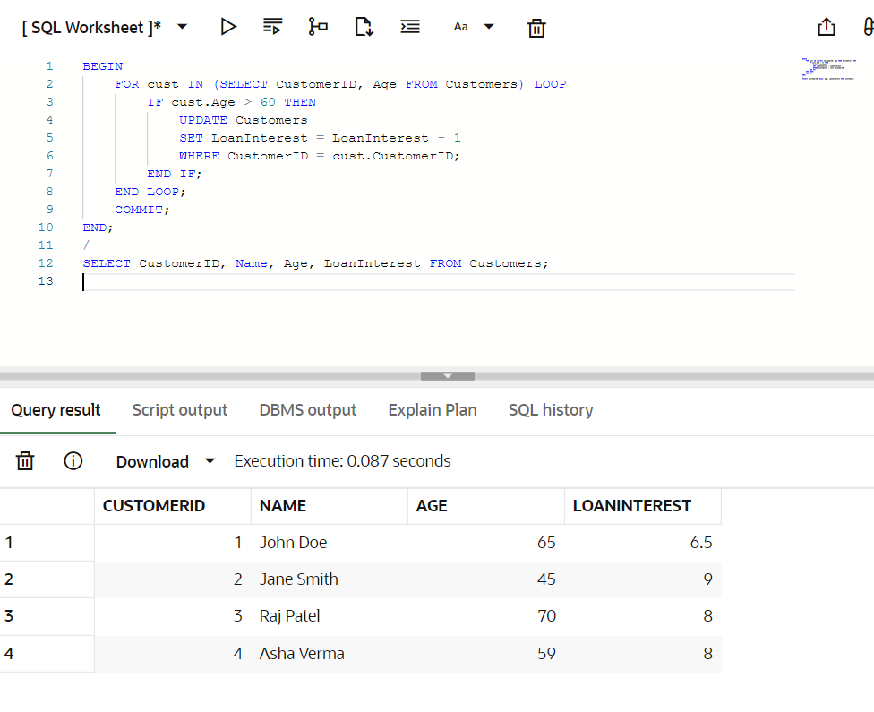
Scenario 2: A customer can be promoted to VIP status based on their balance.
  - Question: Write a PL/SQL block that iterates through all customers and sets a flag IsVIP to TRUE for those with a balance over $10,000.
Code:

BEGIN
FOR cust IN (SELECT CustomerID, Balance FROM Customers) LOOP
IF cust.Balance > 10000 THEN
UPDATE Customers
SET IsVIP = 'Y'
WHERE CustomerID = cust.CustomerID;
END IF;
END LOOP;
COMMIT;
END;

Output:
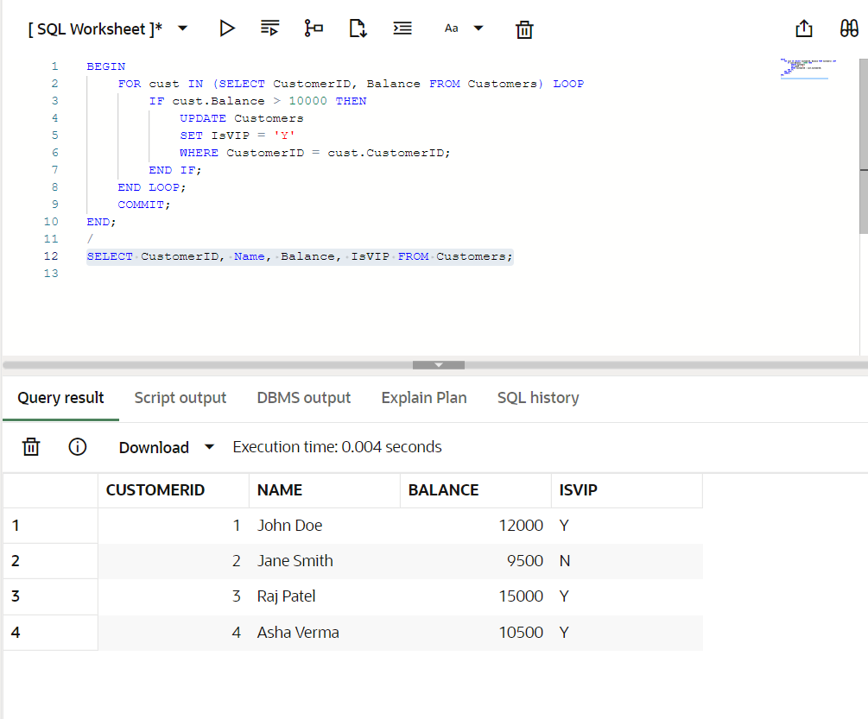

Scenario 3: The bank wants to send reminders to customers whose loans are due within the next 30 days.
  - Question: Write a PL/SQL block that fetches all loans due in the next 30 days and prints a reminder message for each customer.
Code:

SET SERVEROUTPUT ON;

BEGIN
FOR loan IN (
SELECT l.LoanID, c.Name, l.DueDate
FROM Loans l
JOIN Customers c ON l.CustomerID = c.CustomerID
WHERE l.DueDate <= SYSDATE + 30
) LOOP
DBMS_OUTPUT.PUT_LINE('Reminder: Loan ID ' || loan.LoanID ||
' for ' || loan.Name ||
' is due on ' || TO_CHAR(loan.DueDate, 'DD-MON-YYYY'));
END LOOP;
END;
Output:
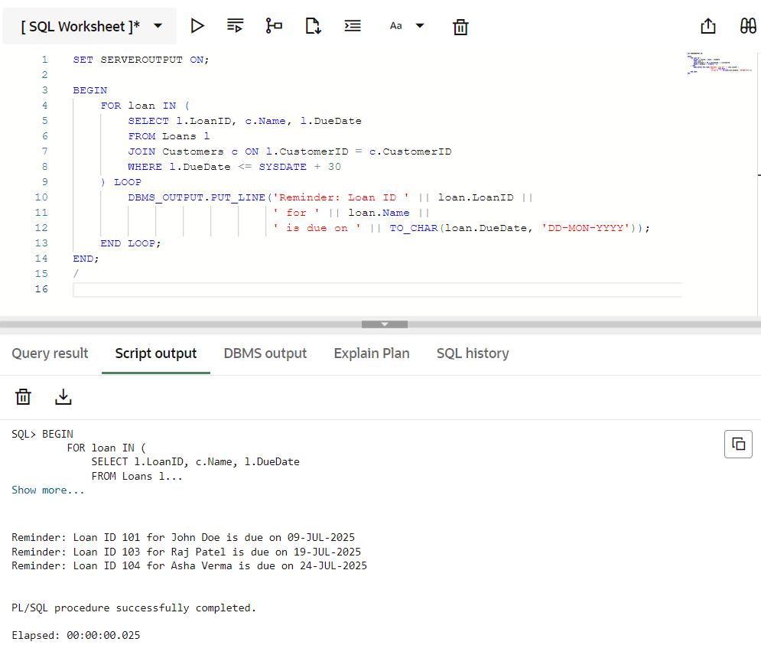

Exercise 3: Stored Procedures

DATABASE CREATION

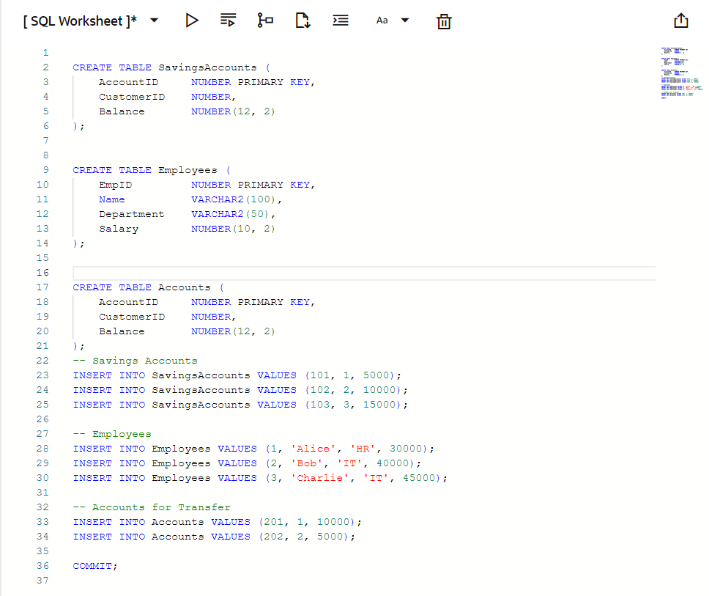

Scenario 1: The bank needs to process monthly interest for all savings accounts.
  - Question: Write a stored procedure ProcessMonthlyInterest that calculates and updates the balance of all savings accounts by applying an interest rate of 1% to the current balance.
Code:

CREATE OR REPLACE PROCEDURE ProcessMonthlyInterest IS
BEGIN
UPDATE SavingsAccounts
SET Balance = Balance + (Balance * 0.01);

COMMIT;
END;
/
Output:
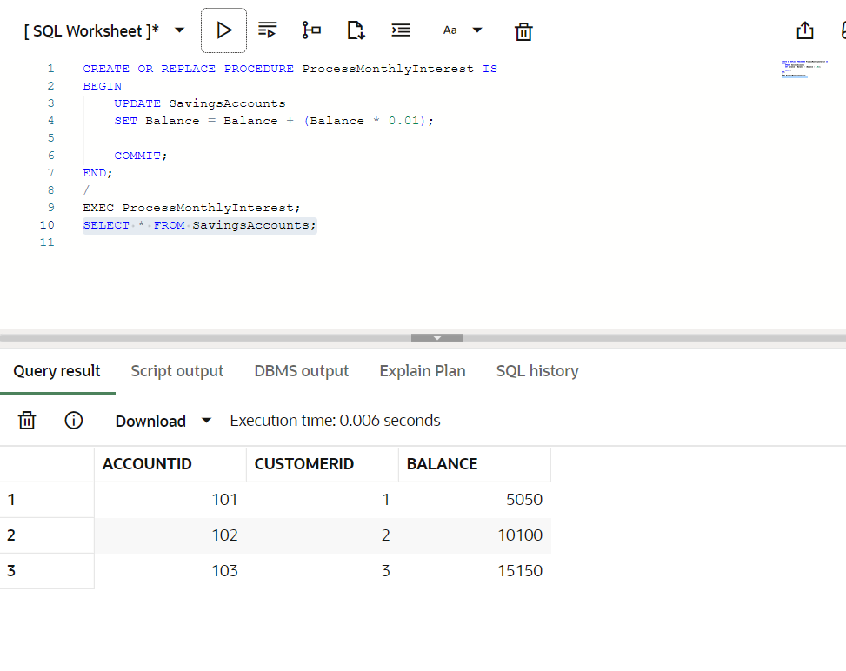

Scenario 2: The bank wants to implement a bonus scheme for employees based on their performance.
  - Question: Write a stored procedure UpdateEmployeeBonus that updates the salary of employees in a given department by adding a bonus percentage passed as a parameter.
Code:

CREATE OR REPLACE PROCEDURE UpdateEmployeeBonus (
dept_name IN VARCHAR2,
bonus_pct IN NUMBER
) IS
BEGIN
UPDATE Employees
SET Salary = Salary + (Salary * bonus_pct / 100)
WHERE Department = dept_name;

COMMIT;
END;
/
Output:
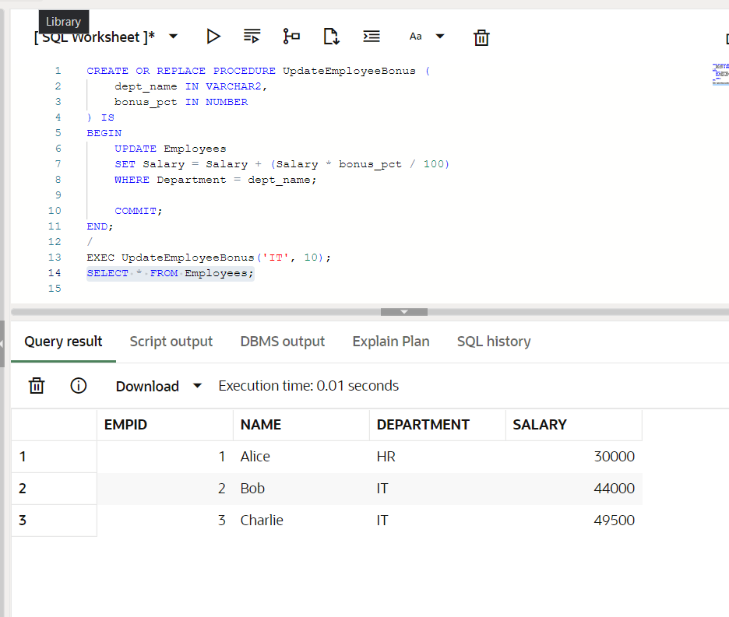

Scenario 3: Customers should be able to transfer funds between their accounts.
  - Question: Write a stored procedure TransferFunds that transfers a specified amount from one account to another, checking that the source account has sufficient balance before making the transfer.

Code:

CREATE OR REPLACE PROCEDURE TransferFunds (
from_acct IN NUMBER,
to_acct IN NUMBER,
amount IN NUMBER
) IS
insufficient_funds EXCEPTION;
from_balance NUMBER;
BEGIN
SELECT Balance INTO from_balance
FROM Accounts
WHERE AccountID = from_acct;
IF from_balance < amount THEN
RAISE insufficient_funds;
END IF;
UPDATE Accounts
SET Balance = Balance - amount
WHERE AccountID = from_acct;
UPDATE Accounts
SET Balance = Balance + amount
WHERE AccountID = to_acct;
COMMIT;
EXCEPTION
WHEN insufficient_funds THEN
DBMS_OUTPUT.PUT_LINE('Transfer failed: Insufficient balance.');
WHEN OTHERS THEN
DBMS_OUTPUT.PUT_LINE('Transfer failed: ' || SQLERRM);
END;
/

Output:
