**Research on Risk Prediction of Dyslipidemia in Steel Workers Based on Recurrent Neural Network and LSTM Neural Network**

Dyslipidemia is a blood clot disease which accumulate cholesterol in human body or at heart side and this accumulation may cause heart attack if not identified on time and to predict such disease author is using deep learning algorithms such as RNN (Recurrent Neural Network) and LSTM (Long Short Term Memory). Author using steel workers dataset to train above two algorithms and then compare accuracy between those two algorithms. Dataset saved inside dataset folder and below screen showing dataset details

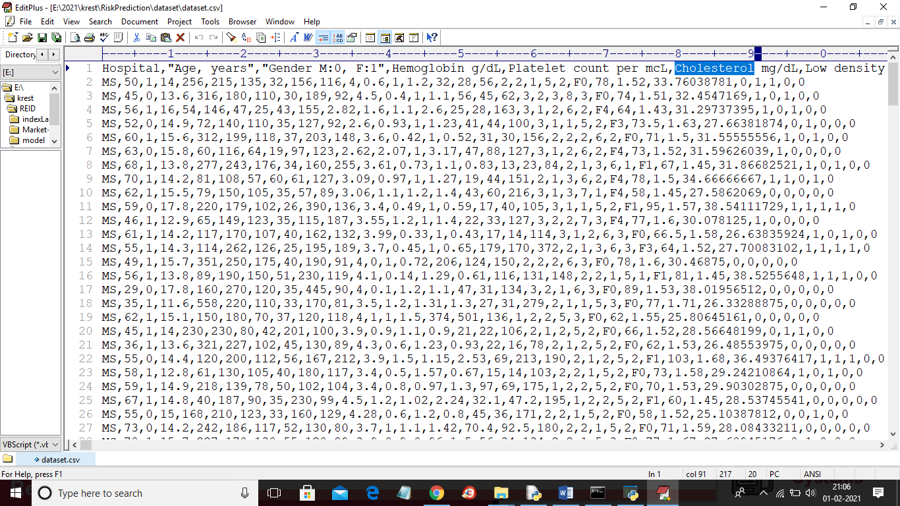

In paper author has describe about disease and you can read from paper as we not require to know about that disease just we need to know how we train both algorithm using above dataset.

About LSTM and RNN algorithm you can read from below URL which describe both algorithms simple format

<http://colah.github.io/posts/2015-08-Understanding-LSTMs/>

Below screen show showing with comments about train LSTM and RNN

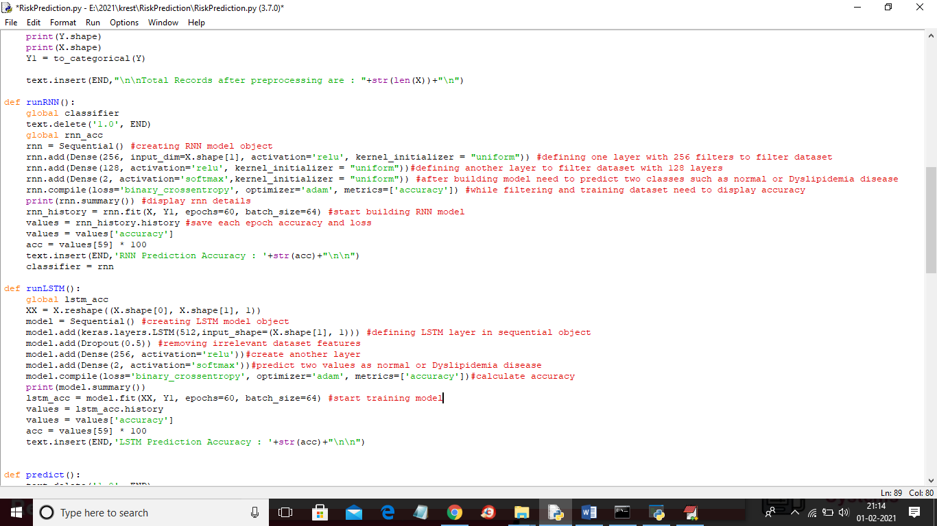

SCREEN SHOTS

To run project double click on run.bat file to get below screen

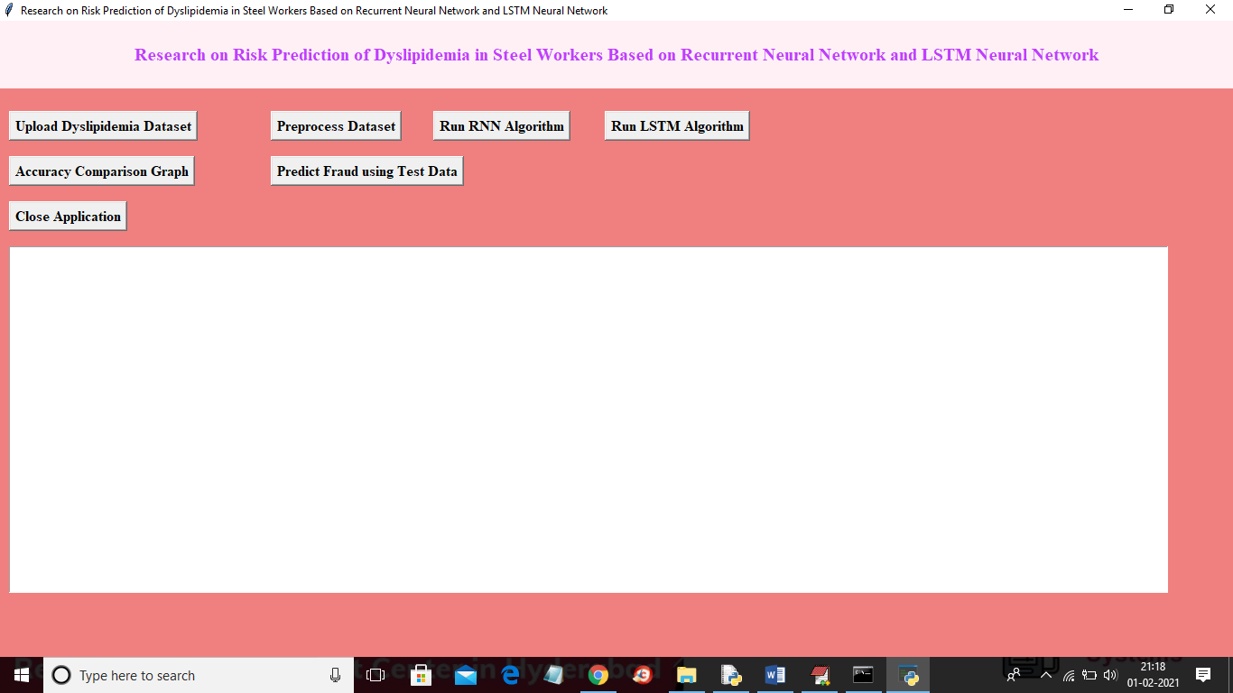

In above screen click on ‘Upload Dyslipidemia Dataset’ button to upload dataset and to get below screen

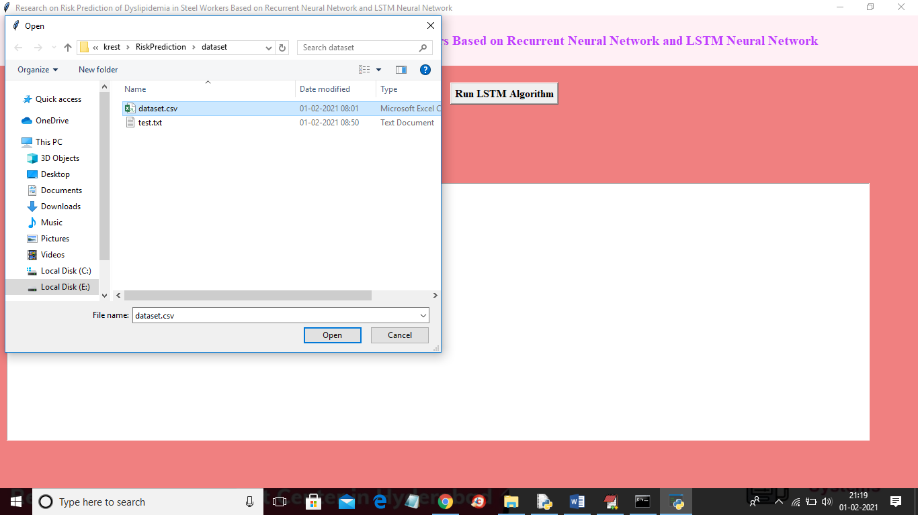

In above screen selecting and uploading ‘dataset.csv’ file and then click on ‘Open’ button to load dataset and to get below screen

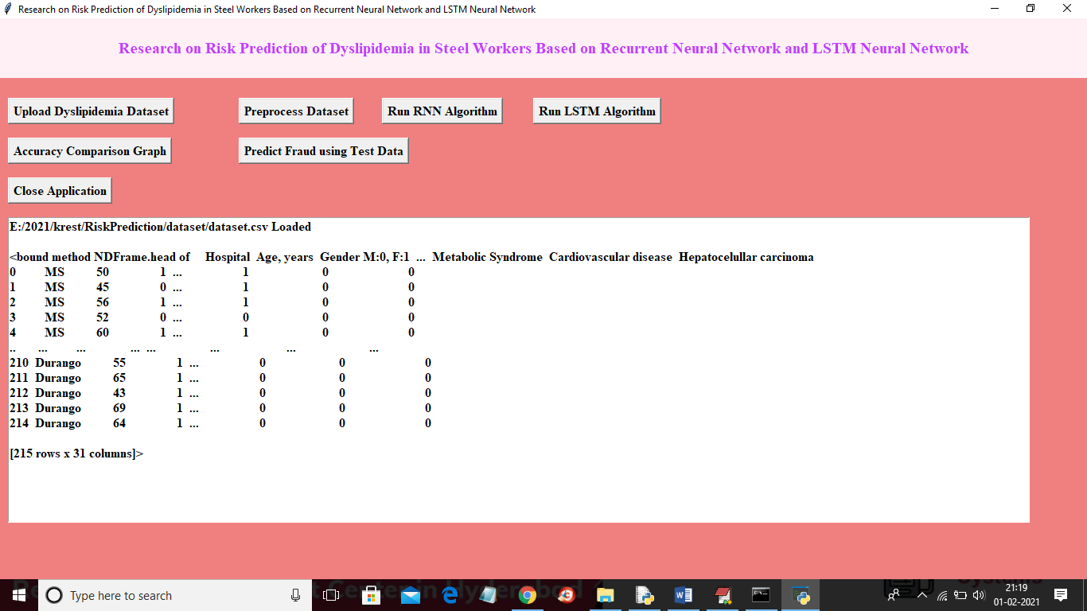

In above screen displaying few rows from dataset and this dataset contains some string values and deep learning only handle numeric values so we need to preprocess above dataset to remove or replace string values with numeric values and now click on ‘Preprocess Dataset’ button to perform string to numeric conversion operation

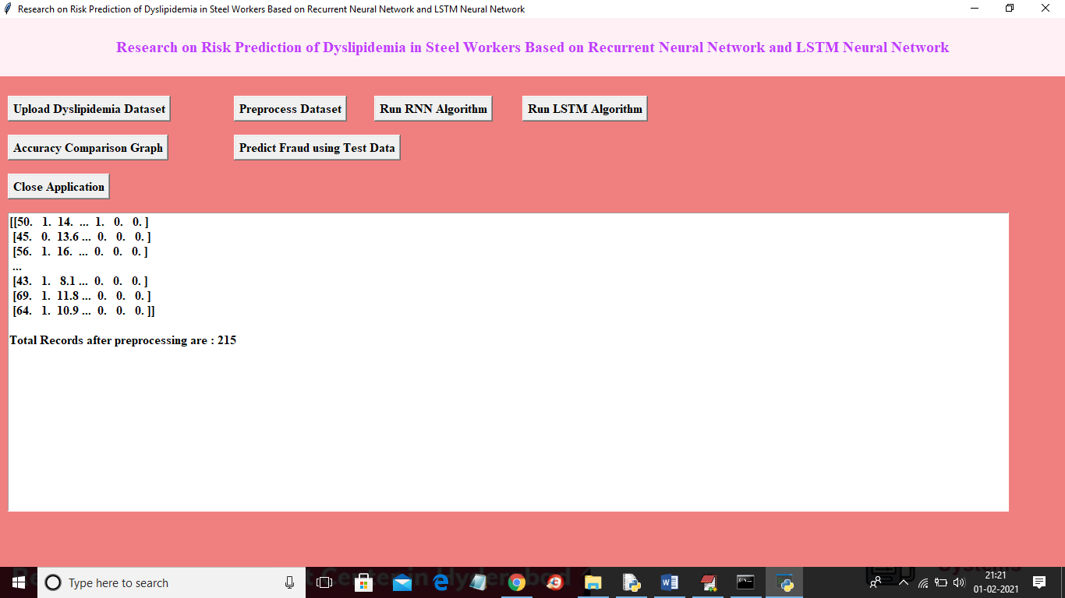

In above screen all string values are converted to numeric and dataset is ready and now click on ‘Run RNN Algorithm’ button to train above dataset with RNN

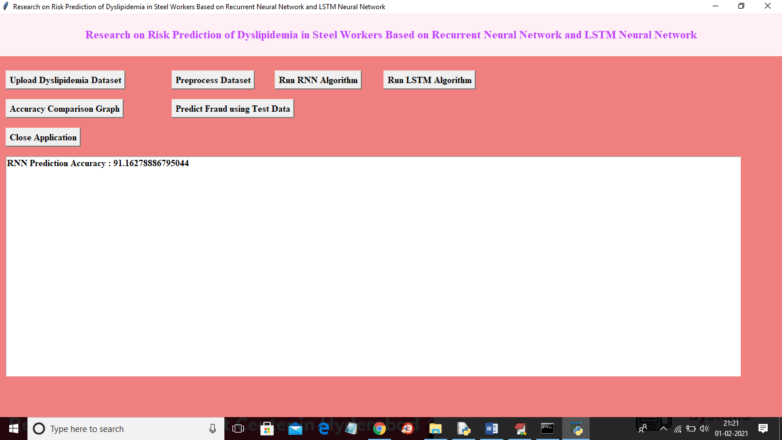in above screen RNN model generated and its prediction accuracy is 91% and in below console we can see RNN model details

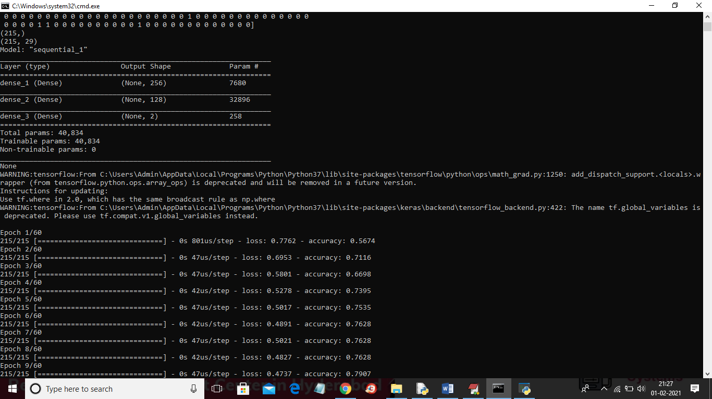

In above screen RNN model generated with multiple layers with 256 and 128 filtration and in above with each iteration accuracy get increase and loss get drop. Now click on ‘Run LSTM Algorithm’ button to train dataset with LSTM and to get it prediction accuracy

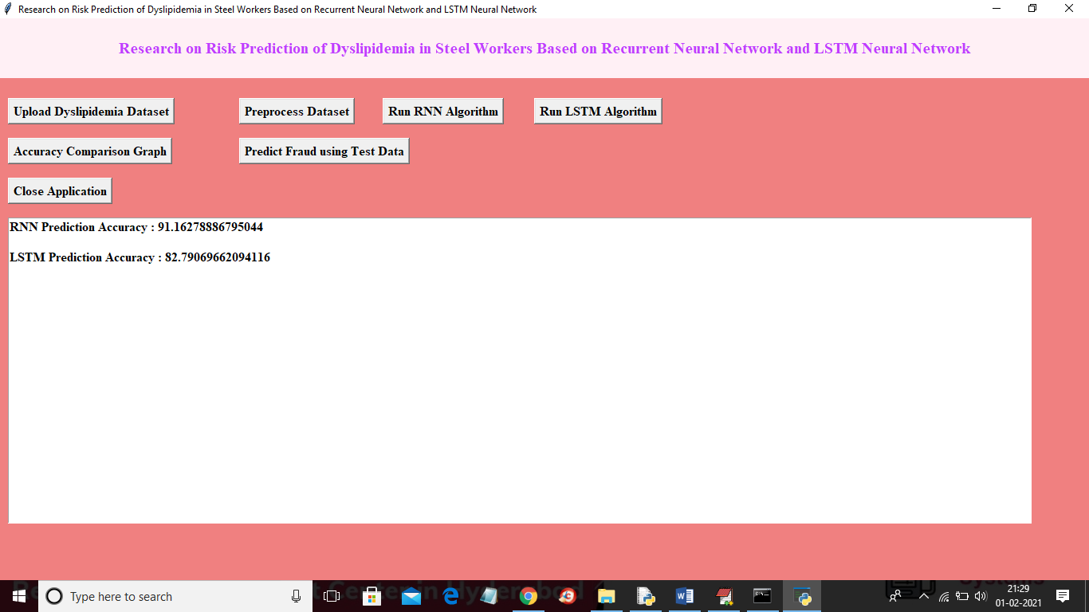

In above screen LSTM accuracy is 82% and in below console we can see LSTM model details

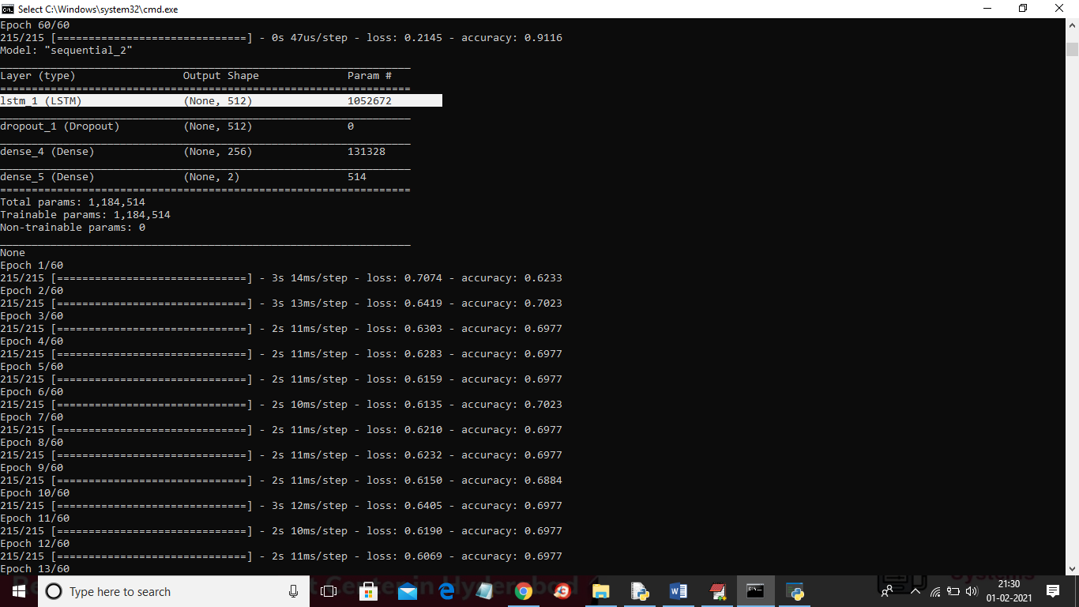

In above console LSTM model details we can see and at each iteration LSTM accuracy got better and now click on ‘Accuracy Comparison Graph’ button to get below graph

In above graph x-axis represents EPOCH/iterations and y-axis represents accuracy and loss value. In above graph red line refers to LSTM accuracy and green line refers to RNN accuracy and blue line for LSTM loss and orange line for RNN loss. From above graph we can conclude that RNN is better than LSTM

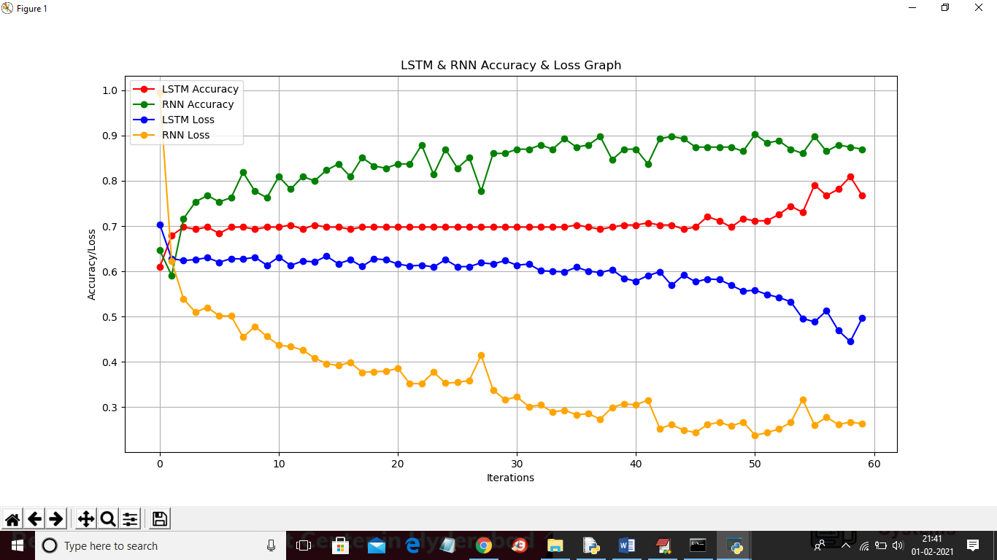

Now click on ‘Predict Disease using Test Data’ button to upload test data and to predict disease from that test data

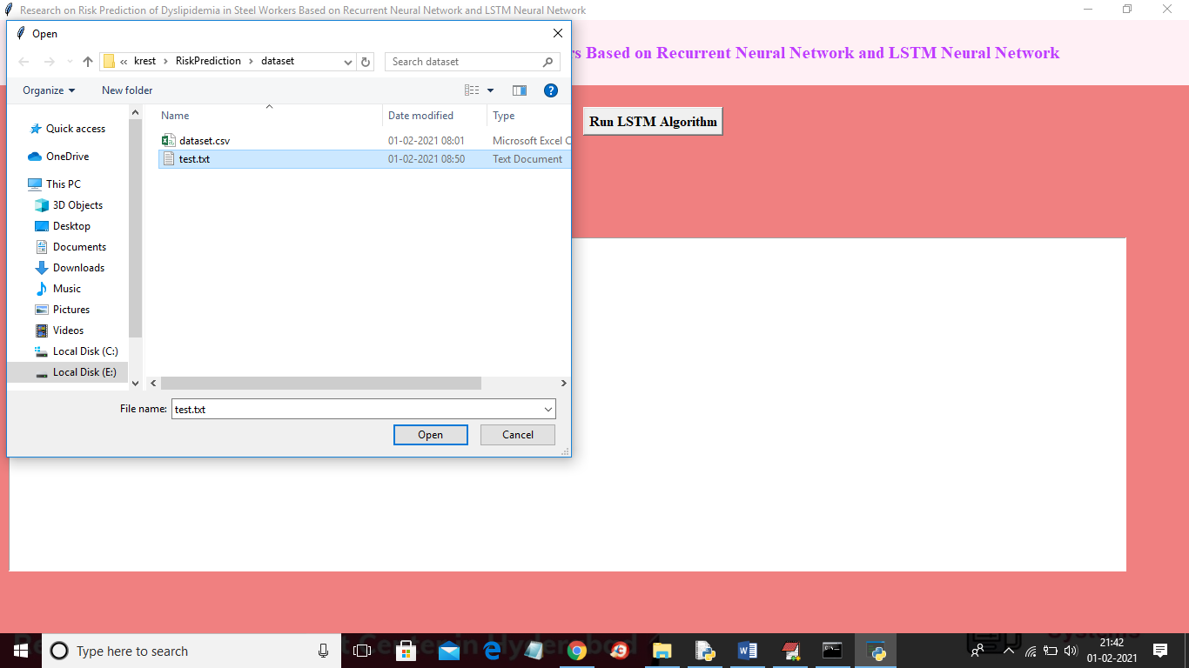

In above screen selecting and uploading ‘test.txt’ test data and then click on ‘Open’ button to load test data and predict disease from it

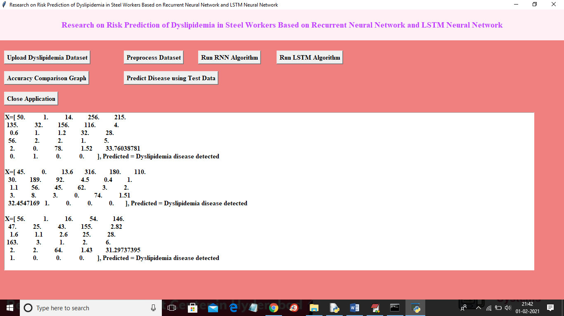

In above screen all values in square brackets and after square bracket we can see predicted value as disease detected or not

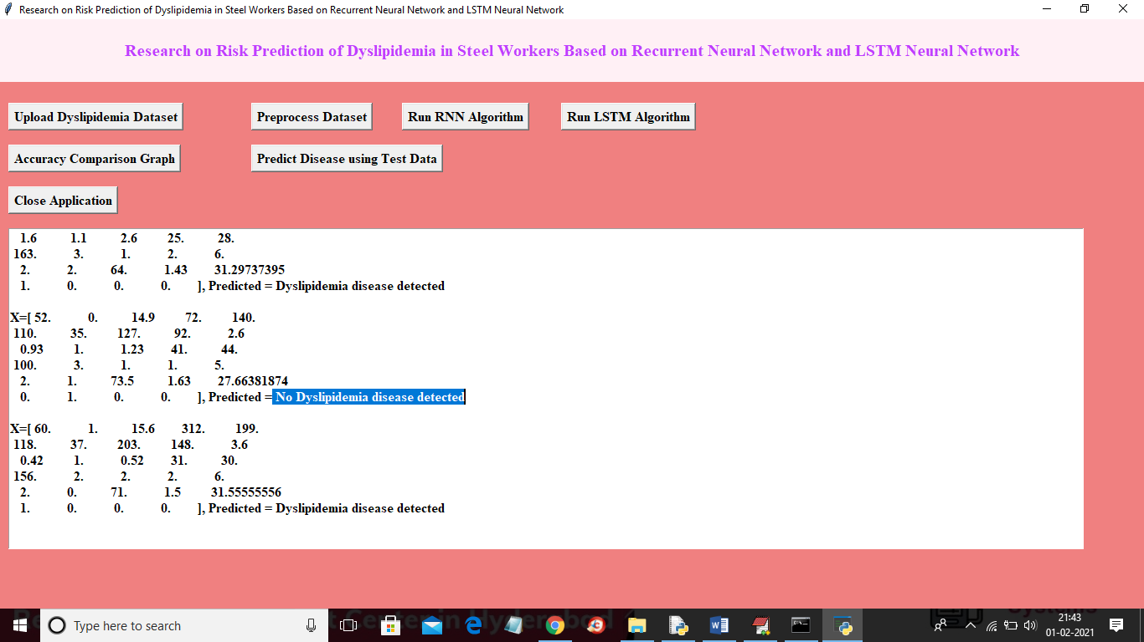

In above screen for some records application predicted Dyslipidaemia disease and for some records no disease detected