7) AIM: Basic Spring Boot Application with Spring Data JPA .

Description :
In this experiment, we will create a Spring Boot application that connects to a MySQL
database and uses Spring Data JPA to perform basic database operations. The
application will allow inserting and retrieving student records through a RESTful
API.
➢ Student.java – The entity class representing students.
➢ StudentRepository.java – The JPA repository interface for database operations.
➢ StudentController.java – REST controller for handling HTTP requests.
➢ StudentsApplication.java – Main application class for bootstrapping the application.
➢ application.properties – Configuration file for database and server.
➢ pom.xml – Maven configuration file for dependencies.
Student.java
package com.example;
import jakarta.persistence.Entity;
import jakarta.persistence.Id;
@Entity
public class Student {
@Id
private int sno;
private String sname;

public Student() {}
public Student(int sno, String sname) {
super();
this.sno = sno;
this.sname = sname;
}
public int getSno() {
return sno;
}
public void setSno(int sno) {
this.sno = sno;
}
public String getSname() {
return sname;
}
public void setSname(String sname) {
this.sname = sname;
}

}

StudentsApplication.java
package com.example;
import org.springframework.boot.CommandLineRunner;
import org.springframework.boot.SpringApplication;
import org.springframework.boot.autoconfigure.SpringBootApplication;
import org.springframework.context.annotation.Bean;
@SpringBootApplication
public class StudentsApplication {
public static void main(String[] args) {
SpringApplication.run(StudentsApplication.class, args);
}
@Bean
CommandLineRunner initDatabase(StudentRepository repo) {
return args -> {
repo.save(new Student(1, "Rakesh kumar"));
repo.save(new Student(2, "Murali"));
repo.save(new Student(3, "vamsi"));
System.out.println("Students inserted!");
};
}
}

StudentController.java
package com.example;
import java.util.List;
import org.springframework.web.bind.annotation.GetMapping;
import org.springframework.web.bind.annotation.PostMapping;
import org.springframework.web.bind.annotation.RequestBody;
import org.springframework.web.bind.annotation.RestController;
@RestController
public class StudentController {
private final StudentRepository repo;
public StudentController(StudentRepository repo) {
this.repo = repo;
}
@PostMapping
public Student addStudent(@RequestBody Student student) {
return repo.save(student);
}
@GetMapping
public List<Student> getAllStudents() {
return repo.findAll();
}

}

StudentRepository.java
package com.example;

import org.springframework.data.jpa.repository.JpaRepository;

public interface StudentRepository extends JpaRepository<Student, Integer> {

}

application.properties

spring.application.name=Students
server.port=8543
spring.datasource.url=jdbc:mysql://localhost:3306/demo
spring.datasource.username=root
spring.datasource.password=Revs@123
spring.jpa.hibernate.ddl-auto=create-drop

spring.jpa.show-sql=true

pom.xml

<?xml version="1.0" encoding="UTF-8"?>
<project xmlns="http://maven.apache.org/POM/4.0.0" xmlns:xsi="http://www.w3.org/2001/XMLSchema-instance"
xsi:schemaLocation="http://maven.apache.org/POM/4.0.0 https://maven.apache.org/xsd/maven-4.0.0.xsd">
<modelVersion>4.0.0</modelVersion>
<parent>
<groupId>org.springframework.boot</groupId>
<artifactId>spring-boot-starter-parent</artifactId>
<version>3.5.5</version>
<relativePath/> <!-- lookup parent from repository -->
</parent>
<groupId>com</groupId>
<artifactId>StudentsApplication</artifactId>
<version>0.0.1-SNAPSHOT</version>
<name>Students</name>
<description>Demo project for Spring Boot</description>
<url/>
<licenses>
<license/>
</licenses>
<developers>
<developer/>
</developers>
<scm>
<connection/>
<developerConnection/>
<tag/>
<url/>
</scm>
<properties>
<java.version>21</java.version>
</properties>
<dependencies>
<dependency>
<groupId>org.springframework.boot</groupId>
<artifactId>spring-boot-starter-data-jdbc</artifactId>
</dependency>

<dependency>
<groupId>org.springframework.boot</groupId>
<artifactId>spring-boot-starter-web</artifactId>
</dependency>

<dependency>
<groupId>com.mysql</groupId>
<artifactId>mysql-connector-j</artifactId>
<scope>runtime</scope>
</dependency>
<dependency>
<groupId>org.springframework.boot</groupId>
<artifactId>spring-boot-starter-test</artifactId>
<scope>test</scope>
</dependency>
<dependency>
<groupId>org.springframework.boot</groupId>
<artifactId>spring-boot-starter-data-jpa</artifactId>

</dependency>
</dependencies>

<build>
<plugins>
<plugin>
<groupId>org.springframework.boot</groupId>
<artifactId>spring-boot-maven-plugin</artifactId>
</plugin>
</plugins>
</build>

</project>

Output:

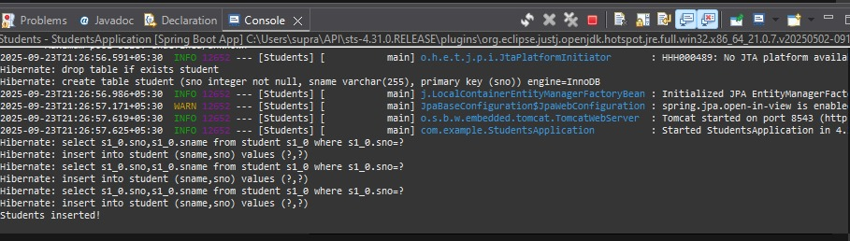

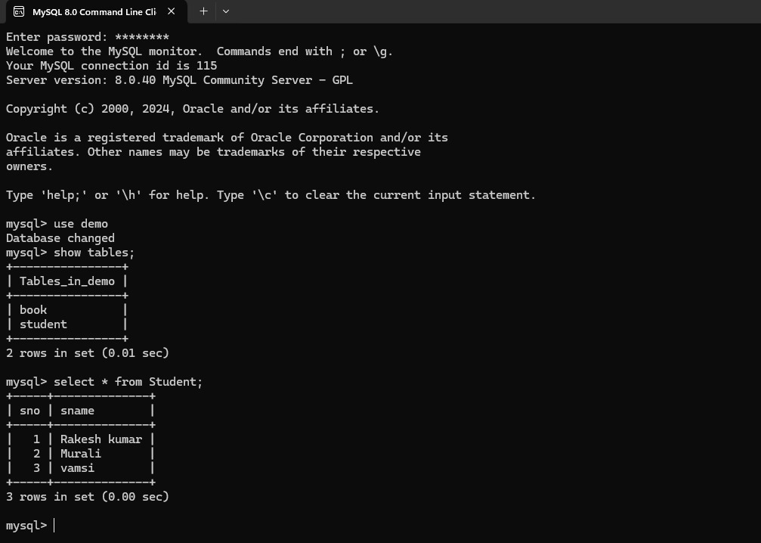

8) AIM: Pagination and Sorting in Spring Data JPA .
Description:
In this experiment, we will create a Spring Boot application that demonstrates how to paginate and sort database records using Spring Data JPA. We will use a Book entity with sample data, a JPA repository interface for database operations, and a REST controller to handle requests. Pagination parameters (page, size) and sorting parameters (sortBy, direction) will be passed via URL query parameters to retrieve data in a aginated and sorted manner.
Book.java
package com.example;
import jakarta.persistence.Entity;
import jakarta.persistence.GeneratedValue;
import jakarta.persistence.GenerationType;
import jakarta.persistence.Id;
@Entity
public class Book {
@Id
@GeneratedValue(strategy = GenerationType.IDENTITY)
private long id;
private String title;
private String author;
public Book() {}
public Book( String title, String author) {
super();
this.title = title;
this.author = author;}
@Override
public String toString() {
return "Book [id=" + id + ", title=" + title + ", author=" + author + "]";}
public long getId() {return id;}
public void setId(long id) {this.id = id;}
public String getTitle() {return title;}
public void setTitle(String title) {this.title = title;}
public String getAuthor() {return author;}
public void setAuthor(String author) {this.author = author;}
}
BookApplication.java
package com.example;
import org.springframework.boot.SpringApplication;
import org.springframework.boot.autoconfigure.SpringBootApplication;
@SpringBootApplication
public class BookApplication {
public static void main(String[] args) {
SpringApplication.run(BookApplication.class, args);
}
}
BookController.java

package com.example;
import org.springframework.data.domain.Page;
import org.springframework.beans.factory.annotation.Autowired;
import org.springframework.data.domain.PageRequest;
import org.springframework.data.domain.Pageable;
import org.springframework.data.domain.Sort;
import org.springframework.web.bind.annotation.*;
@RestController
@RequestMapping("/books")
public class BookController {
@Autowired
private BookRepository bookRepository;
@GetMapping("/init")
public String initData() {
if (bookRepository.count() == 0) {
bookRepository.save(new Book("Spring Boot Basics", "Johnardan"));
bookRepository.save(new Book("Spring Boot Basics", "Eleven"));
bookRepository.save(new Book("Spring Boot Basics", "Will"));
bookRepository.save(new Book("Spring Boot Basics", "Steve"));
bookRepository.save(new Book("Spring Boot Basics", "Dustiban"));
}
return "Sample books added!";
}
@GetMapping
public Page<Book> getBooks(
@RequestParam(defaultValue = "0") int page,
@RequestParam(defaultValue = "3") int size,
@RequestParam(defaultValue = "title") String sortBy,
@RequestParam(defaultValue = "asc") String direction
){
Sort sort = direction.equalsIgnoreCase("asc") ?
Sort.by(sortBy).ascending() :
Sort.by(sortBy).descending();
Pageable pageable = PageRequest.of(page, size, sort);
return bookRepository.findAll(pageable);
}
}

BookRepository.java
package com.example;

import org.springframework.data.jpa.repository.JpaRepository;

public interface BookRepository extends JpaRepository<Book, Long> {

}

application.properties
spring.application.name=Book
server.port=8754
spring.datasource.url=jdbc:mysql://localhost:3306/demo
spring.datasource.username=root
spring.datasource.password=Revs@123
spring.jpa.hibernate.ddl-auto=create-drop

spring.jpa.show-sql=true

pom.xml
<?xml version="1.0" encoding="UTF-8"?>
<project xmlns="http://maven.apache.org/POM/4.0.0" xmlns:xsi="http://www.w3.org/2001/XMLSchema-instance"
xsi:schemaLocation="http://maven.apache.org/POM/4.0.0 https://maven.apache.org/xsd/maven-4.0.0.xsd">
<modelVersion>4.0.0</modelVersion>
<parent>
<groupId>org.springframework.boot</groupId>
<artifactId>spring-boot-starter-parent</artifactId>
<version>3.5.6</version>
<relativePath/> <!-- lookup parent from repository -->
</parent>
<groupId>com</groupId>
<artifactId>BookApplication</artifactId>
<version>0.0.1-SNAPSHOT</version>
<name>Book</name>
<description>Demo project for Spring Boot</description>
<url/>
<licenses>
<license/>
</licenses>
<developers>
<developer/>
</developers>
<scm>
<connection/>
<developerConnection/>
<tag/>
<url/>
</scm>
<properties>
<java.version>21</java.version>
</properties>
<dependencies>
<dependency>
<groupId>org.springframework.boot</groupId>
<artifactId>spring-boot-starter-data-jdbc</artifactId>
</dependency>
<dependency>
<groupId>org.springframework.boot</groupId>
<artifactId>spring-boot-starter-web</artifactId>
</dependency>

<dependency>
<groupId>com.mysql</groupId>
<artifactId>mysql-connector-j</artifactId>
<scope>runtime</scope>
</dependency>
<dependency>
<groupId>org.springframework.boot</groupId>
<artifactId>spring-boot-starter-test</artifactId>
<scope>test</scope>
</dependency>
<dependency>
<groupId>org.springframework.boot</groupId>
<artifactId>spring-boot-starter-data-jpa</artifactId>
</dependency>

</dependencies>

<build>
<plugins>
<plugin>
<groupId>org.springframework.boot</groupId>
<artifactId>spring-boot-maven-plugin</artifactId>
</plugin>
</plugins>
</build>

</project>

Output:

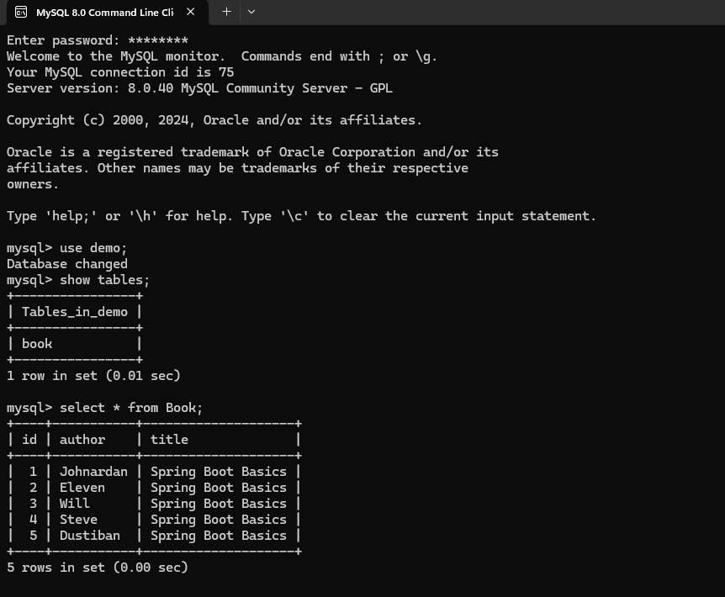

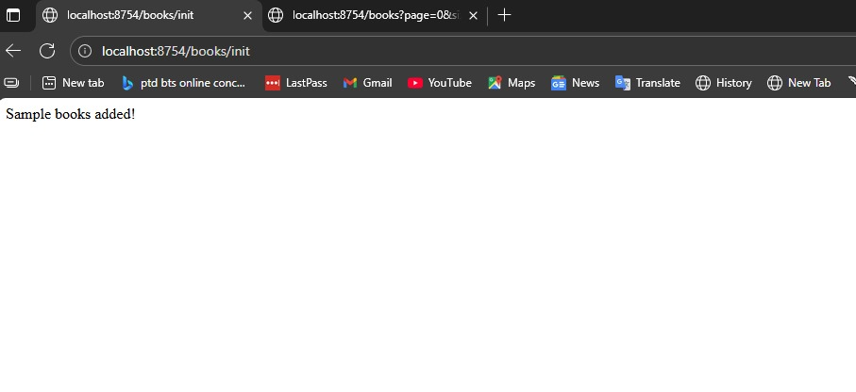

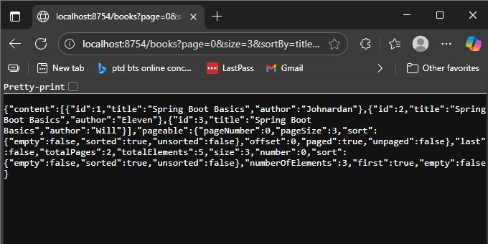

9.AIM: Implementing AOP for Logging with Spring Data JPA .
Description:
In this experiment, we create a Spring Boot application to manage products. The
application includes:
- Entity – Product with id, name, and price.
- Repository – ProductRepository for database operations.
- Service – ProductService to handle business logic.
- Controller – ProductController for REST APIs.
- Aspect – LoggingAspect to log method calls in ProductService.
- Database – H2 in-memory DB or MySQL.
- Dependency Management – Managed via Maven (pom.xml).
This demonstrates the use of Spring Data JPA, Spring AOP, and RESTful API development.

LoggingAspect.java
package com.example;
import org.aspectj.lang.JoinPoint;
import org.aspectj.lang.annotation.Aspect;
import org.aspectj.lang.annotation.Before;
import org.springframework.stereotype.Component;
@Aspect
@Component
public class LoggingAspect {
@Before("execution(* com.example.demo.productService.*(..))")
public void logBefore(JoinPoint joinPoint) {
System.out.println(">>> Entering method: " + joinPoint.getSignature().getName());
}
}

Product.java
package com.example;
import jakarta.persistence.Entity;
import jakarta.persistence.GeneratedValue;
import jakarta.persistence.GenerationType;
import jakarta.persistence.Id;
@Entity
public class product {
@Id
@GeneratedValue(strategy = GenerationType.IDENTITY)
private long id;
private String name;
private double price;
public product() {}
public product(String name, double price) {
super();
this.name = name;
this.price = price;
}
public long getId() {return id; }
public void setId(long id) { this.id = id; }
public String getName() { return name; }
public void setName(String name) { this.name = name; }
public double getPrice() { return price; }
public void setPrice(double price) { this.price = price; }
}

ProductApplication.java
package com.example;
import org.springframework.boot.CommandLineRunner;
import org.springframework.boot.SpringApplication;
import org.springframework.boot.autoconfigure.SpringBootApplication;
import org.springframework.context.annotation.Bean;
@SpringBootApplication
public class ProductApplication {
public static void main(String[] args) {
SpringApplication.run(ProductApplication.class, args);
}
@Bean
CommandLineRunner runner(productRepository repo) {
return args ->{
repo.save(new product("Laptop", 55000));
repo.save(new product("Mobile", 20000));
repo.save(new product("Tablet", 30000));
repo.save(new product("Mouse", 35000));
};
}
}

productController.java
package com.example;
import java.util.List;
import org.springframework.web.bind.annotation.GetMapping;
import org.springframework.web.bind.annotation.PostMapping;
import org.springframework.web.bind.annotation.RequestBody;
import org.springframework.web.bind.annotation.RequestMapping;
import org.springframework.web.bind.annotation.RestController;
@RestController
@RequestMapping("/products")
public class productController {
private final productService service;
public productController(productService service) {
this.service = service;}
@PostMapping("/add")
public product addproduct(@RequestBody product product) {
return service.saveProduct(product);
}
@GetMapping("/all")
public List<product> getAllProducts() {
return service.getAllProducts();
}
}
productRepository.java
package com.example;
import org.springframework.data.jpa.repository.JpaRepository;
public interface productRepository extends JpaRepository<product, Long> {
}
productService.java
package com.example;
import java.util.List;
import org.springframework.stereotype.Service;
@Service
public class productService {
private final productRepository repo;
public productService(productRepository repo) {
this.repo = repo;
}
public product saveProduct(product product) {
return repo.save(product);
}
public List<product> getAllProducts() {
return repo.findAll();
}
}

application.properties
spring.application.name=Product
server.port=8543
spring.datasource.url=jdbc:mysql://localhost:3306/demo
spring.datasource.username=root
spring.datasource.password=Revs@123
spring.jpa.hibernate.ddl-auto=create-drop
spring.jpa.show-sql=true

pom.xml
<?xml version="1.0" encoding="UTF-8"?>
<project xmlns="http://maven.apache.org/POM/4.0.0" xmlns:xsi="http://www.w3.org/2001/XMLSchema-instance"
xsi:schemaLocation="http://maven.apache.org/POM/4.0.0 https://maven.apache.org/xsd/maven-4.0.0.xsd">
<modelVersion>4.0.0</modelVersion>
<parent>
<groupId>org.springframework.boot</groupId>
<artifactId>spring-boot-starter-parent</artifactId>
<version>3.5.6</version>
<relativePath/> <!-- lookup parent from repository -->
</parent>
<groupId>com</groupId>
<artifactId>ProductApplication</artifactId>
<version>0.0.1-SNAPSHOT</version>
<name>Product</name>
<description>Demo project for Spring Boot</description>
<url/>
<licenses>
<license/>
</licenses>
<developers>
<developer/>
</developers>
<scm>
<connection/>
<developerConnection/>
<tag/>
<url/>
</scm>
<properties>
<java.version>21</java.version>
</properties>
<dependencies>
<dependency>
<groupId>org.springframework.boot</groupId>
<artifactId>spring-boot-starter-data-jpa</artifactId>
</dependency>
<dependency>
<groupId>org.springframework.boot</groupId>
<artifactId>spring-boot-starter-data-jdbc</artifactId>
</dependency>
<dependency>
<groupId>org.springframework.boot</groupId>
<artifactId>spring-boot-starter-web</artifactId>
</dependency>
<dependency>
<groupId>com.mysql</groupId>
<artifactId>mysql-connector-j</artifactId>
<scope>runtime</scope>
</dependency>
<dependency>
<groupId>org.springframework.boot</groupId>
<artifactId>spring-boot-starter-test</artifactId>
<scope>test</scope>
</dependency>
</dependencies>
<build>
<plugins>
<plugin>
<groupId>org.springframework.boot</groupId>
<artifactId>spring-boot-maven-plugin</artifactId>
</plugin>
</plugins>
</build>

</project>

Output:
